**IE 310 OPERATION RESEARCH**

**PROJECT**

**REPORT**

**YUSUF KALAYCI**

**2016400357**

**HİLAL DEMİR**

**2014400018**

* **THE MATHEMATICAL MODEL**

The mathematical model of including the definition of the sets, parameters, decision variables, objective function and constraints. The explanation for each constraint ensures also can find as follows:

The sets include the customer index, number of small truck for direct delivery, number of large truck for direct delivery, and type of truck small or large.

The parameters include the clusterability which the costumer can be visited same truck or not, the amount of order of customer in terms of volume, the amount of order of customer in terms of weight, unit cost for indirect delivery and the cost of visiting customer by direct delivery via type of truck.

The decision variables include type of delivery to customer(which is direct or indirect), the truck type which is large and small according to serve , the total delivery cost, largest cost for each large and small truck. In here we have to choose maximized cost for the truck because of the make calculation about the truck cost.

The objection function is about the given day to determine which customers are served by direct delivery and which customers are served by indirect delivery in order to minimize the total delivery cost. For this reason we seperate each direct and indirect situations and find the optimal solution via minimum cost, the costumer select direct or indirect way.For direct delivery cost there are some situations such as the sum of largest cost of large truck and the formula for the large truck direct delivery calculation , the sum of largest cost of small truck and the formula for the small truck direct delivery calculation. For indirect delivery cost there are sum for the unit cost and amount of order of customer in weight multiplication.

* The explanation for each constraints as follows :

Constraint 1 : sum(j, T(i,j)) <= 3

This constraint is about the number of customers which is visited by a truck (small or large) for direct delivery.In this constraint at most three(3) customers can be visited by a large truck.

Constraint 2 : sum(j, S(l,j)) <= 3

This constraint is about the number of customers which is visited by a truck (small or large) for direct delivery.In this constraint at most three(3) customers can be visited by a small truck.

Constraint 3 : sum(j, T(i,j)*dv(j)) <= 33

This constraint is about the volume capacity of large trucks and the large trucks volume capacity is 33 m3, The sum of the large truck which serves customer j and volume of each customer order amount multiplication is smaller or equall 33.

Constraint 4 : sum(j, S(l,j)*dv(j)) <= 18

This constraint is about the volume capacity of small trucks and the small trucks volume capacity is 18 m3, The sum of the small truck which serves customer j and volume of each customer order amount multiplication is smaller or equall 18.

Constraint 5 : X(j) + sum(i, T(i,j)) + sum(l, S(l,j)) = 1

This constraint is about selection of the truck small or large and if it is the direct delivery occurs. Here the type of customer X(j) is zero(0) when the direct delivery. After that , it controlls the type of truck is large or small via equalling the sum of three condition is one(1). For example if the truck is large the others will be zero and the T(i,j) will be one(1). Then the sum of the truck is found.

Constraint 6 : T(i,j)*c(j, ’large’) <= Max1(i)

This constraint is about the among large trucks i for customer j multiply the cost of visiting customer with type of large truck is less than or equall to max1 value.

Constraint 7 : S(l,j)*c(j, ’small’) <= Max2(l)

This constraint is about the among small trucks l for customer j multiply the cost of visiting customer with type of small truck is less than or equall to max1 value.

Constraint 8 : sum(j, a(j,w)) >= sum(j, T(i,j))

This constraint is about the clusterability which is showing the costumer that can be visited together for each of the large truck. The sum of the customer which can visited by same truck in direct delivery is greater or equall to sum of the large truck which serves the customer.

Constraint 9 : sum(j, a(j,w)) >= sum(j, S(l,j))

This constraint is about the clusterability which is showing the costumer that can be visited together for each of the small truck. The sum of the customer which can visited by same truck in direct delivery is greater or equall to sum of the small truck which serves the customer.

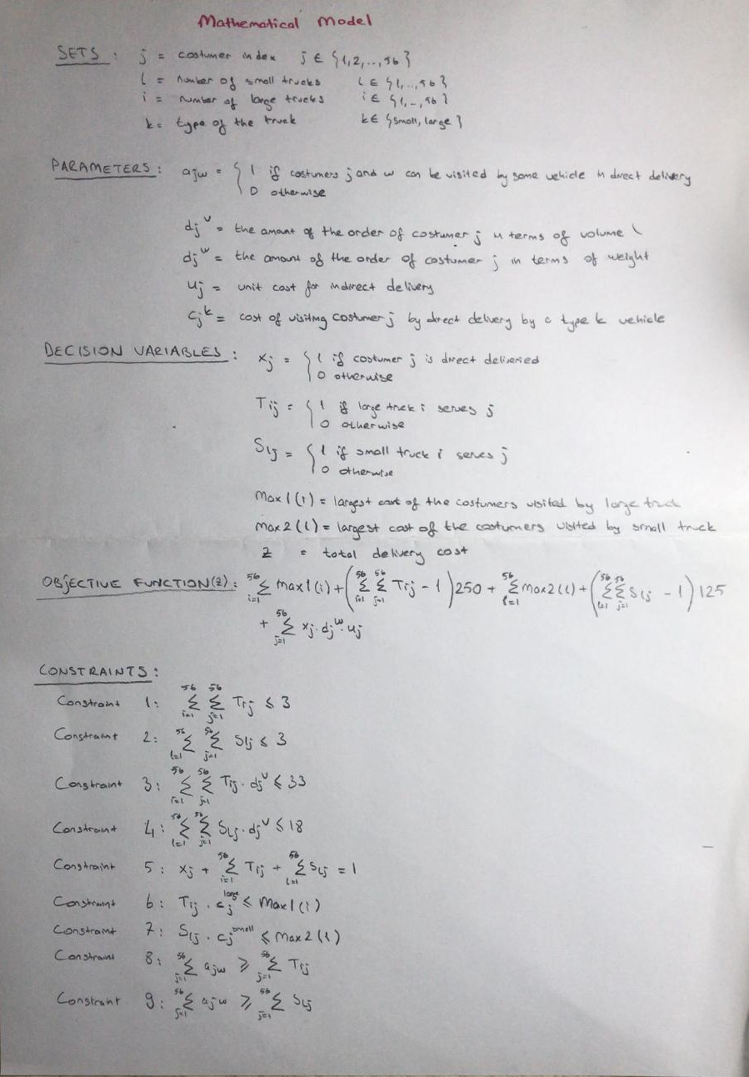

* The model is as follows:

**Sets**

j “customer index” /1*56/

l “number of small trucks(we assumed 56 for this case)” /1*56/

i “number of large trucks(we assumed 56 for this case)” /1*56/

k “type of the truck” /small, large/

**Parameters**

a(j,w) “=1 if customers j and w can be visited by the same vehicle in direct delivery, =0 otherwise.”

dv(j) “the amount of order of costumer j in terms of volume”

dw(j) “the amount of order of costumer j in terms of weight”

u(j) “unit cost for indirect delivery”

c(j,k) “cost of visiting costumer j by direct delivery by a type k vehicle”

**Decision Variables**

X(j) “=1 if costumer j is direct deliveried, =0 otherwise”

T(i,j) “=1 if large truck i serves costumer j, =0 otherwise”

S(l,j) “=1 if small truck l serves costumer j, =0 otherwise”

Max1(i) “largest cost of the costumers visited by large truck”

Max2(l) “largest cost of the costumers visited by small truck”

Z “total delivery cost”

**Objective Function**

Total_cost = Z = sum(i, Max1(i)) + (sum((i,j),T(i,j)) - 1)*250 +

sum(l, Max2(l)) + (sum((l,j), S(l,j)) - 1)*125 +

sum(j, X(j)*dw(j)*u(j))

**Constraints**

Constraint 1 : sum(j, T(i,j)) <= 3

Constraint 2 : sum(j, S(l,j)) <= 3

Constraint 3 : sum(j, T(i,j)*dv(j)) <= 33

Constraint 4 : sum(j, S(l,j)*dv(j)) <= 18

Constraint 5 : X(j) + sum(i, T(i,j)) + sum(l, S(l,j)) = 1

Constraint 6 : T(i,j)*c(j, ’large’) <= Max1(i)

Constraint 7 : S(l,j)*c(j, ’small’) <= Max2(l)

Constraint 8 : sum(j, a(j,w)) >= sum(j, T(i,j))

Constraint 9 : sum(j, a(j,w)) >= sum(j, S(l,j))

**Optimal Solution**

MIP Solution : 15056.820282 (21562126 iterations, 44728 nodes)

Final Solve : 15056.820282 (0 iterations)

Best Possible : 12699.368795

Absolute Gap : 2357.451487

Relative Gap : 0.156570

* **THE OPTIMAL SOLUTION**

The optimal solution we obtained including how each customer is being served (directly or indirectly), the group of customer served directly with the same small or large truck is as follows :

***VARIABLE Z.L = 15056.820 total delivery cost

***VARIABLE X.L type of delivery to customer j(0 is direct and 1 is indirect)

39999031 1.000, 30002532 1.000, 30004701 1.000, 30002981 1.000, 30003646 1.000, 30003649 1.000, 30007192 1.000, 30008142 1.000, 30002991 1.000, 30008173 1.000, 30006465 1.000, 30003020 1.000, 30005146 1.000

30007097 1.000, 30007008 1.000, 30002990 1.000, 30002962 1.000, 30003006 1.000, 30005002 1.000, 30006719 1.000, 30001483 1.000, 30007348 1.000, 30005139 1.000, 30003018 1.000, 30007662 1.000, 30008728 1.000

30008083 1.000, 30007169 1.000, 30006774 1.000, 30008666 1.000, 30008699 1.000, 30003818 1.000, 30008348 1.000, 30002979 1.000, 30002141 1.000, 30000547 1.000, 30000414 1.000, 30006535 1.000, 30000077 1.000

***VARIABLE T.L large truck i serves j(1 it serves 0 otherwise)

( ALL 0.000 )

***VARIABLE S.L small truck l serves j(1 it serves 0 otherwise)

30003002 30002989 30007858 30003000 30003813 30005483 30004646 30006671 30008775 30008347 30008774 30008624 30008654 30007897 30008444 30002978 30002985

3 1.000 1.000 1.000

14 1.000 1.000

26 1.000 1.000 1.000

45 1.000 1.000 1.000

48 1.000 1.000 1.000

53 1.000 1.000 1.000

***VARIABLE Max1.L largest cost of the customers visited by large truck

( ALL 0.000 )

***VARIABLE Max2.L largest cost of the customers visited by small truck

3 352.740, 14 1571.840, 26 878.980, 45 2642.460, 48 352.740, 53 352.740

