Multiple Linear Regression Analysis
Jul.04 Yusuke MURAYAMA

[Regression]
X: models (n length and p models)
Y: data
β: regression coefficient

A constant components is included in “models” (p+1).
“models” are standardized (mean=0, std=1) EXCEPT A CONSTANT ONE.
Least square method is equal to solve
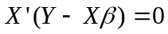
If set 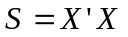, 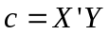 then
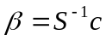
where 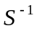 is the inverse matrix of S.

If set 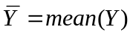, 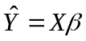 then
error | sum of squares | freedom | mean sum of squares
regresson | 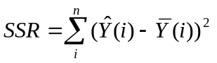 | p | 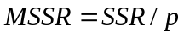
residuals | 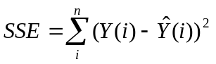 | n-p-1 | 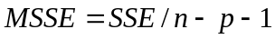
total | 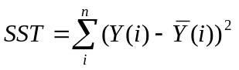 | n-1 | 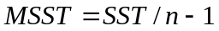

t statiscs for each β is given by
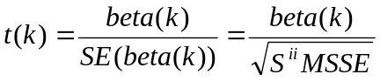
where beta(k): k element of β, SE: standard error, 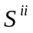: i-i element of , freedom is n-p-1

F statistics for the full regression is given by
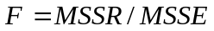
where freedoms are p and n-p-1

[Contrast Map]
“newbeta” is computed as
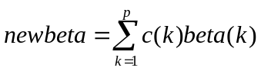
where, c(k): Contrast vector, beta(k): Regression coefficient, p: Number of coefficients

Estimated value of “newbeta” is given as
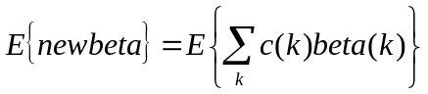

Estimated value of “newbeta^2” is given as
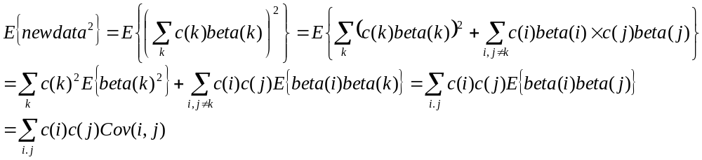
where Cov(i,j) is a i-j componet of covariance for beta.

T statistics for “newbeta” is computed as
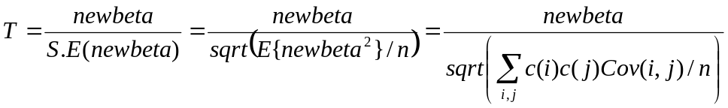
where S.E: standard error of newbeta, n: dimension of a model.

function varargout = mulregress(y,X)
%MULREGRESS - does multiple linear regression analysis.
% STATS = MULREGRESS(Y,X) does multiple linear regression analysis.
%
% VERSION :
% 0.90 29.06.05 YM pre-release
% 0.91 30.06.05 YM bug fix for "degrees of freedom".
% 0.92 01.07.05 YM adds "stdbeta", but formula NOT CONFIRMED.
%
% See also REGRESS, REGSTATS, X2FX, VREGRESS

if nargin < 2, help mulregress; return; end

% CHECK DEBUG MODE OR NOT %%%%%%%%%%%%%%%%%%%%%%%%%%%%%%%%%%%%%%%%%%%%%%%%%%%%%
DEBUG = 0;
if ischar(y) & strcmpi(y,'debug'),
DEBUG = 1;
fprintf('%s %s: DEBUG: loading...',datestr(now,'HH:MM:SS'),mfilename);
[y X nX nY nS] = subLoadExample();
fprintf(' processing...');
end
%%%%%%%%%%%%%%%%%%%%%%%%%%%%%%%%%%%%%%%%%%%%%%%%%%%%%%%%%%%%%%%%%%%%%%%%%%%%%%%

% Check that matrix (X) and left hand side (y) have compatible dimensions
[n,ncolX] = size(X);

if isvector(y), y = y(:); end
if ndims(y) > 2,
error('%s:regress:InvalidData', 'Y must be a vector/matrix.',mfilename);
elseif size(y,1) ~= n
error('%s:regress:InvalidData', ...
'The number of rows in Y must equal the number of rows in X.',mfilename);
end

% create desired models %%%%%%%%%%%%%%%%%%%%%%%%%%%%%%%%%%%%%%%%%%%%%%%%%%%%
%Xi = X;
%X = x2fx(Xi,model); % moded: 'linear','interaction','quadratic','purequadratic'

% Check whether "X" contains a constant model that will affects degrees of freedom.
% If exists a "const", then ignore it from degrees of freedom.
NoConst = 1;
for N = 1:size(X,2),
if all(X(:,N) == X(1,N)),
NoConst = 0; break;
end
end

% orthogonalize models %%%%%%%%%%%%%%%%%%%%%%%%%%%%%%%%%%%%%%%%%%%%%%%%%%%%%
[n, ncolX] = size(X);
[Q,R,perm] = qr(X,0);
p = sum(abs(diag(R)) > max(n,ncolX)*eps(R(1)));
if p < ncolX
warning('%s:regress:RankDefDesignMat', ...
'X is rank deficient to within machine precision.',mfilename);
R = R(1:p,1:p);
Q = Q(:,1:p);
perm = perm(1:p);
end

% Get back to the original order of X %%%%%%%%%%%%%%%%%%%%%%%%%%%%%%%%%%%%%
%Q = Q(:,perm);
%R = R(perm,perm);
%perm = 1:length(perm); % later proc may use...

% compute statistics %%%%%%%%%%%%%%%%%%%%%%%%%%%%%%%%%%%%%%%%%%%%%%%%%%%%%%%
beta(perm,:) = R\(Q'*y); % Regression coefficients
yhat = X * beta; % Fitted values of the response data
residuals = y - yhat; % Residuals of full model
if NoConst == 1,
dfe = n - p - 1; % Degrees of freedom for error
dfr = p; % Degrees of freedom for residuals
else
% Ignores contribution of the const. component, see regress().
dfe = n - p;
dfr = p - 1;
end
ybar = mean(y,1); % mean of y
sse = zeros(1,size(y,2));
ssr = zeros(1,size(y,2));
sst = zeros(1,size(y,2));
for N = 1:size(y,2),
sse(N) = norm(residuals(:,N))^2; % sum of squared errors
ssr(N) = norm(yhat(:,N) - ybar(N))^2; % regression sum of squares
sst(N) = norm(y(:,N) - ybar(N))^2; % total sum of squares
end
mse = sse ./ dfe; % Mean squared error
%h = sum(abs(Q).^2,2);
ri = R\eye(p);
xtxi = ri*ri';
xtxi = xtxi(perm,perm);
covb = zeros(size(xtxi,1),size(xtxi,2),size(y,2));
for N = 1:size(y,2),
covb(:,:,N) = xtxi * mse(N); % Covariance of regression coefficients
end

% standarized beta, 01.07.05 YM: I'm not sure this is correct or not....
sxx = zeros(size(X,2),1);
xbar = mean(X,1);
for N = 1:size(X,2),
sxx(N) = norm(X(:,N) - xbar(N))^2;
end
stdbeta = zeros(size(beta));
for N = 1:size(beta,2),
stdbeta(:,N) = beta(:,N) .* sqrt(sxx./sst(N));
end

% t statistics %%%%%%%%%%%%%%%%%%%%%%%%%%%%%%%%%%%%%%%%%%%%%%%%%%%%%%%%%%%%%%%%%
tstat.dfe = dfe;
tstat.se = zeros(size(covb,1),size(y,2));
for N = 1:size(y,2),
tstat.se(:,N) = sqrt(diag(covb(:,:,N)));
end
tstat.t = beta ./ tstat.se;
tstat.pval = 2*(tcdf(-abs(tstat.t), dfe));

% F statistics %%%%%%%%%%%%%%%%%%%%%%%%%%%%%%%%%%%%%%%%%%%%%%%%%%%%%%%%%%%%%%%%
fstat.dfe = dfe;
fstat.dfr = dfr;
fstat.f = (ssr/dfr) ./ (sse/dfe);
fstat.pval = 1 - fcdf(fstat.f, dfr, dfe);

% PREPARE "STATS" structure %%%%%%%%%%%%%%%%%%%%%%%%%%%%%%%%%%%%%%%%%%%%%%%%%%%%
STATS.Q = Q; % Q from the QR eecomposition of the design matrix
STATS.R = R; % R from the QR decomposition of the design matrix
STATS.perm = perm; % permutation vector from QR decompositon
STATS.beta = beta; % Regression coefficients
STATS.stdbeta = stdbeta;
STATS.yhat = yhat; % Fitted values of the response data
STATS.r = residuals; % Residuals of full model
STATS.dfe = dfe; % Degrees of freedom for error
STATS.dfr = dfr; % Degrees of freedom for residuals
STATS.ymean = ybar; % mean of y
STATS.sse = sse; % Sum of squared errors
STATS.ssr = ssr; % Regression sum of squares
STATS.sst = sst; % Total sum of squares
%STATS.h = h;
%STATS.ri = ri;
%STATS.xtxi = xtxi;
STATS.covb = covb; % Covariance of regression coefficients

STATS.tstat = tstat; % t statistics for coefficients
STATS.fstat = fstat; % F statistic for full model

% RETURN THE RESULT %%%%%%%%%%%%%%%%%%%%%%%%%%%%%%%%%%%%%%%%%%%%%%%%%%%%%%%%%%%%
if nargout,
varargout{1} = STATS;
end

if DEBUG > 0,
fprintf(' plotting...');
figure('name',sprintf('%s: DEBUG',mfilename));
subplot(2,3,1);
imagesc(reshape(sse, [nX,nY])'); colorbar; title('sse=norm(y-yhat)^2');
subplot(2,3,2);
imagesc(reshape(mse, [nX,nY])'); colorbar; title('mse=sse/dfe=norm(y-yhat)^2/dfe');
subplot(2,3,4);
imagesc(reshape(sst, [nX,nY])'); colorbar; title('sst=norm(y-ymean)^2');
subplot(2,3,5);
imagesc(reshape(ssr, [nX,nY])'); colorbar; title('ssr=norm(yhat-ymean)^2');
subplot(2,3,6);
imagesc(reshape(fstat.f, [nX,nY])'); colorbar; title('F=(ssr/dfr)/(sse/dfe)');
fprintf(' done.\n');
end

return;

%%%%%%%%%%%%%%%%%%%%%%%%%%%%%%%%%%%%%%%%%%%%%%%%%%%%%%%%%%%%%%%%%%%%%%%%%%%%%%%
% SUBFUNCTION to load example data for debug
function [y X nX nY nS] = subLoadExample(varargin)
%%%%%%%%%%%%%%%%%%%%%%%%%%%%%%%%%%%%%%%%%%%%%%%%%%%%%%%%%%%%%%%%%%%%%%%%%%%%%%%

% CONTROL FLAGS / SETTINGS %%%%%%%%%%%%%%%%%%%%%%%%%%%%%%%%%%%%%%%%%%%%%%%
USE_PCA = 1;
XYFILT_HSIZE = 3;
XYFILT_SIGMA = 0.8;
SLICE = 51;

% GET BASIC INFO %%%%%%%%%%%%%%%%%%%%%%%%%%%%%%%%%%%%%%%%%%%%%%%%%%%%%%%%%
Ses = goto('d03se1');
grp = getgrp(Ses,'mdeftinj');
fprintf(' %s(%s-sl%d)',Ses.name,grp.name,SLICE);

% load data %%%%%%%%%%%%%%%%%%%%%%%%%%%%%%%%%%%%%%%%%%%%%%%%%%%%%%%%%%%%%
tcImg = mn_tcslice_load(Ses,grp,SLICE);
nX = size(tcImg.dat,1); nY = size(tcImg.dat,2); nS = size(tcImg.dat,3);
nT = size(tcImg.dat,4);
if USE_PCA > 0,
y = double(tcImg.pca_denoised);
else
y = double(tcImg.dat);
end

% XY filtering %%%%%%%%%%%%%%%%%%%%%%%%%%%%%%%%%%%%%%%%%%%%%%%%%%%%%%%%%
h = fspecial('gaussian',XYFILT_HSIZE,XYFILT_SIGMA);
for N = 1:size(y,3),
for iT = 1:size(y,4),
y(:,:,N,iT) = filter2(h,y(:,:,N,iT),'same');
end
end

% convert dimension %%%%%%%%%%%%%%%%%%%%%%%%%%%%%%%%%%%%%%%%%%%%%%%%%%%%%
y = reshape(y,[nX*nY*nS,nT]);
y = permute(y,[2 1]);

% load models %%%%%%%%%%%%%%%%%%%%%%%%%%%%%%%%%%%%%%%%%%%%%%%%%%%%%%%%%%%
MODELS = { 'plgn','mlgn','sc','v1','arteries' };
X = [];
ROI = load('Roi.mat',grp.grproi);
ROI = ROI.(grp.grproi);
for N = 1:length(MODELS),
tmpts = mn_roits_cat(mn_roits_get(ROI,grp,MODELS{N},[],USE_PCA));
if ~isempty(tmpts) & ~isempty(tmpts.dat),
tmpdat = mean(double(tmpts.dat),2);
X = cat(2,X,tmpdat);
end
end

% normalize data %%%%%%%%%%%%%%%%%%%%%%%%%%%%%%%%%%%%%%%%%%%%%%%%%%%%%%%%
fprintf(' normalizing...');
TC_GLOBAL = load('globaltc.mat',grp.name);
TC_GLOBAL = TC_GLOBAL.(grp.name);
for N = 1:length(TC_GLOBAL.dat),
y(N,:) = y(N,:) / TC_GLOBAL.dat(N);
X(N,:) = X(N,:) / TC_GLOBAL.dat(N);
end

% adds a constant component
X(:,end+1) = 1;

return;
function varargout = mulregress_contrast(BETA,COVB,CONTVEC,dfe)
%MULREGRESS_CONTRAST - Returns statistics for given contrast vector.
% STATS = MULREGRESS_CONTRAST(BETA,COVB,CONTVEC,DFE) returns statistics for
% given contrast vector, "CONTVEC". "COVB" is a covariance matrix of
% regression coefficients and must be symmetric. "DFE" is degrees of freedom
% for error, n-p-1 for usual cases, n-p for models with a const. component.
%
% !!!!!!!!!!!!!!!!!!!!!!!!!
% AT THIS MOMENT (01.Jul.2005), I FOUND NO BOOK/LITERATURE DISCRIBING
% THIS KIND OF FUNCTION. SO THERE IS NO GURANTEE THAT I MADE ARE CORRECT.
% !!!!!!!!!!!!!!!!!!!!!!!!!
%
% VERSION :
% 0.90 01.07.05 YM pre-release
%
% See also MULREGRESS

if nargin < 4, help mulregress_contrast; return; end

NumModels = size(COVB,1);

% make sure that "CONTVEC" is a row vector %%%%%%%%%%%%%%%%%%%%%%%%%%%%%%%
CONTVEC = CONTVEC(:)';

% check the size of "CONTVEC" %%%%%%%%%%%%%%%%%%%%%%%%%%%%%%%%%%%%%%%%%%%
if length(CONTVEC) < NumModels,
CONTVEC(length(CONTVEC)+1:NumModels) = 0;
elseif length(CONTVEC) > NumModels,
CONTVEC = CONTVEC(1:NumModels);
end

CC = CONTVEC'*CONTVEC;

newbeta = zeros(1,size(COVB,3));
tstat.dfe = dfe;
tstat.se = zeros(1,size(COVB,3));
for N = 1:size(COVB,3),
newbeta(N) = CONTVEC * BETA(:,N);
tstat.se(N) = sqrt(sum(diag(COVB(:,:,N)*CC)));
end
tstat.t = newbeta ./ tstat.se;
tstat.pval = 2*(tcdf(-abs(tstat.t), dfe));

% PREPARE THE STRUCTURE FOR OUTPUT %%%%%%%%%%%%%%%%%%%%%%%%%%%%%%%%%%%%
STATS.beta = newbeta;
STATS.tstat = tstat;

if nargout,
varargout{1} = STATS;
end

return;

