ClnBlpGui
Thursday, July 11, 2013

Contents
1 Getting started 1
1.1 Aims 1
1.2 Function call 2
2 GUI components 3
2.1 Channel selection 3
2.2 Band selection 3
2.3 Time interval 4
2.4 Filters 5
2.5 Z-score 5
2.6 Show events 6
2.7 Waveform / TF profile 8
2.8 Time course / Peri-event 9
2.9 Spikes 11
2.10 Average events 14
2.11 Average z-score 15
2.12 Average TF profile 16
2.13 Principal component analysis (PCA) 17
2.14 Separate picture 19
2.15 Reset GUI 20

Getting started

Aims

  - Visualization of MRI and EEG measurement data (this includes raw data (CLN), all frequency bands, that were determined in BLP, event data (NEVT), spike data (SPKT))
  - Many different options for data preparation and representation (filtering, z-score, time-frequency (TF) profile, jump to specific event, peri-event mode etc.)
  - Different data analysis possibilities (average events, average TF profile of events, principal component analysis etc.)

Function call

>> ClnBlpGui ( Session , ExperimentNumber )
e.g. >> ClnBlpGui('rathm1',4)

=> opens GUI with default settings (all channels of raw cln data)

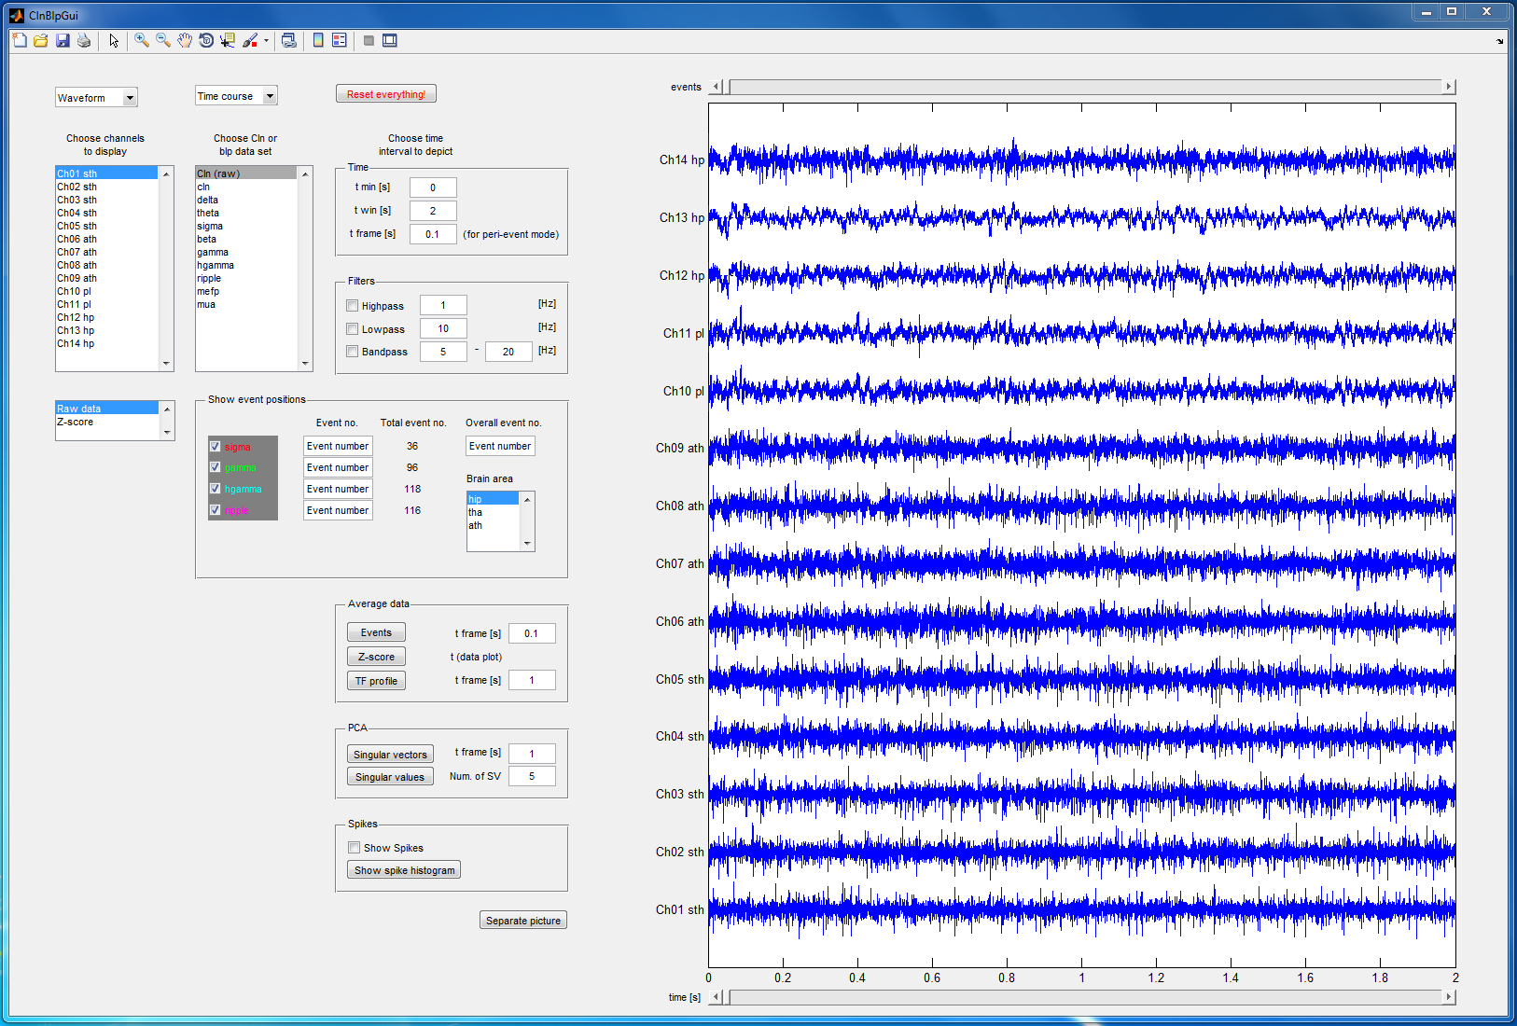

GUI components

Channel selection

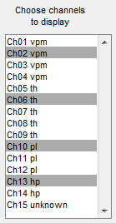

  - Number of channels and denotations are loaded automatically
  - Select one or more channels (select multiple channels by pressing CTRL)
  - Confirm selection by pressing ENTER or executing another GUI element
  - The data for the selected channels is displayed in the plot area
  - The names of the data sets in the plot are adapted automatically

Band selection

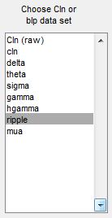

  - Choose frequency band to show (by mouse click)
  - The first element in the list addresses the real Cln data (chosen initially)
  - The other elements (number and names) are loaded to the list automatically from blp data

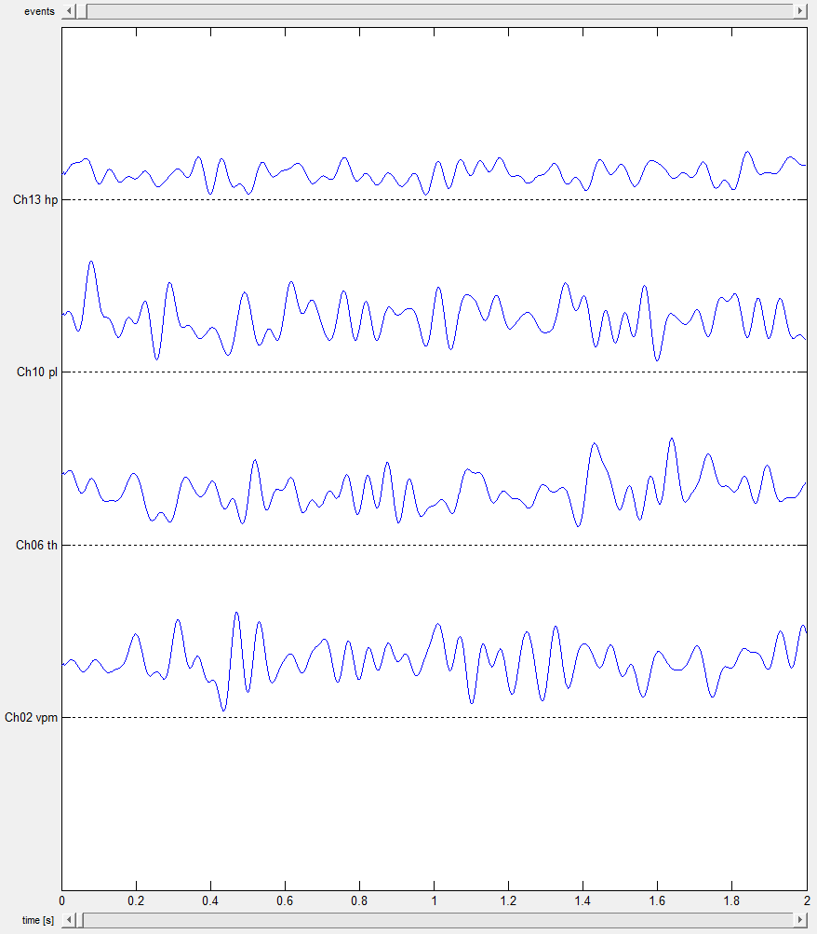

Time interval

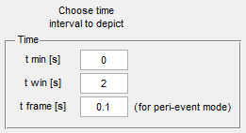

  - The input fields to define the time interval to show are strongly connected to the time slider
  - The value "t min" is consistent with the time slider position (no matter which one is changed)
  - The value "t win" defines the time range which is displayed and the time slider step
e.g.: t min = 10
t win= 2
=> clicking on the arrows of the slider (or slider bar) changes the time interval by 2s
AND the range which is shown is 2s

Filters

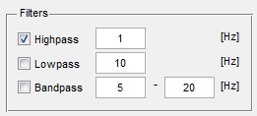

  - When a filter is activated (checkbox) it is applied to the data displayed in the plot area
  - Respective frequencies can be adapted in the input fields
  - The filters are exclusive (only one filter can be activated)
  - Filters can also be applied to z-score or TF data

Z-score

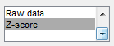

  - One can switch between original data (Raw data) and Z-score
  - Z-scores can be calculated for all kinds of post-processed data, which is shown in the plot area

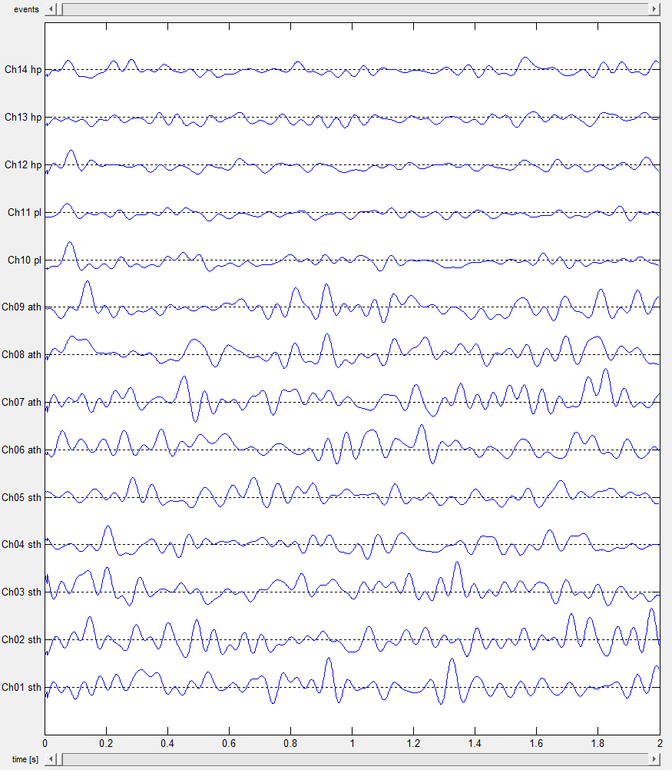
z-score of ripple data

Show events

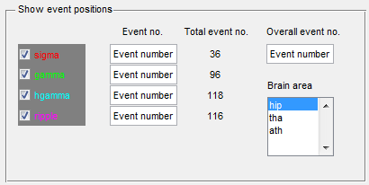

  - The number of event types and names are handed over to the checkboxes and the total event numbers are determined automatically
  - 6 different event types are possible (predefined)
  - When activating a checkbox according colored lines appear at the event positions (in the plot area), deactivating the checkbox hides them
  - One can jump to specific events by editing the event number (≤ total event number)
  - In time course mode the addressed event is shown in the middle of the plot, in peri-event mode it is marked by the first vertical line in the plot (see 2.8)
  - The event input fields are linked to the "t min" field and the time slider
(the current time is updated)
  - A list containing the measured brain areas is generated automatically (from NEVT data); an area can be selected by mouse click
  - The different events (names, numbers, positions) are adapted automatically for the respective brain area

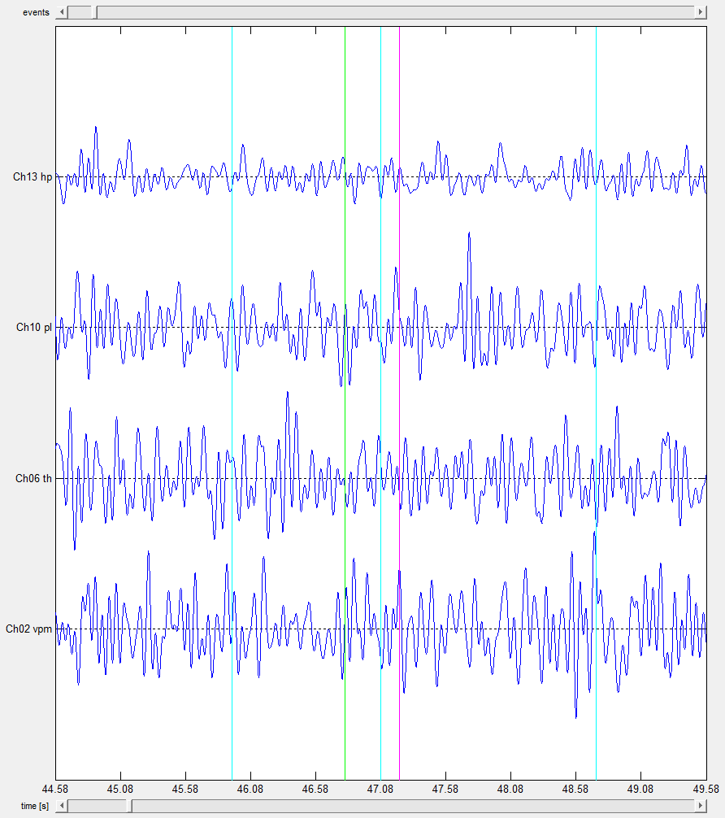
event positions shown on ripple data in time course mode

  - By using the event slider one can jump to the next/previous event
  - This works in time course and peri-event mode
  - Only the selected event types (checkboxes) are considered
  - Choosing a specific event number (input field) also sets the event slider (and time slider / t min) to the right position

Waveform / TF profile

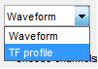

  - In this popup menu one can select the display format (waveform or time-frequency profile)
  - The selected data sets are shown from the bottom upwards
  - The y-axis is labeled with the frequencies
  - The example shows the TF profile of cln data for a selection of channels

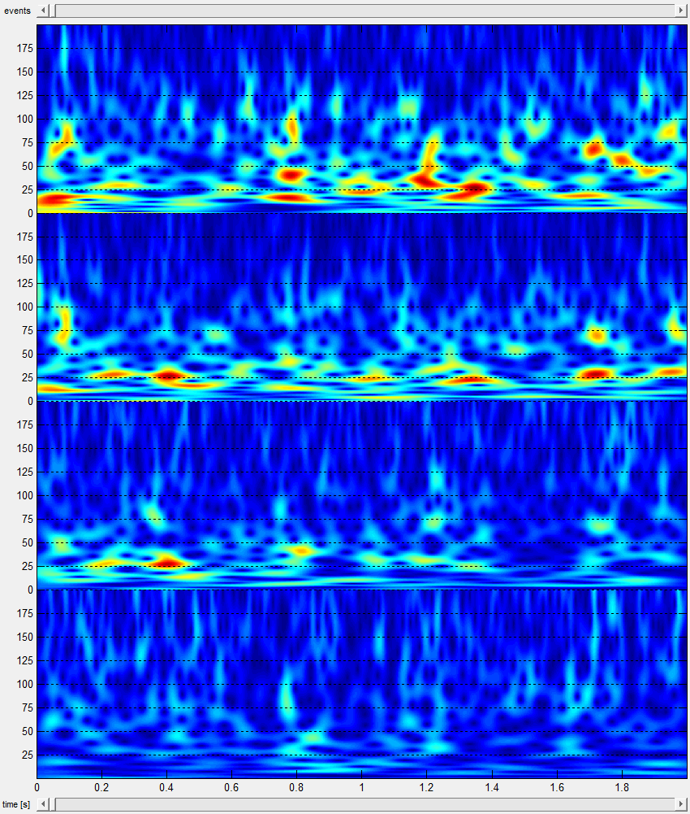
TF profile of cln data

Time course / Peri-event
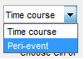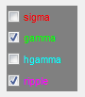

  - In this popup menu one can select the time format (time course or peri-event mode)
  - In peri-event mode the data sets are manipulated as follows: time frames around the events (of selected types) are strung together to a new data set, such that events occur in equidistant intervals
  - As described in 2.6 the events are marked by vertical colored lines
  - The range of the single time frames can be defined in the correspondent input field

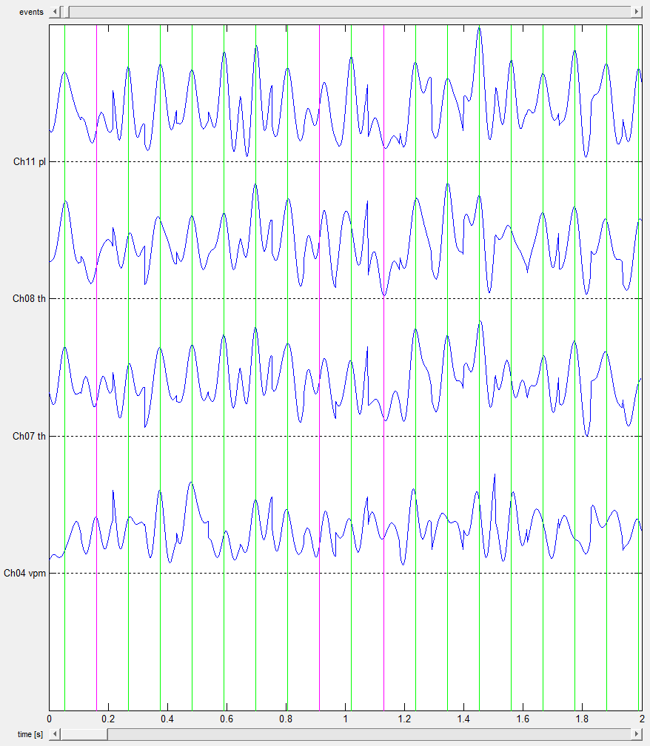
peri-event representation of gamma data in waveform format
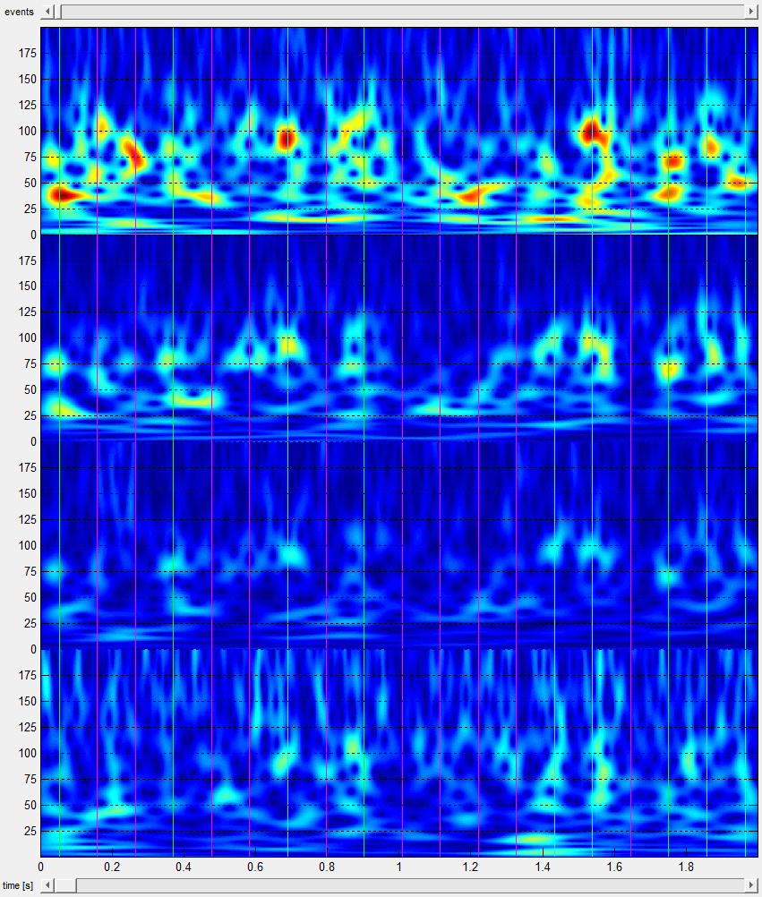
peri-event representation of cln data in TF format

Spikes

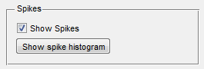

  - Activating the checkbox displays spikes, marked by small red vertical lines
  - Pushing the "Show spike histogram" button displays the spike histogram of the selected data sets; the representation vanishes when activating any other GUI element

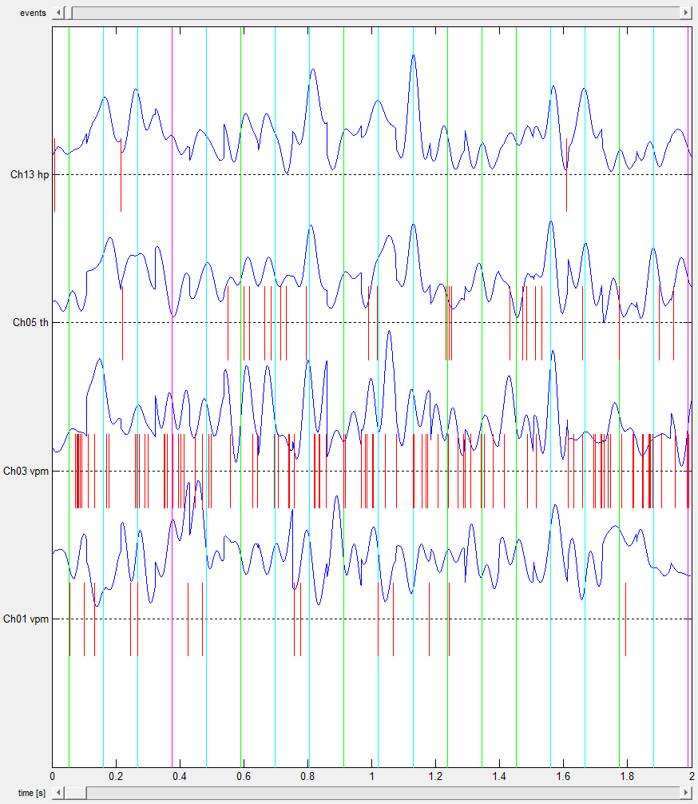
spikes shown on hgamma data using peri-event mode

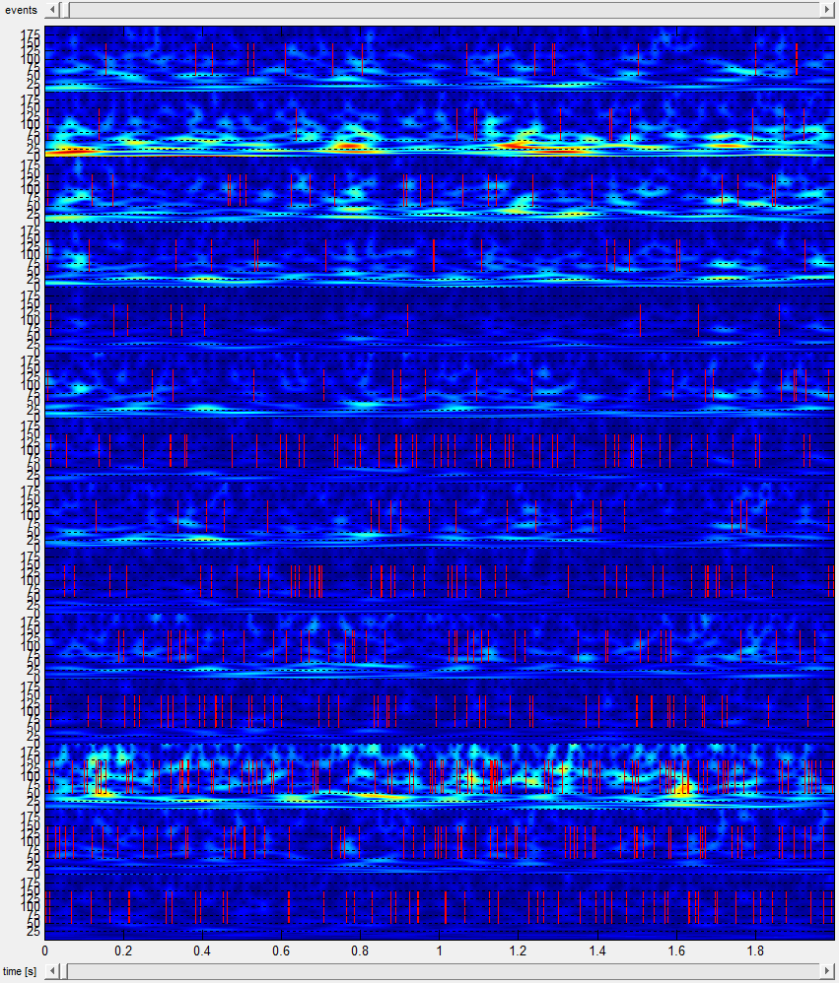
spikes shown on cln data in TF format and time course mode

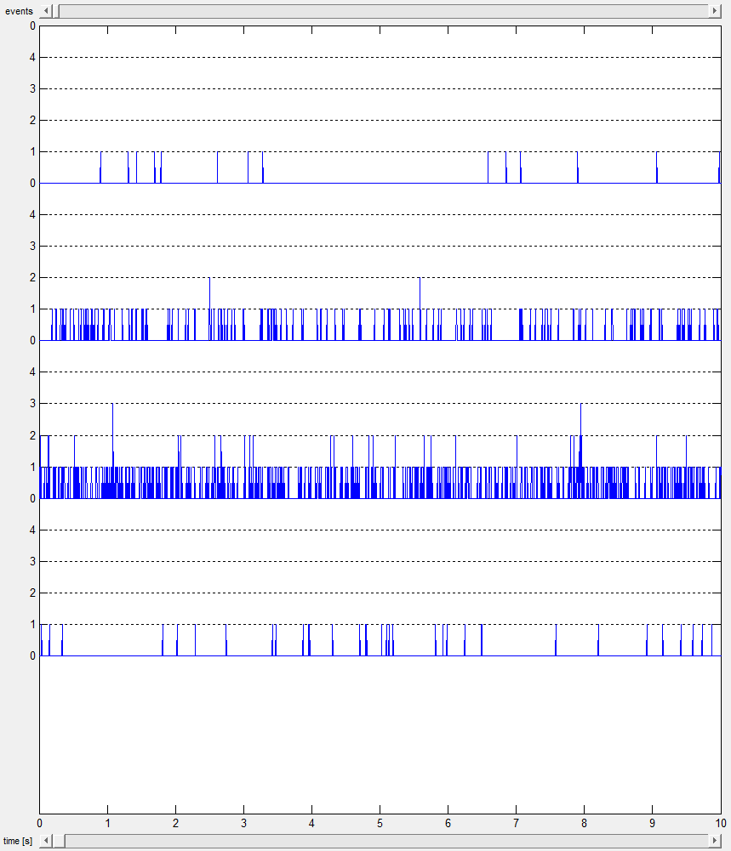
spike histogram for channels 1, 3, 5, 13 (from bottom upwards)

Average events

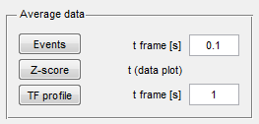

  - When pushing the "Events" button in the "Average data" panel the average waveform of the different event types is calculated in an interval "t frame", which can be defined in the corresponding input field
  - The results for the selected channels and band are shown in a separate figure window
  - Filters and z-score are also taken into account if necessary

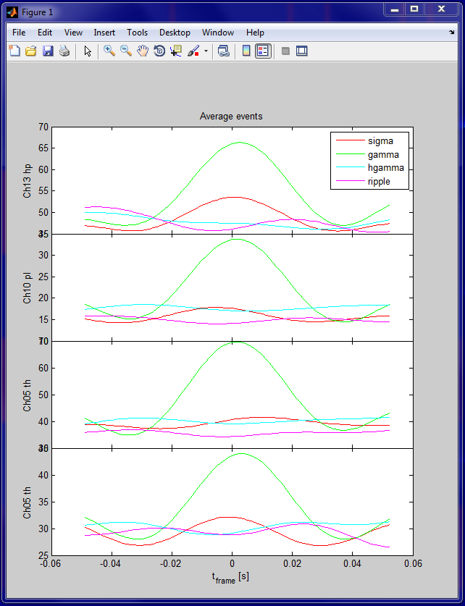
average events for gamma data; gamma events can be recognized very well

Average z-score



  - When pushing the "Z-Score" button in the "Average data" panel the mean value of the z-score of all channels is calculated in the time interval selected in the plot area
  - The results for the selected band are shown in a separate figure window
  - Filters and peri-event mode are also taken into account if necessary

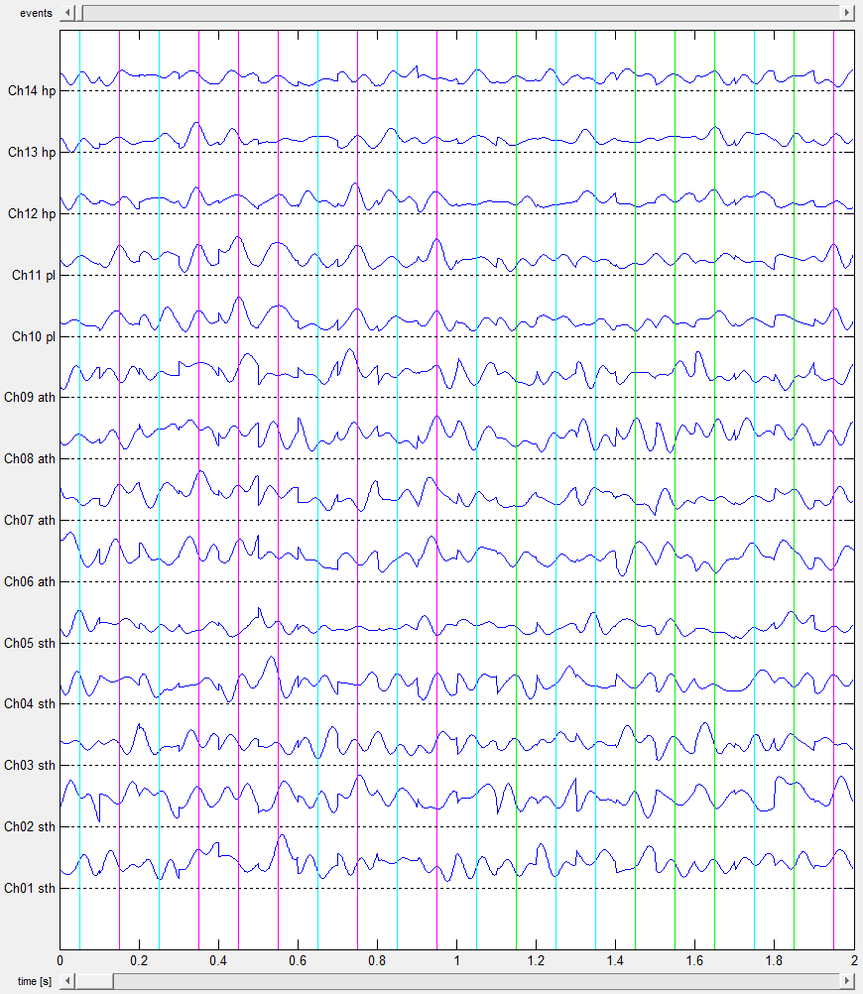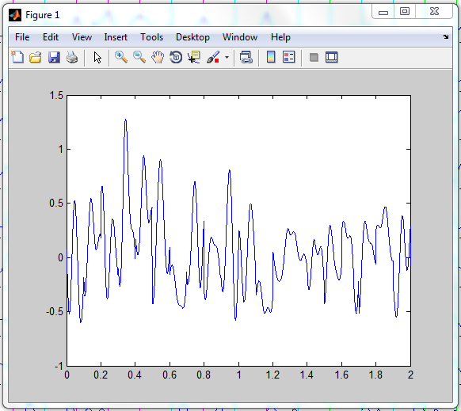
mean z-score of ripple data in peri-event mode

Average TF profile



  - When pushing the "TF profile" button in the "Average data" panel the average TF profile of the different event types is calculated in an interval "t frame", which can be defined in the corresponding input field (similar to average events)
  - The results for the selected channels and band are shown in a separate figure window
  - Filters and z-score are also taken into account if necessary

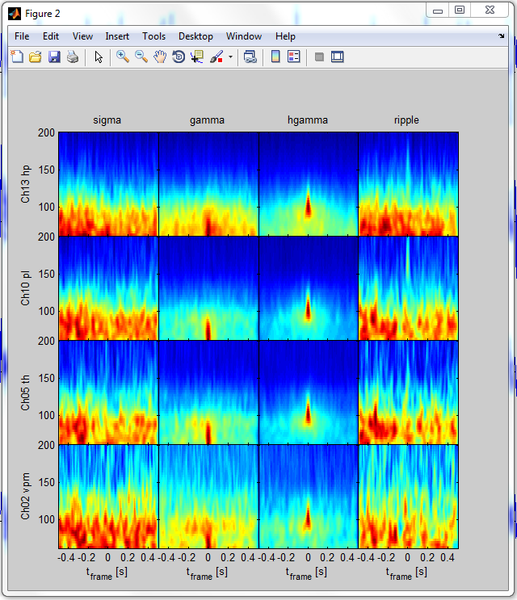
average TF profiles of events using cln data

Principal component analysis (PCA)

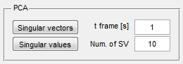

  - In the principal component analysis the covariance matrices of the data of the different event types (in predefined time frames "t frame") are calculated
  - Thereof the largest singular values and corresponding singular vectors are determined, which give information about the largest impact factors on the system
  - The number of singular values and vectors, which have to be determined, can be defined in an input field
  - The results for the selected channels and band are shown in separate figure windows
  - Filters and z-score are also taken into account if necessary

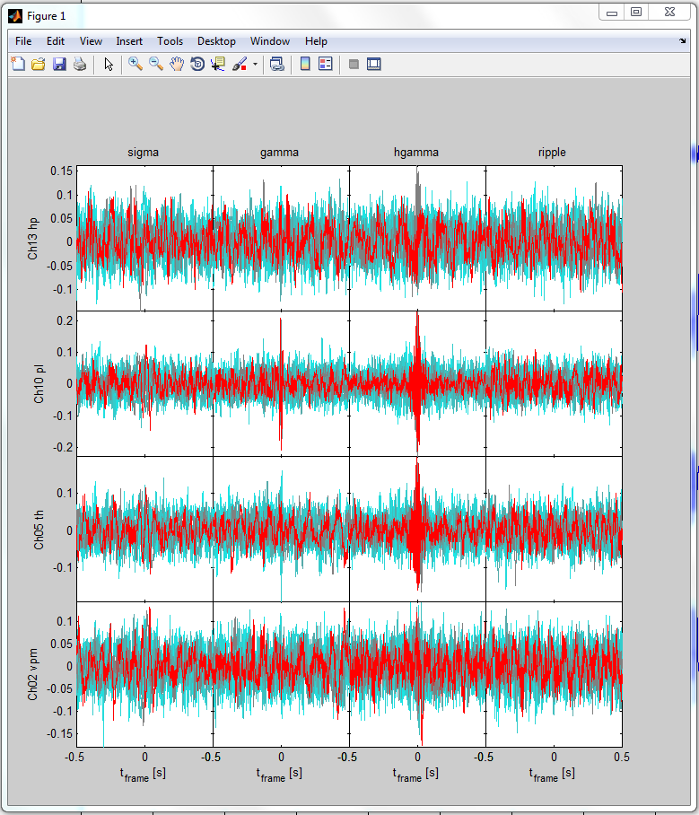
largest singular vectors resulting from PCA using cln data, the red vector belongs to the largest singular value

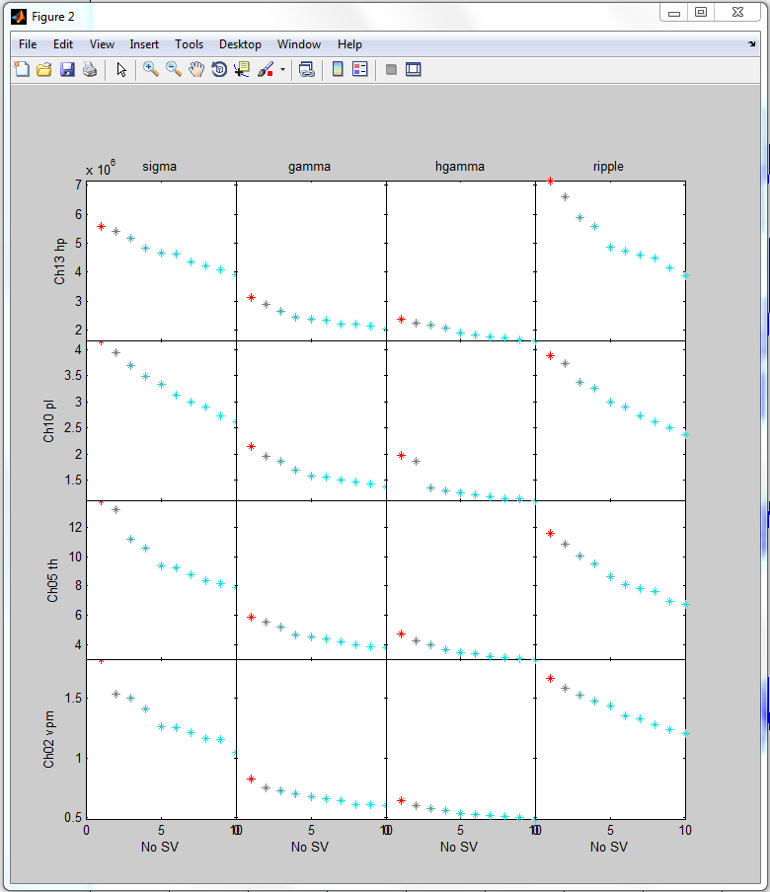
largest singular values resulting from PCA using cln data

Separate picture

  - Open a copy of the current picture in figure area in a separate figure window
  - Thereby, different times, frequency bands etc. can be compared

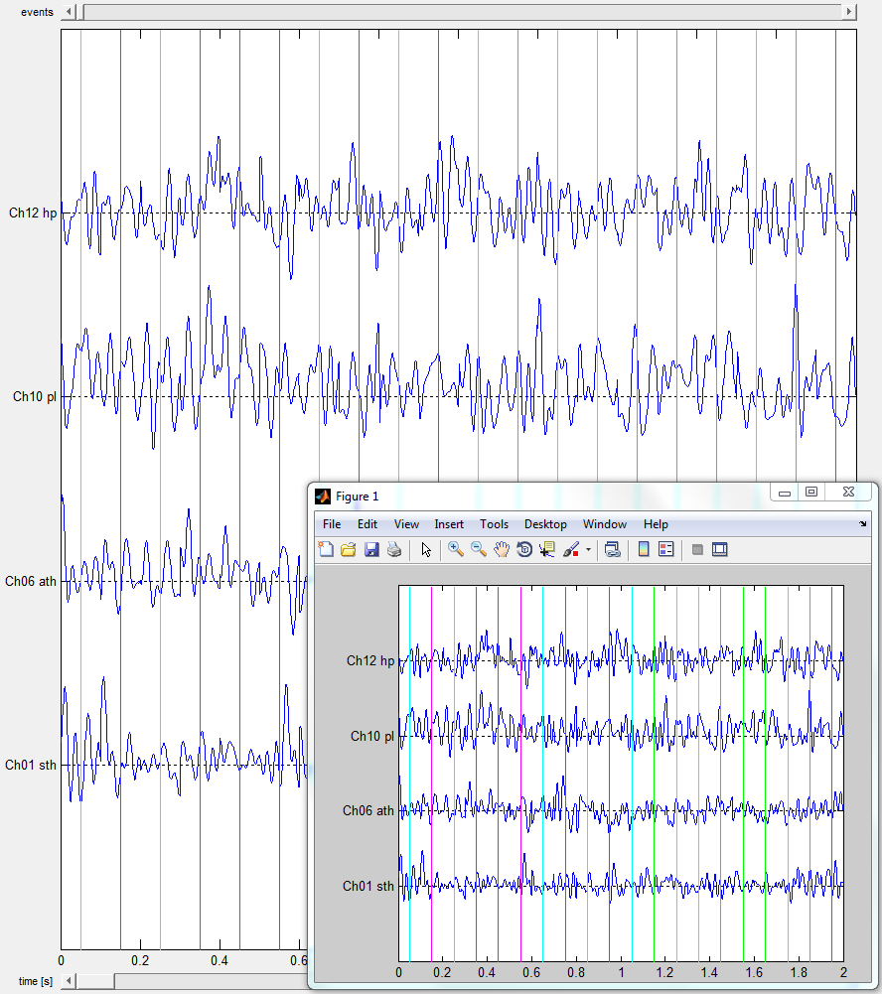
mua data in peri-event mode

Reset GUI

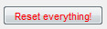

  - The GUI window is closed and a new GUI with last chosen session, event number and default settings is opened

