**HANOI UNIVERSITY OF SCIENCE AND TECHNOLOGY**

**TECHNICAL REPORT**

**A CLOSED-FORM SOLUTION FOR A QUEUEING MODEL OF ENERGY EFFICIENT ETHERNET LINKS**

**Quoc Bao Vu**

bao.vq225694@sis.hust.edu.vn

**Vietnam – Japan Information Technology (IT-E6)**

Signature of Lecturer

|  |  |
| --- | --- |
| **Lecturer:** | Ph.D. Thanh Tung Duong |
| **Subject:** | Technical Writing and Presentation |
| **University:** | Information and Communications Technology |
| **HANOI, 12/2023** | |

**Abstract.** To save energy consumption of Ethernet switches, IEEE has standardized a new energy- efficient operation for Ethernet links with a low-power state and transition mechanisms between the high-power state for transporting traffic and the low-power state. In this paper, we propose a queueing model with the Markov Modulated Compound Poisson Process that is able to characterize backbone packet traffic. We derive a closed-form solution for the stationary distribution of the proposed queueing model. We show that our model can capture an entire system where the transition times are constant.

**Keywords.** Energy efficient Ethernet; Queueing model; Markov modulated compound Poission process.

Contents

1. INTRODUCTION 4

2. A NEW ANALYTICAL MODEL 4

2.1. The left-eigenvalues for an EEE 10GBASE-T link model **11**

2.2. The left-eigenvalues for an EEE 10GBASE-TX or 1000BASE-T link model **12**

2.3. Performance measures **12**

3. NUMERICAL RESULTS 13

4. CONCLUSIONS 14

REFERENCES 15

# 1. INTRODUCTION

The fact that legacy Ethernet lines are still in use during times of low traffic might result in energy waste [7, 14]. Four modes are defined for the functioning of green Ethernet lines by the IEEE 802.3az Energy Efficient Ethernet (EEE) standard: Active (*A*), Sleep (*S*), Wake (*W*), and Low Power Idle (*L*). A low-power state and transition mechanisms between the active state with high power consumption and the low-power state make up the energy-efficient operation for Ethernet networks that are specified by IEEE [6, 5, 8, 16, 17]. 90% power savings in state *L*, when there is no traffic, was recorded by Reviriego et al. [15]. The triggering mechanism that determines whether conditions state *L* should be met, however, was not standardized by IEEE. Consequently, several techniques, such as frame transmission [16] and burst transmission [18] algorithms, have been developed for more efficient use of *L* states.

For Ethernet networks based on new standards, Herreria-Alonso et al. [8], Reviriego et al. [16], and Ajmone Marsan et al. [1] reported performance evaluations using simulation models and basic analytical models (with Poisson traffic and a fixed batch packet size). These models assessed the impact of configuration settings and offered a qualitative comparison of algorithms. An analytical model for frames and burst transmission techniques was presented by Herreria-Alonso et al. [9], Larrabeiti et al. [11] provided a performance comparison of cooper-based versus optical Ethernet and suggested an analytical model to calculate the energy consumption of a two-state link. The bidirectional behavior of the linkages is taken into account in the *M*/*G*/1 model as explained by Chatzipapas et al. [4]. Minor differences arise when burst traffic deviates from the Poisson assumption, despite the fact that their model provides a good approximation. In a work by Cenedese et al.[2], a further efficient triggering mechanism to achieve state *L* is examined utilizing traffic prediction. In a similar vein, Jiang et al. [10] and colleagues put out a generalized predictive control system for automatically modifying the time window parameter. Sadly, no analytical models that incorporate stochastic processes (such as the Markov Modulated Poisson Process [13]) are currently available for use in characterizing IP packet traffic.

The Markov Modulated Poisson Process, a generalization of the Markov Modulated Poisson Process and an appealing model for backbone packet traffic, is the basis for the novel model we present in this research, which assumes packet arrivals. It is important to highlight that the fixed transition periods between the modes of energy-efficient Ethernet networks allow for only approximate Markov models. In order to create a tractable model, we therefore assume that the transition periods between the states of Ethernet networks are exponentially distributed. We use an accurate simulation of energy-efficient Ethernet networks to verify our model. Moreover, we extract the precise solution for the suggested analytical model to efficiently compare options about the modes of operation of green Ethernet links.

The rest of this paper is organized as follows. A queueing model is proposed in Section 2. Numerical results are shown in Section 3. Finally, Section 4 concludes our paper.

# 2. A NEW ANALYTICAL MODEL

Green Ethernet links have four states: Active (*A*), Sleep (*S*), Wake (*W*) and Low Power Idle (*L*). The transitions between the states for EEE 10GBASE-T links and for EEE 100BASE-TX or 1000BASE-T links are illustrated in Figure 1 (a) and (b). and are the transition times between the modes of energy efficient Ethernet links.

We assume that packets arrive at an Ethernet link according to the Markov Modulated Compound Poisson Process (MMCPP).

* The modulating Markov process has two states ON and OFF with parameters and .
* In the OFF state, there are no packet arrivals.
* In the ON state, packets arrive according to the CPP with parameters (, ). Note that 0 *≤ <* 1. The probability distribution function of inter-arrival times for customers is defined by Pr(= 0) = and Pr(0 *<*  *< t*) = (1 *−* )(1*−*). Therefore, during ON state, the arrival process can be seen as batch-Poisson, with batches having geometric size distribution. The probability that a batch is of size *s* is (1 *−* ).

Similarly, to [1], the size of the transmission buffer of a specific link is assumed to be infinite.

Let *J*(*t*) be the number of packets in the system heading for the specific link (including the number of packet in the transmission buffer and a packet being transmitted) at time instant *t*.

Figure 1: The state transitions

To jointly describe the state of the link and the state of the modulating process at time instant *t*, random variable *I*(*t*) is introduced. From the operation rule [6,](#_bookmark19) [5] (illustrated in Figure 1) it is observed that the link

* is never in state *L* when there are packets heading for the link (i.e., when *J*(*t*) *>* 0),
* is never in state *W* when no packet is in the system (i.e., when *J*(*t*) = 0).

Therefore, we join state *L* and *W* in our analytical model into state *LW* . If *J*(*t*) = 0 and the model is in state *LW* then the link is in state *L*. If *J*(*t*) ≥1 and the model is in state *LW* , then the link is in state *W* . We assume that the transition times between the states of Ethernet links are exponentially distributed to obtain a tractable model. The transition times from the state *S* to state *L* and the transition times from the state *W* to state *A* are exponentially distributed with rate and , respectively. Note that = and = .

Now it is easy to identify the value set of *I*(*t*) if we lexicographically sort the states representing the link and the modulating process as in Table 1. The system is described by continuous time Markov chain (CTMC) {*I*(*t*), *J*(*t*)} The possible transitions of the CTMC for EEE 10GBASE-T links when 1 *≤ I*(*t*) *≤* 3 are illustrated in Figure 1 (c). The possible transitions of the CTMC for EEE 100BASE-TX or 1000BASE-T links when 1 *≤ I*(*t*) *≤* 3 are depicted in Figure 1 (d).

Table 1: Values of *I(t)*

|  |  |  |  |  |  |  |
| --- | --- | --- | --- | --- | --- | --- |
| I(t) | 1 | 2 | 3 | 4 | 5 | 6 |
| The state of the link | A | S | LW | A | S | LW |
| The state of the modulating Markov process | ON | | | OFF | | |

Let the steady state probabilities of CTMC {*I*(*t*), *J*(*t*)} be denoted by

= (*I*(*t*) = *i*, *J*(*t*) = *j*).

Define the row vector = [, . . . , ]. We have = = 0 due to the operation rule of the link.

The infinitesimal matrix Q of CTMC {*I*(*t*), *J*(*t*)}is a block matrix (see Table 4). The blocks contain the transitions of the Markov chain as follows.

1. Block includes element (*i*, *k*) that is the *s−*step upward transition from state (*i*, *j*) to state (*k, j + s*) (1 ≤ *i*, *k* ≤ 6; *j* = 0, 1, . . .). These transitions are caused by the arrivals of customers.
2. Block 1 consists of element (*i*, *k*) that denotes the purely phase transition from state (*i*, *j*) to state () (1 ≤ *i*, *k* ≤ 6, *k* *i*; *j* = 0, 1, . . .).
3. Block contains element (*i, k*) that is the one*−*step downward transition from state (*i*, *j*) to state (*k*, *j* – 1) (1 ≤ *i*, *k* ≤ 6; *j* = 1, . . .). These transitions are caused by the departures of customers from the system.

Based on the operation of the link, we can write the transition matrices and the infinitesimal generator matrix in Tables 2, 3 and 4. Note that matrices , *j* ≥ 0, are the same for EEE 10GBASE-T, EEE 100BASE-TX and EEE 1000BASE-T links.

The balance equations and the normalization equation can be written as follows

|  |  |
| --- | --- |
|  | (1) |
|  | (2) |

**Theorem 1.** *For* j > 1, *the following equation holds between the stationary probabilities*

|  |  |
| --- | --- |
| , | (3) |

*where* , *and* .

*Proof.* Let us define =, = *Diag*[*, , ,* 0*,* 0*,* 0], = *Diag*[*, , ,* 0*,* 0*,* 0]. Then, we obtain

|  |  |
| --- | --- |
| , | (4) |
| . | (5) |

Multiplying balance equation concerning level *j −* 1, *j ≥* 2, with , we get

We substitute (6) into (2), and utilize equations (4) and (5). After some algebraic steps, we get = 0, which yields (3).

Table 2: Transition matrices for modeling an EEE 10GBASE-T link

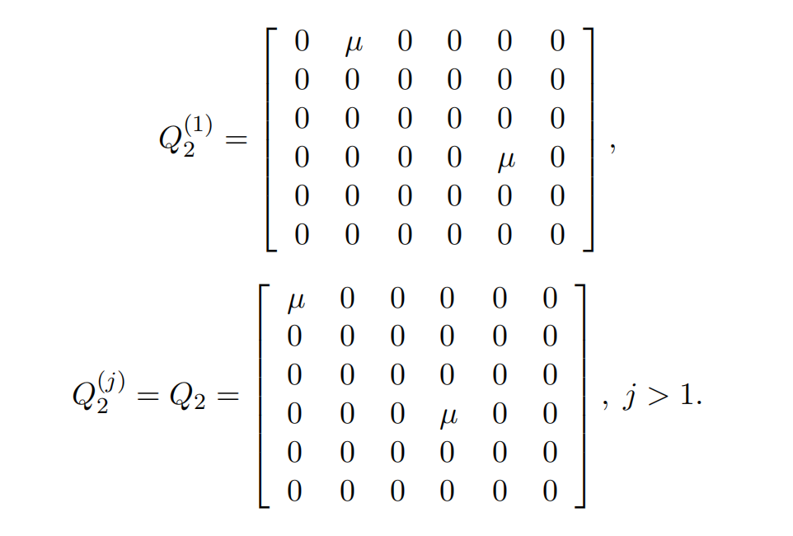

Table 3: Transition matrices for modeling an EEE 100BASE-TX or 1000BASE-T link

Table 4: Infinitesimal generator matrix

The consequence of Theorem 1 is that , *j* ≥ 1, is the solution of quadratic matrix equation (3) as

|  |  |
| --- | --- |
|  | (6) |

where

* *bk* are suitable coefficients to be determined using balance equation (1), balance equation (2) for *j* = 1, and the normalization equation,
* (), *k* = 1, . . . ,6 are the left eigenvalue-eigenvector pairs of = + + inside the circle (see [3]). Let . Note that the left eigenvalue-eigenvector pairs satisfy and det[, *k* = 1, … , 6.

**Remarks.** One may observe that equation (3) looks like the balance equation of homoge- neous quasi-birth-death processes [12]. Therefore, one may express *vj* as the function of the so-called rate matrix *R* (see [12] for the matrix geometric solution). However, some proper- ties (e.g., the non-negative elements) of the rate matrix do not hold because + + is not a stochastic matrix.

Figure 2: Probability vs for = 0*.*1

## **2.1. The left-eigenvalues for an EEE 10GBASE-T link model**

Utilizing Theorem 1, we obtain

Figure 3: Probability vs for = 0.2

where

As a consequence, has 8 roots. The roots inside the unit circle are

## **2.2. The left-eigenvalues for an EEE 10GBASE-TX or 1000BASE-T link model**

In this case, can be expressed as follows

where

Thus, the roots inside the unit circle are

The corresponding eigenvectors of zero-eigenvalues are [0, 0, 0, 1, 0, 0],[0, 0, 0, 0, 1, 0], [0, 0, 0, 0, 0, 1]. Using = **0**, we can easily determine the exact formula of for non zero eigenvalues. Then, the expressions for and , *k* = 1, . . . ,6, can be derived as well (we do not write here because the long formulae).

## **2.3. Performance measures**

The probability of state *A*, *S*, *L* and *W* can be determined as

# 3. NUMERICAL RESULTS

To show that the queueing model can evaluate the performance of Energy Efficient Eth-ernet links, we compare results obtained by a simulation where transition times and between states are fixed. Note that in the proposed queueing model, the transition times follow the exponential distribution. Simulations are performed with a confidence level of 99%. For = 2*.*88, = 4*.*16 (see [16]), = 0*.*0001695 (the average ON period is 5.899 ms), = 0.000110 (the average OFF period is 9.09 ms), the average packet size is of 1500 bytes (hence = 0.833 1 in 10Gbits links), , we plot the probabilities obtained with our model and the simulation model in Figures 2, 3 and 4. We can conclude that the agreement between the simulation and analytical results is excellent.

Figure 4: Probability vs for = 0.5

From Figure 5, when the load is small, the higher is is, the better energy saving can be achieved. At the same load (the same amount of packets), the burstiness (packets in batches of more packets) would have a better impact on energy saving.

For an EEE 1000BASE-T link model, we plot the probability in state *L* versus and in Figure 6. From the curve, it seems that has a minimal impact on .

# 4. CONCLUSIONS

We have proposed a queueing model for Energy Efficient Ethernet links. In the model packets arrive according to the Markov Modulated Compound Poisson Process and the transition times between the states of Ethernet links are exponentially distributed. We have derived the exact solution for the steady-state probabilities of the analytical model. The comparison between our model and the simulation of energy-efficient Ethernet links shows that the proposed model can capture the behaviour of Energy Efficient Ethernet links.

Figure 5: Probability in state *L*

Figure 6: Probability in state *L* vs and , 1000BASE-T links

# REFERENCES

1. M. Ajmone Marsan, A. Anta, V. Mancuso, B. Rengarajan, P. Vasallo, and G. Rizzo, “A simple analytical model for energy efficient Ethernet,” *IEEE Communications Letters*, vol. 15, no. 7, pp. 773 –775, July 2011.
2. A. Cenedese, F. Tramarin, and S. Vitturi, “An energy efficient Ethernet strategy based on traffic prediction and shaping,” *IEEE Transactions on Communications*, pp. 1–1, 2016. [Online]. Available: <https://doi.org/10.1109/tcomm.2016.2623702>
3. R. Chakka and T. V. Do, “The MM /*GE*/*c*/*L G*-Queue with Heterogeneous Servers: Steady state solution and an application to performance evaluation,” *Performance Evaluation*, vol. 64, no. 3, pp. 191–209, March 2007.
4. A. Chatzipapas and V. Mancuso, “An M/G/1 model for gigabit energy efficient Ethernet links with coalescing and real-trace-based evaluation,” *IEEE*/*ACM* *Transactions on Networking*, vol. 24, no. 5, pp. 2663–2675, Oct. 2016. [Online]. Available: https: //doi.org/10.1109/tnet.2015.2477090
5. K. Christensen, P. Reviriego, B. Nordman, M. Bennett, M. Mostowfi, and J. Maestro, “IEEE 802.3az: the road to energy efficient Ethernet,” *Communications Magazine*, *IEEE*, vol. 48, no. 11, pp. 50 –56, November 2010.
6. K. Christensen, P. Reviriego, B. Nordman, M. Bennett, M. Mostowfi, and J. A. Maestro, “Ieee 802.3az: the road to energy efficient Ethernet,” *IEEE Communications Magazine*, vol. 48, no. 11, pp. 50–56, 2010.
7. M. Gupta, S. Grover, and S. Singh, “A feasibility study for power management in LAN switches,” in *Proceedings of the 12th IEEE International Conference on Network Protocols*, *2004*. *ICNP 2004*., 2004, pp. 361–371.
8. S. Herreria-Alonso, M. Rodriguez-Perez, M. Fernandez-Veiga, and C. Lopez-Garcia, “A power saving model for burst transmission in energy-efficient Ethernet,” *Communications Letters*, *IEEE*, vol. 15, no. 5, pp. 584 –586, May 2011.
9. ––––, “A GI/G/1 Model for 10 Gb/s Energy Efficient Ethernet Links,” *IEEE Transactions on Communications*, vol. 60, no. 11, pp. 3386–3395, Nov. 2012. [Online]. Available: <https://doi.org/10.1109/tcomm.2012.081512.120089>
10. W. Jiang, J. Wang, L. Peng, and J. Wang, “Generalized predictive control of the time window for energy efficient Ethernet with prediction,” *IEEE Communications Letters*, vol. 25, no. 5, pp. 1491–1495, May 2021. [Online]. Available: [https: //doi.org/10.1109/lcomm.2021.3051626](https://doi.org/10.1109/lcomm.2021.3051626)
11. D. Larrabeiti, P. Reviriego, J. Hernández, J. Maestro, and M. Uruea, “Towards an energy efficient 10 Gb/s optical Ethernet: Performance analysis and viability,” *Optical Switching and Networking*, vol. 8, no. 3, pp. 131–138, Jul. 2011. [Online]. Available: <https://doi.org/10.1016/j.osn.2011.03.009>
12. G. Latouche and V. Ramaswami, *Introduction to Matrix Analytic Methods in Stochastic Modeling*. ASA-SIAM Series on Statistics and Applied Probability, 1999.
13. L. Muscariello, M. Mellia, M. Meo, M. A. Marsan, and R. L. Cigno, “Markov models of internet traffic and a new hierarchical MMPP model,” *Computer Communications*, vol. 28, no. 16, pp. 1835–1851, 2005.
14. B. Nordman, “Eee savings estimate,” *IEEE 802.03az Task Force Information*”, *year =2008*.
15. P. Reviriego, K. Christensen, J. Rabanillo, and J. A. Maestro, “An initial evaluation of energy efficient Ethernet,” *IEEE Communications Letters*, vol. 15, no. 5, pp. 578–580, 2011.
16. P. Reviriego, J. Hernandez, D. Larrabeiti, and J. Maestro, “Performance evaluation of energy efficient Ethernet,” *Communications Letters*, *IEEE*, vol. 13, no. 9, pp. 697 –699, Sept. 2009.
17. P. Reviriego, J. Maestro, J. Hern´andndez, and D. Larrabeiti, “Burst transmission for energyefficient Ethernet,” *Internet Computing*, *IEEE*, vol. 14, no. 4, pp. 50 –57, july-aug. 2010.
18. M. Rodriguez-Perez, S. Herreria-Alonso, M. Fernandez-Veiga, and C. Lopez-Garcia, “Improved opportunistic sleeping algorithms for lan switches,” in *GLOBECOM 2009 - 2009 IEEE Global Telecommunications Conference*, 2009, pp. 1–6.