





Basic Swing
Better GUI Controls
© 2007 Marty Hall

2
Originals of Slides and Source Code for Examples:
http://courses.coreservlets.com/Course-Materials/java5.html

Customized J2EE Training: http://courses.coreservlets.com/
Servlets, JSP, Struts, JSF/MyFaces, Hibernate, Ajax, GWT, Java 5, Java 6, etc. Ruby/Rails coming soon.
Developed and taught by well-known author and developer. At public venues or onsite at your location.

© 2007 Marty Hall

For live Java training, please see training courses
at http://courses.coreservlets.com/. Servlets, JSP,
Struts, JSF/MyFaces, Ajax, GWT, Java 5 or 6, and
custom courses. Ruby/Rails coming soon.
Taught by the author of Core Servlets and JSP, More Servlets
and JSP, and this tutorial. Available at public venues, or
customized versions can be held on-site at your organization.

3
Customized J2EE Training: http://courses.coreservlets.com/
Contact hall@coreservlets.com for details.
Servlets, JSP, Struts, JSF/MyFaces, Hibernate, Ajax, GWT, Java 5, Java 6, etc. Ruby/Rails coming soon.
Developed and taught by well-known author and developer. At public venues or onsite at your location.



4

5

Agenda

• New features
• Basic approach
• Summary of Swing components
– Starting points
• JApplet, JFrame
– Swing equivalent of AWT components
• JLabel, JButton, JPanel, JSlider
– New Swing components
• JColorChooser, JInternalFrame, JOptionPane, JToolBar,
JEditorPane
– Other simple components
• JCheckBox, JRadioButton, JTextField, JTextArea,
JFileChooser
J2EE training: http://courses.coreservlets.com

New Features

• Many more built-in controls
– Image buttons, tabbed panes, sliders, toolbars, color
choosers, HTML text areas, lists, trees, and tables.
• Increased customization of components
– Border styles, text alignments, and basic drawing
features. Images can be added to almost any control.
• A pluggable “look and feel”
– Not limited to “native” look.
• Many miscellaneous small features
– Built-in double buffering, tool-tips, dockable toolbars,
keyboard accelerators, custom cursors, etc.
• Model-view-controller architecture
– Can change internal representation of trees, lists, tables.
J2EE training: http://courses.coreservlets.com
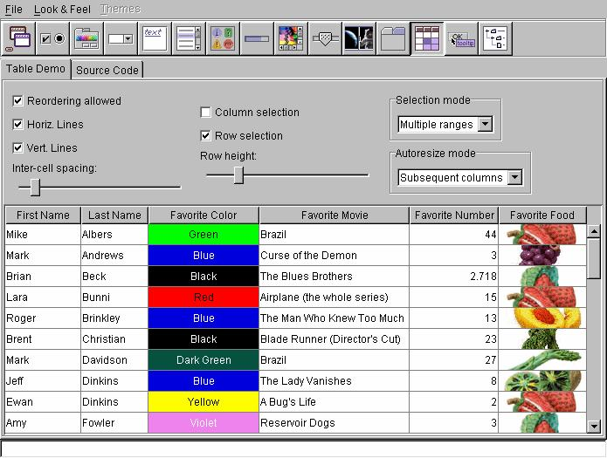

6

7

Swing vs. AWT Programming

• Naming convention
– All Swing component names begin with a capital J and
follow the format JXxx. E.g., JFrame, JPanel, JApplet,
JDialog, JButton. Many are just AWT names with a J.
• Lightweight components
– Most Swing components are lightweight: formed by
drawing in the underlying window.
• Use of paintComponent for drawing
– Custom drawing code is in paintComponent, not paint.
Double buffering turned on by default.
• New Look and Feel as default
– With Swing, you have to explicitly set the native look.
• Don't mix Swing and AWT in same window
J2EE training: http://courses.coreservlets.com

Windows Look and Feel

J2EE training: http://courses.coreservlets.com
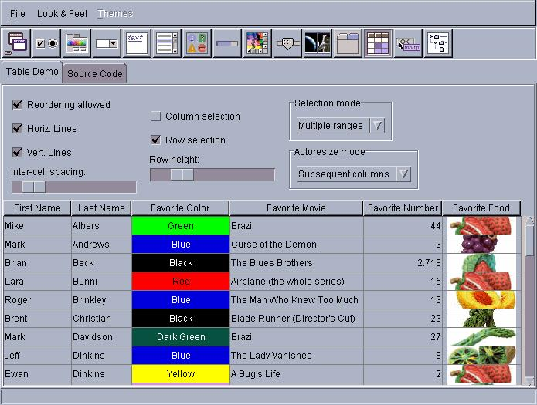
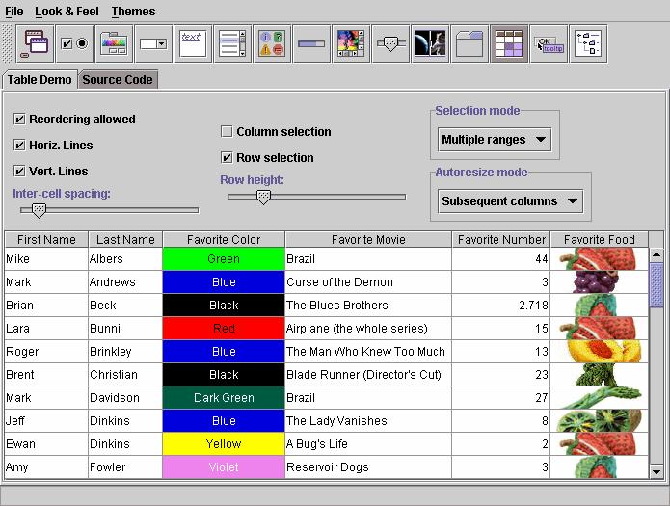

8

9

Motif Look and Feel

J2EE training: http://courses.coreservlets.com

Java Look and Feel

J2EE training: http://courses.coreservlets.com

10

11

Setting Native Look and Feel

• Most applications should use native look,
not default “Java” look
• Changing is tedious, so use static method

public class WindowUtilities {
public static void setNativeLookAndFeel() {
try {
UIManager.setLookAndFeel(
UIManager.getSystemLookAndFeelClassName());
} catch(Exception e) {
System.out.println("Error setting native LAF: "
+ e);
}
}
...
J2EE training: http://courses.coreservlets.com

Whirlwind Tour of Basic
Components
• Starting points
– JApplet, JFrame
• Swing equivalent of AWT components
– JLabel, JButton, JPanel, JSlider
• New Swing components
– JColorChooser, JInternalFrame, JOptionPane, JToolBar,
JEditorPane
• Other simple components
– JCheckBox, JRadioButton, JTextField, JTextArea,
JFileChooser

J2EE training: http://courses.coreservlets.com

12

13

Starting Point 1: JApplet

• Content pane
– A JApplet contains a content pane in which to add
components. Changing other properties like the layout
manager, background color, etc., also applies to the
content pane. Access the content pane through
getContentPane.
• Layout manager
– The default layout manager is BorderLayout (as with
Frame and JFrame), not FlowLayout (as with Applet).
BorderLayout is really layout manager of content pane.
• Look and feel
– The default look and feel is Java (Metal), so you have to
explicitly switch the look and feel if you want the native
look J2EE training: http://courses.coreservlets.com

JApplet: Example Code

import java.awt.*;
import javax.swing.*;

public class JAppletExample extends JApplet {
public void init() {
WindowUtilities.setNativeLookAndFeel();
Container content = getContentPane();
content.setBackground(Color.WHITE);
content.setLayout(new FlowLayout());
content.add(new JButton("Button 1"));
content.add(new JButton("Button 2"));
content.add(new JButton("Button 3"));
}
}

J2EE training: http://courses.coreservlets.com

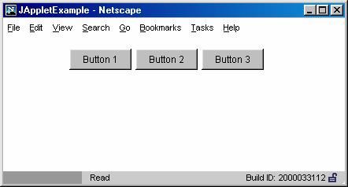

14

JApplet: Example Output

J2EE training: http://courses.coreservlets.com

Starting Point 2: JFrame

• Content pane
– JFrame uses content pane in same way as does JApplet.
• Auto-close behavior
– JFrames close automatically when you click on the Close
button (unlike AWT Frames). However, closing the last
JFrame does not result in your program exiting the Java
application. So, your “main” JFrame still needs a
WindowListener to call System.exit. Or, alternatively, if
using JDK 1.3 or later, you can call setDefault-
CloseOperation(EXIT_ON_CLOSE). This permits the
JFrame to close; however, you won’t be able to complete
any house cleaning as you might in the WindowListener.
• Look and feel

15
– The default look and feel is Java (Metal)
J2EE training: http://courses.coreservlets.com

16

17

JFrame: Example Code

import java.awt.*;
import javax.swing.*;
public class JFrameExample {
public static void main(String[] args) {
WindowUtilities.setNativeLookAndFeel();
JFrame f = new JFrame("This is a test");
f.setSize(400, 150);
Container content = f.getContentPane();
content.setBackground(Color.WHITE);
content.setLayout(new FlowLayout());
content.add(new JButton("Button 1"));
content.add(new JButton("Button 2"));
content.add(new JButton("Button 3"));
f.addWindowListener(new ExitListener());
f.setVisible(true);
}
}
J2EE training: http://courses.coreservlets.com

JFrame Helper: ExitListener

import java.awt.*;
import java.awt.event.*;

public class ExitListener extends WindowAdapter {
public void windowClosing(WindowEvent event) {
System.exit(0);
}
}

J2EE training: http://courses.coreservlets.com
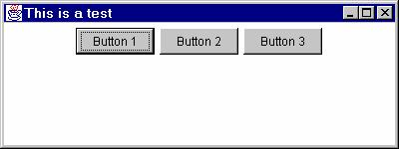

18

19

JFrame: Example Output

J2EE training: http://courses.coreservlets.com

Swing Equivalents of AWT
Components
• JLabel
– New features: HTML content images, borders
• JButton
– New features: icons, alignment, mnemonics
• JPanel
– New feature: borders
• JSlider
– New features: tick marks and labels

J2EE training: http://courses.coreservlets.com

20

21

JLabel

• Main new feature: HTML content
– If text is "<html>...</html>", it gets rendered as HTML
– HTML labels only work in JDK 1.2.2 or later, or in
Swing 1.1.1 or later.
– In JDK 1.2 the label string must begin with <html>, not
<HTML>. It is case-insensitive in JDK 1.3 and 1.4.
– JLabel fonts are ignored if HTML is used. If you use
HTML, all font control must be performed by HTML.
– You must use <P>, not <BR>, to force a line break.
– Other HTML support is spotty.
• Be sure to test each HTML construct you use. Permitting
the user to enter HTML text at runtime is asking for
trouble.
• Other new features: images, borders
J2EE training: http://courses.coreservlets.com

JLabel: Example Code

String labelText =
"<html><FONT COLOR=WHITE>WHITE</FONT> and " +
"<FONT COLOR=GRAY>GRAY</FONT> Text</html>";
JLabel coloredLabel =
new JLabel(labelText, JLabel.CENTER);
...
labelText =
"<html><B>Bold</B> and <I>Italic</I> Text</html>";
JLabel boldLabel =
new JLabel(labelText, JLabel.CENTER);
labelText =
"<html>The Applied Physics Laboratory is..." +
"of the Johns Hopkins University." +
"<P>" + ... "...</html>";

J2EE training: http://courses.coreservlets.com
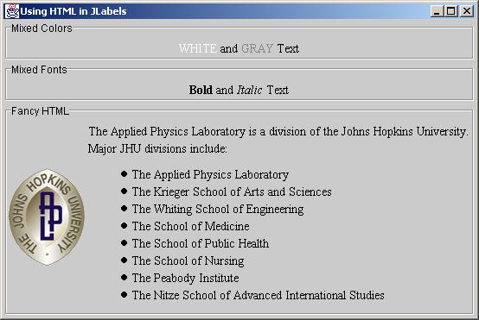

22

23

•

•

JLabel: Example Output

J2EE training: http://courses.coreservlets.com

JButton

Main new feature: icons
1. Create an ImageIcon by passing the ImageIcon
constructor a String representing a GIF or JPG file
(animated GIFs are supported!).
• From an applet, call getImage(getCodeBase()…)
normally, then pass resultant Image to ImageIcon.
2. Pass the ImageIcon to the JButton constructor.
• Alternatively, call setIcon. In fact, there are 7 possible
images (rollover images, images for when button is
depressed, etc.)
Other features
– HTML content as with JLabel
– Alignment: location of image with respect to text
– Mnemonics: keyboard accelerators that let you use Alt-
someChar to trigger the button.
J2EE training: http://courses.coreservlets.com

24

25

JButton: Example Code

import java.awt.*;
import javax.swing.*;

public class JButtons extends JFrame {
public static void main(String[] args) {
new JButtons();
}

public JButtons() {
super("Using JButton");
WindowUtilities.setNativeLookAndFeel();
addWindowListener(new ExitListener());
Container content = getContentPane();
content.setBackground(Color.WHITE);
content.setLayout(new FlowLayout());

J2EE training: http://courses.coreservlets.com

JButton: Example Code
(Continued)
JButton button1 = new JButton("Java");
content.add(button1);
ImageIcon cup = new ImageIcon("images/cup.gif");
JButton button2 = new JButton(cup);
content.add(button2);
JButton button3 = new JButton("Java", cup);
content.add(button3);
JButton button4 = new JButton("Java", cup);
button4.setHorizontalTextPosition
(SwingConstants.LEFT);
content.add(button4);
pack();
setVisible(true);
}
}

J2EE training: http://courses.coreservlets.com
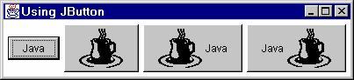

26

27

JButton: Example Output

J2EE training: http://courses.coreservlets.com

JPanel

• Main new feature: borders
– Create a Border object by calling
BorderFactory.createXxxBorder.
– Supply the Border object to the JPanel by means of
setBorder.
JPanel p = new JPanel();
p.setBorder(BorderFactory.createTitledBorder("Java"));
• Other features:
– Layout manager settings
• Can pass the layout manager to the JPanel constructor
– Setting preferred size
• There is no JCanvas. If you want JPanel to act like
Canvas, call setPreferredSize.

J2EE training: http://courses.coreservlets.com

28

Standard Borders

• Static methods in BorderFactory
– createEmptyBorder(int top, int left, int bottom, int right)
• Creates an EmptyBorder object that simply adds space
(margins) around the component.
– createLineBorder(Color color)
– createLineBorder(Color color, int thickness)
• Creates a solid-color border
– createTitledBorder(String title)
– createTitledBorder(Border border, String title)
• The border is an etched line unless you explicitly provide a
border style in second constructor.
– createEtchedBorder()
– createEtchedBorder(Color highlight, Color shadow)
• Creates a etched line without the label
J2EE training: http://courses.coreservlets.com

JPanel: Example Code

public class SixChoicePanel extends JPanel {
public SixChoicePanel(String title, String[] buttonLabels)
{
super(new GridLayout(3, 2));
setBackground(Color.LIGHT_GRAY);
setBorder(BorderFactory.createTitledBorder(title));
ButtonGroup group = new ButtonGroup();
JRadioButton option;
int halfLength = buttonLabels.length/2;
for(int i=0; i<halfLength; i++) {
option = new JRadioButton(buttonLabels[i]);
group.add(option);
add(option);
option = new JRadioButton(buttonLabels[i+halfLength]);
group.add(option);
add(option);
}
}

29
}
J2EE training: http://courses.coreservlets.com

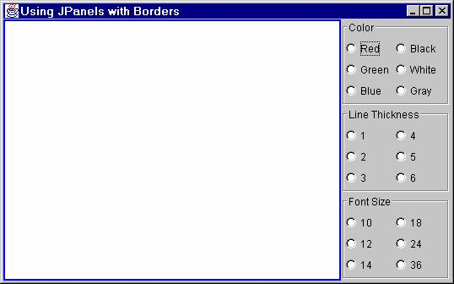

30

31

JPanel: Example Output

• Left window uses createLineBorder
• Right window has three SixChoicePanels

J2EE training: http://courses.coreservlets.com

JSlider

• Basic use
– public JSlider()
– public JSlider(int orientation)
– public JSlider(int min, int max)
– public JSlider(int min, int max, int initialValue)
– public JSlider(int orientation, int min, int max,
int initialValue)
• New features: tick marks and labels
– setMajorTickSpacing
– setMinorTickSpacing
– setPaintTicks
– setPaintLabels (icons allowed as labels)
J2EE training: http://courses.coreservlets.com
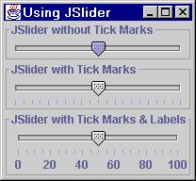
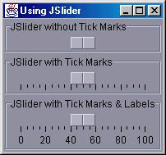
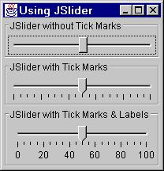

32

33

JSlider: Example Code

JSlider slider1 = new JSlider();
slider1.setBorder(...);
content.add(slider1, BorderLayout.NORTH);
JSlider slider2 = new JSlider();
slider2.setBorder(...);
slider2.setMajorTickSpacing(20);
slider2.setMinorTickSpacing(5);
slider2.setPaintTicks(true);
content.add(slider2, BorderLayout.CENTER);
JSlider slider3 = new JSlider();
slider3.setBorder(...);
slider3.setMajorTickSpacing(20);
slider3.setMinorTickSpacing(5);
slider3.setPaintTicks(true);
slider3.setPaintLabels(true);
content.add(slider3, BorderLayout.SOUTH);
J2EE training: http://courses.coreservlets.com

JSlider: Example Output
(Windows, Motif, Java LAF)

J2EE training: http://courses.coreservlets.com

34

35

JColorChooser

• Open
– Call JColorChooser.showDialog
• First argument: parent component
• Second argument: title string
• Third argument: initially-selected Color
• Return value
– Selected Color if "OK" chosen
– null if "Cancel" chosen

J2EE training: http://courses.coreservlets.com

JColorChooser:
Example Code
• Button that lets you change color of window

public void actionPerformed(ActionEvent e) {
Color bgColor
= JColorChooser.showDialog
(this,
"Choose Background Color",
getBackground());
if (bgColor != null)
getContentPane().setBackground(bgColor);
}

J2EE training: http://courses.coreservlets.com

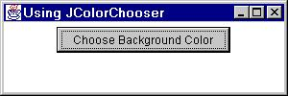
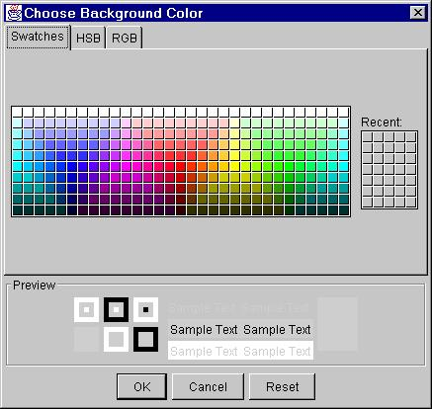
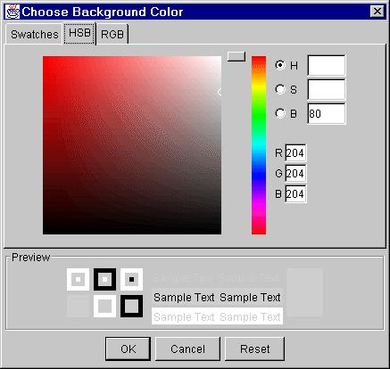
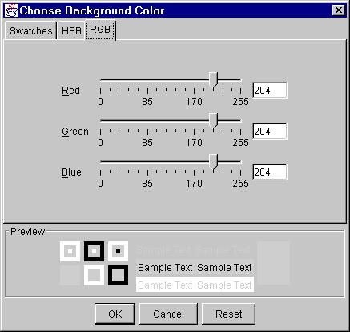

36
JColorChooser:
Example Output

Internal Frames

J2EE training: http://courses.coreservlets.com

37

• MDI: Multiple Document Interface
– Program has one large “desktop” pane that holds all other
windows. The other windows can be iconified
(minimized) and moved around within this desktop pane,
but not moved outside the pane. Furthermore, minimizing
the desktop pane hides all the contained windows as well.
– Examples: Microsoft PowerPoint, Corel Draw, Borland
JBuilder, and Allaire HomeSite
• Swing Support for MDI
– JDesktopPane
• Serves as a holder for the other windows.
– JInternalFrame
• Acts mostly like a JFrame, except that it is constrained to
stay inside the JDesktopPane. J2EE training: http://courses.coreservlets.com

38

39

Using JInternalFrame

• Main constructor
– public JInternalFrame(String title,
boolean resizable,
boolean closeable,
boolean maximizable,
boolean iconifiable)
• Other useful methods
– moveToFront
– moveToBack
– setSize (required!)
– setLocation (required!)

J2EE training: http://courses.coreservlets.com

Internal Frames: Example Code

import java.awt.*;
import java.awt.event.*;
import javax.swing.*;

public class JInternalFrames extends JFrame {
public static void main(String[] args) {
new JInternalFrames();
}

public JInternalFrames() {
super("Multiple Document Interface");
WindowUtilities.setNativeLookAndFeel();
addWindowListener(new ExitListener());
Container content = getContentPane();
content.setBackground(Color.WHITE);

J2EE training: http://courses.coreservlets.com
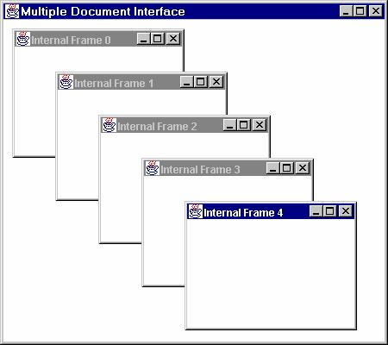
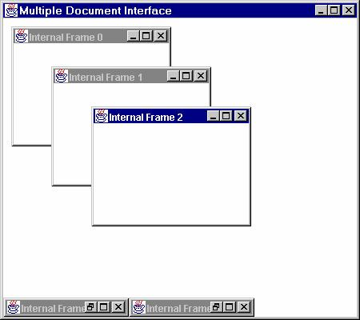

40

41
Internal Frames: Example Code
(Continued)
JDesktopPane desktop = new JDesktopPane();
desktop.setBackground(Color.WHITE);
content.add(desktop, BorderLayout.CENTER);
setSize(450, 400);
for(int i=0; i<5; i++) {
JInternalFrame frame
= new JInternalFrame(("Internal Frame " + i),
true, true, true, true);
frame.setLocation(i*50+10, i*50+10);
frame.setSize(200, 150);
frame.setBackground(Color.WHITE);
frame.setVisible(true);
desktop.add(frame);
frame.moveToFront();
}
setVisible(true);
} } J2EE training: http://courses.coreservlets.com

Internal Frames:
Example Output

J2EE training: http://courses.coreservlets.com
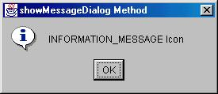
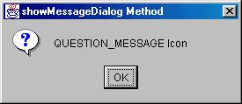
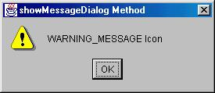
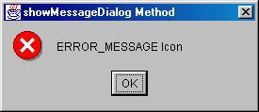

42

43

JOptionPane

• Very rich class with many options for
different types of dialog boxes.
• Five main static methods
– JOptionPane.showMessageDialog
• Icon, message, OK button
– JOptionPane.showConfirmDialog
• Icon, message, and buttons:
OK, OK/Cancel, Yes/No, or Yes/No/Cancel
– JOptionPane.showInputDialog (2 versions)
• Icon, message, textfield or combo box, buttons
– JOptionPane.showOptionDialog
• Icon, message, array of buttons or other components

J2EE training: http://courses.coreservlets.com

JOptionPane Message Dialogs
(Windows LAF)

J2EE training: http://courses.coreservlets.com
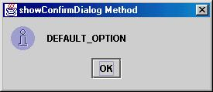
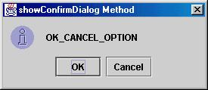
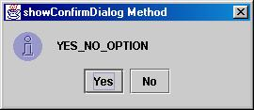
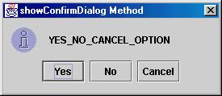
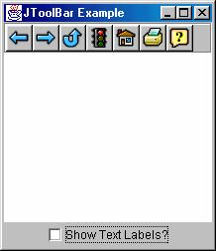
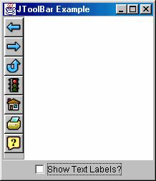
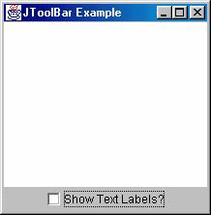
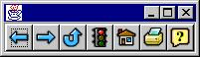
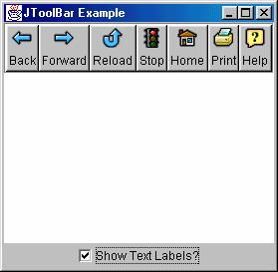

44

45
JOptionPane Confirmation
Dialogs (Java LAF)

J2EE training: http://courses.coreservlets.com

JToolBar

• Acts mostly like a JPanel for buttons
• Dockable: can be dragged and dropped

J2EE training: http://courses.coreservlets.com

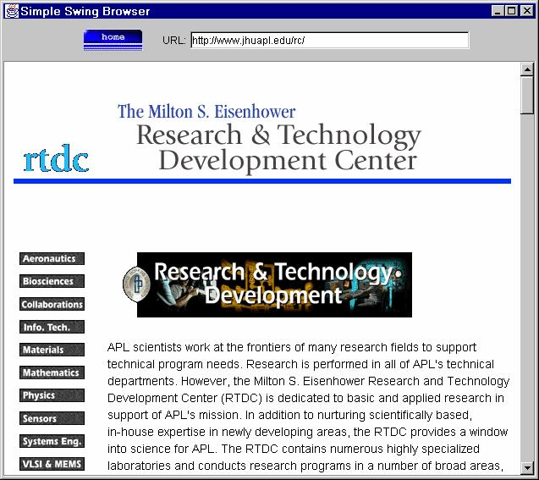
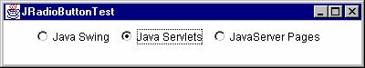
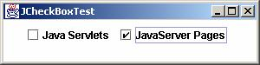
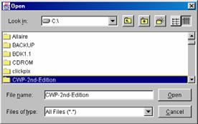

46

JEditorPane

• Acts somewhat like a text area
• Can display HTML and, if HyperLinkListener
attached, can follow links

J2EE training: http://courses.coreservlets.com

Other Simple Swing
Components
• JCheckBox
– Note uppercase B
(vs. Checkbox in AWT)
• JRadioButton
– Use a ButtonGroup to
link radio buttons
• JTextField
– Just like AWT TextField except that it does not act as a
password field (use JPasswordField for that)
• JTextArea
– Place in JScrollPane if
you want scrolling

47
• JFileChooser

J2EE training: http://courses.coreservlets.com

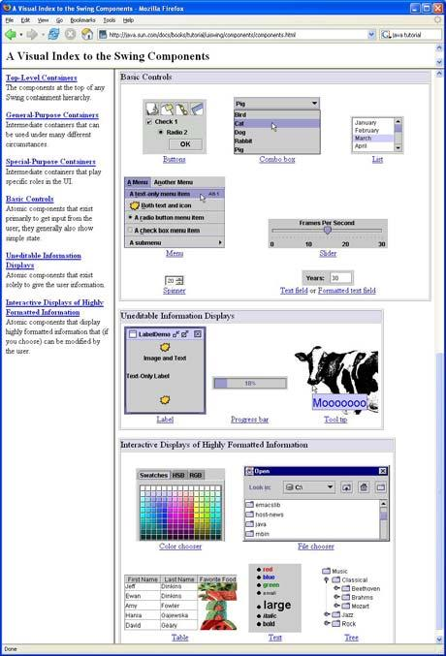

48

More Info

• Sun Java Tutorial
– http://java.sun.com/docs/
books/tutorial/uiswing/
components/index.html
– Very useful summary
of almost all Swing
components
– Gives code examples
– Includes graphical
table showing each

Summary

J2EE training: http://courses.coreservlets.com

49

• Port simple AWT components to Swing by
adding J to front of class name
• Put custom drawing in paintComponent
– Call super.paintComponent at beginning unless you turn
off double buffering
• Java look and feel is default
– But you almost always want native look and feel
• Frames and applets use content pane
– Don't put anything directly in window
• Most components support borders & icons
• Many new components

J2EE training: http://courses.coreservlets.com

Questions?
© 2007 Marty Hall

50

Customized J2EE Training: http://courses.coreservlets.com/
Servlets, JSP, Struts, JSF/MyFaces, Hibernate, Ajax, GWT, Java 5, Java 6, etc. Ruby/Rails coming soon.
Developed and taught by well-known author and developer. At public venues or onsite at your location.

