Cloud SQL Cross-Regional Replication
PSA IP Range Justification

Primary Region: europe-west2 (London) | Replica Region: europe-west1 (Belgium)
Request: Single /23 Private Service Access IP Allocation
Date: 3 April 2026
Classification: Internal Use Only

1. Executive Summary
This document justifies the request for a single /23 CIDR block to be allocated for Google Cloud Private Service Access (PSA). This allocation is required to enable Cloud SQL cross-regional replication with High Availability (HA) between europe-west2 (London) as the primary region and europe-west1 (Belgium) as the disaster recovery (DR) replica region.

PSA is a mandatory Google Cloud networking construct for Cloud SQL instances using private IP addresses. It creates a VPC peering connection between the organisation's VPC and Google's service producer network. The IP range allocated is not assigned to any user-facing VMs or subnets — it is reserved exclusively for Google's managed service infrastructure.

⚠ A single /24 allocation is insufficient for cross-regional replication. Google Cloud requires a minimum free /24 block per region. A /23 is the smallest contiguous allocation that satisfies both regions. This document provides the technical evidence for this requirement.

Attribute | Detail
Request | One /23 CIDR block for GCP Private Service Access
Size | 512 addresses (minimum contiguous block for 2 regions)
Purpose | Cloud SQL private IP — cross-regional replication (PSA)
Regions | europe-west2 (primary) + europe-west1 (DR replica)
Consumed by VMs? | No — reserved for Google-managed service infrastructure only
Alternative | Two separate /24s are technically possible but risky (see Section 5)

2. What is Private Service Access (PSA)?
Private Service Access is a Google Cloud networking mechanism that enables managed services — such as Cloud SQL, Memorystore (Redis), and Filestore — to have private IP addresses within a customer's VPC. Without PSA, Cloud SQL instances can only be accessed via public IP addresses, which introduces security risks and increased latency.

2.1 How PSA Works
- The customer allocates a dedicated IP range in their VPC with the purpose VPC_PEERING
- A VPC peering connection is established between the customer VPC and Google's service producer VPC
- Google's managed services (e.g. Cloud SQL) are assigned IP addresses from the allocated range
- All traffic between the customer's VMs and Cloud SQL stays entirely within Google's network — never traversing the public internet

2.2 Key Characteristics of PSA
- The IP allocation is a GLOBAL resource — it is configured once per VPC using the --global flag
- The IP range is NOT used by VMs, subnets, or load balancers — it is exclusively for Google-managed services
- Google automatically carves regional /24 subnets from the allocated pool as instances are created in each region
- The same PSA allocation covers all supported services: Cloud SQL, Memorystore, Filestore, etc.
- PSA uses standard VPC Network Peering — this means it is non-transitive (a known limitation vs. Private Service Connect)

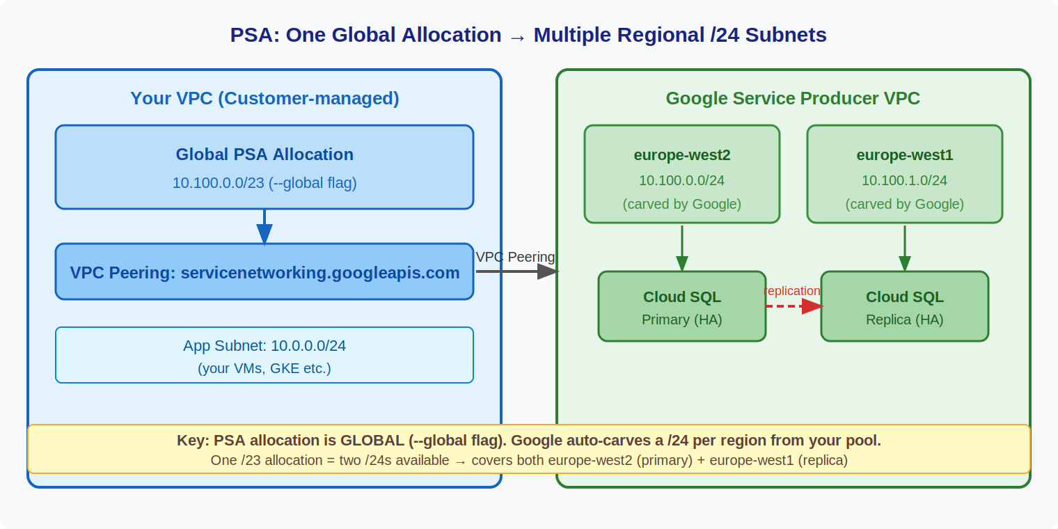
Figure 1: PSA architecture — one global allocation, Google carves /24 subnets per region

3. Cloud SQL High Availability (HA) — How It Works
Cloud SQL HA provides automatic zonal failover within a single region. When HA is enabled on an instance, Google manages a synchronous standby instance in a different availability zone within the same region.

3.1 HA Behaviour
- The primary instance handles all reads and writes in zone -a (for example)
- A standby instance is maintained synchronously in zone -b within the same region
- If the primary zone fails, Cloud SQL automatically promotes the standby — typically within 60 seconds
- The IP address of the instance does not change during failover
- HA standby uses the SAME /24 regional subnet as the primary — no additional PSA range is required

✅ HA does NOT require additional IP ranges. Both the active instance and its HA standby are placed within the same regional /24 subnet that Google carves from the PSA allocation.

3.2 HA on Read Replicas
Since mid-2022, Google Cloud supports enabling HA on read replicas. This is critical for cross-regional DR scenarios:
- The replica in europe-west1 can itself be configured with HA (zonal failover within Belgium)
- If europe-west1 zone -b fails, the replica fails over within europe-west1 — no cross-region traffic
- This means if we promote the replica during a DR event, it is already HA-enabled — reducing recovery time by 5-6 minutes
- Again, no extra PSA range is needed — the replica and its HA standby share the same europe-west1 /24

4. Why a Single /24 is Insufficient for Cross-Regional Replication
This is the core of the justification. A /24 (256 addresses) works perfectly for same-region configurations but fails for cross-regional replication. The following explains why.

4.1 How Google Uses the PSA Allocation
When a Cloud SQL instance is created with private IP, Google does not assign individual IPs directly from the allocated range. Instead, it:
- Identifies the region the instance is being created in
- Carves out a dedicated /24 subnet within Google's service producer VPC for that region
- The /24 subnet's address space is drawn from the customer's PSA allocation
- Assigns an IP from within that /24 to the Cloud SQL instance

This is documented in Google Cloud's official documentation:
"Each Google Cloud service creates a subnet in which to provision resources. The subnet's IP address range is typically a /24 CIDR block that is chosen by the service and comes from the allocated IP address range."
— Google Cloud: Learn about using private IP for Cloud SQL

4.2 The /24 Exhaustion Problem
If the PSA allocation is exactly /24:
- Creating the primary instance in europe-west2 causes Google to carve the entire /24 for that region
- When creating the replica in europe-west1, Google needs to carve a NEW /24 for that region
- There are no free /24 blocks remaining in the allocation
- Instance creation fails with the following error:

"Failed to create subnetwork. Couldn't find free blocks in allocated IP ranges. Please allocate new ranges for this service provider."

⚠ Note: Cloud SQL also enforces a 60% IP usage threshold per subnet. When a regional /24 reaches 60% utilisation, Google automatically attempts to carve an additional /24 from the pool. This makes even a slightly oversized /24 risky in production environments with multiple instances.

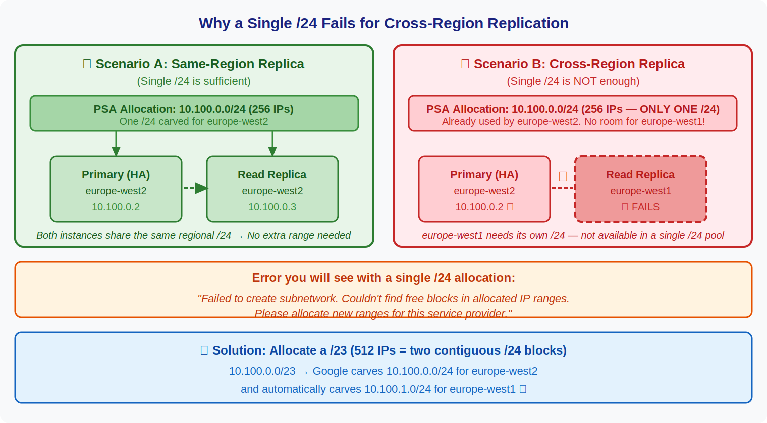
Figure 2: Why a single /24 fails — same-region works, cross-region requires two /24 blocks

5. IP Range Recommendation: /23

5.1 Why /23 is the Minimum Justifiable Request
A /23 (512 addresses) contains exactly two contiguous /24 blocks:

Block | CIDR | Region Used | Purpose
First /24 | e.g. 10.x.0.0/24 | europe-west2 | Primary + HA standby
Second /24 | e.g. 10.x.1.0/24 | europe-west1 | Replica + HA standby

- Each /24 supports up to 50 Cloud SQL instances per Google's documentation (well above our requirement of 1 primary + 1 replica)
- HA standby instances in each region are placed within the same /24 — no additional blocks required
- The /23 is allocated as a single global reservation — simpler to manage than two separate /24s

5.2 Why Two Separate /24s Are Riskier Than a Single /23
While two separate (non-contiguous) /24s are technically supported, they introduce operational risk:
- Must be explicitly registered in the same PSA peering connection — an operational step that can be missed
- Each instance must be pinned to its specific range using --allocated-ip-range-name, adding deployment complexity
- No headroom: if the 60% utilisation threshold is hit in either /24, Google will attempt to carve a new /24 — which will fail as no further blocks are available
- Zero capacity for a third region, a second DB engine (PostgreSQL requires a separate range from MySQL), or additional services like Memorystore
- A single /23 avoids all of the above — Google manages the subdivision automatically

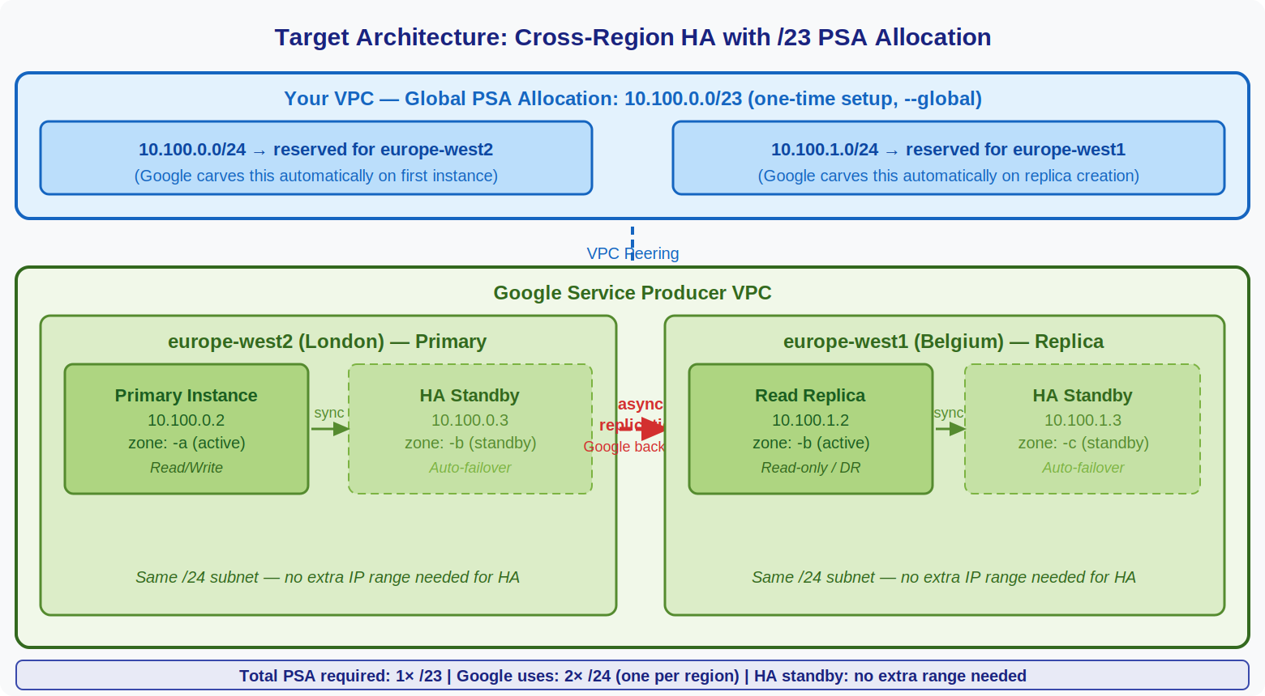
Figure 3: Target architecture — /23 PSA allocation supporting HA primary (europe-west2) and HA replica (europe-west1)

6. IP Consumption Analysis
This section demonstrates that the /23 request (512 addresses) is the minimum viable allocation and not an over-request.

Component | Region | IPs Used | Notes
Cloud SQL Primary (HA) | europe-west2 | 2 | Active + HA standby
Cloud SQL Replica (HA) | europe-west1 | 2 | Replica + HA standby
Google infrastructure IPs | Both | ~10 | Reserved by Google per /24
Regional /24 subnet overhead | Both | ~5 | Network/broadcast/gateway
TOTAL CONSUMED | — | ~19 | Out of 512 available in /23

The /23 provides 512 addresses total. Only approximately 19 are consumed by this architecture. However, the allocation cannot be reduced below /23 because:
- Google requires one full free /24 block per region — individual IPs are not assignable across regional boundaries
- The /24 blocks are carved by Google, not the customer — the customer cannot influence how IPs within a /24 are distributed
- A /25 (128 addresses) would not contain two full /24 blocks and is therefore technically invalid for this use case

The apparent 'waste' of ~493 unassigned IPs in the /23 is structural — it is a consequence of Google's regional subnet architecture, not over-allocation by the requester. The /23 is the smallest technically valid allocation for this use case.

7. Alternatives Considered

Option | Feasible? | Risk | Verdict
Single /24 | ❌ No | Instance creation fails | Rejected — technically invalid
Two /24s (non-contiguous) | ⚠ Possible | Operational complexity, no headroom | Bare minimum, fragile
Single /23 (contiguous) | ✅ Yes | Minimal | Recommended minimum
Single /16 | ✅ Yes | None | Ideal for growth, rejected due to IP scarcity policy
Public IP (no PSA) | ✅ Possible | Security/compliance risk | Rejected — does not meet private networking policy
Private Service Connect (PSC) | ✅ Possible | More complex, single IP per endpoint | Future consideration; PSA is current standard

8. Summary and Formal Request

FORMAL REQUEST: Allocation of one /23 CIDR block from the organisation's available IP space, to be configured as a Global Private Service Access reservation in GCP for the purpose of enabling Cloud SQL cross-regional replication with High Availability between europe-west2 (primary) and europe-west1 (DR replica).

8.1 Justification Summary
- PSA is mandatory for Cloud SQL private IP — there is no alternative that meets our private networking policy
- The /23 allocation is a global VPC reservation — it does NOT consume subnet space, cannot be used by VMs, and is invisible to workloads
- A /23 is the minimum contiguous block that satisfies Google's architectural requirement of one free /24 per region
- A single /24 will cause instance creation to fail when the cross-regional replica is deployed
- HA (zonal failover) within each region does NOT require additional IP blocks — both active and standby instances share the same regional /24
- The total effective IP consumption for this architecture is approximately 19 addresses out of 512 — the remainder cannot be reclaimed due to Google's regional subnet model

8.2 Commitments
- The /23 range will be used exclusively for Google Cloud PSA — no VMs, subnets, or other resources will be assigned from it
- Instances will be pinned to specific named ranges (--allocated-ip-range-name) to prevent unintended consumption
- No expansion beyond the /23 is anticipated for the current architecture (1 primary region + 1 DR replica region)
- Any future addition of regions or DB engines will be brought back for separate IP approval

Requested CIDR | Reason
1× /23 (e.g. 10.x.x.0/23) | Minimum for 2-region Cloud SQL PSA with HA

Prepared by: ___________________________________ Date: _______________

Approved by: ___________________________________ Date: _______________

