Reconfigurable Series-Parallel
Battery Management System using ESP32
Project Documentation Report

Abstract
This report documents the design, implementation, and testing of a reconfigurable Battery Management System (BMS) built around an ESP32 microcontroller. The system manages a 3-cell Li-ion pack and can electronically reconfigure the pack between series and parallel topologies using MOSFET switching (IRF530 N-channel and IRF9640 P-channel devices), controlled and monitored in real time by the ESP32. The BMS tracks per-cell voltage, pack current, State of Charge (SOC), and State of Health (SOH), and logs telemetry for post-analysis.
Two independent rounds of charge/discharge testing were performed comparing the series and parallel configurations, measured simultaneously at the DC charger input and the AC wall input. Across both test rounds, the series configuration consistently delivered higher round-trip efficiency, requiring 6.7-15.3% less DC energy and 12.8-16.6% less AC wall energy to deliver an equivalent amount of discharge capacity, at the cost of 6-19 minutes longer charge time. These results are presented with full telemetry plots, comparison tables, and discussion in Section 5.

Table of Contents
1. Introduction 4
1.1 Background and Motivation 4
1.2 Objectives 4
1.3 Scope 4
2. System Design 4
2.1 System Overview 4
2.2 Series-Parallel Switching Circuit 5
2.3 Key Components 6
2.4 ESP32 Control and Monitoring 6
3. Working Principle 6
3.1 Series Mode 6
3.2 Parallel Mode 7
3.3 Monitored Parameters 7
4. Test Methodology 7
4.1 Test Setup 7
4.2 Instrumentation 7
4.3 Test Procedure 7
5. Results and Analysis 8
5.1 Test Pair 1 - Series vs. Parallel 8
5.2 Test Pair 2 - Series vs. Parallel 8
5.3 Telemetry - Overall Run (Test Pair 2) 9
5.4 Charging Curves 10
5.5 Discharging Curves 11
5.6 Cumulative Energy 12
5.7 Discussion 13
6. Conclusion 13
7. Future Scope 14
Appendix A: Firmware and Data Files 15
Appendix B: Instrumentation Evidence (Test Pair 2) 15
Appendix C: ESP32 Firmware Source Code 17

1. Introduction

1.1 Background and Motivation
Battery Management Systems are essential in any multi-cell battery pack, responsible for protecting cells from over-voltage, under-voltage, and over-current conditions while balancing charge across cells. A less common but valuable capability is dynamic reconfiguration: electronically switching a battery pack between series and parallel arrangements without physically rewiring it. Series configuration provides a higher pack voltage suited to charging or high-voltage loads, while parallel configuration provides higher current capability at lower voltage. A reconfigurable BMS allows a single pack to serve both roles, and allows direct, controlled experimental comparison of the efficiency of each topology under identical charge/discharge conditions. # efficiency drops when current increases that point is the real motivation and background

1.2 Objectives
- Design and build a 3-cell Li-ion BMS capable of electronic series/parallel reconfiguration using MOSFET switching.
- Implement real-time monitoring of per-cell voltage, pack current, SOC, and SOH using an ESP32 microcontroller.
- Characterize and compare charge/discharge efficiency of the series vs. parallel configurations under repeatable test conditions.
- Validate results across two independent test rounds and quantify the efficiency difference at both the DC and AC (wall) measurement points.

1.3 Scope
This report covers the hardware design (switching circuit and control/monitoring electronics), the ESP32 firmware's role in configuration control and telemetry logging, and the experimental methodology and results from two rounds of comparative testing. Firmware source code and full raw telemetry logs (CSV) are referenced but not reproduced in full; they are available as supplementary files.

2. System Design

2.1 System Overview
The system consists of three Li-ion cells whose interconnection is controlled by a MOSFET switching network. An ESP32 development board acts as the central controller: it drives the gate signals that select series or parallel mode, reads per-cell and pack-level voltage/current via onboard sensing, computes SOC/SOH, and logs all telemetry over serial/USB for later analysis. The physical build (breadboard/perfboard prototype) is shown in Figure 1.
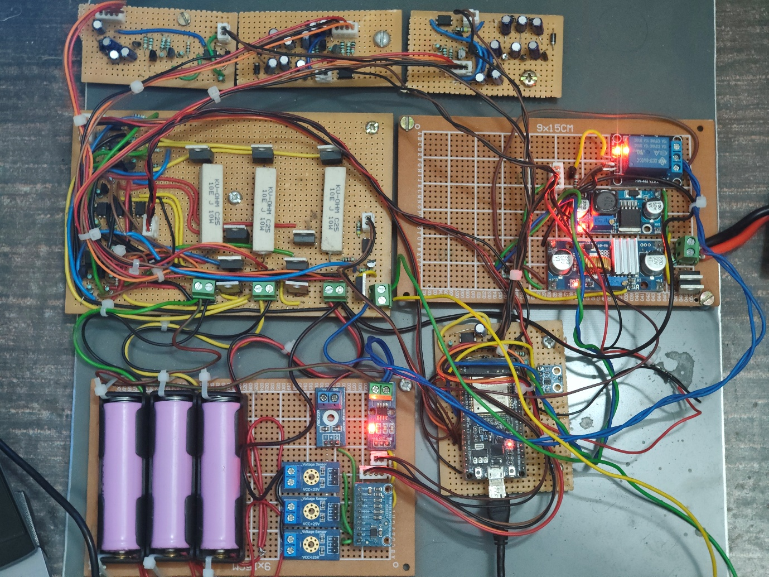

Figure 1. Hardware prototype
The board is organized into functional sub-sections: a battery holder bank (bottom left) housing the 3-cell pack, a relay/MOSFET switching stage for series-parallel reconfiguration, a voltage regulation stage (buck converter, visible near the relay module) that conditions the charger input, and the ESP32 control module with its associated sensing wiring. An external switch-mode DC power supply and DC-DC boost/charge module (right of frame) provide the charging source used during testing.
#mosfet driving circuit not mentioned

2.2 Series-Parallel Switching Circuit # and bleed network
The switching topology was first modeled and simulated in LTspice (Switch_circuit.asc) before hardware implementation. The simulation models the three cells as independent 4.2 V sources with 10 Ω bleed resistors, and uses a bank of N-channel (IRF530) and P-channel (IRF9640) MOSFETs to route the cells into either a series or parallel chain. Two control parameters, VS and VP, act as the mode-select signals: setting VS=10V/VP=0V configures the network for series operation, while VS=0V/VP=10V configures it for parallel operation - in the physical build, these correspond to the ESP32 GPIO/relay driver outputs #remove.

2.3 Key Components
Designator | Component | Function
M1, M4–M8 | N-MOSFET, IRF530 | Series/parallel reconfiguration switches for the 3-cell array
M3, M9 | P-MOSFET, IRF9640 | High-side reconfiguration switches
M2 | N-MOSFET, IRF530 | Charge-input path switch
Bleed_R1–R3 | 10 Ω resistor | Per-cell bleed / balancing resistors
Cell1–Cell3 | 4.2 V source (model) | Represents the three Li-ion cells in simulation
VS / VP | Control parameters | Logic signals selecting Series (VS) or Parallel (VP) topology

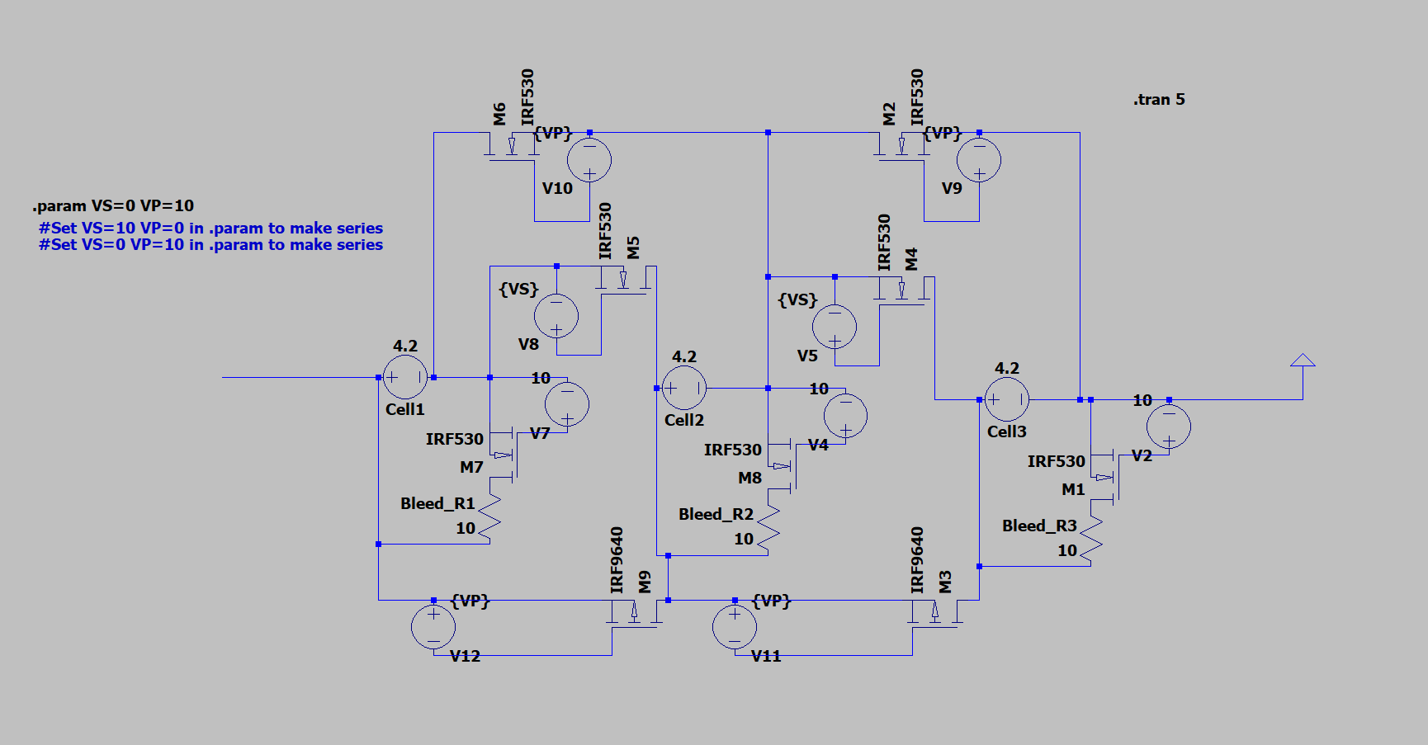
Figure 2. LTspice schematic

2.4 ESP32 Control and Monitoring
The ESP32 is responsible for: (1) driving the gate/relay control lines #by giving appropriate signal to the mosfet driver circuit to select series or parallel mode, (2) sampling per-cell voltages (C1, C2, C3) and pack current (I, I_bat) via its ADC and current-sense circuitry, (3) computing derived quantities - State of Charge (SOC) and per-cell State of Health (SOH1-3) - and (4) logging all values with a timestamp to a serial/CSV stream for offline analysis. The logged fields captured during testing include: Timestamp, state (SERIES/PARALLEL), V_in, Vast, per-cell voltages C1-C3, pack current I, battery current I_bat, SOC, SOH1-3, cycle count, DAC output, per-channel bleed current, and charging/load status flags.

3. Working Principle

3.1 Series Mode
In series mode, the three cells are connected end-to-end, so the pack presents roughly 3x the single-cell voltage (approx. 9-12.6 V for Li-ion) to the charger/load, at the single-cell current rating. This mode was used for the higher-voltage DC charging test path in this project.

3.2 Parallel Mode
In parallel mode, the three cells are connected across the same two terminals, so the pack presents a single-cell voltage (approx. 3-4.2 V) but at up to 3x the single-cell current rating. This mode trades voltage for current capability.

3.3 Monitored Parameters
- Per-cell voltage (C1, C2, C3) - used for balancing and over/under-voltage protection.
- Pack and battery current (I, I_bat) - used for over-current protection and coulomb counting.
- State of Charge (SOC) - estimated pack charge level, logged continuously through charge/discharge cycles.
- State of Health (SOH1-3) - per-cell health metric tracked across cycles.
- Bleed current channels - used during active cell balancing. #passive not active

4. Test Methodology

4.1 Test Setup
Two independent rounds of testing (Test Pair 1 and Test Pair 2) were conducted. In each round, the pack was run through a full charge cycle followed by a full discharge cycle in Series mode, and separately in Parallel mode, with identical charger hardware and load conditions between the two modes within a round.

4.2 Instrumentation
- DC Charger Meter - measures energy (Wh) delivered from the bench power supply into the charging circuit.
- AC Wall Meter - measures total energy (Wh) drawn from the wall outlet, capturing the combined losses of the AC-DC power supply plus the charging/regulation circuitry.
- ESP32 telemetry log - per-cell voltage, current, SOC/SOH, sampled continuously and timestamped throughout each run.
Photographic evidence of the AC and DC meter readings at the end of each run is included in Appendix B.

4.3 Test Procedure
- 1. Set the pack to the target configuration (Series or Parallel) via the ESP32 control interface.
- 2. Zero/record the AC wall meter and DC charger meter.
- 3. Run a full charge cycle to completion; record elapsed time and both meter readings.
- 4. Run a full discharge cycle under a fixed load to a defined cutoff; record elapsed time and discharge energy from telemetry.
- 5. Repeat for the other configuration under matched conditions.
- 6. Repeat the entire procedure a second time (Test Pair 2) to check repeatability.

5. Results and Analysis

5.1 Test Pair 1 - Series vs. Parallel
Metric | Series | Parallel | Difference | Better Config
Charge Energy (DC logged, Wh) | 13.215 | 11.022 | 2.193 Wh | Parallel uses less
Charge Time | 02:18:53 | 02:24:53 | 00:06:00 | Series faster
Discharge Energy (Wh) | 6.289 | 6.425 | 0.137 Wh | Parallel (+2.17%)
Discharge Time | 01:04:43 | 01:07:26 | 00:02:43 | Series faster
DC-side Wh to deliver 6.425 Wh(normalized) | 11.852 | 12.700 | 0.848 Wh | Series saves 6.68%
DC-side Efficiency | 54.21% | 50.59% | 3.62 pts | Series (+7.16% rel.)
AC-side Wh to deliver 6.425 Wh(normalized) | 35.760 | 41.000 | 5.240 Wh | Series saves 12.78%
AC-side Efficiency | 17.97% | 15.67% | 2.30 pts | Series (+14.65% rel.)

Test Pair 1 result: Parallel delivered a marginally higher discharge capacity (+2.17%) #include reason, but Series was more efficient overall - saving 6.68% of DC-side energy and 12.78% of AC-side energy to deliver the same capacity.

5.2 Test Pair 2 - Series vs. Parallel
Metric | Series | Parallel | Difference | Better Config
Charge Energy (DC logged, Wh) | 12.425 | 11.377 | 1.047 Wh | Parallel uses less
Charge Time | 02:10:02 | 02:28:54 | 00:18:52 | Series faster
Discharge Energy (Wh) | 6.444 | 6.142 | 0.302 Wh | Series (+4.92%)
Discharge Time | 01:03:25 | 01:06:20 | 00:02:55 | Series faster
DC-side Wh to deliver 6.444 Wh(normalized) | 11.200 | 13.220 | 2.020 Wh | Series saves 15.28%
DC-side Efficiency | 57.54% | 48.75% | 8.79 pts | Series (+18.03% rel.)
AC-side Wh to deliver 6.444 Wh(normalized) | 35.000 | 41.967 | 6.967 Wh | Series saves 16.60%
AC-side Efficiency | 18.41% | 15.36% | 3.06 pts | Series (+19.91% rel.)

Test Pair 2 result: Series delivered higher discharge capacity (+4.92%) and was substantially more efficient - saving 15.28% of DC-side energy and 16.60% of AC-side energy compared to Parallel. This confirms the direction of the Test Pair 1 result and shows a larger efficiency gap on repeat.

5.3 Telemetry — Overall Run (Test Pair 2)
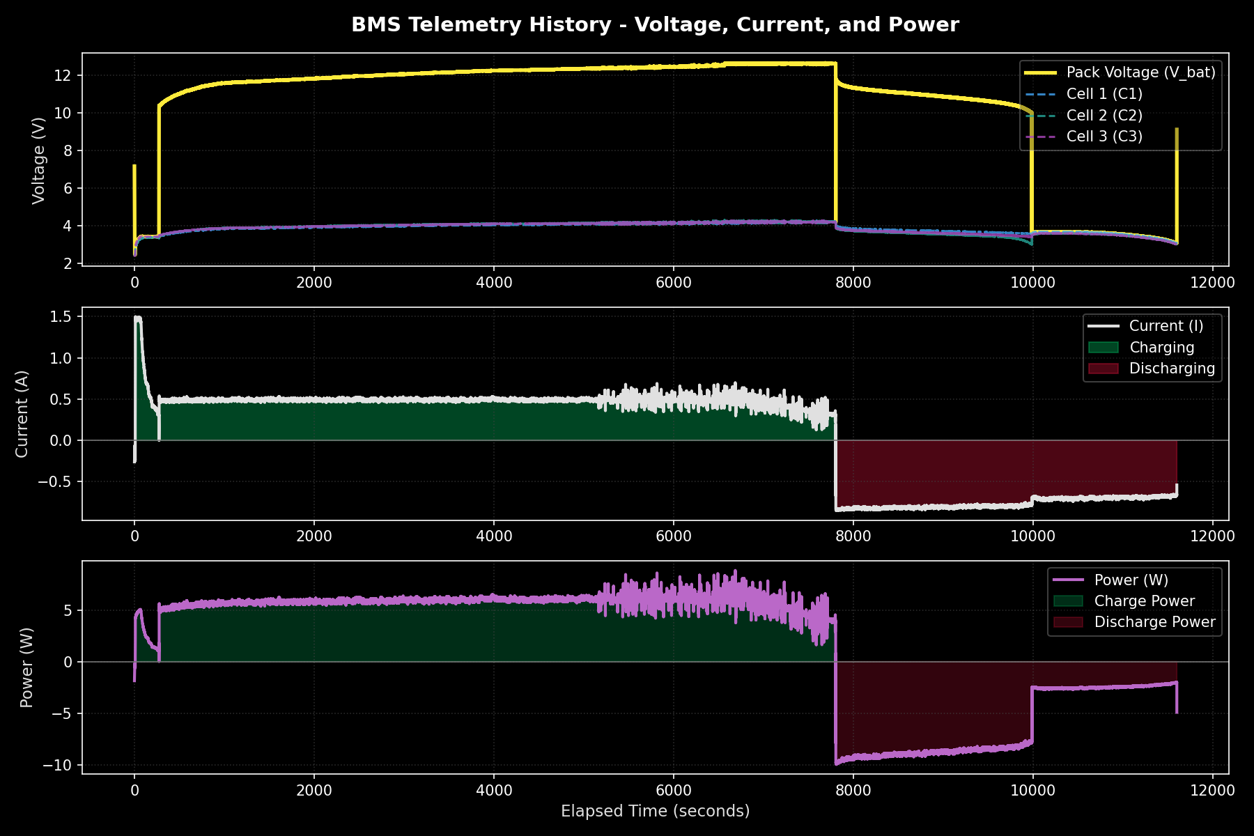
Figure 4. Full telemetry - Series mode, Test 2
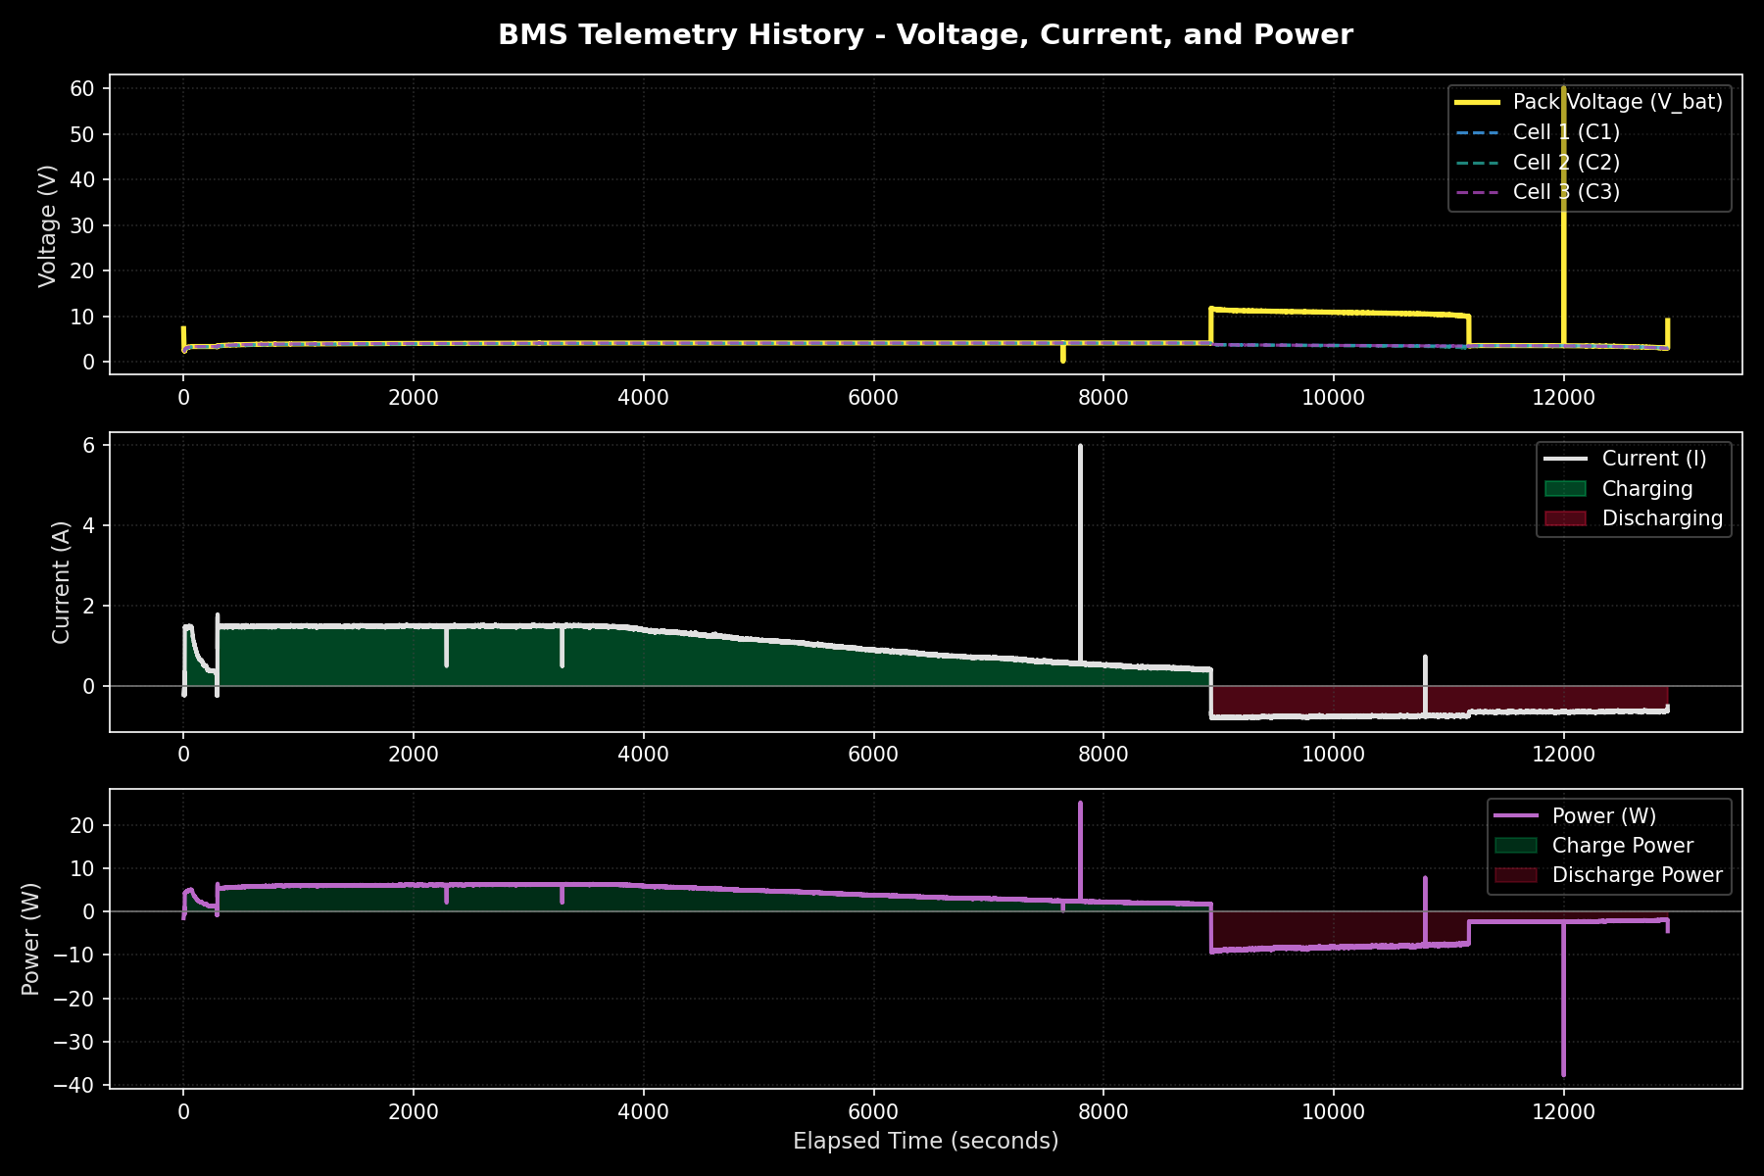
Figure 5. Full telemetry - Parallel mode, Test 2.

5.4 Charging Curves
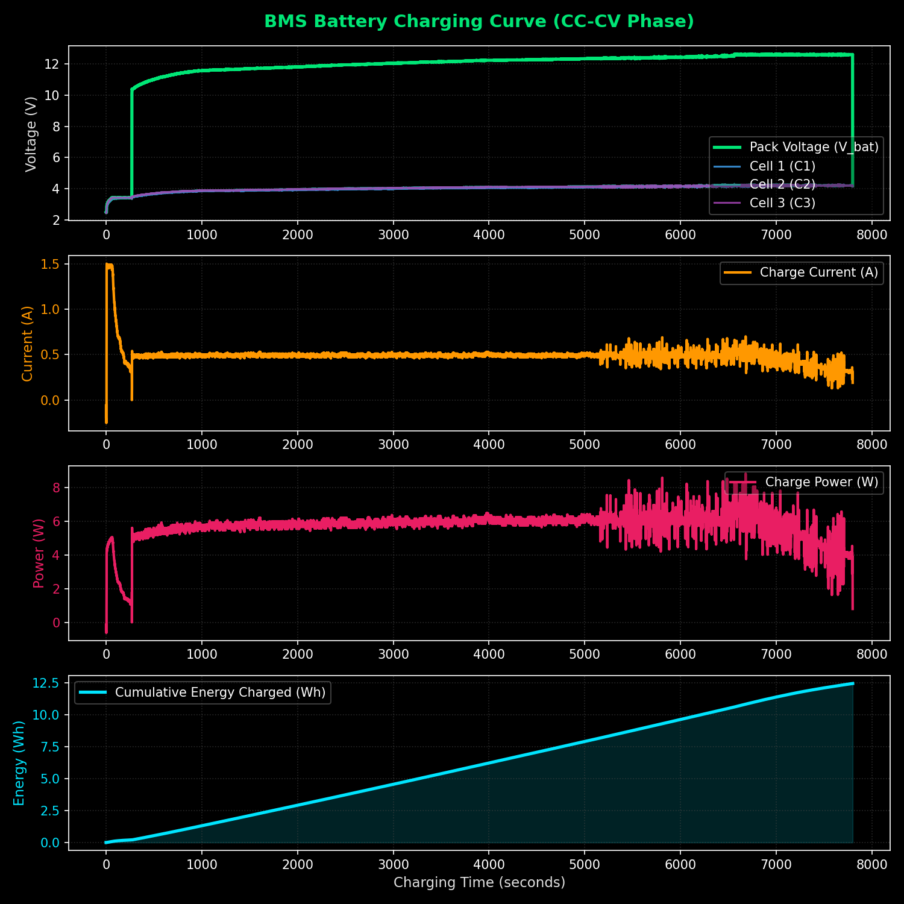
Figure 6. Charging curve - Series mode, Test 2.
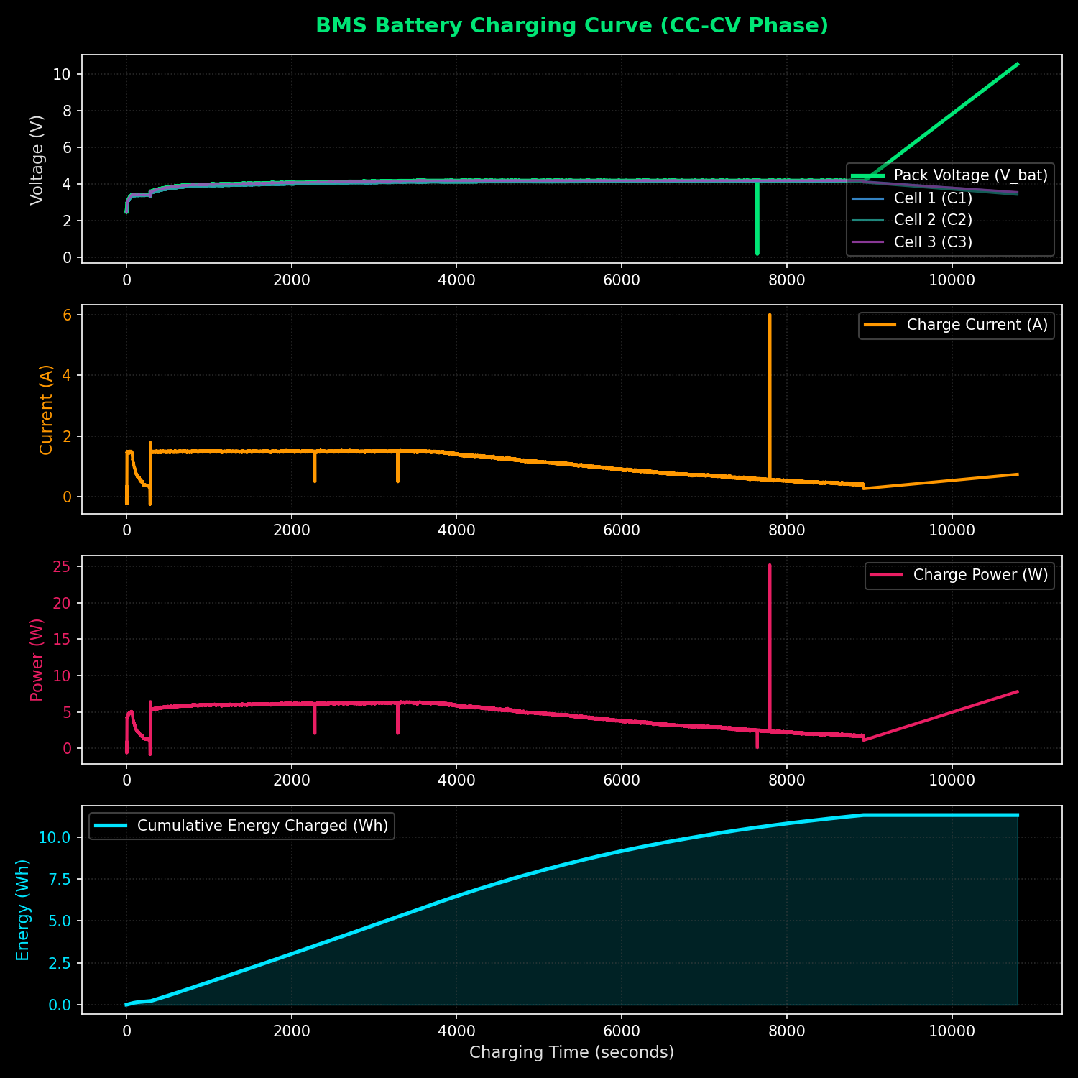
Figure 7. Charging curve - Parallel mode, Test 2.

5.5 Discharging Curves
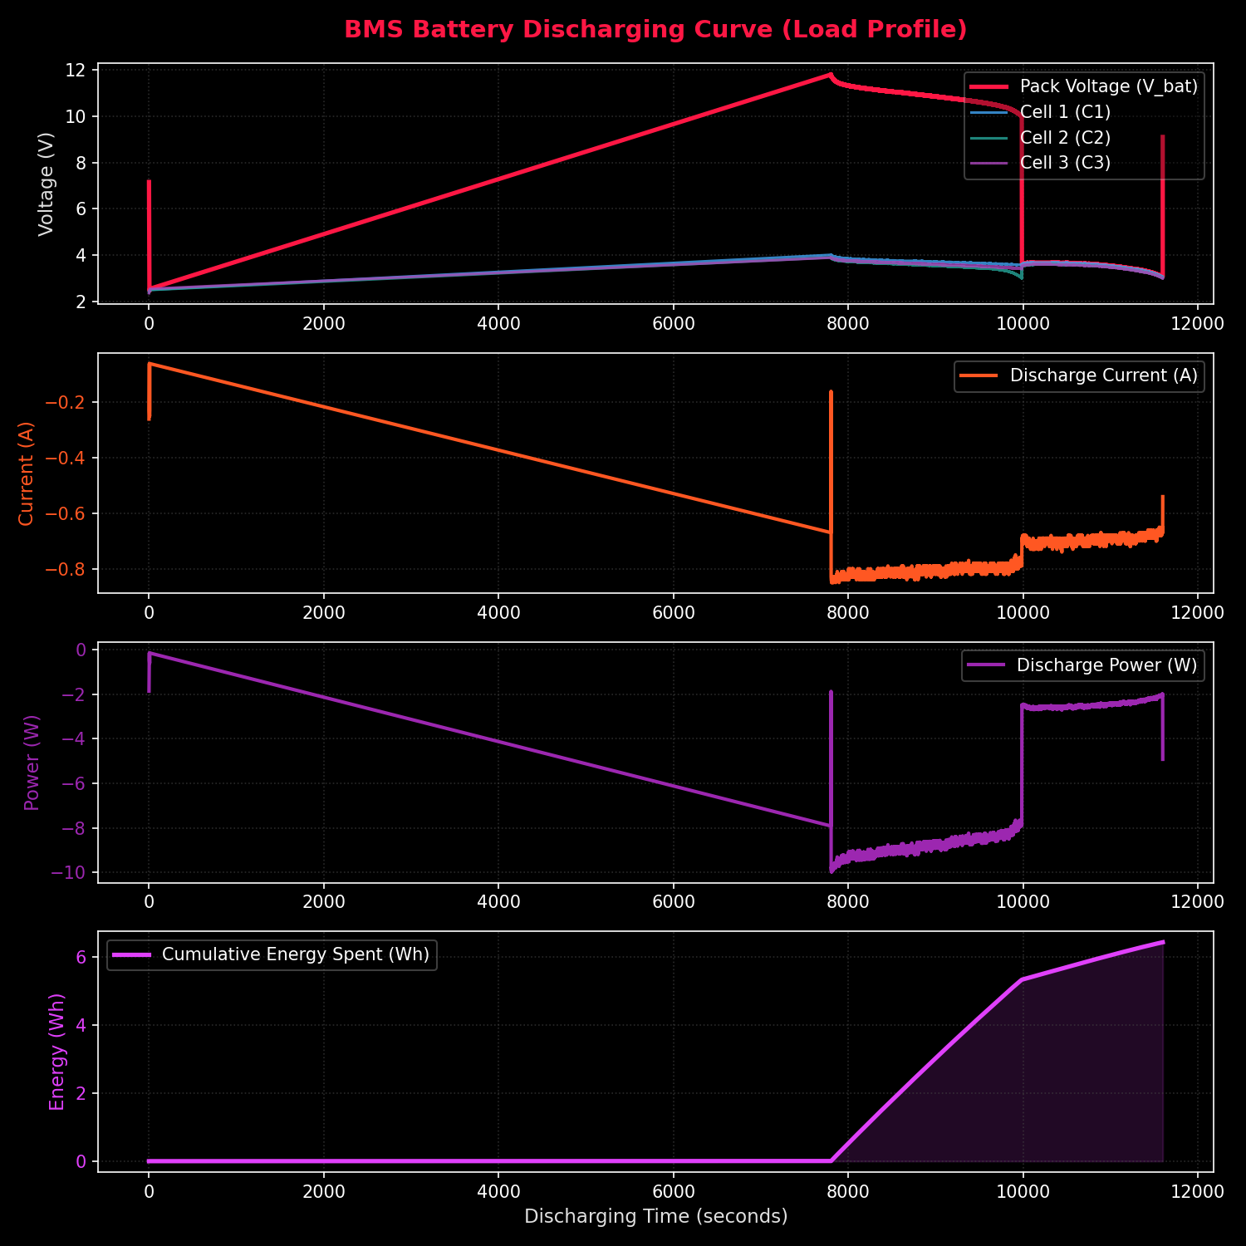
Figure 8. Discharging curve - Series mode, Test 2.
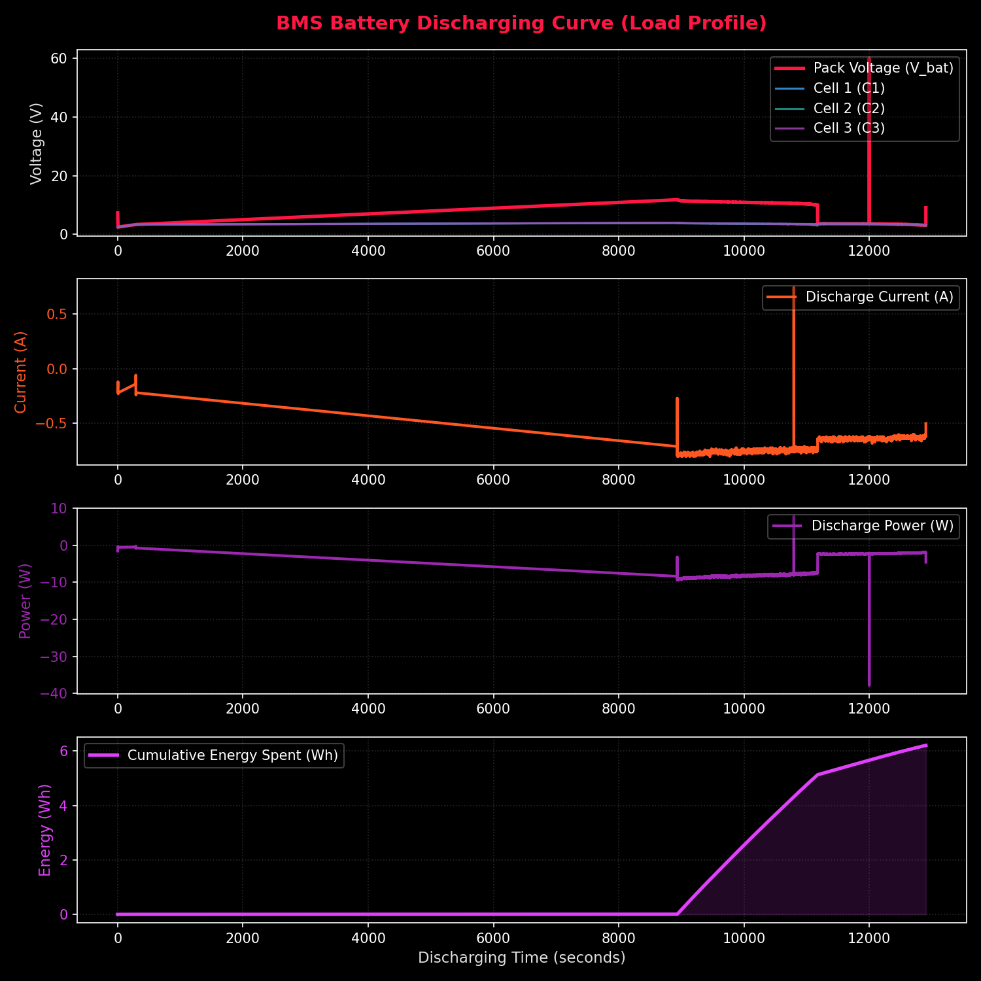
Figure 9. Discharging curve - Parallel mode, Test 2.

5.6 Cumulative Energy
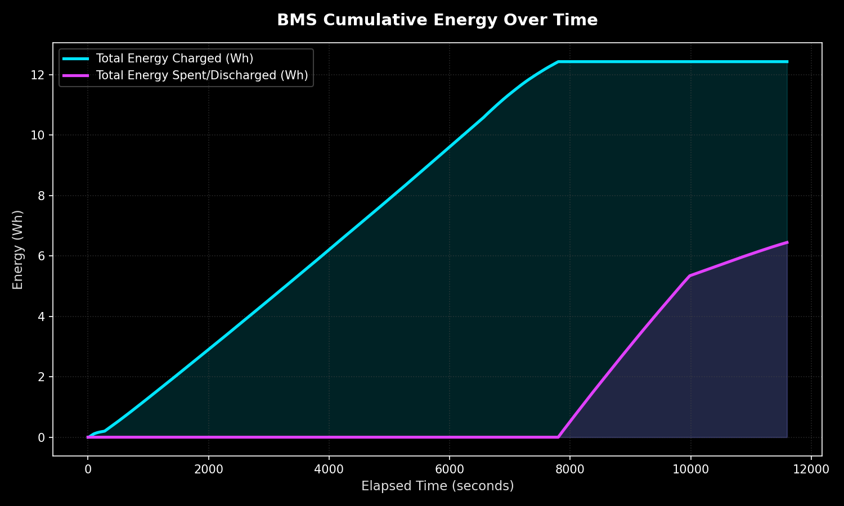
Figure 10. Cumulative energy - Series mode, Test 2.
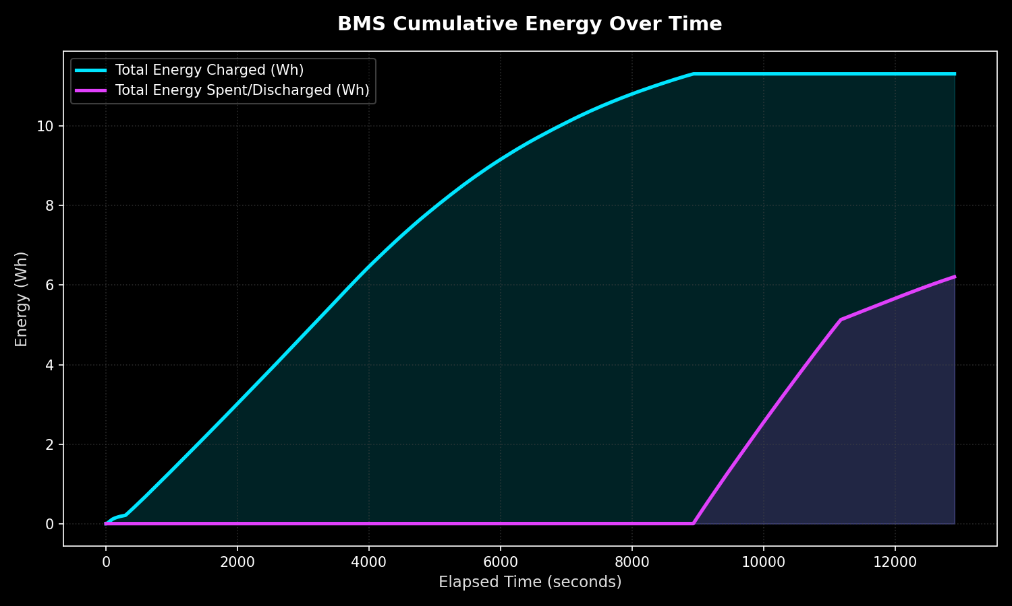
Figure 11. Cumulative energy - Parallel mode, Test 2.

5.7 Discussion
Across both independent test rounds, Series configuration consistently required less input energy - at both the DC charger and the AC wall - to deliver an equivalent amount of discharge capacity. The efficiency advantage was larger and more consistent on the AC side (12.8% and 16.6% savings) than the DC side (6.7% and 15.3% savings), which is expected since the AC measurement also captures losses in the AC-DC power supply stage; those losses do not scale linearly with the pack topology, amplifying the relative gap. Series mode did take longer to charge in both rounds (6 and 19 minutes longer), which is the practical trade-off for its higher efficiency and is consistent with charging at lower current into a higher-voltage pack through the same regulation stage.
Absolute round-trip efficiencies were low in both configurations (roughly 15-18% at the AC wall meter), which reflects the losses inherent in the buck/boost regulation and switching stages of this prototype rather than the cells themselves; the DC-side efficiency (48-58%) is a better indicator of the switching/relay network's own losses. This suggests the AC-DC power supply and regulation stage - not the series/parallel switching network - is the dominant source of loss in the present design, and would be the first target for efficiency improvement.

6. Conclusion
A working ESP32-based reconfigurable BMS was designed, built, and characterized across two independent test rounds. The system successfully switches a 3-cell Li-ion pack between series and parallel topologies under ESP32 control while logging per-cell voltage, current, SOC, and SOH. Theoretically and Experimentally, Series configuration was consistently more energy-efficient than Parallel for the charge-discharge cycle tested, at the cost of a longer charge time. These results provide a quantified basis for choosing pack topology in future revisions of the design.

7. Future Scope
- Investigate and reduce losses in the AC-DC power supply / regulation stage, identified as the dominant source of inefficiency.
- Add active cell balancing validation and quantify its energy cost.
- Extend testing to more charge/discharge cycles to assess long-term SOH degradation under each topology.
- Automate configuration switching based on load demand (e.g., auto-select Parallel under high-current load, Series for charging).
- Add over-voltage / over-current / over-temperature protection characterization and fault-injection testing.
- Optimize the system for EVs and enable power saving, suitable for multiple voltage power sources.

Appendix A: Firmware and Data Files
The following supplementary files accompany this report and are referenced throughout:
- Switch_circuit.asc - LTspice schematic/netlist of the series-parallel MOSFET switching network.
- test_pair1/, test_pair2/ - raw CSV telemetry logs, generated plots, and meter photos for each test round.
- comparison_report_series_vs_parallel (test1, test2) - auto-generated summary reports used as the source for Section 5 tables.

Appendix B: Instrumentation Evidence (Test Pair 2)
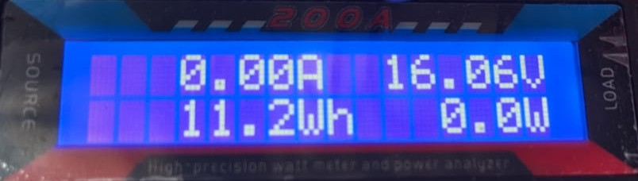
Figure 12. DC charger meter reading — Series mode, Test 2.
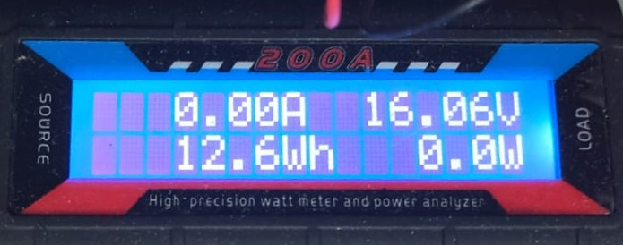
Figure 13. DC charger meter reading — Parallel mode, Test 2.
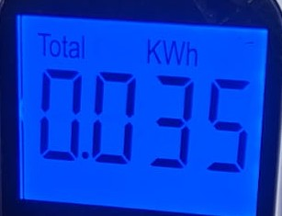
Figure 14. AC wall meter reading — Series mode, Test 2.
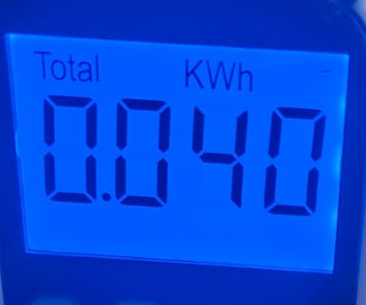
Figure 15. AC wall meter reading — Parallel mode, Test 2.

Appendix C: ESP32 Firmware Source Code
Full source listing of the working firmware (bms_2_working.ino) used to control mode switching, cell balancing, and telemetry logging for all tests in this report.
#include "MCP4725.h"
#include "Wire.h"
#include "battery_model.h"
#include <7semi_ADS1xx5.h>
#include <Preferences.h>

#define COMPLETE_DISCHARGE false
#define charge_override false

ADS1xx5_7semi adc;
Preferences preferences;

MCP4725 MCP(0x61);

#define relay_pin 19
#define I_adc 32
#define PARALLEL 0
#define SERIES 1

#define _switch 23
#define bal1 12
#define bal2 14
#define bal3 27

#define load 13

#define MIN_VOLTAGE_CELL 3.0
#define MAX_VOLTAGE_CELL 4.2 // 3.3

#define MAX_VOLTAGE 12.6
#define MIN_VOLTAGE 9.2
#define MAX_CURRENT 0.8
#define MAX_CURRENT_PARALLEL 0.8 * 3

#define CHARGING_MINIMUM_PERCENTAGE 0.8

#define MIN_SERIES_VOLTAGE 9.6

#define NOMINAL_CELL_CAPACITY 1.6
#define PARALLEL_CAPACITY (NOMINAL_CELL_CAPACITY * 3.0)
#define SERIES_CAPACITY (NOMINAL_CELL_CAPACITY)

#define CHARGING_MODE SERIES
#define DISCHARGE_MODE PARALLEL

#define cutoff_series_current 0.3

int dac = 4095;
int dac2 = 255;

bool _display = true;
bool charging = false;
bool pause_balancing = false;

float cell_volt[] = { 0, 0, 0 };
uint8_t cell_channel[] = { 1, 2, 3 };
float calibration[] = { 0.2077286732379577, 0.20356074801812143,
0.20298407368164226 };
float calibration_p[] = { 0.20616287921857612, 0.2076627278270508,
0.20707443284903052 };
float current_bleed[] = { 0, 0, 0 };
// float current_comp_p[] = {0.059027, 0.0360655, 0.06818};
int charger_channel = 0;
float charger_calibration = 0.20236;
float rate[] = { 0, 0, 0 };

float voltage_set = 8.9;
float current_set = 1.2;
bool dac_set = false;
bool config_mode = false; // false-paramllel; true-series;
bool lock = false;
bool load_state = false;

float capture[][4] = { { 0, 0, 0, 0 }, { 0, 0, 0, 0 } };
float internal_resistance[] = { 0, 0, 0 };
float raw_cell_volt[] = { 0, 0, 0 };

float current_compensate = 0;

// SOC & SOH tracking
float soc = 0.0;
float soh[3] = { 100.0, 100.0, 100.0 };
float fresh_ir[3] = { 0.09, 0.11, 0.13 }; // Isolated for ML Reference
float capacity_ah = PARALLEL_CAPACITY; // nominal capacity
float remaining_capacity_ah = (PARALLEL_CAPACITY / 2.0); // default to 50% start
unsigned long last_time = 0;
float prev_cell_volt[3] = { 0, 0, 0 };
unsigned long last_balance_time = 0;
bool charging_lock = false;

// ML Health Status
float cycle_count = 0;
float cumulative_discharge_ah = 0;
String health_status[3] = { "UNKNOWN", "UNKNOWN", "UNKNOWN" };
const char *health_labels[] = { "GOOD", "DEGRADING", "DEAD" };

SemaphoreHandle_t i2c_mutex;

void read_cell_voltages() {
float _cell_volt[] = { 0, 0, 0 };
if (xSemaphoreTake(i2c_mutex, portMAX_DELAY) == pdTRUE) {
for (int i = 0; i < 3; i++) {
if (!config_mode)
raw_cell_volt[i] =
abs((adc.readCH(cell_channel[i]) / calibration_p[i]));
else {
_cell_volt[i] = abs((adc.readCH(cell_channel[i]) / calibration[i]));
raw_cell_volt[i] = _cell_volt[i] - ((i != 0) ? _cell_volt[i - 1] : 0);
}
}
xSemaphoreGive(i2c_mutex);
}

for (int i = 0; i < 3; i++) {
cell_volt[i] = raw_cell_volt[i];
}
}

float read_voltage() {
float v = 0;
if (xSemaphoreTake(i2c_mutex, portMAX_DELAY) == pdTRUE) {
v = abs(((adc.readCH(charger_channel)) / charger_calibration));
xSemaphoreGive(i2c_mutex);
}
return v;
}

float read_current() {
const int num_samples = 60; // 60ms window helps filter 50Hz/60Hz AC noise
int samples[num_samples];

for (int i = 0; i < num_samples; i++) {
samples[i] = analogRead(I_adc);
delay(1);
}

// Insertion sort to find median and remove outliers
for (int i = 1; i < num_samples; i++) {
int key = samples[i];
int j = i - 1;
while (j >= 0 && samples[j] > key) {
samples[j + 1] = samples[j];
j = j - 1;
}
samples[j + 1] = key;
}

// Average the middle 50% of the sorted samples
long sum = 0;
int start_idx = num_samples / 4;
int end_idx = num_samples - start_idx;
int valid_samples = end_idx - start_idx;

for (int i = start_idx; i < end_idx; i++) {
sum += samples[i];
}

float avg_adc = (float)sum / valid_samples;

// Convert ADC to voltage
float voltage = (avg_adc * 3.3) / 4095.0;

// Calculate raw current (ACS712-30A: 66mV/A, 2.48V assumed zero point)
float raw_I = (voltage - 2.47) / 0.066;

// Apply Exponential Moving Average (EMA) filter
static float filtered_I = 0.0;
static bool first_run = true;

if (first_run) {
filtered_I = raw_I;
first_run = false;
} else {
// 20% weight to new reading, 80% to historical data
filtered_I = (0.2 * raw_I) + (0.8 * filtered_I);
}

// Deadband: clamp to 0 if noise is extremely low
if (abs(filtered_I) < 0.05) {
return 0.0;
}

// Abstract away the physical current bump caused by the series voltage
// divider effect of the active bleeds We use the exact, real-time
// current_bleed arrays (which track real cell voltage) rather than a
// hardcoded max voltage
float bleed_floor =
(config_mode == SERIES)
? ((current_bleed[0] + current_bleed[1] + current_bleed[2]) / 3.0)
: 0;

return filtered_I - bleed_floor - current_compensate;
}

float get_true_charge_current() {
// read_current() already subtracts current_bleed internally,
// so it directly returns the true net battery current.
return abs(read_current());
}

void relay(bool state) {
digitalWrite(relay_pin, !state);
}

void DACWrite(uint16_t value) {
MCP.setValue(value);
}

void cc_mode(float current_set, float max_voltage = -1,
float (*func)() = read_voltage) {
if (max_voltage != -1 and (int)(func() * 10) >= (int)(max_voltage * 10)) {
cv_mode(max_voltage, read_voltage);
dac_set = true;
return;
}

static float prev_current = -1.0;
static int prev_dac = -1;
static float amps_per_step = 0.01; // Initial conservative hardware guess

float current = read_current();
float error = current_set - current;

if (!dac_set) {
if (abs(error) > 0.03) {
// 1. Mathematically estimate the hardware's dynamic slope (Amps per DAC
// step)
if (prev_dac != -1 && abs(dac - prev_dac) > 5) {
float d_current = abs(current - prev_current);
int d_dac = abs(dac - prev_dac);

// Only update slope if the current actually changed above the sensor's
// noise floor
if (d_current > 0.03) {
float measured_slope = d_current / (float)d_dac;

// Clamp slope to physical hardware bounds to prevent math blowups
// (0.001 to 0.1 A/step)
if (measured_slope < 0.001)
measured_slope = 0.001;
if (measured_slope > 0.1)
measured_slope = 0.1;

// Apply a low-pass filter (Exponential Moving Average) to learn and
// smooth the slope
amps_per_step = (0.7 * amps_per_step) + (0.3 * measured_slope);
}
}

// 2. Mathematically solve for the exact DAC steps needed to close the
// current error. We apply a damping factor of 0.8 to gently slide into
// the target without violently overshooting.
int steps_needed = (int)((abs(error) / amps_per_step) * 0.8);

// 3. Safety boundaries
if (steps_needed > 500)
steps_needed = 500; // Cap maximum jump to prevent catastrophic spikes
if (steps_needed < 2)
steps_needed =
2; // Always ensure we move at least 2 steps so it never stalls

// Store current state for the next iteration's slope calculation
prev_dac = dac;
prev_current = current;

// 4. Apply the solved adjustment
if (error > 0) { // Current too low -> decrease DAC (increases voltage/current)
dac = (dac - steps_needed < 0) ? 0 : dac - steps_needed;
} else { // Current too high -> increase DAC (decreases voltage/current)
dac = (dac + steps_needed > 4095) ? 4095 : dac + steps_needed;
}
DACWrite(dac);
} else {
dac_set = true;
prev_dac = -1; // Reset tracker so the next CC cycle starts fresh
}
} else {
// If it drifts by more than 0.1A, reactivate CC loop tracking
if (abs(error) > 0.01) {
dac_set = false;
prev_dac = -1; // Reset tracker
}
}
}

void voltage_mode(bool high) {
digitalWrite(25, !high);
if (high) {
DACWrite(4095);
dac = 4095;
} else {
DACWrite(0);
dac = 0;
}
}

void cv_mode(float voltage_set, float (*func)()) {
if (!dac_set) {
if ((int)(func() * 100) < (int)(voltage_set * 100)) {
int incr = 100 * (voltage_set - func());
dac = (dac - incr < 0) ? 0 : dac - incr;
DACWrite(dac);

} else if ((int)(func() * 100) > (int)(voltage_set * 100)) {
int incr = 100 * (func() - voltage_set);
dac = (dac + incr > 4095) ? 4095 : dac + incr;
DACWrite(dac);
} else {
dac_set = true;
}
} else {
if (abs((int)(func() * 100) - (int)(voltage_set * 100)) > 1) {
dac_set = false;
}
}
}

float b_read_voltage() {
read_cell_voltages();
float sum = 0;
float max = 0;
for (int i = 0; i < 3; i++) {
sum += cell_volt[i];
if (cell_volt[i] > max)
max = cell_volt[i];
}
// SERIES mode: sum of all 3 cells; PARALLEL mode: average (all same voltage)
if (config_mode == SERIES)
return sum;
else
return max;
}

void display() {
if (_display) {
Serial.print("state: ");
Serial.print(config_mode ? "SERIES" : "PARALLEL");
Serial.print(" V_in:");
Serial.print(read_voltage());
Serial.print("V V_bat:");
Serial.print(b_read_voltage());
Serial.print("V C1:");
Serial.print(raw_cell_volt[0]);
Serial.print("V C2:");
Serial.print(raw_cell_volt[1]);
Serial.print("V C3:");
Serial.print(raw_cell_volt[2]);
Serial.print("V I:");
Serial.print(read_current());
Serial.print("A I_bat:");
Serial.print(get_true_charge_current());
Serial.print("A SOC:");
Serial.print(soc);
Serial.print("% SOH1:");
Serial.print(soh[0]);
Serial.print("% H1:");
Serial.print(health_status[0]);
Serial.print(" SOH2:");
Serial.print(soh[1]);
Serial.print("% H2:");
Serial.print(health_status[1]);
Serial.print(" SOH3:");
Serial.print(soh[2]);
Serial.print("% H3:");
Serial.print(health_status[2]);
Serial.print(" cycles:");
Serial.print(cycle_count);
Serial.print(" Ah_left:");
Serial.print(remaining_capacity_ah, 3);
Serial.print(" Ah_discharged:");
Serial.print(cumulative_discharge_ah, 3);
Serial.print(" dac:");
Serial.print(dac);
Serial.print(" current bleed[0]: " + String(current_bleed[0]));
Serial.print(" current bleed[1]: " + String(current_bleed[1]));
Serial.print(" current bleed[2]: " + String(current_bleed[2]));
Serial.print(" charging: " + String(charging));
Serial.println(" load: " + String(load_state));
}
}

void turn_off_bleeds() {
if (digitalRead(bal1) == HIGH) {
digitalWrite(bal1, LOW);
delay(50);
}
if (digitalRead(bal2) == HIGH) {
digitalWrite(bal2, LOW);
delay(50);
}
if (digitalRead(bal3) == HIGH) {
digitalWrite(bal3, LOW);
delay(50);
}
current_bleed[0] = 0;
current_bleed[1] = 0;
current_bleed[2] = 0;
}

void Balance_code(void *pvParameters) {
Serial.print("Balance code running on core ");
Serial.println(xPortGetCoreID());

for (;;) {
if (pause_balancing) {
turn_off_bleeds();
last_balance_time = 0; // Force re-initialization of dV/dt tracking to
// prevent false voltage spikes when unpaused
vTaskDelay(500 / portTICK_PERIOD_MS);
continue;
}

// Ground-bounce / Crosstalk Mitigation:
// Temporarily disable active cell balancing (quiet period) to measure
// clean, unperturbed cell voltages.
bool b1_was_on = (digitalRead(bal1) == HIGH);
bool b2_was_on = (digitalRead(bal2) == HIGH);
bool b3_was_on = (digitalRead(bal3) == HIGH);
bool any_was_on = (b1_was_on || b2_was_on || b3_was_on);

if (any_was_on) {
digitalWrite(bal1, LOW);
digitalWrite(bal2, LOW);
digitalWrite(bal3, LOW);
// Wait for chemistry and ADC input filter to completely settle (100ms)
vTaskDelay(100 / portTICK_PERIOD_MS);
}

// Take clean cell voltage readings with bleed resistors disabled
read_cell_voltages();

// Restore previous balancing states immediately to resume bleed action
// while we perform calculations
if (any_was_on) {
digitalWrite(bal1, b1_was_on ? HIGH : LOW);
digitalWrite(bal2, b2_was_on ? HIGH : LOW);
digitalWrite(bal3, b3_was_on ? HIGH : LOW);
}

float current = read_current();
unsigned long current_time = millis();

// Initialization of last_balance_time and prev_cell_volt
if (last_balance_time == 0) {
last_balance_time = current_time;
for (int i = 0; i < 3; i++)
prev_cell_volt[i] = cell_volt[i];
vTaskDelay(5000 / portTICK_PERIOD_MS);
continue;
}

float dt = (current_time - last_balance_time) / 1000.0; // seconds
last_balance_time = current_time;

// Only start predictive balancing if charging and approaching the top of
// charge
if (current > 0.1 && (cell_volt[0] > 4.10 || cell_volt[1] > 4.10 || cell_volt[2] > 4.10)) {
float time_to_full[3] = { 99999, 99999, 99999 };
float max_time = 0;
float min_volt = 999.0;

// First pass: find minimum voltage for reactive balancing fallback
for (int i = 0; i < 3; i++) {
if (cell_volt[i] < min_volt) {
min_volt = cell_volt[i];
}
}

for (int i = 0; i < 3; i++) {
float dV = cell_volt[i] - prev_cell_volt[i];

// Calculate instantaneous rate (V/s) and apply EMA filter
float current_rate = dV / dt;

// Jump-start the EMA filter on first real reading to avoid lag
if (abs(rate[i]) < 0.00001) {
rate[i] = current_rate;
} else {
rate[i] = (0.2 * current_rate) + (0.8 * rate[i]);
}

// Project time to full (MAX_VOLTAGE_CELL target)
if (rate[i] > 0.0001) { // Avoid divide by zero
time_to_full[i] = (MAX_VOLTAGE_CELL - cell_volt[i]) / rate[i];
} else if (cell_volt[i] >= MAX_VOLTAGE_CELL) {
time_to_full[i] = 0; // Cell is already full
}

// Track the slowest charging cell
if (time_to_full[i] > max_time && time_to_full[i] != 99999) {
max_time = time_to_full[i];
}

prev_cell_volt[i] = cell_volt[i];
}

// Trigger bleed resistors using a hybrid approach:
// 1. Predictive: Finishing >= 60 seconds faster than the slowest cell
// 2. Reactive Fallback: Voltage is >= 30mV higher than the lowest cell
// (helps near CV phase)
if (CHARGING_MODE == SERIES) {
int state_bal1 = ((time_to_full[0] < max_time - 20 || (cell_volt[0] - min_volt) >= 0.05) && cell_volt[0] > 4.15)
? HIGH
: LOW;
int state_bal2 = ((time_to_full[1] < max_time - 20 || (cell_volt[1] - min_volt) >= 0.05) && cell_volt[1] > 4.15)
? HIGH
: LOW;
int state_bal3 = ((time_to_full[2] < max_time - 20 || (cell_volt[2] - min_volt) >= 0.05) && cell_volt[2] > 4.15)
? HIGH
: LOW;

if (digitalRead(bal1) != state_bal1) {
digitalWrite(bal1, state_bal1);
delay(50);
}
current_bleed[0] = (state_bal1 == HIGH) ? (cell_volt[0] / 10.0) : 0;

if (digitalRead(bal2) != state_bal2) {
digitalWrite(bal2, state_bal2);
delay(50);
}
current_bleed[1] = (state_bal2 == HIGH) ? (cell_volt[1] / 10.0) : 0;

if (digitalRead(bal3) != state_bal3) {
digitalWrite(bal3, state_bal3);
delay(50);
}
current_bleed[2] = (state_bal3 == HIGH) ? (cell_volt[2] / 10.0) : 0;
} else {
turn_off_bleeds();
}

} else {
// Safe state
turn_off_bleeds();
for (int i = 0; i < 3; i++)
prev_cell_volt[i] = cell_volt[i];
}

// Evaluate every 5 seconds to get a clean dV/dt reading
vTaskDelay(5000 / portTICK_PERIOD_MS);
}
}

void set_mode(bool state) {
if (config_mode != state || capacity_ah == 0) {
config_mode = state;
float old_capacity = capacity_ah;
capacity_ah = (state == SERIES) ? SERIES_CAPACITY : PARALLEL_CAPACITY;

if (old_capacity > 0) {
// Scale absolute Amp-hours when switching topology so SOC% remains perfectly constant
float scale_factor = capacity_ah / old_capacity;
remaining_capacity_ah *= scale_factor;
}
}
digitalWrite(_switch, !state);
}

void switch_load(bool state, bool mode = DISCHARGE_MODE) {
if (state) {
turn_off_bleeds();

set_mode(mode);
Serial.println("Load ON - DISCHARGE mode");
} else {
set_mode(mode);
Serial.println("Load OFF");
}
digitalWrite(load, state);
load_state = state;
}

bool check_cutoff() {
read_cell_voltages();
for (int i = 0; i < 3; i++) {
if (cell_volt[i] <= MIN_VOLTAGE_CELL) {
return true;
}
}
return false;
}

void monitor() {
float signed_current = read_current();
float current = abs(signed_current);

if (abs(capture[0][3] - signed_current) >= 0.5) { // Increased threshold to 0.5A for better Signal-to-Noise
read_cell_voltages();
for (int i = 0; i < 3; i++)
capture[1][i] = raw_cell_volt[i];
capture[1][3] = signed_current;

for (int i = 0; i < 3; i++) {
float new_ir = abs((capture[0][i] - capture[1][i]) / (capture[1][3] - capture[0][3]));
if (new_ir > 0.0 && new_ir < 1.0) {
// Apply EMA filter to smooth out calculation variations
float smoothed_ir = (0.1 * new_ir) + (0.9 * internal_resistance[i]);

// Only write to flash if value changed significantly to prevent wear
if (abs(internal_resistance[i] - smoothed_ir) > 0.002) {
internal_resistance[i] = smoothed_ir;
String key = "ir" + String(i);
preferences.putFloat(key.c_str(), smoothed_ir);
}
}
// Serial.println();
// Serial.print("Internal resistance: ");
// Serial.print(internal_resistance[i]);
// Serial.println();
}
for (int i = 0; i < 3; i++)
capture[0][i] = raw_cell_volt[i];
capture[0][3] = signed_current;
} else {
read_cell_voltages();
for (int i = 0; i < 3; i++)
capture[0][i] = raw_cell_volt[i];
capture[0][3] = signed_current;
}

// SOC and cycle calculation — dt_hours computed ONCE before last_time update
unsigned long current_time = millis();
float dt_hours = (last_time != 0) ? ((current_time - last_time) / 3600000.0) : 0.0;

if (last_time != 0) {
// 1. Fractional Cycle Counting (Continuous integration to prevent RAM loss across reboots)
float active_nominal_capacity = (config_mode == SERIES) ? SERIES_CAPACITY : PARALLEL_CAPACITY;
if (signed_current < -0.1 && dt_hours > 0) {
float discharged_ah = abs(signed_current) * dt_hours;
cycle_count += (discharged_ah / active_nominal_capacity);
cumulative_discharge_ah += discharged_ah; // Track live Ah extracted!
}

// 2. State of Health (SOH) calculated via cycle degradation (0.04% per cycle = 20% drop over 500 cycles)
// IR is strictly isolated for ML Health Prediction only.
float current_soh = 100.0 - (cycle_count * 0.04);
if (current_soh < 0) current_soh = 0;
if (current_soh > 100) current_soh = 100;
for (int i = 0; i < 3; i++) {
soh[i] = current_soh;
}

// 3. State of Charge (SOC) with Degraded Capacity and OCV Recalibration
float degraded_capacity = capacity_ah * (soh[0] / 100.0);
remaining_capacity_ah += signed_current * dt_hours; // Integrate current

// Calculate true OCV for the weakest cell (compensated for IR drop)
float min_v = min(cell_volt[0], min(cell_volt[1], cell_volt[2]));
float min_ir = (min_v == cell_volt[0]) ? internal_resistance[0] :
((min_v == cell_volt[1]) ? internal_resistance[1] : internal_resistance[2]);
float true_ocv = min_v + (abs(signed_current) * min_ir);

// Dynamic Voltage-based SOC estimation (Simple Li-Ion Curve)
float v_soc = 0;
if (true_ocv >= 4.15) v_soc = 100.0;
else if (true_ocv <= MIN_VOLTAGE_CELL) v_soc = 0.0;
else if (true_ocv >= 4.0) v_soc = 80.0 + ((true_ocv - 4.0) / 0.15) * 20.0;
else if (true_ocv >= 3.6) v_soc = 20.0 + ((true_ocv - 3.6) / 0.4) * 60.0;
else v_soc = ((true_ocv - MIN_VOLTAGE_CELL) / (3.6 - MIN_VOLTAGE_CELL)) * 20.0;

// Calculate baseline Coulomb-counted SOC
float c_soc = (remaining_capacity_ah / degraded_capacity) * 100.0;

// 4. ML Health Prediction (Evaluated BEFORE Hybrid SOC destroys the Coulomb anomaly evidence!)
for (int i = 0; i < 3; i++) {
float features[10];
features[0] = raw_cell_volt[i];
features[1] = abs(signed_current);
features[2] = 25.0;
features[3] = internal_resistance[i] * 1000.0;
features[4] = c_soc; // Feed RAW Coulomb SOC for anomaly detection!
features[5] = cycle_count;
features[6] = (NOMINAL_CELL_CAPACITY * (soh[i] / 100.0)) * 1000.0;
features[7] = (4.2 - features[0]) / (cycle_count + 1.0);
features[8] = features[3] / (cycle_count + 1.0);
features[9] = features[0] * features[1];

int health_index = predict_health(features);
if (health_index >= 0 && health_index <= 2) {
health_status[i] = health_labels[health_index];
}
}

// Hybrid SOC Blending: Coulomb counting in the middle, True OCV at the boundaries
if (v_soc < 15.0) {
float weight = (15.0 - v_soc) / 15.0; // 0 at 15%, 1 at 0%
soc = (c_soc * (1.0 - weight)) + (v_soc * weight);
remaining_capacity_ah = (soc / 100.0) * degraded_capacity; // Sync Ah pool
} else if (v_soc > 90.0) {
float weight = (v_soc - 90.0) / 10.0; // 0 at 90%, 1 at 100%
soc = (c_soc * (1.0 - weight)) + (v_soc * weight);
remaining_capacity_ah = (soc / 100.0) * degraded_capacity; // Sync Ah pool
} else {
soc = c_soc; // Pure Coulomb counting
}

// Smart OCV Recalibration to eliminate drift and recover from temporary shorts
if (abs(signed_current) < 0.1) {
float avg_v = (cell_volt[0] + cell_volt[1] + cell_volt[2]) / 3.0;
if (avg_v >= 4.15) {
remaining_capacity_ah = degraded_capacity;
soc = 100.0;
cumulative_discharge_ah = 0.0; // Reset capacity tracker on full charge
} else if (min_v <= MIN_VOLTAGE_CELL) {
remaining_capacity_ah = 0.0;
soc = 0.0;
} else if (abs(soc - v_soc) > 15.0) {
// Self-healing: If resting voltage heavily disagrees with Coulomb counter
// (e.g. recovering from a false 0% short-circuit), restore the SOC!
soc = v_soc;
remaining_capacity_ah = (soc / 100.0) * degraded_capacity;
}
}

// Final safety clamps
if (remaining_capacity_ah > degraded_capacity) remaining_capacity_ah = degraded_capacity;
if (remaining_capacity_ah < 0) remaining_capacity_ah = 0;
if (soc > 100.0) soc = 100.0;
if (soc < 0.0) soc = 0.0;

// Save SOC and fractional Cycle Count to flash if SOC has changed by more than 1% to prevent memory wear
static float last_saved_soc = -1.0;
if (last_saved_soc == -1.0) last_saved_soc = soc;
if (abs(soc - last_saved_soc) >= 1.0) {
preferences.putFloat("soc", soc);
preferences.putFloat("cycles", cycle_count);
last_saved_soc = soc;
}
}
last_time = current_time;
}

void Monitor_Task(void *pvParameters) {
Serial.print("Monitor code running on core ");
Serial.println(xPortGetCoreID());
for (;;) {
monitor();
vTaskDelay(500 / portTICK_PERIOD_MS);
}
}

void setup() {
// preferences.clear(); // Wipes all saved SOC, Cycles, and IR memory

i2c_mutex = xSemaphoreCreateMutex();

preferences.begin("bms", false);
// preferences.clear(); // Wipes all saved SOC, Cycles, and IR memory
internal_resistance[0] = preferences.getFloat("ir0", 0.04);
internal_resistance[1] = preferences.getFloat("ir1", 0.04);
internal_resistance[2] = preferences.getFloat("ir2", 0.04);

// Load SOC, Cycles, and initialize remaining capacity against True SOH
soc = preferences.getFloat("soc", 50.0); // Default to 50% if never saved
cycle_count = preferences.getFloat("cycles", 0.0);

float current_soh = 100.0 - (cycle_count * 0.04);
if (current_soh < 0) current_soh = 0;
if (current_soh > 100) current_soh = 100;

float degraded_capacity = capacity_ah * (current_soh / 100.0);
remaining_capacity_ah = (soc / 100.0) * degraded_capacity;

pinMode(_switch, OUTPUT);
pinMode(bal1, OUTPUT);
pinMode(bal2, OUTPUT);
pinMode(bal3, OUTPUT);
pinMode(load, OUTPUT);
digitalWrite(load, LOW);
digitalWrite(bal1, LOW);
digitalWrite(bal2, LOW);
digitalWrite(bal3, LOW);
digitalWrite(_switch, HIGH);

// Start with a safe value (1.25V at DAC usually results in lower Vout)
Wire.begin();

MCP.begin();
// calibrate max voltage
MCP.setMaxVoltage(5);

Serial.begin(115200);
if (!adc.begin()) {
Serial.println("Failed to connect to ADS1xx5!");
while (1)
;
}
Serial.println("ADS1xx5 Connected");

// Optional: Set PGA (reference voltage)
// Default: ±2.048V
// To change: use
// PGA_6_144V 6.144V
// PGA_4_096V 4.096V
// PGA_1_024V 1.024V
// PGA_0_512V 0.512V
// PGA_0_256V 0.256V
adc.setRefV(PGA_4_096V);

Serial.print("\nVoltage:\t");
pinMode(relay_pin, OUTPUT);
digitalWrite(relay_pin, HIGH);
pinMode(25, OUTPUT);
Serial.println();
DACWrite(4095);
Serial.println(MCP.getVoltage());
DACWrite(4095);

switch_load(false);
delay(5000);

float _current_compensate = 0;
for (int i = 0; i < 10; i++)
read_current();
for (int i = 0; i < 10; i++)
_current_compensate += read_current();
current_compensate = _current_compensate / 10;

Serial.println("current compensate: " + String(current_compensate));

xTaskCreatePinnedToCore(Balance_code, "BalanceTask", 10000, NULL, 1, NULL, 0);

xTaskCreatePinnedToCore(Monitor_Task, "MonitorTask", 10000, NULL, 1, NULL, 0);
}

/*
TODO: implement data collecition
*/

void recovery_charge_override() {
if ((CHARGING_MODE == SERIES && b_read_voltage() < MIN_SERIES_VOLTAGE) || (CHARGING_MODE == PARALLEL && b_read_voltage() < ((MIN_SERIES_VOLTAGE / 3.0) + 0.2))) {
set_mode(PARALLEL);
voltage_mode(LOW);

while (abs((int)(read_voltage() * 10) - (int)(b_read_voltage() * 10)) > 1) {
// Serial.println("--------------recovery cv mode---------------");
cv_mode(b_read_voltage(), read_voltage);
display();
if (dac == 4095)
break;
}
relay(true);
for (int i = 0; i < 100; i++) {
while ((int)(b_read_voltage() * 10) < (int)(((MIN_SERIES_VOLTAGE * 10) / 3) + 2)) {
// Serial.println("--------------recovery cc mode---------------");
cc_mode(MAX_CURRENT_PARALLEL, ((MIN_SERIES_VOLTAGE / 3.0) + 0.2),
b_read_voltage);
display();
}
}

while (read_current() > 0.3) {
// Serial.println("--------------recovery cv mode---------------");
cv_mode((MIN_SERIES_VOLTAGE / 3) + 0.2, b_read_voltage);
display();
}

relay(false);
}
}

void loop() {
display();

if (read_voltage() > 4.2 and ((int)(b_read_voltage()) < (int)(((config_mode == SERIES) ? MAX_VOLTAGE : MAX_VOLTAGE_CELL) * CHARGING_MINIMUM_PERCENTAGE)) and !charging_lock and !load_state) {
lock = false;
charging = true;
switch_load(false);

delay(3000);

float _current_compensate = 0;
current_compensate = 0;
for (int i = 0; i < 10; i++)
read_current();
for (int i = 0; i < 10; i++){
_current_compensate += read_current();
delay(100);
}
current_compensate = _current_compensate / 10;
Serial.println("current compensate: " + String(current_compensate));

recovery_charge_override();

float max_voltage = MAX_VOLTAGE;
float max_current = MAX_CURRENT;
if (CHARGING_MODE == SERIES) {
voltage_mode(HIGH);
set_mode(SERIES);
} else {
voltage_mode(LOW);
set_mode(PARALLEL);
max_voltage = MAX_VOLTAGE_CELL;
max_current = MAX_CURRENT_PARALLEL;
}

while (abs((int)(read_voltage() * 10) - (int)(b_read_voltage() * 10)) > 1) {
// Serial.println("--------------cv mode---------------");
cv_mode(b_read_voltage(), read_voltage);
display();
if (dac == 4095 and (b_read_voltage() < read_voltage())) {
recovery_charge_override();
// Serial.println("doing it again");

if (CHARGING_MODE == SERIES) {
voltage_mode(HIGH);
set_mode(SERIES);
}
}
}

relay(true);
for (int i = 0; i < 100; i++) {
while ((int)(b_read_voltage() * 10) < (int)(max_voltage * 10)) {
// Serial.println("--------------cc mode---------------");
cc_mode(max_current, max_voltage, b_read_voltage);
display();
}
}

unsigned long cutoff_timer = 0;
bool checking_cutoff = false;
unsigned long check_start_time = 0;
unsigned long last_check_time = 0;

while (true) {
float current = abs(read_current());
float cutoff = (config_mode == SERIES) ? (cutoff_series_current)
: (0.1);

// Serial.println("--------------cv mode---------------");
cv_mode(max_voltage, b_read_voltage);
display();

if (!checking_cutoff) {
// Trigger a true check only when the compensated current is at or below
// the cutoff threshold, and enforce a 20-second cooling-off period
// between checks to allow cells to balance.
if (current <= cutoff && (millis() - last_check_time > 20000 || last_check_time == 0)) {
checking_cutoff = true;
pause_balancing = true;
// Force turn off immediately so we don't wait for BalanceTask to wake
// up
turn_off_bleeds();
check_start_time = millis();
cutoff_timer = 0;
}
} else {
// We are in a checking phase (balancing is paused)
// Give the DAC and EMA filter 3 seconds to completely settle without
// bleed loads
if (millis() - check_start_time > 1000) {
if (current <= cutoff + 0.02) {
// True current is below cutoff!
if (cutoff_timer == 0) {
cutoff_timer = millis();
} else if (millis() - cutoff_timer > 3000) {
pause_balancing = false; // Reset for next charge cycle
break; // Safely terminate
}
} else {
// It was a false alarm. True current is still high.
checking_cutoff = false;
pause_balancing = false;
cutoff_timer = 0;
last_check_time = millis();
}
}
}
}

turn_off_bleeds();

// Charge cycle completed perfectly, sync SOC to 100% to eliminate drift
soc = 100.0;
remaining_capacity_ah = capacity_ah;
preferences.putFloat("soc", soc);

relay(false);
// Serial.println("--------------end---------------");
charging_lock = true;
lock = false;
set_mode(PARALLEL);
charging = false;
}

else if ((b_read_voltage() <= ((config_mode == SERIES) ? MIN_VOLTAGE : MIN_VOLTAGE_CELL)) || check_cutoff()) {
if ((COMPLETE_DISCHARGE == true) && (config_mode == SERIES) && !lock) {
// Serial.println("entered");
switch_load(false);
relay(false);
// delay(1000);
switch_load(true, PARALLEL);
}
else {
relay(false);
switch_load(false);
// Serial.println("lock initiated");
lock = true;
}
}

if (!lock and !load_state) {
delay(100);
if (COMPLETE_DISCHARGE == true)
switch_load(true, SERIES);
else
switch_load(true);
charging_lock = true;
}
else if (lock and load_state) {
switch_load(false);
relay(false);
}

if ((read_voltage() < 4.2 and charging_lock) || (COMPLETE_DISCHARGE == true and check_cutoff() and lock)) {
charging_lock = false;
}
}

