Reconfigurable Series-Parallel Battery Management System And Experimental Evaluation Using ESP32

Abstract—Battery management systems (BMS) are critical for the safe, reliable, and efficient operation of lithium-ion battery packs. Conventional packs are static in series or parallel topology, limiting adaptability to varying load or environmental conditions. Unlike fixed architectures, the proposed design enables on-the-fly reconfiguration to adapt to changing load conditions. This paper presents a novel reconfigurable BMS architecture using an embedded microcontroller to dynamically switch a three-cell lithium-ion pack between series and parallel via a MOSFET switching network. The system monitors each cell’s voltage and pack current, estimates battery state-of-charge and state-of-health, and logs telemetry data for analysis. Experimental validation was conducted with two independent charge-discharge cycles under identical conditions. Results show that in series configuration, the pack required about 6.7–15.3% less DC input energy and 12.8–16.6% less AC wall energy than in parallel configuration for the same delivered capacity, demonstrating higher energy efficiency. These results suggest that topology reconfiguration can significantly enhance energy utilization while maintaining continuous battery monitoring. The proposed system provides a practical, cost-effective platform for adaptive battery management, with potential applications in electric vehicles, renewable energy storage, and other battery-powered systems.
Keywords—Battery Management System (BMS), Lithium-Ion Battery, Reconfigurable Battery system, Series-parallel switching, ESP32, Energy Efficiency

Introduction
The Lithium-ion (Li-ion) batteries have become the preferred energy-storage technology for a wide range of applications, including electric vehicles (EVs), portable electronic devices, renewable energy systems, and backup power solutions. Their high energy density, long cycle life, and low self-discharge characteristics make them well suited for modern energy-storage requirements. However, conventional battery packs are typically designed with a fixed series or parallel configuration, limiting their ability to adapt to varying voltage and current demands during operation. Such fixed-topology architectures also restrict flexibility in battery management and reduce the ability to optimize system performance under different operating conditions.
To address these limitations, reconfigurable battery systems have been proposed, enabling battery packs to dynamically switch between different electrical configurations. Existing research has demonstrated the potential benefits of reconfigurable topologies for improving energy utilization, enhancing fault tolerance, and facilitating cell balancing. Nevertheless, many reported approaches are either validated primarily through simulation or are intended for large-scale electric vehicle or grid-storage systems employing complex converter-based architectures and specialized switching hardware. Consequently, low-cost, hardware-validated implementations suitable for embedded battery management remain comparatively limited.
This paper presents a low-cost reconfigurable Battery Management System (BMS) that dynamically switches a three-cell Li-ion battery pack between Series and Parallel configurations using an ESP32-controlled MOSFET switching network. The proposed system is experimentally validated using a physical hardware prototype and incorporates real-time monitoring of battery voltage, current, State of Charge (SOC), and State of Health (SOH). Furthermore, unlike many previous studies, the proposed work evaluates the energy efficiency of both operating modes through measurements at two different points in the charging path: the DC charging input and the AC wall input, providing a more comprehensive assessment of overall system efficiency.
The main contributions of this work are summarized as follows:
- Development of a low-cost ESP32-controlled reconfigurable BMS capable of electronically switching a three-cell Li-ion battery pack between Series and Parallel configurations using a discrete MOSFET switching network.
- Experimental validation of the proposed architecture through repeated charge-discharge testing on a physical hardware prototype with integrated telemetry logging and battery-state monitoring.
- Comparative evaluation of Series and Parallel operation using both DC charger input and AC wall input energy measurements to quantify the efficiency of each configuration under identical operating conditions.
The remainder of this paper is organized as follows. Section II presents the proposed system design and architecture, Section III describes the experimental setup, Section IV discusses the experimental results and analysis, and Section V concludes the paper with recommendations for future work.

Proposed System Architecture

System Overview:
The proposed system consists of a 3-cell Li-ion battery pack whose interconnection topology is controlled electronically rather than through fixed wiring. An ESP32 microcontroller serves as the central controller, performing three primary functions: (i) driving the gate signals of a MOSFET switching network to select between series and parallel configurations, (ii) sampling per-cell voltage, pack current, and battery current through onboard ADC and current-sensing circuitry, and (iii) computing derived quantities, namely the State of Charge (SOC) and per-cell State of Health (SOH), while logging all measured and computed parameters with timestamps over a serial interface for offline analysis.
Fig. 1 illustrates the overall system architecture. The battery pack is connected to a MOSFET-based switching network that dynamically establishes either a series or parallel configuration under the control of the ESP32. A buck-converter stage conditions the charger input before power is supplied to the battery pack, while the ESP32 continuously acquires voltage and current measurements, supervises the switching operation, computes battery-state parameters, and records operational data for subsequent performance analysis. An external switch-mode DC power supply serves as the charging source during the experimental evaluation.
The functional blocks shown in Fig. 1 are described in detail in the following subsections.
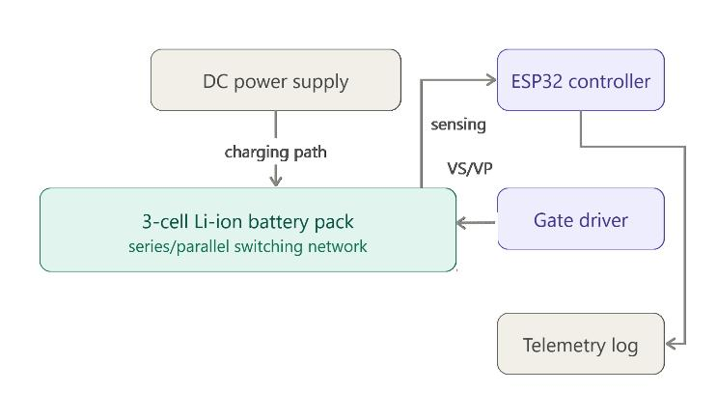
- System architecture

Switching Circuit Topology :
The core reconfiguration mechanism is a MOSFET switching network comprising N-channel (IRF530) and P-channel (IRF9640) MOSFETs arranged to route the three battery cells into either a series chain or a parallel bank under software control. The combination of N-channel and P-channel MOSFETs enables both low-side and high-side switching, providing an effective means of implementing dynamic battery reconfiguration. Prior to hardware implementation, the proposed switching topology was designed and functionally verified in LTspice. During simulation, each battery cell was represented by an independent 4.2 V voltage source, with a 10 Ω resistor connected in parallel to model the passive cell-balancing network incorporated into the prototype.
Two logic control signals, denoted VS and VP, determine the operating configuration. When VS is asserted while VP is de-asserted, the switching network establishes the series configuration. Conversely, asserting VP while de-asserting VS reconfigures the battery pack into the parallel configuration. In the hardware implementation, these control signals originate from the ESP32 GPIO pins and are routed through a dedicated gate-driver stage, which translates the ESP32's 3.3 V logic levels into the gate-voltage levels required for reliable operation of the IRF530 and IRF9640 MOSFETs. Consequently, the ESP32 provides only the control logic, while the gate-driver circuitry interfaces directly with the power-switching stage. During a mode transition, the gate-driver activates only the MOSFETs associated with the selected configuration while disabling the alternate switching path, ensuring that only one battery topology is active at any given time.
Table I summarizes the principal components of the switching network and their respective functions within the proposed topology.
- KEY SWITCHING-NETWORK COMPONENTS
Component | Function
IRF530(N-MOSFET) | Series/parallel reconfiguration switches for the 3-cell array
IRF9640 (P-MOSFET) | High-side reconfiguration switches
IRF530(N-MOSFET) | Charge-input path switch
10 Ω resistor | Per-cell bleed/balancing resistors
Logic control signals | Select series (VS) or parallel (VP) topology

Operating Modes:
The proposed battery pack operates in two electrically distinct configurations depending on the selected switching state.
In series mode, the three cells are connected end-to-end, producing an output voltage approximately three times that of an individual cell (approximately 9-12.6 V for Li-ion cells) while maintaining the current capability of a single cell. This configuration is therefore suitable for applications requiring higher operating voltage.
In parallel mode, the cells share common positive and negative terminals, maintaining the voltage of a single cell (approximately 3-4.2 V) while increasing the available current capacity. This configuration is advantageous for applications requiring higher current delivery at lower voltage.
These two operating modes represent complementary voltage-current characteristics. Consequently, comparing their performance under identical hardware conditions provides insight into the influence of battery topology on charging efficiency, current distribution, and conduction losses within the switching network, MOSFETs, and associated interconnections.

ESP32 Control and Monitoring:
The ESP32 firmware coordinates both the control and monitoring functions of the proposed battery management system. Its primary responsibilities include: (1) generating the appropriate gate-driver control signals to establish either the series or parallel configuration, (2) acquiring per-cell voltage measurements (C1-C3) together with pack and battery current measurements (I and I_bat), (3) computing the corresponding SOC and per-cell SOH values from the acquired measurements, and (4) transmitting a timestamped telemetry log for offline analysis.
The recorded telemetry includes the active battery configuration (SERIES or PARALLEL), input and battery voltages (V_in and V_bat), individual cell voltages, pack and battery currents, SOC, per-cell SOH, cycle count, DAC output, per-channel bleed current, and charging or load status indicators. These measurements constitute the experimental dataset used for the efficiency comparison and performance evaluation presented in Section V.
The overall firmware operation follows a repetitive monitoring-and-control sequence in which battery parameters are acquired, processed, logged, and used to supervise the operating configuration throughout the experiment.

Design Rationale :
From an experimental perspective, this approach enables both operating configurations to be evaluated under matched hardware and testing conditions using the same battery pack. Consequently, differences in measured performance can be attributed primarily to the selected electrical configuration rather than variations between separate hardware implementations. This methodology addresses a limitation identified in several existing reconfigurable battery studies, where comparative evaluation is frequently performed through simulation or across different hardware platforms rather than repeated measurements on the same prototype. The resulting architecture therefore serves not only as a practical battery management platform but also as an experimental framework for evaluating the impact of battery topology on charging efficiency under identical operating conditions.

Experimental Setup
The proposed reconfigurable BMS was evaluated using the physical 3-cell Li-ion prototype described in Section III. All experiments were performed using the ESP32 firmware's integrated mode-selection and telemetry-logging functions. To evaluate the repeatability of the proposed system, two independent charge–discharge test rounds (Test Pair 1 and Test Pair 2) were conducted under identical operating conditions. Repeating the full procedure provides a more reliable hardware evaluation than studies that rely solely on simulation or a single prototype demonstration [6], [9].
Fig. 2 shows the hardware implementation of the proposed ESP32-based reconfigurable battery management system used during the experimental evaluation. The prototype consists of the ESP32 controller, MOSFET switching network, gate-driver circuitry, current-sensing module, buck converter, and a three-cell Li-ion battery holder.
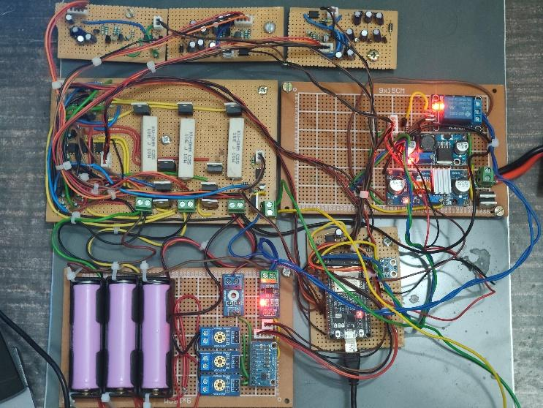
- Hardware implementation of the proposed ESP32-based reconfigurable battery management system.

Procedure:
Each test round began by configuring the battery pack into the required topology (Series or Parallel) through the ESP32 control interface. The selected configuration then underwent one complete charging cycle followed by one complete discharge cycle under a fixed load. The same charger, load, and operating conditions were maintained for both configurations within each round to ensure a fair comparison. After evaluating both topologies, the complete procedure was repeated under identical conditions to verify the consistency of the results.

Instrumentation :
Three independent measurement systems were used throughout the experiments: A DC charger energy meter recorded the energy (Wh) delivered from the laboratory power supply to the charging circuit.
An AC wall energy meter measured the total energy (Wh) drawn from the mains supply, thereby accounting for the battery charging energy as well as the losses introduced by the AC-DC power supply and onboard voltage-regulation circuitry.
The ESP32 telemetry system continuously logged pack current, individual cell voltages, SOC, SOH, and timestamps using the telemetry framework described in Section III-D. Current measurements were obtained using median-filtered ADC sampling followed by an exponential moving-average filter, a combination commonly used to improve measurement stability in low-cost microcontroller-based battery monitoring systems [1].
Small variations in delivered discharge energy were observed between configurations and across repeated experiments. To enable a fair comparison, the measured input energy was normalized to a common discharge energy before calculating efficiency, ensuring that reported efficiencies reflect differences in system performance rather than variations in delivered capacity.

Experimental Result and Analysis

Test Pair 1 :
Table II summarizes the measured charging energy, discharge energy, normalized input energy, and calculated efficiencies for Test Pair 1.

- TEST PAIR 1 — SERIES VS. PARALLEL
Metric | Series | Parallel | Better configuration
Charge time | 02:18:53 | 02:24:53 | Series faster
Discharge time | 01:04:43 | 0107:26 | Series faster
DC-side Wh (normalized to 6.425 Wh) | 11.852 | 12.700 | Series saves 6.68%
DC-side efficiency | 52.21% | 50.59% | Series (+7.16% rel.)
AC-side Wh (normalized) | 35.760 | 41.000 | Series saves 12.78%
AC-side efficiency | 17.97% | 15.67% | Series (+14.65% rel.)

Test Pair 2 :
Table III presents the corresponding results for the second test round, following the same measurement and normalization procedure.
- TEST PAIR 2 — SERIES VS. PARALLEL
Metric | Series | Parallel | Better configuration
Charge time | 02:10:02 | 02:28:54 | Series faster
Discharge time | 01:03:25 | 01:06:20 | Series faster
DC-side Wh (normalized to 6.444 Wh) | 11.200 | 13.220 | Series saves 15.28%
DC-side efficiency | 57.54% | 48.75% | Series (+18.03% rel.)
AC-side Wh (normalized) | 35.000 | 41.967 | Series saves 16.60%
AC-side efficiency | 18.41% | 15.36% | Series (+19.91% rel.)

The second round produced results consistent with Test Pair 1. Although Series delivered approximately 4.92% higher discharge energy than Parallel, it again demonstrated superior energy efficiency after normalization: Series required 15.28% less DC-side input energy and 16.60% less AC-side input energy than Parallel, reinforcing the trend observed in the first round.

Discussion :
The results from both independent test rounds consistently show that Series required less input energy to deliver an equivalent amount of usable discharge energy. Compared with Parallel, Series operation reduced normalized DC-side energy consumption by 6.7–15.3% and AC-side energy consumption by 12.8–16.6%. These observations are consistent with the expected electrical characteristics of a reconfigurable battery pack: for the same load power, Parallel draws a higher current from each cell than Series, and since conduction losses in the cells, interconnections, and switching devices increase with the square of current (I²R), higher losses are expected during Parallel operation [1].
The efficiency improvement observed at the AC wall meter was consistently greater than that measured at the DC charging side. One possible explanation is that the AC-side measurement also includes the efficiency of the AC-DC power supply and voltage-regulation stages, whose losses vary with operating conditions and therefore amplify the difference measured at the wall outlet.
Although the measured round-trip efficiency at the AC wall was relatively low (approximately 15–18%), the corresponding DC-side efficiency was considerably higher (49–58%). Because the DC-side measurement excludes much of the upstream power-conversion hardware, this gap suggests that the primary source of energy loss in the present prototype is the AC-DC power supply and voltage-regulation stage rather than the MOSFET-based reconfiguration network itself. This observation provides useful guidance for future hardware optimization and offers a more complete assessment of system efficiency than many previous reconfigurable battery studies, which typically report converter-side or battery-side efficiency alone [5], [7], [8].
The present evaluation was performed using a three-cell laboratory prototype under a fixed load condition. While the results clearly demonstrate the effectiveness of the proposed switching architecture, additional testing under varying load profiles, larger battery packs, and long-term cycling conditions would further establish its practical applicability.

Conclusion
This paper presented the design, implementation, and experimental evaluation of a low-cost ESP32-based reconfigurable Battery Management System capable of electronically switching a three-cell Li-ion battery pack between Series and Parallel configurations using IRF530 N-channel and IRF9640 P-channel MOSFETs. Unlike many existing reconfigurable battery systems that are evaluated primarily through simulation or focus on larger modular architectures requiring dedicated converter hardware [5], [6], [8], the proposed prototype was validated through two independent hardware charge–discharge test rounds, with efficiency measured simultaneously at both the DC charger input and the AC wall input.
Across both rounds, Series consistently demonstrated superior energy efficiency: after normalization to a common discharge energy, it required 6.7–15.3% less DC-side input energy and 12.8–16.6% less AC-side input energy than Parallel. The results further indicate that the largest energy losses originate from the AC-DC power supply and voltage-regulation stages rather than from the Series-Parallel switching network itself. These results give a clear direction for future hardware optimization and show that a low-cost embedded reconfigurable BMS can improve energy utilization without requiring complex converter-based architectures.

Acknowledgment
Generative artificial intelligence tools were used during the preparation of this manuscript for language refinement, grammar correction, and improvement of clarity. The authors remain responsible for the technical content, experimental results, analysis, and conclusions presented in this paper.

References
- N. Allafi and T. Iqbal, “Low-cost ESP32-based monitoring platform for photovoltaic battery systems with wireless telemetry.”
- S. Hashim et al., “Single Switched Capacitor cell-balancing technique with an auxiliary battery and unidirectional DC-DC converter.”
- Y.-C. Hsu, C.-Y. Lin, and T.-H. Wu, “Battery management architecture with individual buck-boost converters and shared capacitor for series/parallel balancing.”
- H. Kim et al., “Chain-structured switched-capacitor balancing topology for improved charge transfer between electrically distant cells.”
- Y. Chen, W. Qiao, and L. Qu, “Modular reconfigurable battery system based on cascaded battery modules and an H-bridge converter.”
- S. Steinhorst et al., “Classification of distributed reconfigurable battery-management architectures by control strategy and electrical topology.”
- S.-W. Lee, T.-W. Noh, and B.-H. Ha, “Switch-only reconfigurable power circuits with simultaneous active cell balancing.”
- Y. Wang, J. Pou, and V. G. Agelidis, “Reconfigurable battery energy storage system for utility-scale applications using contactor-based switching panels.”
- H. Kim, W. Qiao, and L. Qu, “Series-connected self-reconfigurable multicell battery.”
- C. Lin, Y. Wang, and D. Ho, “Dynamic-impedance-based SOC/SOH estimation exploiting voltage-current variations.”
- N. Azis, E. Joelianto, and A. Widyotriatmo, “Dual Extended Kalman Filter for simultaneous SOC, internal resistance, and capacity estimation.”
- Z. Chen et al., “Random Forest model for SOH estimation from partial charging data.”
- S. Locorotondo et al., “Improved Ampere-Count method incorporating Incremental Capacity Analysis for SOH estimation.”
- D. N. T. How, M. A. Hannan, M. S. H. Lipu, and P. J. Ker, “State-of-charge estimation techniques: A comprehensive review.”

