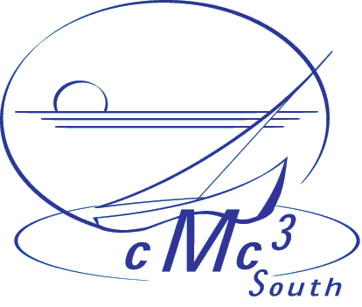
January 24, 2004

To: Bruce Yoshiwara, Pierce College

Dear Bruce,
Please accept my thanks for volunteering to speak at the CMC3 South 19th annual conference: “Beyond Eighteen and Feeling Prime”. The conference will be held at the Doubletree Hotel Anaheim/Orange County. It opens on Friday, March 5, with a preconference workshop day 9:00 – 4:45 pm and a wine and cheese reception at 6:00 pm. If you want information about the workshop day, send me a note. Dr. Lawrence Lesser, from Emery/Weiner High School in Houston, will deliver a talk at this event, titled “Math Song Sing-Along with Larry Lesser (a Choral-Larry.)” On Saturday, March 6th, there will be a continental breakfast, two morning sessions, lunch with our keynote speaker, Dr. Eli Maor, from Loyola University Chicago, two afternoon sessions and a closing reception. Dr. Maor’s talk is “Venus in Transit: Two Chances in our Life to Witness Astronomical History”. Your talk, “Excel for Math Teachers” is scheduled for a Saturday session, 9:00 – 10:30 am. If there are any changes, I will contact you later. CMC-South offers our Saturday session speakers conference registration and meals on Saturday. We ask that you provide your own computer projection device, if you need one for your presentation. Each breakout room is equipped only with a regular overhead projector.
Would you please fill out the registration form that I am attaching and email it to Mark Greenhalgh, mgreenhalgh@fullcoll.edu. This will ensure that you get a conference packet. I am also attaching the hotel information, for you to make arrangements for your stay.
The CMC3-South Board is delighted that you have agreed to share your expertise with our members.
I look forward to seeing you and having an opportunity to talk at the conference. Please contact me if you have any questions.

Sincerely,

Ignacio Alarcon
Santa Barbara City College
721 Cliff Dr
Santa Barbara, CA 93109 Phone: (805) 965 – 0581 ext 2559 Email: alarcon@sbcc.edu

Speaker Registration Form:

Last: Yoshiwara First: Bruce M.I. W

College/Affiliation: Los Angeles Pierce College

Mailing Address Street: 6201 Winnetka Avenue

City: Woodland Hills State: CA Zip: 91372

Phone Work: (818)710-4160 Home: (805)480-9705

Would you like CMC³-South to release your mailing address to the book publishers? Many of the publishers would like to send you notice in advance about new products to be exhibited or demonstrated at the conference.

NO

Saturday Conference:

Lunch Included: Vegetarian: Non-Vegetarian: X

Return Registration to: Mark Greenhalgh mgreenhalgh@fullcoll.edu
Fullerton College
321 E. Chapman Ave.
Fullerton, CA 92832

