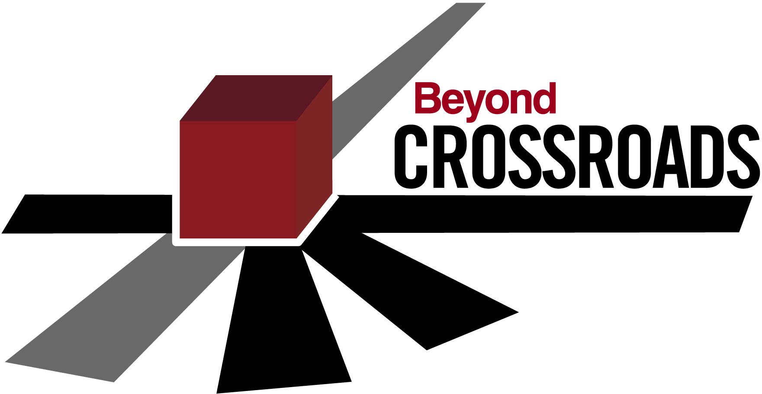

Beyond Crossroads Summer Workshops
July 10–11, 2008 in San Diego, CA
June 6–7, 2008 in Colorado Springs, CO

The BC Way: Embracing Change for Continuous Improvement
Want help to make the changes you need to improve mathematics teaching and learning in your classroom and in your department? Consider attending one of the two Beyond Crossroads Summer Workshops!
- June 6–7 workshop on the Centennial Campus of Pikes Peak CC in Colorado Springs ($150 for AMATYC members and $225 for non-members, including lunches for both days)
- July 10–11 workshop at the Town and Country Resort and Convention Center in Mission Valley ($130 for AMATYC members and $205 for non-members).
- More details in the flyer in your goodie bag, or go to www.amatyc.org

