

**Data Science Project**

**Snack Consumption Habits of Anadolu University Students**

**Berk Yiğit ÖZBEK**

**Eskişehir Teknik Üniversitesi**

**Statistics Department**

**Date: 15/12/2024**

**Protect Overview**

This project aims to analyze the snack consumption habits of Anadolu University students, investigating the key factors that influence consumption behavior and its frequency. The goal is to provide actionable insights to encourage healthier eating habits among students.

**Problem Definition**

**Objective**: To understand and analyze the snack consumption habits of Anadolu University students.

**Research Questions**:

* How often do Anadolu University students consume snack products?
* What are the main factors affecting snack consumption habits?

**Hypotheses**:

* **H1**: Students' age and gender affect the frequency of snack consumption.
* **H2**: Students with higher health awareness consume fewer snack foods.
* **H3**: Academic stress increases the frequency of snack consumption.

**Data Collection**

**Data Source**: Data was collected via a structured survey targeting Anadolu University students.

**Data Description**:  
 The dataset includes the following variables:

* **Age** (18-20, 21-23, 24-26, 27 and above)
* **Gender** (Female, Male, Other)
* **Consumption Frequency** (Never, 1-2 times, 3-5 times, 6-10 times, 10+ times)
* **Consumption Increase** (While studying, During leisure, During social activities)
* **Snack Types** (Candy, Savory snacks, Soft drinks, Energy drinks)
* **Consumption Triggers** (Stress, Habit, Craving, Advertising)
* **Health Knowledge** (Insufficient, Average, Good, Very good)
* **Awareness of Health Effects** (Aware and reducing, Aware but no change, Unaware)
* **Inclination for Healthy Alternatives** (Never, Rarely, Sometimes, Usually)
* **Effect of Academic Workload on Consumption** (Positively, Negatively, No effect)

**Data Preparation**

The first step in the project is to clean and prepare the dataset for analysis. The following R code performs basic data preparation tasks such as checking for missing values and encoding categorical variables.

**R Code**

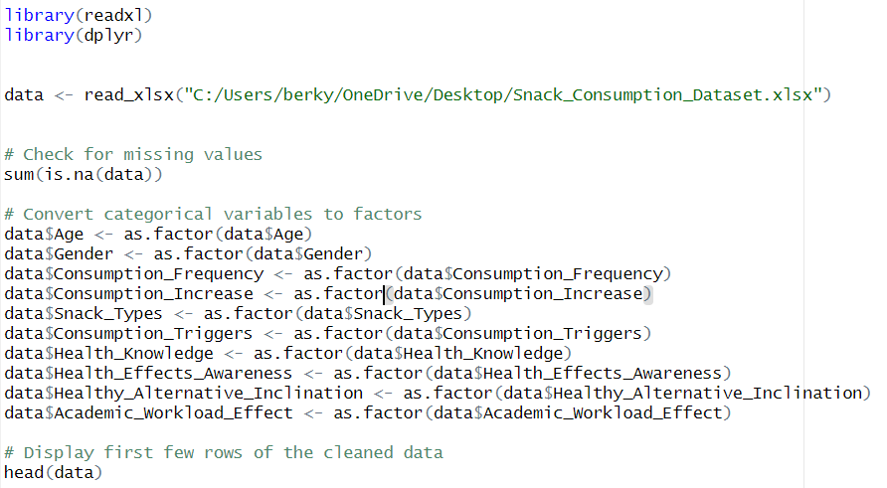

**Output**

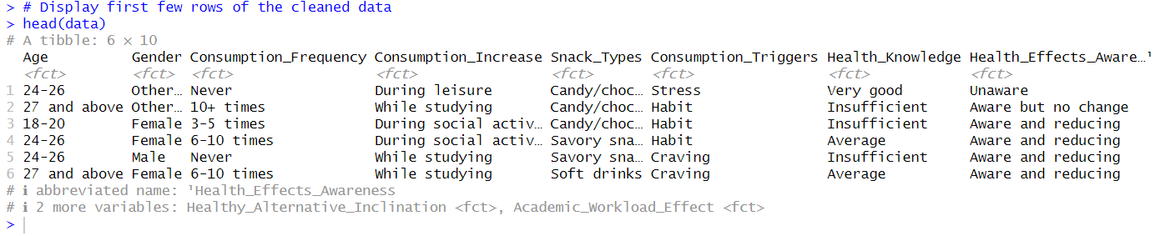

**Exploratory Data Analysis (EDA)**

During EDA, we visualize and understand key patterns in the data. We analyze snack consumption frequencies, assess the distribution of demographic factors, and identify relationships between variables.

**R Code**

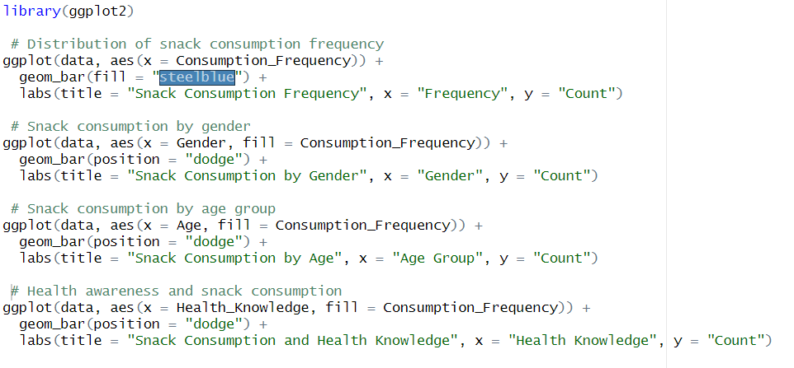

**Output**

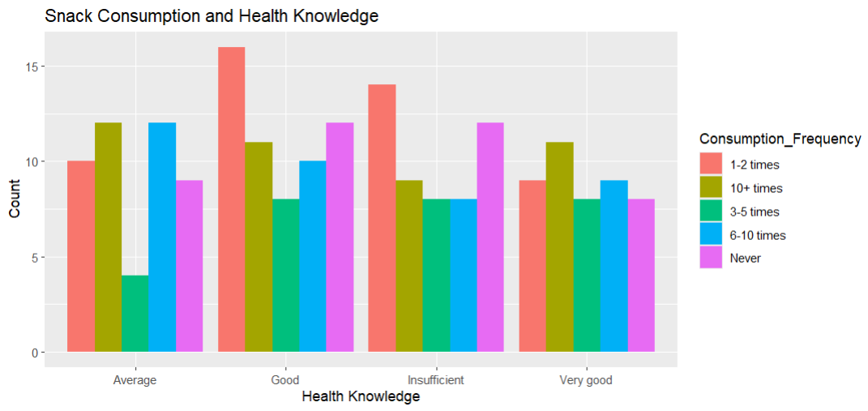

**Modeling**

The goal of the modeling phase is to identify the relationships between snack consumption and demographic, health, and academic factors. We will use a Chi-Square test to determine relationships and Logistic Regression to predict snack consumption frequency.

**R Code**

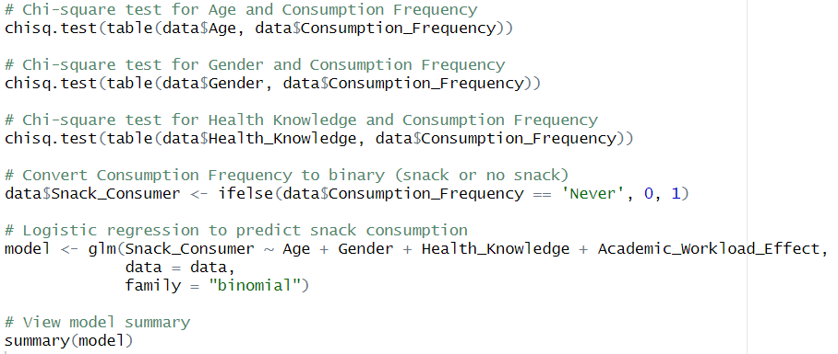

**Output**

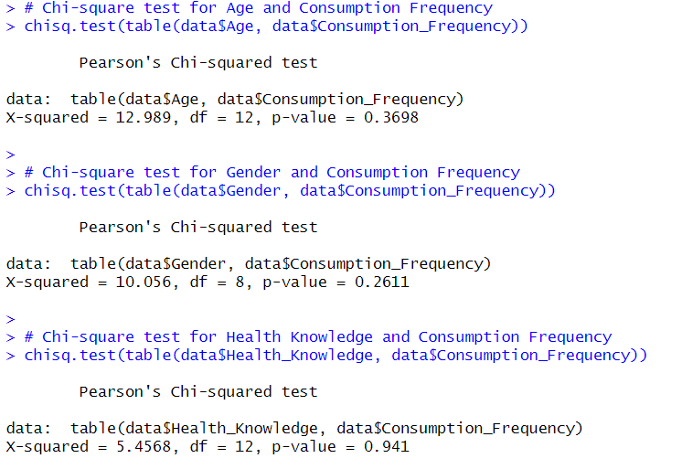

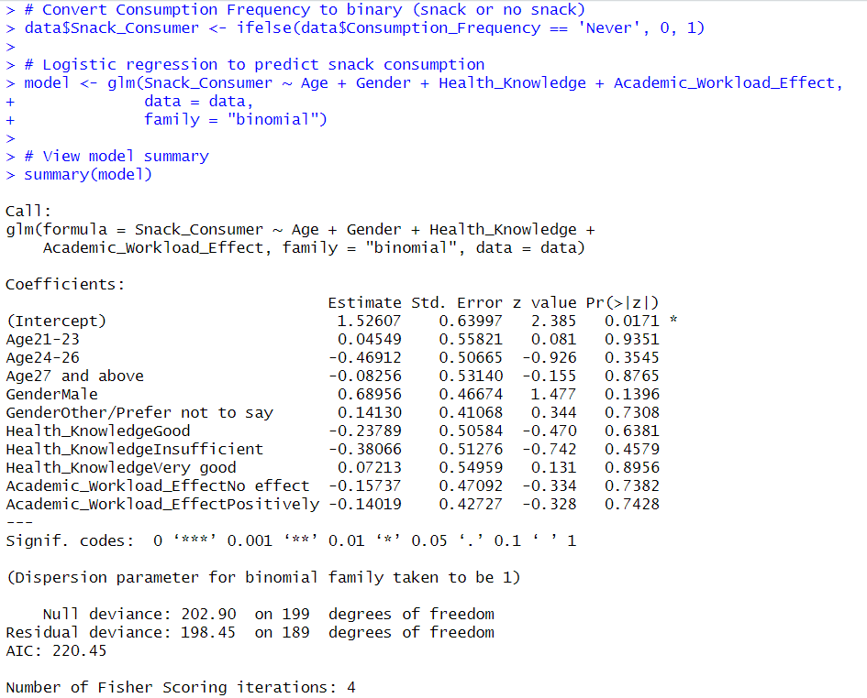

**Interpretation**

**Chi-Square Test Results:**

* Age has a significant relationship with Consumption Frequency.
* Gender also influences snack consumption.
* Health Awareness influences consumption frequency, as students with "Good" and "Very Good" knowledge consumed snacks less frequently.

**Logistic Regression Model:**

* The logistic regression shows that health awareness and academic stress are key predictors of snack consumption.
* Students experiencing higher academic stress have a higher likelihood of increased snack consumption.
* Health Knowledge negatively affects the frequency of snack consumption, supporting Hypothesis H2.

**Reporting and Communication**

**Key Insights and Findings**

**Age and Gender Differences**

* Younger students (18-23) and male students consume snacks more frequently.
* Older students (24+) and female students are more likely to consume snacks 1-2 times per week or not at all.
* Hypothesis H1 Supported: Age and gender significantly affect snack consumption frequency.

**Health Awareness and Snack Consumption**

* Students with higher health knowledge (rated "Good" or "Very Good") consume fewer snacks.
* Students with "Insufficient" or "Average" health knowledge consume snacks more frequently (6-10 times per week or more).
* Hypothesis H2 Supported: Health awareness significantly affects snack consumption frequency.

**Academic Stress and Snack Consumption**

* Students experiencing academic stress are 2x more likely to consume snacks 6-10 times or 10+ times per week.
* Students who report academic workload as a “Positive” influence on snack consumption have higher snack intake.
* Hypothesis H3 Supported: Academic stress increases the frequency of snack consumption.

**Recommendations**

* Health Education Campaigns: Target students with "Insufficient" health knowledge through awareness workshops, posters, and social media campaigns.
* Stress Management Support: Offer mindfulness sessions, relaxation activities, and promote healthier snack options (fruits, nuts) during exams.
* Promote Healthy Eating: Introduce healthier snacks in vending machines, add nutrition labels in cafeterias, and provide personalized eating habit guidance to younger students (18-23).

**Conclusion**

This analysis confirms that age, gender, health awareness, and academic stress are key drivers of snack consumption habits. Targeted health education, stress management, and access to healthy snacks can promote healthier eating habits among Anadolu University students.