ZipRyde User Technical document

Overview:

The ZipRyde is used to book a taxi for now and later. The user can book one ride at a time. The user can cancel the ride before the ride starts. Even they can raise their lost item when ride completed.

The user is allowed to Name their price from the listed prices for the selected locations.

1. Splash screen
   1. Displays the application screen for a while.
2. Login Screen:

It’s a landing screen if the user has not logged yet. It asks the mobile number and password.

Buttons to redirect :

Forget Password screen.

Register screen.

API :

/VerifyLoginUser

This service validate the user .

If the “overrideSessionToken = 0”.

Response code

i) 200

Check for the access-token. Its an session token used for all the other services with the server. And move to the next screen.

1. Check the response parameter (bookingId), if its greater than 0 then move to Booking Tracking page where the ride booking will be tracked.
2. If the value is 0 then move to home page where we have to show the map with user current location along with near by drivers.

ii) 409

Display the messge which is received from the server with “Yes” and “Cancel”.

1. If user press Yes then send the verifyLoginUser with “overrideSessionToken = 1”
2. If NO, then stay on the same screen

Please refer the Android mobile for the design.

1. Registration flow
   1. OTP screen
      1. Input box to get the user’s mobile number
      2. API – getOTPByMobile
   2. Verify OT Screen
      1. Input box to enter the Pin code
      2. API – verifyOTPByMobile
   3. Registration screen
      1. Please follow the android design
      2. API – saveUser
2. Home Screen

The home screen will be with google map with the user’s current location zoomed-in.

It should have navigation menu with the following items,

1. Edit Profile
2. Book ZipRydes
3. Your ZipRydes
4. Payment Setup
5. Logout

Api: getNearByActiveDrivers

This service has to be called even the user moves a place in a map.

Naviagtion : Please provide two buttons .

On Top – Where to?

On Bottom – Select Pickup Location

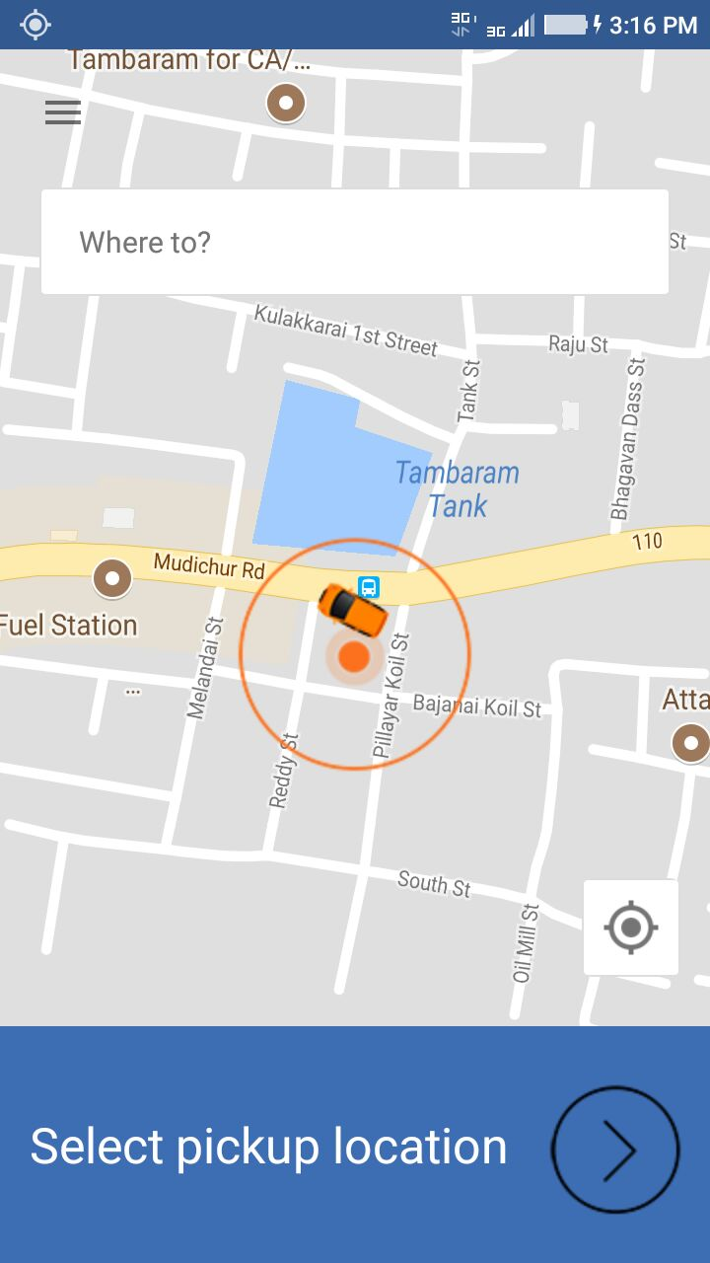

On taping of any of these two buttons should got to google search view with From and To location selection.

# From-To Selection

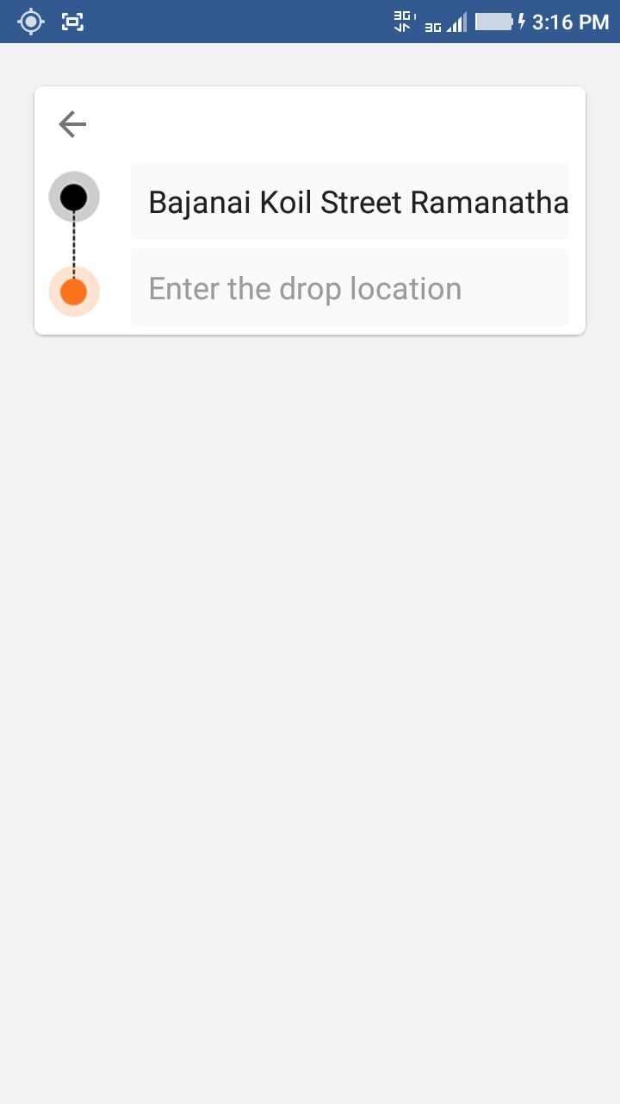

Once user selected both locations. Then we have to go the next screen that is the Cab selection view.

# Cab Selection Screen

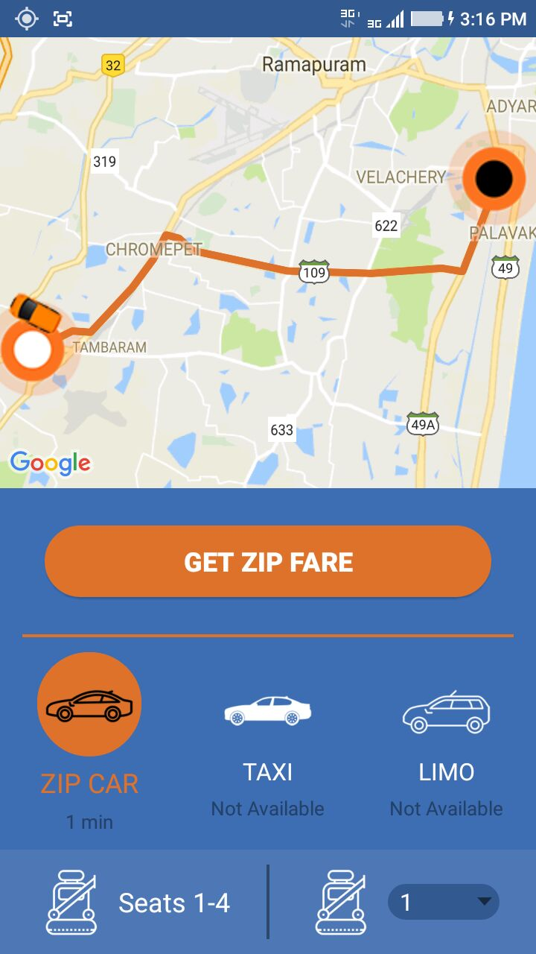

APIs: Google Direction API

<Key will be shared in the mail >

ZIPRyde server API:

1. To get CabType -- getAllCabTypes
2. Then call the Active Drivers API
   1. getNearByActiveDrivers

Then match with received cab types. You have to call the google’s direction API to get the reaching time for the first entry of the each cab type in the list.

1. On tapping of the “Get Zip Fare” call the below service
   1. getAllNYOPByCabTypeDistAndNoOfPassenger
2. Based on the success code moved to the next screen

# Price screen:

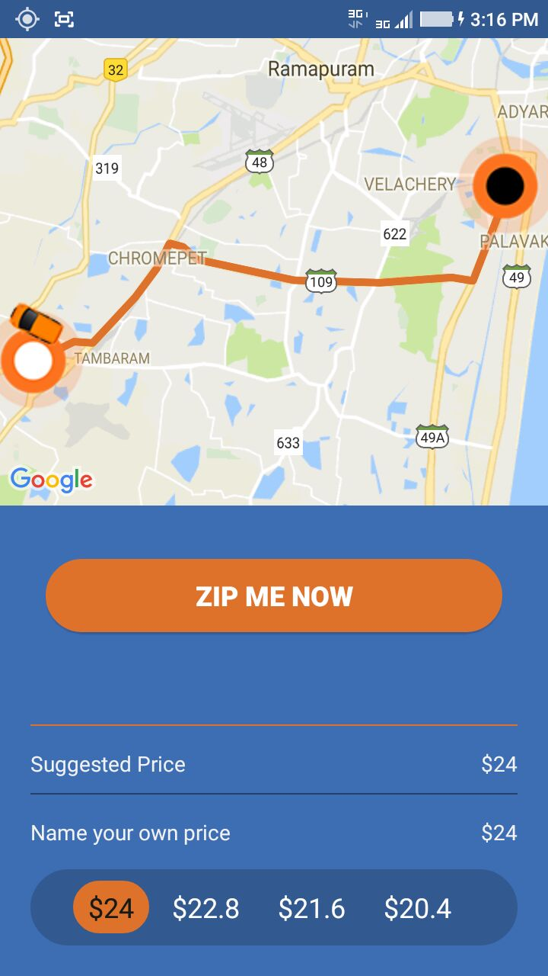

User can select any price available in the list. The price list should be scrollable if its more than 4.

On tapping of the “Zip Me Now” . Please call the below API.

API Call 🡪requestBooking

And wait for 30secs, if there is no push message from the server then please call this API on timer expired,

API Call 🡪 getBookingByBookingId

*Response code:*

200 – then move to the driver tracking page.

Other error code – Display “Error message” then move to home screen.

**Driver Acceptance Waiting Screen**

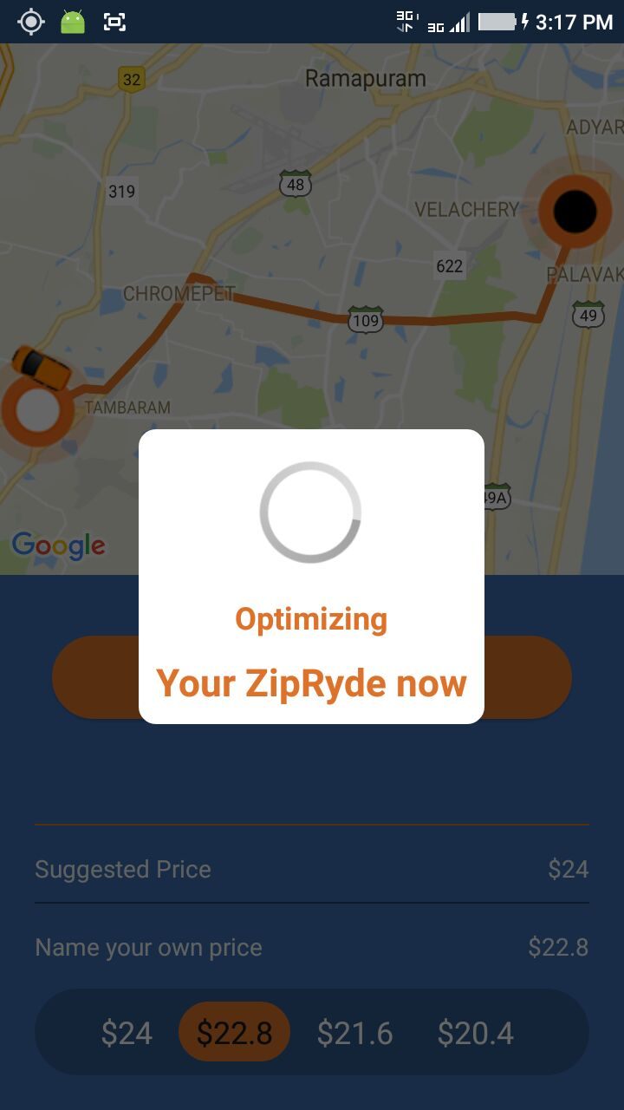

In this class, you have to listen for the push notification. Push notification codes are in the API XL doc. Please refer.

Driver Track Page:

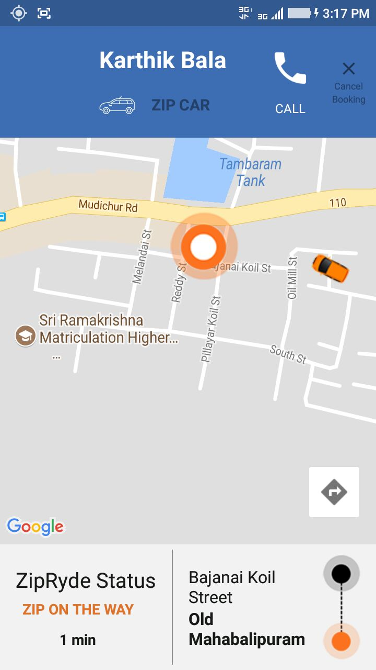

Here after listen the Push notification and call every time the below API and animate the car

API Call 🡪getGeoLocationByDriverId

Button actions:

1. Route map icon – On clicking of the icon display the route Driver to your location till the status ZIP On THE WAY.
2. Call Button – Call the driver using device’s phone
3. Cancel booking – Call this service 🡪updateBookingStatus

# Your Rides Screen:

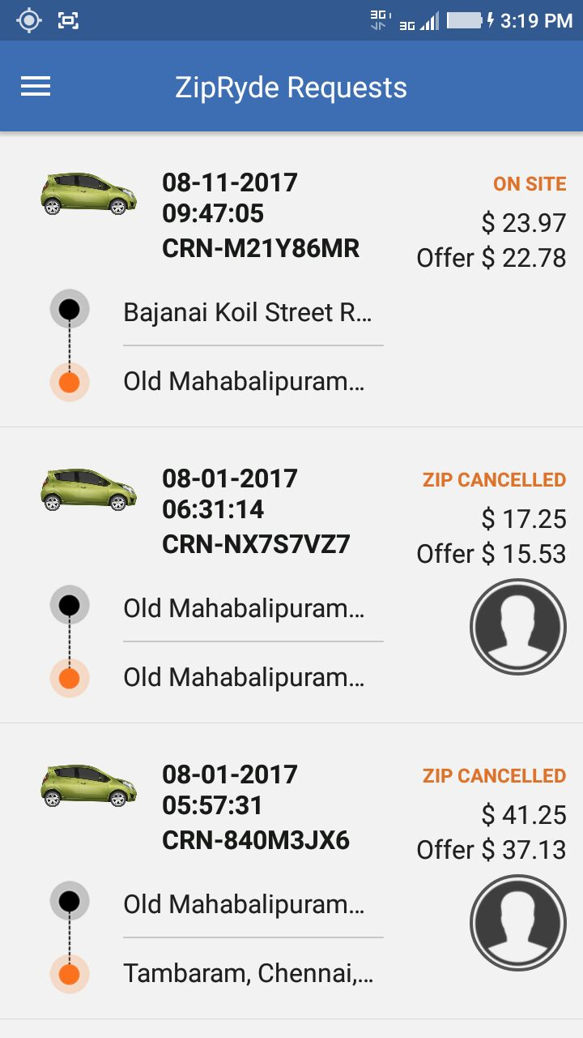

API Call 🡪 getBookingByuserId

On tapping of each item should be given the detail view with map.

API Call 🡪getBookingByBookingId