Code breakdown:

1. Import Statements:

- Imported necessary modules like `json` and `datetime`.

2. Class Definitions:

- Defined the following classes:

- `Book`: Represents a book with attributes such as title, author, ISBN, quantity, etc.

- `Patron`: Represents a library patron with attributes like name, ID, contact information, etc.

- `Transaction`: Handles book checkouts and returns, storing the book, patron, and due date.

- `Library`: Manages the overall library system, including books, patrons, and transactions.

3. Initialization:

- Created instances of the Library, Book, Patron, and Transaction classes to initialize the Library Management System.

4. Book Class:

- Defined the `Book` class with attributes and methods:

- Attributes: `title`, `author`, `isbn`, `quantity`.

- Methods: `display_details`, `update_quantity`, `to_dict`.

5. Patron Class:

- Defined the `Patron` class with attributes and methods:

- Attributes: `name`, `id`, `contact_info`, `borrowed_books`.

- Methods: `display_details`, `borrow_book`, `return_book`, `to_dict`.

6. Transaction Class:

- Defined the `Transaction` class with attributes and methods:

- Attributes: `book`, `patron`, `due_date`.

- Methods: `checkout_book`, `return_book`, `calculate_fine`, `to_dict`.

7. Library Class:

- Defined the `Library` class to manage the library system:

- Attributes: `books`, `patrons`, `transactions`.

- Methods: `search_books`, `add_book`, `remove_book`, `add_patron`, `remove_patron`, `handle_transaction`, `generate_reports`, `save_data`, `load_data`.

8. Main Program Flow:

- Performs operations such as adding books and patrons, handling transactions, generating reports, etc., within the main program flow.

9. Data Persistence:

- Implemented methods for saving and loading data to/from a file using JSON serialization/deserialization.

10. User Interface ( FUTURE PLAN ):

- Develop a simple user interface (CLI or GUI) to interact with the Library Management System.

- Allow users to perform operations like adding/removing books, managing patrons, handling transactions, etc.

Here’s a diagram (flowchart) to represent the algorithm and sequence of the code.

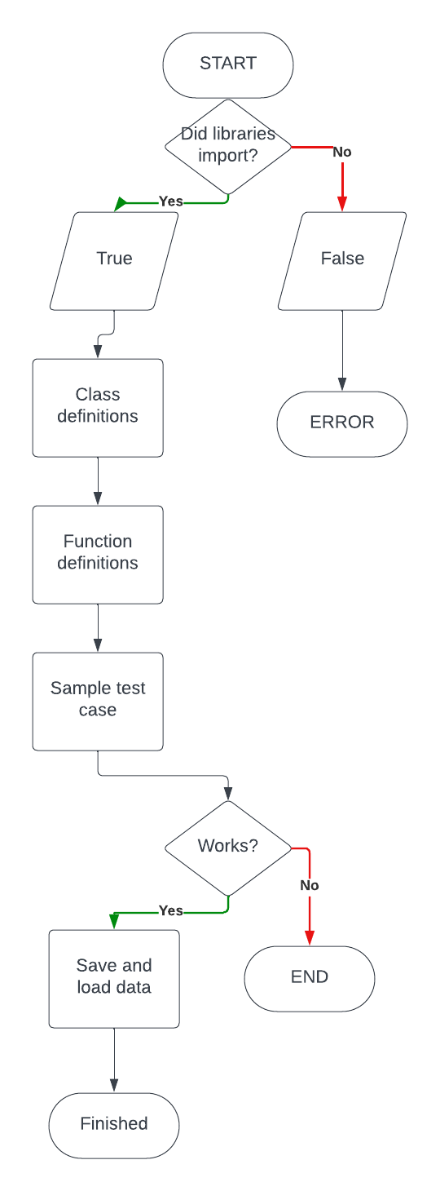

Instructions:

Certainly! Here are instructions on how to use the full functionalities provided by the Library Management System code:

1. Adding Books:

- To add a new book to the library, create a `Book` object with the title, author, ISBN, and quantity.

- Use the `add_book` method of the `Library` class to add the book to the library.

Example:

```python

library = Library()

book = Book("Title", "Author", "ISBN", 5)

library.add_book(book)

```

2. Adding Patrons:

- To add a new patron to the library, create a `Patron` object with the name, ID, and contact information.

- Use the `add_patron` method of the `Library` class to add the patron to the library.

Example:

```python

library = Library()

patron = Patron("Name", "ID", "Contact Info")

library.add_patron(patron)

```

3. Handling Transactions (Checking Out/Returning Books):

- To check out a book to a patron, create a `Transaction` object with the book and patron.

- Use the `handle_transaction` method of the `Library` class to handle the transaction.

Example (Check Out):

```python

library = Library()

book = library.search_books("Title")[0] # Assuming you found the desired book

patron = library.patrons[0] # Assuming you selected a patron

transaction = Transaction(book, patron)

library.handle_transaction(transaction)

```

Example (Return):

```python

library = Library()

book = library.search_books("Title")[0] # Assuming you found the desired book

patron = library.patrons[0] # Assuming you selected a patron

transaction = Transaction(book, patron)

transaction.return_book()

```

4. Searching for Books:

- Use the `search_books` method of the `Library` class to search for books by title.

Example:

```python

library = Library()

found_books = library.search_books("Title")

for book in found_books:

book.display_details()

```

5. Saving and Loading Data:

- Use the `save_data` method of the `Library` class to save library data to a file.

- Use the `load_data` method of the `Library` class to load library data from a file.

Example (Save Data):

```python

library = Library()

library.save_data("library_data.json")

```

Example (Load Data):

```python

library = Library()

library.load_data("library_data.json")

```

6. Displaying Patron Details:

- Use the `display_details` method of the `Patron` class to display details of a patron.

Example:

```python

patron = library.patrons[0] # Assuming you selected a patron

patron.display_details()

```

7. Displaying Book Details:

- Use the `display_details` method of the `Book` class to display details of a book.

Example:

```python

book = library.books[0] # Assuming you selected a book

book.display_details()

```

8. Generating Reports:

- Implement the `generate_reports` method of the `Library` class to generate reports as needed.

Example:

```python

library = Library()

library.generate_reports()

```

These instructions cover the full functionalities provided by the Library Management System code, allowing you to effectively manage books, patrons, transactions, and more within the library system.

***Sample scenarios demonstrating common operations in the Library Management System:***

Scenario 1: Adding Books

1. Initialize Library:

```python

library = Library()

```

2.Add Books

```python

book1 = Book("The Great Gatsby", "F. Scott Fitzgerald", "9780743273565", 3)

book2 = Book("To Kill a Mockingbird", "Harper Lee", "9780061120084", 5)

library.add_book(book1)

library.add_book(book2)

```

Scenario 2: Checking Out Books

1. **Search for Book:**

```python

book = library.search_books("To Kill a Mockingbird")[0]

```

2. Select Patron:

```python

patron = library.patrons[0] # Assuming the first patron

```

3. Check Out Book:

```python

transaction = Transaction(book, patron)

library.handle_transaction(transaction)

```

Scenario 3: Returning Books

1. Search for Book:

```python

book = library.search_books("To Kill a Mockingbird")[0]

```

2. Select Patron:

```python

patron = library.patrons[0] # Assuming the first patron

```

3. Return Book:

```python

transaction = Transaction(book, patron)

transaction.return_book()

```

Scenario 4: Generating Reports

1. Generate Reports:

```python

library.generate_reports()

```

Scenario 5: Saving and Loading Data

1. Save Data:

```python

library.save_data("library_data.json")

```

2. Load Data:

```python

library.load_data("library_data.json")

```

Reflecting on the project,

I found several key insights and encountered some challenges during implementation:

Findings:

1. Structured Design: Breaking down the system into separate classes for books, patrons, transactions, and the library itself allowed for a structured and modular design, making the codebase more organized and easier to maintain.

2. Data Persistence: Implementing data persistence using JSON serialization/deserialization enabled the system to save and load data from a file, providing a convenient way to store library information persistently.

3. User Interface: While not implemented in the provided code, developing a user interface, either command-line or graphical, would enhance user interaction and usability, making it more intuitive for librarians to manage the library.

4. Functionalities: The implemented functionalities covered most basic operations expected in a library management system, including adding books, managing patrons, handling transactions, and generating reports.

Challenges Faced:

1. Error Handling: Implementing robust error handling mechanisms to handle edge cases, invalid inputs, and unexpected behavior required careful consideration and thorough testing to ensure the system's stability and reliability.

2. Data Management: Managing relationships between books, patrons, and transactions, especially when implementing checkout and return functionalities, posed some challenges in maintaining data integrity and consistency.

3. Complexity: As the project grows in scale and complexity, maintaining clean and understandable code becomes more challenging. Ensuring clear documentation and adhering to best practices in coding standards helped mitigate this challenge.

Limitations and Areas for Improvement:

1. User Interface Enhancement: Implementing a more user-friendly interface, such as a graphical user interface (GUI) or web application, would improve usability and accessibility for librarians.

2. Advanced Features: While the provided code covers basic functionalities, implementing advanced features like role-based access control, fine management, and analytics could enhance the system's capabilities and usefulness.

3. Scalability: As the size of the library and the volume of transactions grow, optimizing the system for scalability becomes important to ensure efficient performance and responsiveness.

4. Testing: While the code includes basic testing scenarios, implementing comprehensive unit tests and integration tests would enhance code reliability and help catch bugs early in the development process.

Overall, while the project provides a solid foundation for a Library Management System, there are opportunities for improvement in terms of user interface, functionality expansion, scalability, and testing to further enhance the system's effectiveness and robustness.