**SAMPLE PAPER FORMAT FOR TRB PEER REVIEW PAPERS**

**Kimberly Fisher**

Transportation Research Board

500 Fifth Street, NW, Washington, DC 20001

Tel: 202-334-2968 Fax: 202-334-2030; Email: [kfisher@nas.edu](mailto:kfisher@nas.edu)

**Brie Schwartz**

National Research Council

Arnold and Mabel Beckman Center

100 Academy, Irvine, CA 92617

Tel: 949-721-2200 Email: [bschwartz@nas.edu](mailto:bschwartz@nas.edu)

**Jennifer L. Weeks, Corresponding Author**

Transportation Research Board

500 Fifth Street, NW, Washington, DC 20001

Tel: 202-334-2983; Fax: 202-334-2030; Email: [jlweeks@nas.edu](mailto:jlweeks@nas.edu)

Word count: 1,825 words text + 2 tables/figures x 250 words (each) = 2,325 words

Submission Date

**Abstract**

No longer than 250 words, an abstract should be a stand-alone summary of the contents of the paper. The abstract should present the primary objectives and scope of the study, techniques, methods or approaches briefly described and a concise summary of findings and/or conclusions reached.

*Keywords*: Keyword, Keyword, Keyword, Keyword, Keyword, Keyword

**LEVEL 1 Header**

Lorem ipsum dolor sit amet, consectetuer adipiscing elit, sed diam nonummy nibh euismod tincidunt ut laoreet dolore magna aliquam erat volutpat. Ut wisi enim ad minim veniam, quis nostrud exerci tation ullamcorper suscipit lobortis nisl ut aliquip ex ea commodo consequat. Nam liber tempor cum soluta nobis eleifend option congue nihil imperdiet doming id facer possim assum.

**Level 2 Header**

Nam liber tempor cum soluta nobis eleifend option congue nihil imperdiet doming id quod mazim placerat facer possim assum. Typi non habent claritatem insitam; est usus legentis in iis qui facit eorum claritatem (*3*). Investigationes demonstraverunt lectores legere me lius quod ii legunt saepius. Claritas est etiam processus dynamicus, qui sequitur mutationem consuetudium lectorum. Mirum est notare quam littera gothica, quam nunc putamus parum claram, anteposuerit litterarum formas humanitatis per seacula quarta decima et quinta decima. Eodem modo typi, qui nunc nobis videntur parum clari, fiant sollemnes in futurum (*4*).

*Level 3 Header*

Lorem ipsum dolor sit amet, consectetuer adipiscing elit, sed diam nonummy nibh euismod tincidunt ut laoreet dolore magna aliquam erat volutpat. Ut wisi enim ad minim veniam, quis nostrud exerci tation ullamcorper suscipit lobortis nisl ut aliquip ex ea commodo consequat.

**Level 4 Header** Typi non habent claritatem insitam; est usus legentis in iis qui facit eorum claritatem. Investigationes demonstraverunt lectores legere me lius quod ii legunt saepius. Claritas est etiam processus dynamicus, qui sequitur mutationem consuetudium lectorum. Mirum est notare quam littera gothica, quam nunc putamus parum claram, anteposuerit litterarum formas humanitatis per seacula quarta decima et quinta decima.

*Level 5 Header* Lorem ipsum dolor sit amet, consectetuer adipiscing elit, sed diam nonummy nibh euismod tincidunt ut laoreet dolore magna aliquam erat volutpat (*10*). Ut wisi enim ad minim veniam, quis nostrud exerci tation ullamcorper suscipit lobortis nisl ut aliquip ex ea commodo consequat. Duis autem vel eum iriure dolor in hendrerit in vulputate velit esse molestie consequat, vel illum dolore eu feugiat nulla facilisis at vero eros et accumsan et iusto odio dignissim qui blandit praesent luptatum zzril delenit augue duis dolore te feugait nulla facilisi.

**To reference sources within the text, include the reference number at the appropriate place with an italicized Arabic numeral in parentheses:**

Eodem modo typi, qui nunc nobis videntur parum clari, fiant sollemnes in futurum (*4*).

**When including equations, please use the following format. If equations are numbered, use an Arabic numeral in parentheses, placed flush right. Additional information on equation format details can be found in *Preparing Papers for Peer Review and Presentation at the TRB Annual Meeting*.**

 (1)

 (2)

 (3)

 (4)

**When including a table, please use the following format. Note the label location and capitalization. Each table should be referenced in the accompanying text in the following fashion. Additional information on table format details can be found in *Preparing Papers for Peer Review and Presentation at the TRB Annual Meeting.***

Mirum est notare quam littera gothica, quam nunc putamus parum claram, anteposuerit litterarum formas humanitatis per seacula quarta decima et quinta decimal (Table 1).

**TABLE 1 Measurement Conversion**

|  |  |  |
| --- | --- | --- |
| **When You Know** | **Multiply by** | **To Find** |
|  |  |  |
| **Length** |  |  |
| inches (in.) | 25.4 | millimeters (mm) |
| feet (ft) | 0.305 | meters (m) |
| yards (yd) | 0.914 | meters (m) |
| miles (mi) | 1.61 | kilometers (km) |
|  |  |  |
| **Area** |  |  |
| square inches (in.2) | 645.1 | millimeters squared (mm2) |
| square feet (ft2) | 0.093 | meters squared (m2) |
| square yards (yd2) | 0.836 | meters squared (m2) |
| acres | 0.405 | hectares (ha) |
| square miles (mi2) | 2.59 | kilometers squared (km2) |
|  |  |  |
| **Volume** |  |  |
| fluid ounces (fl oz) | 29.57 | milliliters (mL) |
| gallons (gal) | 3.785 | liters (L) |
| cubic feet (ft3) | 0.028 | meters cubed (m3) |
| cubic yards (yd3) | 0.765 | meters cubed (m3) |

**When including a figure, please use the following format. Note the label location and capitalization. Each figure should be referenced in the accompanying text in the following fashion. Additional information on table format details can be found in “*Preparing Papers for Peer Review and Presentation at the TRB Annual Meeting*”.**

Duis autem vel eum iriure dolor in hendrerit in vulputate velit esse molestie consequat, vel illum dolore eu feugiat nulla facilisis at vero eros et accumsan et iusto odio dignissim qui blandit praesent luptatum zzril delenit augue duis dolore te feugait nulla facilisi (Figure 1).

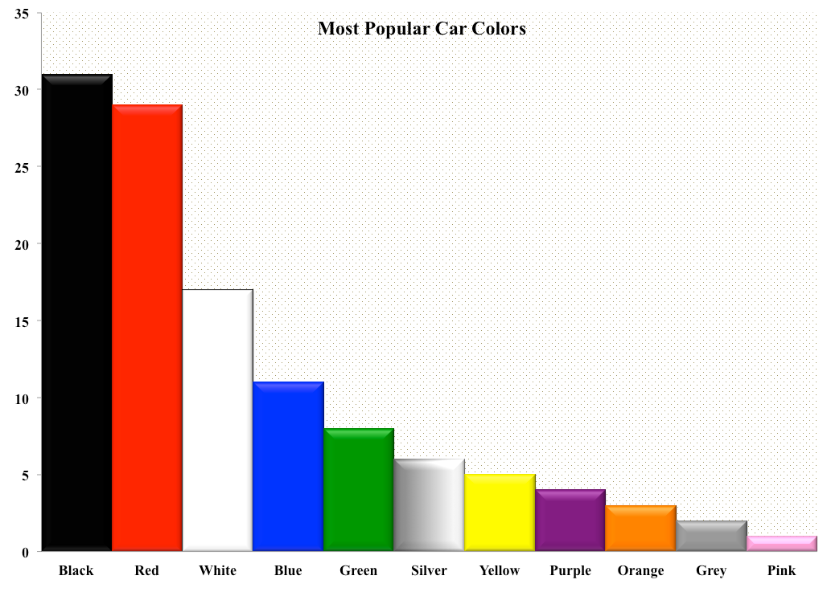

**FIGURE 1 Most popular car colors.**

**REFERENCES**

1. Dewan, S. A., and R. E. Smith. Creating Asset Management Reports from a Local Agency Pavement Management System. In *Transportation Research Record: Journal of the Transportation Research Board*, *No. 1853*, Transportation Research Board of the National Academies, Washington, D.C., 2003, pp. 13–20.
2. Newland, D. E. *Random Vibrations: Spectral and Wavelet Analysis*. John Wiley & Sons, Inc., New York, 1998.
3. Dawley, C. B., B. L. Hogenwiede, and K. O. Anderson. Mitigation of Instability Rutting of Asphalt Concrete Pavements in Lethbridge, Alberta, Canada. *Journal of Association of Asphalt Paving Technologists*, Vol. 59, 1990, pp. 481–508.
4. Sansalone, M., J. M. Lin, and W. B. Streett. Determining the Depths of Surface-Opening Cracks Using Impact-Generated Stress Waves and Time-of-Flight Techniques. *ACI Materials Journal*, Vol. 95, No. 2, 1998, pp. 168–177.
5. Von Quintus, H. L., and A. L. Simpson. *Documentation of the Backcalculation of Layer Parameters for LTPP Test Sections*. Publication FHWA-RD-01-113. FHWA, U.S. Department of Transportation, 2002.
6. Colaimanian, M., J. Harvey, M. Tahmoressi, and V. Tandon. Test Methods to Predict Moisture Sensitivity of Hot-Mix Asphalt Pavements. In *Moisture Sensitivity of Asphalt Pavements*. CD-ROM. Transportation Research Board of the National Academies, Washington, D.C., 2004, pp. 77–110.
7. State and Local Policy Program. *Value Pricing*. Hubert H. Humphrey Institute of Public Affairs, University of Minnesota, Minneapolis. www.hhh.umn.edu/centers/slp/vp/vp_org. Accessed Feb. 5, 2008.
8. *Guide to Developing Performance-Related Specifications*. FHWA-RD-98-155, FHWA­RD-98-156, FHWA-RD-98-171, Vol. III, Appendix C. www.tfhrc.gov/pavement/pccp/pavespec. Accessed March 5, 2003.
9. Nemmers, C. Transportation Asset Management. *Public Roads Magazine*, July 1997. www.tfhrc.gov/pubrds/july97/tam.htm. Accessed Jan. 13, 2002.
10. *MINITAB User’s Guide 2: Data Analysis and Quality Tools*. Minitab, State College, Pa., 2000, pp. 27–52.