**DIAS: Data-Intensive Applications and Systems Laboratory**

School of Computer and Communication Sciences

Ecole Polytechnique Fédérale de Lausanne

Building BC, Station 14

CH-1015 Lausanne

URL: <http://dias.epfl.ch/>

Databases Project – Spring 2019



Team No: 22

Names: Gerald Sula, Georgios Fotiadis, Ridha Chahed

Contents

Contents 1

Deliverable 1 2

Assumptions 2

Entity Relationship Schema 2

Schema 3

Description 3

Relational Schema 4

ER schema to Relational schema 6

DDL 6

General Comments 6

Deliverable 2 10

Assumptions 10

Data Loading 10

Query Implementation 10

Query a: 10

Description of logic: 10

SQL statement 10

Interface 10

Design logic Description 10

Screenshots 10

General Comments 10

Deliverable 3 11

**DIAS: Data-Intensive Applications and Systems Laboratory**

School of Computer and Communication Sciences

Ecole Polytechnique Fédérale de Lausanne

Building BC, Station 14

CH-1015 Lausanne

URL: <http://dias.epfl.ch/>

Assumptions 11

Query Implementation 11

Query a: 11

Description of logic: 11

SQL statement 11

Query Analysis 11

Selected Queries (and why) 11

Query 1 11

Query 2 11

Query 3 11

Interface 12

Design logic Description 12

Screenshots 12

General Comments 12

**Deliverable 1**

***Assumptions***

We are using as a central reference point the Listing entity (which has only 3 attributes unique to each listing) because almost all of the data could be linked to it in a very intuitive way.

All the entities have been selected judging on the principle that: if the attributes found in one instance of an entity are repeated in the data, those attributes must be included in one entity. We have made sure to “package” contextually similar attributes into one entity, as to not increase the complexity of the schema. For the attributes which can be different from one instance to the other, we have set them as relationship attributes (to avoid having a new entity all together, and also for not violating the aforementioned principle).

This is an overview of the percentage of unique attributes per field of the Barcelona listings dataset. Note that the plot is exactly the same for every city.

**DIAS: Data-Intensive Applications and Systems Laboratory**

School of Computer and Communication Sciences

Ecole Polytechnique Fédérale de Lausanne

Building BC, Station 14

CH-1015 Lausanne

URL: <http://dias.epfl.ch/>

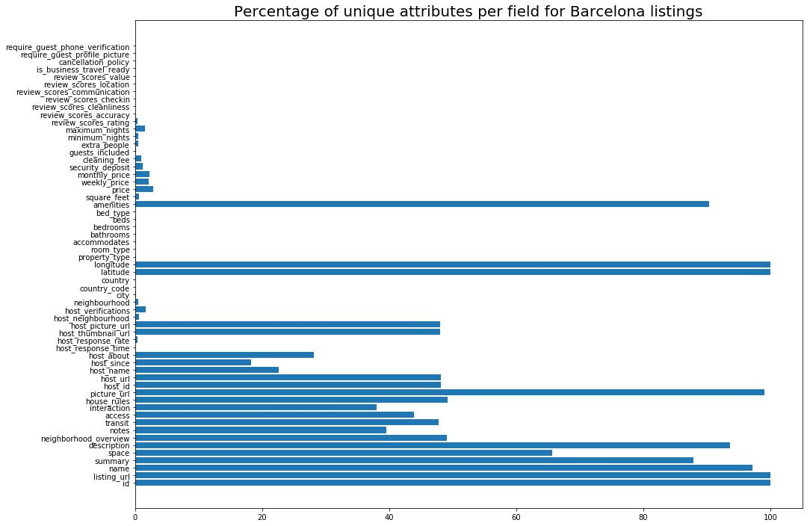

***Entity Relationship Schema***

Schema

**Note**: We included all the attributes of an entity in a big bubble as to conserve space in the diagram.

**DIAS: Data-Intensive Applications and Systems Laboratory**

School of Computer and Communication Sciences

Ecole Polytechnique Fédérale de Lausanne

Building BC, Station 14

CH-1015 Lausanne

URL: <http://dias.epfl.ch/>

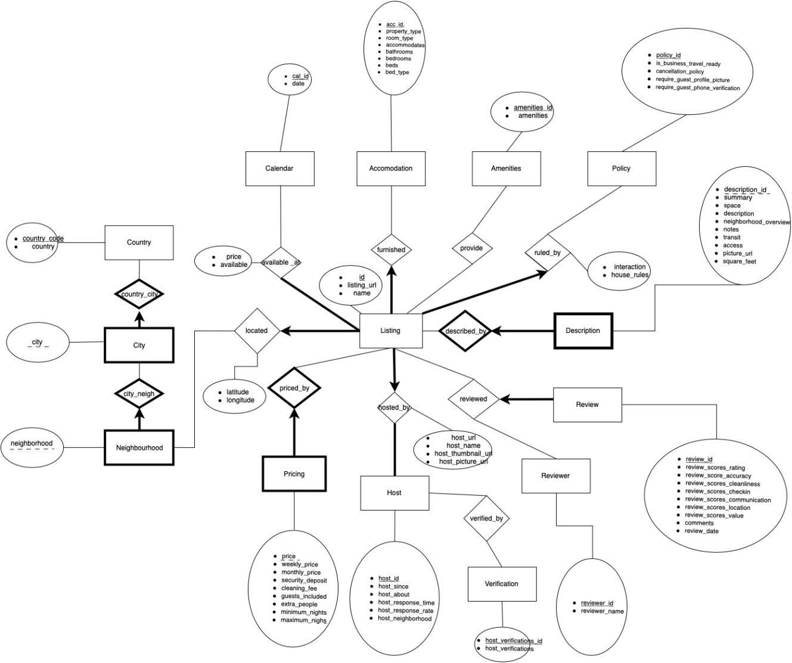

Description

**Calendar**: there is a ‘one to many’ relation with listing because one listing will have at least one date ofavailability. The ‘price’ and ‘available’ attributes were set as relational attributes, because they were different for different listings (as they should be).

**Accommodation**: This entity describes the interior of the listing’s apartment. All of these attributes will changefrom listing to listing so getting them together in one entity seems to be the right choice. Every listing will have exactly one set of those attributes, hence we used the ‘exactly one’ relation. It can happen that there are more than one listing that have the same set of attributes of this kind, that’s why we opted out on having a weak relation here.

**DIAS: Data-Intensive Applications and Systems Laboratory**

School of Computer and Communication Sciences

Ecole Polytechnique Fédérale de Lausanne

Building BC, Station 14

CH-1015 Lausanne

URL: <http://dias.epfl.ch/>

**Amenities**: The data contained here would make sense to be included in the accommodation entity, but sincelistings have more than exactly one amenity, we decided to create a separate simple entity.

**Policy**: Similar to the accommodation entity, we grouped together attributes which are unique to the listing(and also describe the same thing, in this case the rules of the listing) into one place. There is again an ‘exactly one’ relationship for the same reasons. One difference is that there are two relationship attributes here (interaction and house_rules). We decided to put them here because when looking at the data we saw that the policy was similar in most of the listings, with the exception of these two fields, as you can see in the plot above.

**Description**: Once again we grouped together attributes which describe the same aspect of the listing. Wemade this a weak entity, because a description should not exist on its own, it should always be paired with a listing.

**Review and Reviewer**: We decided to go with a ternary relation here between review-reviewer-listing. This is

because they will always be used together: A review is given by a reviewer for a listing. The attributes we assigned to each entity are self-explanatory and there is an ‘exactly one” relation for review because that has to be unique to the listing-reviewer. There are ‘many to many’ relations for both listing and reviewer because a listing can have many reviews from different reviewers, and a reviewer can leave many reviews for different listings.

**Host**: The host entity has all the attributes which describe a host. There is an “exactly one” relation from listing,because a listing should have exactly one host (we are not allowing multiple host to manage the same listing, same as Airbnb does in real life). The host has an ‘at least’ relation with listing because it makes no sense to be a host when you have no listing to manage.

**Verification**: We decided to split the verification into a new entity because the data of the field

‘host_verification’ was reused multiple times for different hosts. There is an ‘exactly one’ relation with hos since every host has only one verification. Pricing: For the exact same reasons as with description we decided do have a weak entity of similar data here.

**Country, City, Neighborhood**: Here we are using the logic that a Country can have multiple Cities, and each Citycan have multiple Neighborhoods. City and Neighborhood are weak entities to the ones above them because, for example, there can be no city which has no country. Finally, we ‘connect’ the most descriptive of the three (Neighborhood) with Listing with an ‘exactly one’ relation, because each listing is located at exactly one neighborhood. The attributes of country, city and neighborhood are reused for different instances of listings, the ones that change (latitude and longitude), we put inside the relationship, as to be able to keep the property of reusability.

**DIAS: Data-Intensive Applications and Systems Laboratory**

School of Computer and Communication Sciences

Ecole Polytechnique Fédérale de Lausanne

Building BC, Station 14

CH-1015 Lausanne

URL: <http://dias.epfl.ch/>

***Relational Schema***

ER schema to Relational schema, DDL:

CREATE TABLE Calendar(cal_id CHAR(32),

date DATE,

PRIMARY KEY (cal_id))

CREATE TABLE available_at(id CHAR(32),

cal_id CHAR(32),

price FLOAT,

available CHAR(1),

PRIMARY KEY (id,cal_id),

FOREIGN KEY (cal_id) REFERENCES Calendar(cal_id),

FOREIGN KEY (id) REFERENCES Listing(id)

/*can't ensure participation constraint*/)

CREATE TABLE Accomodation(acc_id CHAR(32),

property_type CHAR(32),

room_type CHAR(32),

accomodates CHA(32),

bathrooms INTEGER,

bedrooms INTEGER,

beds INTEGER,

bed_type CHAR(32,

PRIMARY KEY (acc_id) )

CREATE TABLE Amenities(amenities_id CHAR(32),

amenities CHAR(32))

CREATE TABLE Provide(id CHAR(32),

amenities_id CHAR(32),

PRIMARY KEY (id,amenities_id),

FOREIGN KEY (amenities_id) REFERENCES Amenities(amenities_id),

FOREIGN KEY (id) REFERENCES Listing(id) )

CREATE TABLE Policy(policy_id CHAR(32),

is_buisness_travel_ready CHAR(1),

**DIAS: Data-Intensive Applications and Systems Laboratory** School of Computer and Communication Sciences Ecole Polytechnique Fédérale de Lausanne

Building BC, Station 14

CH-1015 Lausanne

URL: <http://dias.epfl.ch/>

cancellation_policy CHAR(32),

require_guest_profile_picture CHAR(1),

require_guest_phone_verification CHAR(1)

PRIMARY KEY (policy_id) )

CREATE TABLE Described_Description(description_id CHAR(32),

summary CHAR(1024),

space CHAR(1024),

description CHAR(1024),

neighborhood_overview CHAR(1024),

notes CHAR(1024),

transit CHAR(1024),

access CHAR(1024),

picture URL CHAR(32),

square_feet FLOAT,

id CHAR(32) NOT NULL

PRIMARY KEY (description_id,id)

FOREIGN KEY (id) REFERENCES Listing(id)

ON DELETE CASCADE) )

CREATE TABLE Review(review_id CHAR (32),

review_scores_rating INTEGER,

review_score_accuracy INTEGER,

review_scores_cleanliness INTEGER,

review_scores_checkin INTEGER,

review_scores_communication INTEGER,

review_scores_location INTEGER,

review_scores_value INTEGER,

comments CHAR(1024),

review_date DATE,

id CHAR(32) NOT NULL,

reviewer_id CHAR(32) NOT NULL,

PRIMARY KEY (review_id),

FOREIGN KEY (id) REFERENCES Listing(id),

FOREIGN KEY (reviewer_id) REFERENCES Reviewer(reviewer_id) )

CREATE TABLE Reviewer(reviewer_id CHAR(32),

**DIAS: Data-Intensive Applications and Systems Laboratory** School of Computer and Communication Sciences Ecole Polytechnique Fédérale de Lausanne

Building BC, Station 14

CH-1015 Lausanne

URL: <http://dias.epfl.ch/>

reviewer_name CHAR(32)

PRIMARY KEY (reviewer_id) )

CREATE TABLE Host(host_id CHAR(32),

host_since DATE,

host_about CHAR(1024),

host_response_time FLOAT,

host_response_rate FLOAT,

host_neighborhood CHAR(32),

PRIMARY KEY(host_id) )

CREATE TABLE Verification(host_verifications_id CHAR(32),

host_verifications CHAR(32),

PRIMARY KEY (host_verifications_id) )

CREATE TABLE Verified_by(host_id CHAR(32),

host_verifications_id CHAR(32),

PRIMARY KEY (host_id,host_verifications_id),

FOREIGN KEY (host_id) REFERENCES Host(host_id),

FOREIGN KEY (host_verifications_id) REFERENCES

Verification(host_verifications_id) )

CREATE TABLE Pricing(price FLOAT,

weekly_price FLOAT,

monthly_price FLOAT,

security_deposit FLOAT,

cleaning_fee FLOAT,

guests_included INTEGER,

extra_people FLOAT,

minimum_nights INTEGER,

maximum_nighs INTEGER,

id CHAR(32) NOT NULL,

PRIMARY KEY(price,id),

FOREIGN KEY (id) REFERENCES Listing(id) ON DELETE CASCADE )

CREATE TABLE Country(country_code CHAR(32),

country CHAR(32),

**DIAS: Data-Intensive Applications and Systems Laboratory**

School of Computer and Communication Sciences

Ecole Polytechnique Fédérale de Lausanne

Building BC, Station 14

CH-1015 Lausanne

URL: <http://dias.epfl.ch/>

PRIMARY KEY (country_code) )

CREATE TABLE City(city CHAR(32),

country_code CHAR(32),

PRIMARY KEY (country_code,city),

FOREIGN KEY (country_code) REFERENCES Country(country_code) )

CREATE TABLE Neighbourhood(neighborhood CHAR(32),

city CHAR(32),

country_code CHAR(32),

PRIMARY KEY (country_code,city,neighborhood),

FOREIGN KEY (country_code) REFERENCES Country(country_code),

FOREIGN KEY (city) REFERENCES City(city) )

CREATE TABLE Listing(id CHAR(32),

lisitng_url CHAR(32),

name CHAR(32),

acc_id CHAR(32) NOT NULL,

policy_id CHAR(32) NOT NULL,

host_id CHAR(32) NOT NULL,

host_url CHAR(32),

host_name CHAR(32),

host_thumbnail_url CHAR(32),

host_picture_ur CHAR(32),

neighborhood CHAR(32) NOT NULL

PRIMARY KEY (id),

FOREIGN KEY (acc_id) REFERENCES Accomodation(acc_id), FOREIGN KEY (policy_id) REFERENCES Policy(policy_id), FOREIGN KEY (host_id) REFERENCES Host(host_id),

FOREIGN KEY (neighborhood) REFERENCES Neighbourhood(neighborhood) )

***General Comments***

We all worked on the design of the ER schema, for the rest we decided to split the workload like this:

* Ridha did the translation to the Relational Model
* George analysed the data to further optimize the ER schema for maximum data reusability and locality
* Gerald wrote the report explaining what each relation contains and justify our design choices

**DIAS: Data-Intensive Applications and Systems Laboratory**

School of Computer and Communication Sciences

Ecole Polytechnique Fédérale de Lausanne

Building BC, Station 14

CH-1015 Lausanne

URL: <http://dias.epfl.ch/>

**Deliverable 2**

***Changes from Deliverable 1:***

***Tables:***

CREATE TABLE Calendar(date DATE,

PRIMARY KEY (date));

CREATE TABLE available_at(id INTEGER,

date DATE,

price FLOAT,

available CHAR(1),

PRIMARY KEY (id,date),

FOREIGN KEY (date) REFERENCES Calendar(date),

FOREIGN KEY (id) REFERENCES Listing(id) ) ;

CREATE TABLE Accommodation(accommodates INTEGER,

PRIMARY KEY (accomodates) ) ;

CREATE TABLE Bedding(beds INTEGER,

bed_type CHAR(32),

PRIMARY KEY (beds,bed_type) );

CREATE TABLE Bathrooms(bathrooms FLOAT,

PRIMARY KEY (bathrooms) );

CREATE TABLE Bedrooms(bedrooms INTEGER,

PRIMARY KEY(bedrooms) );

CREATE TABLE Room(room_type CHAR(32),

PRIMARY KEY(room_type) );

CREATE TABLE Property(property_type CHAR(32),

PRIMARY KEY (property_type) );

CREATE TABLE Amenities(amenities CHAR(32),

PRIMARY KEY (amenities) );

CREATE TABLE Provides(id INTEGER,

amenities CHAR(32),

PRIMARY KEY (id,amenities),

FOREIGN KEY (amenities) REFERENCES Amenities(amenities),

FOREIGN KEY (id) REFERENCES Listing(id) ) ;

CREATE TABLE Policy(cancellation_policy CHAR(32),

PRIMARY KEY (cancellation_policy) );

CREATE TABLE Described_Description(description_id INTEGER AUTO_INCREMENT,

summary VARCHAR(1024),

space VARCHAR(1024),

description VARCHAR(1024),

neighbourhood_overview VARCHAR(1024),

notes VARCHAR(1024),

transit VARCHAR(1024),

access VARCHAR(1024),

picture_URL CHAR(32),

square_feet FLOAT,

id INTEGER NOT NULL,

PRIMARY KEY (description_id,id),

FOREIGN KEY (id) REFERENCES Listing(id)

ON DELETE CASCADE) ;

CREATE TABLE Score (review_scores_rating INTEGER,

review_score_accuracy INTEGER,

review_scores_cleanliness INTEGER,

review_scores_checkin INTEGER,

review_scores_communication INTEGER,

review_scores_location INTEGER,

review_scores_value INTEGER,

id INTEGER,

PRIMARY KEY(id),

FOREIGN KEY (id) REFERENCES Listing(id) ON DELETE CASCADE ) ;

CREATE TABLE Reviewer(reviewer_id INTEGER,

reviewer_name CHAR(32),

PRIMARY KEY (reviewer_id) )

CREATE TABLE Review (review_id INTEGER AUTO_INCREMENT,

review_date DATE,

comments VARCHAR(1024),

PRIMARY key(review_id) )

CREATE TABLE Reviewed(id INTEGER,

reviewer_id INTEGER,

review_id INTEGER,

PRIMARY KEY(id, review_id, reviewer_id),

FOREIGN KEY (id) REFERENCES Listing(id),

FOREIGN KEY (reviewer_id) REFERENCES Reviewer(reviewer_id),

FOREIGN KEY (review_id) REFERENCES Review(review_id) )

CREATE TABLE Host(host_id INTEGER,

host_since DATE,

host_about VARCHAR(1024),

host_response_time FLOAT,

host_response_rate FLOAT,

host_neighborhood CHAR(32) NOT NULL,

host_country_code INTEGER NOT NULL,

host_city CHAR(32) NOT NULL,

PRIMARY KEY(host_id),

FOREIGN KEY (host_country_code,host_city,host_neighborhood) REFERENCES Neighbourhood(country_code,city,neighbourhood) )

CREATE TABLE Verification(host_verifications CHAR(32),

PRIMARY KEY (host_verifications) );

CREATE TABLE Verified_by(host_id INTEGER,

host_verifications CHAR(32),

PRIMARY KEY (host_id,host_verifications),

FOREIGN KEY (host_id) REFERENCES Host(host_id),

FOREIGN KEY (host_verifications) REFERENCES Verification(host_verifications) );

CREATE TABLE Pricing(price FLOAT,

weekly_price FLOAT,

monthly_price FLOAT,

security_deposit FLOAT,

cleaning_fee FLOAT,

guests_included INTEGER,

extra_people FLOAT,

minimum_nights INTEGER,

maximum_nighs INTEGER,

id INTEGER NOT NULL,

PRIMARY KEY(price,id),

FOREIGN KEY (id) REFERENCES Listing(id) ON DELETE CASCADE ) ;

CREATE TABLE Country(country_code CHAR(2),

country CHAR(32),

PRIMARY KEY (country_code) ) ;

CREATE TABLE City(city CHAR(32),

country_code CHAR(2),

PRIMARY KEY (country_code,city),

FOREIGN KEY (country_code) REFERENCES Country(country_code) );

CREATE TABLE Neighbourhood(neighbourhood CHAR(32),

city CHAR(32),

country_code CHAR(2),

PRIMARY KEY (country_code,city,neighbourhood),

FOREIGN KEY (country_code) REFERENCES Country(country_code),

FOREIGN KEY (city) REFERENCES City(city) );

CREATE TABLE Listing(id INTEGER,

listing_url CHAR(32),

name CHAR(32),

accommodates CHAR(32) NOT NULL,

cancellation_policy CHAR(32) NOT NULL,

host_id INTEGER NOT NULL,

host_name CHAR(32),

neighbourhood CHAR(32) NOT NULL,

city CHAR(32) NOT NULL,

country_code CHAR(2) NOT NULL,

latitude FLOAT,

longitude FLOAT,

property_type CHAR(32) NOT NULL,

room_type CHAR(32) NOT NULL,

bathrooms FLOAT NOT NULL,

bedrooms INTEGER NOT NULL,

beds INTEGER NOT NULL,

bed_type CHAR(32) NOT NULL,

interaction VARCHAR(1024),

house_rules VARCHAR(1024),

is_business_travel_ready CHAR(1),

require_guest_profile_picture CHAR(1),

require_guest_phone_verification CHAR(1),

PRIMARY KEY (id),

FOREIGN KEY (property_type) REFERENCES Property(property_type),

FOREIGN KEY (room_type) REFERENCES Room(room_type),

FOREIGN KEY (accommodates) REFERENCES Accommodation(accommodates),

FOREIGN KEY (bathrooms) REFERENCES Bathrooms(bathrooms),

FOREIGN KEY (bedrooms) REFERENCES Bedrooms(bedrooms),

FOREIGN KEY (beds,bed_type) REFERENCES Bedding(beds,bed_type),

FOREIGN KEY (cancellation_policy) REFERENCES Policy(cancellation_policy),

FOREIGN KEY (host_id) REFERENCES Host(host_id),

FOREIGN KEY (country_code,city,neighbourhood) REFERENCES Neighbourhood(country_code,city,neighbourhood),

FOREIGN KEY (country_code,city) REFERENCES City(country_code,city),

FOREIGN KEy (country_code) REFERENCES Country(country_code),

FOREIGN KEY (cancellation_policy) REFERENCES Policy(cancellation_policy) );

***New ER diagram:***

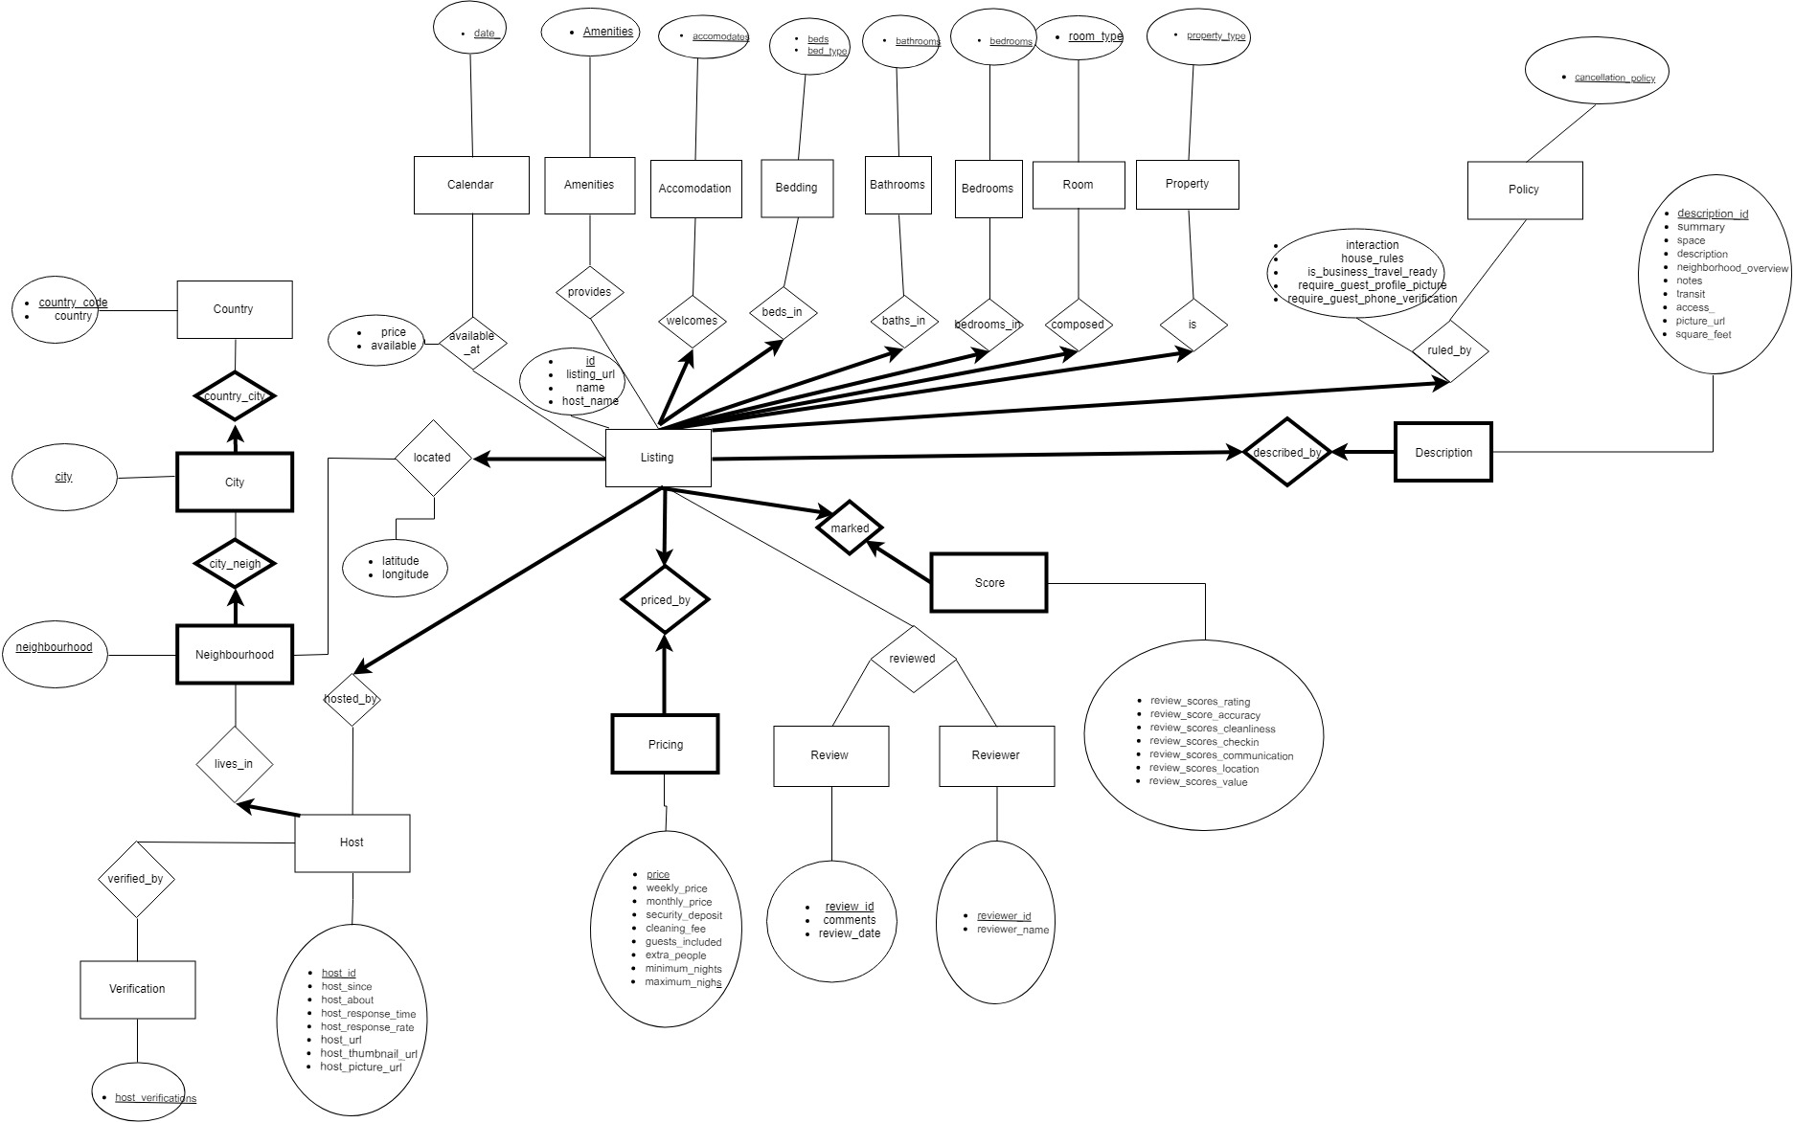

***Assumptions***

General changes:

We decided to split the 'accomodation' entity into different smaller entities each with one or two attributes. Since most of these attributes can be reused for different listings, we need to generate all possible combinations of these entities, and by splitting them we decrease drastically the number of generated combinations. We did not split policy because it has up to 16 combinations, which is reasonable.

Other change we made was turning the 'Pricing' entity into a full one, as opposed to a weak entity. The entity can be reused by another listing which has the exact same values, so it should not be deleted when a listing is deleted.

A small change was the one-to-one relation of liting with Description. This will be unique for that listing so this constraint had to be added.

Another small change was made to the relation of Calendar with Listing. After checking the data we decided that it was not true that there should be an 'at least one constraint' here, so it was removed.

The 'host_neighbourhood' attribute in Host was removed. Insteaad we decided to add a direct relation of Host with Neighborhood. This makes a lot of sense from a practical point of view (there was no need or advantage to keep the neighbourhood as an attribute).

Finally, we changed the Review Entity. We had misunderstood the significance of the attributes such as 'review_scores_rating', 'review_score_accuracy' etc. as multiple ratings given by in each review. What they were actually supposed to do was represent an aggregation of the scores received by all the reviews for that listing. That's why we decided to put all of these attributes as a weak entity named 'Score' which has a one-to-one relation with Listing. The two atributes ('comments' and 'review_date') which were actually given by each review to the listing, are now set as attributes of the 'reviewed' relation.

***Data Loading***

Bedding had NAN values, which we replaced with 0

Description: every NAN was replaced either eith an empty string or wit -1 in the case of square feet

The description_id is an incrementing number starting from 0

Reviewer: The data contained two users with the same reviewer_id but different reviewer_name so we decided to drop one of them (casa nuna) as it is an anomally.

Pricing: Most of the listings contained values for the daily price but not the weekly and the monthly. So, to fill the missing entries we multiplied the daily price by 7 and 30 accordingly. For the security deposit and the cleaning fee we decided to put 0 in the missing entries.

Policy: With regards to the old ER table we removed the policy_id and replaced it with cancellation_policy. The other boolean attributes were transformed to relationship attributes.

Score: There were listings that had no reviews so all their entries where NaN. We replaced these values with -1.

Provides had some duplicate lines, meaning that some listings mentioned some amenities more than once. We dropped them.

While observing the data, we realized that users inserted Madrid, Barcelona and Berlin with many different ways. We decided to remove any confusion from future queries by replacing all that by just the proper names of the cities.

In the Listing entity we added the host_name because it drastically fascilitated our queries.

***Query Implementation***

SELECT AVG(P.price)

FROM Listing L, Pricing P

WHERE L.id=P.id AND L.beds=8 ;

SELECT AVG(S.review_scores_cleanliness)

FROM Listing L, Amenities A, SCORE S, PROVIDES P

WHERE L.id=S.id AND P.id=L.id AND P.amenities='tv' ;

SELECT DISTINCT L.host_id FROM Listing L, AVAILABLE_AT AV WHERE AV.id=L.id AND AV.available='t' AND AV.date <= '2019-09-31' AND AV.date >= '2019-03-00' ;

SELECT COUNT(*)

FROM Listing L1

WHERE EXISTS (SELECT L2.host_name

FROM Listing L2

WHERE L1.host_id < L2.host_id AND

L1.host_name = L2.host_name) ;

SELECT DISTINCT AV.date

FROM Listing L, AVAILABLE_AT AV

WHERE L.host_name='Viajes Eco' AND AV.id= L.id AND AV.available='t' ;

SELECT DISTINCT L.host_id, L.host_name

FROM Listing L

GROUP BY (L.host_id)

HAVING COUNT (*) = 1 ;

SELECT AVG(L1.price) - AVG(L2.price)

FROM Listing L1, Listing L2

WHERE L1.id IN (SELECT L3.id

FROM Listing L3, PROVIDE P1

WHERE L3.id=P1.id AND P1.amenities='wifi')

AND L2.id NOT IN (SELECT L4.id

FROM Listing L4, PROVIDE P2

WHERE L4.id=P2.id AND P2.amenities='wifi') ;

SELECT AVG(L1.price) - AVG(L2.price)

FROM Listing L1, Listing L2

WHERE L1.neighborhood='Berlin' AND L2.neighborhood='Madrid'

AND L1.beds=L2.beds AND L1.beds=8 ;

SELECT TOP (10)

L.host_id,L.host_name

FROM Listing L

WHERE L.country='Spain'

ORDER BY (SELECT COUNT(*)

FROM Listing L1

WHERE L.host_id = L1.host_id AND L.id < L1.id) DESC ;

SELECT TOP (10)

L.id,L.name

FROM Listing L, Score S

WHERE L.neighborhood='Barcelona', S.id=L.id

ORDER BY (S.review_scores_cleanliness) DESC ;

***Interface***

Design logic Description

The UI will be fairly simple, it has a search tab (where you can search by keywords) and another tab where you can run the predefined queries.

The way we implemented it was using Flask, a python library which runs a local server on your machine, from which you can access html files. The data

Screenshots

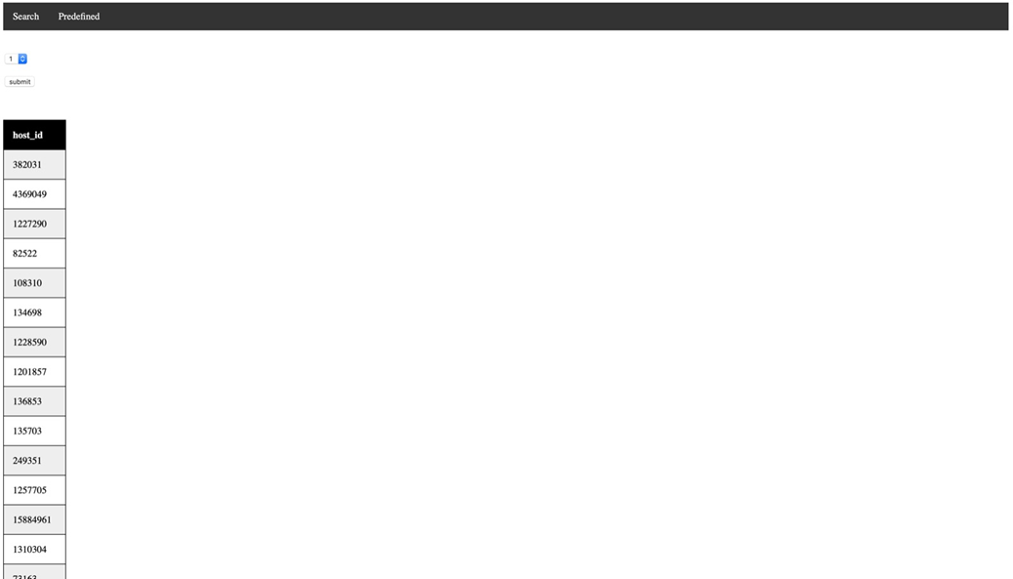

This is a screenshot of what it looks like if you run the 3rd predefined query. The user can select a query from the drop-down menu and then run it. In the other tab the user will be able to search by a keyword, but we did not have time to finish this before the deadline this time. (This is how we intend to search: <https://hashnode.com/post/sqlite-fts5-full-text-searching-cjmklqx50000d6is2lkuspn09> )

***General Comments***

We decided to use Sqlite for our database. It was easier and faster to do it this way than accessing it remotely every single time. We used pandas for the data cleaning and sqlalchemy for when inserting into our sqlite database. The way we implemented the UI was using Flask, a python library which runs a local server on your machine, from which you can access html files.

George- Primarily worked on the data cleaning process

Gerald- Primarily worked on the UI

Ridha- Primarily worked on the predefined queries

All three worked together on the decision making process that we went through when making changes to our ER diagram and Tables, and during the process of deciding how to clean the data.

**DIAS: Data-Intensive Applications and Systems Laboratory**

School of Computer and Communication Sciences

Ecole Polytechnique Fédérale de Lausanne

Building BC, Station 14

CH-1015 Lausanne

URL: <http://dias.epfl.ch/>

**Deliverable 3**

**Assumptions**

<In this section write down the assumptions you made about the data. Write a sentence for each assumption you made>

***Query Implementation***

--Query 1  
SELECT COUNT(DISTINCT L.**host_id**), N.**city**FROM Neighbourhood N, Listing L, Described_Description D  
WHERE L.**id** = D.**id** AND L.**neighbourhood** = N.**neighbourhood** AND D.**square_feet** <> -1  
GROUP BY N.**city**ORDER BY N.**city** ASC;  
  
--Query 2  
WITH RankedTable AS(  
 SELECT neighbourhood, review_scores_rating,  
 ROW_NUMBER() OVER (PARTITION BY neighbourhood ORDER BY review_scores_rating) AS rank,  
 COUNT(*) OVER (PARTITION BY neighbourhood) AS number_total  
 FROM (SELECT L.neighbourhood, S.review_scores_rating  
 FROM Listing L, Score S  
 WHERE L.id=S.id AND L.city = 'Madrid')  
)  
SELECT R.neighbourhood  
FROM RankedTable R  
WHERE R.rank = R.number_total / 2 + 1  
ORDER BY R.review_scores_rating DESC LIMIT 5;  
  
--Query 3  
SELECT L.**host_id**, H.**host_name**FROM Listing L, Host H  
WHERE L.**host_id** = H.**host_id**GROUP BY L.**host_id**HAVING COUNT(*\**) = (SELECT COUNT(L.**id**) as max_listings  
FROM Listing L  
GROUP BY **host_id**ORDER BY COUNT (L.**id**) DESC limit 1)  
  
--Query 4  
SELECT AVG(AV.**price**)  
FROM Listing L, Available_at AV, Score S, Verified_by V  
WHERE L.**city**='Berlin' AND L.**beds** >= 2 AND S.**review_scores_location** >= 8 AND S.**id**= L.**id** AND L.**cancellation_policy** = 'flexible' AND L.**host_id** = V.**host_id** AND (V.**host_verifications**='government_id' OR V.**host_verifications**='offline_government_id')  
 AND L.**id**=AV.**id** AND AV.**date** >= '2019-03-01' AND AV.**date** <= '2019-04-30' AND AV.**available** = 't';  
  
  
--Query 5  
SELECT *\** from(  
SELECT L.**id**, L.**accommodates**, ROW_NUMBER() OVER(  
 PARTITION BY L.accommodates  
 ORDER BY (SELECT S.review_scores_rating)  
) rank_for_this_type  
FROM Listing L, Score S  
WHERE L.**id** = S.**id** and S.**review_scores_rating** >= 0  
AND 2 >= (SELECT COUNT (*\**)  
FROM Provides P  
WHERE P.**id**=L.**id**AND(P.**amenities**='Wifi' OR P.**amenities**='Internet'  
 OR P.**amenities**='TV'OR P.**amenities**='Free street parking'))  
)  
WHERE rank_for_this_type <= 5;  
  
--Query 6  
SELECT *\** FROM(  
 SELECT L.**host_id**, H.**host_name**, L.**id**, L.**name**, ROW_NUMBER() OVER (  
 PARTITION BY L.host_id  
 ORDER BY (SELECT COUNT(R.review_id))  
 )rank  
 FROM Listing L, Reviewed R, Host H  
 WHERE R.**id**=L.**id** AND H.**host_id** = L.**host_id** GROUP BY L.**id**)  
WHERE rank <= 3  
  
  
--Query 7  
SELECT nc.**neighbourhood**, cc.**city**, **amenities**FROM (  
 SELECT ROW_NUMBER () OVER (  
 PARTITION BY n.neighbourhood  
 ORDER BY count(lp.id) DESC  
 )AS c,  
 n.**neighbourhood**, lp.**amenities**, count(*\**)  
 FROM Provides lp JOIN Listing l ON l.**ID** = lp.**id** JOIN NEIGHBOURHOOD n ON n.**neighbourhood** = l.**neighbourhood** WHERE n.**city** IN  
 (SELECT City.**city** FROM City WHERE **city** = 'Berlin') and l.**room_type** = 'Private room'  
 GROUP BY n.**neighbourhood**, lp.**amenities** ORDER BY count(lp.**id**) DESC  
)a  
JOIN NEIGHBOURHOOD nc on a.**neighbourhood** = nc.**neighbourhood**JOIN CITY cc ON cc.**city** = nc.**city**WHERE a.c < 4  
ORDER BY nc.**neighbourhood**, **amenities** DESC;  
  
  
--Query 8  
SELECT *AV1 – AV2*FROM(  
 (SELECT H.**host_id** AS ID1, COUNT(V.**host_verifications**) AS N1, AVG(S.**review_scores_communication**) AS AV1  
 FROM Verified_by V, Host H,Listing L, SCORE S  
 WHERE V.**host_id** = H.**host_id** and L.**host_id**=h.**host_id** AND S.**id** = L.**id** GROUP BY H.**host_id** ORDER BY COUNT(**host_verifications**) DESC LIMIT 1),  
  
 (SELECT H2.host_id AS ID2, COUNT(V2.host_verifications) AS N2, AVG(S2.review_scores_communication) AS AV2  
 FROM Verified_by V2, Host H2, Listing L2, SCORE S2  
 WHERE V2.host_id = H2.host_id and L2.host_id=h2.host_id AND S2.id = L2.id  
 AND S2.review_scores_communication != -1 --  
 GROUP BY H2.host_id  
 ORDER BY COUNT(host_verifications) ASC LIMIT 1));  
  
--Query 9  
select city  
From (  
 Select count(r.**id**) as reviews ,listing.**city** as city  
 From Listing listing, Reviewed r,  
 (  
 Select rt  
 From (  
 Select avg(l.accommodates)as avg, l.room_type as rt  
 From Listing l  
 GROUP BY l.room_type)  
 where avg>3)  
 where r.**id**=listing.**id** and listing.**room_type**=rt  
 group by listing.**city**)  
order by reviews desc limit 1;  
  
--Query 10  
Select *\**From(  
 select count(distinct a.**id**) as occupiedNr, l1.**neighbourhood** as occupiedN  
 from available_at a, host h, Listing l1  
  
 where L1.**id** in (  
 SELECT L3.**id** as occupiedId  
 FROM Listing L3, available_at A3  
 WHERE L3.**id** = A3.**id** AND A3.**date** >= '2019-01-01' and A3.**date** <= '2019-12-31'  
 GROUP BY L3.**id** HAVING COUNT(A3.**available** = 'f') >= 1  
 ) and h.**host_id**= l1.**host_id** and a.**id**=l1.**id** and h.**host_since** < '2017-06-01' and l1.**city**='Madrid'  
 group by l1.**neighbourhood**),  
  
 (Select count( distinct l2.**id**) as totalNr, l2.**neighbourhood** as N  
 from Listing l2  
 where l2.**city**='Madrid'  
 group by l2.**neighbourhood**)  
where occupiedN=N and occupiedNr >= totalNr / 2;  
  
--Query 11  
SELECT CC1  
FROM  
(select L.**country_code** AS CC1, count(DISTINCT L.**id**) AS CA  
From Listing L  
Where L.**id** in(  
 select A.**id** from available_at A  
 where A.**date** >= '2018-01-01' AND A.**date** <= '2018-12-31'  
 GROUP BY A.**id** HAVING COUNT(A.**available** = 't') >= 1  
)  
group by L.**country_code**),  
  
(select L1.**country_code** AS CC2, count(DISTINCT L1.**id**) AS CTOT  
From Listing L1  
Where L1.**id** in(  
 select A1.**id** from available_at A1  
 where A1.**date** >= '2018-01-01' AND A1.**date** <= '2018-12-31'  
 GROUP BY A1.**id**)  
group by L1.**country_code**)  
WHERE CC1 = CC2 AND CA >= CTOT / 5  
  
--Query 12  
SELECT NE1 FROM  
(SELECT L.**neighbourhood** AS NE1, COUNT(DISTINCT L.**id**) AS COUNT1  
FROM Neighbourhood N, Listing L  
WHERE L.**cancellation_policy** = 'strict_14_with_grace_period' AND N.**city** = 'Barcelona' AND L.**neighbourhood** = N.**neighbourhood**GROUP BY L.**neighbourhood**),  
  
(SELECT L1.**neighbourhood** AS NE2, COUNT(DISTINCT L1.**id**) AS COUNT2  
FROM Neighbourhood N1, Listing L1  
WHERE N1.**city** = 'Barcelona' AND L1.**neighbourhood** = N1.**neighbourhood**GROUP BY L1.**neighbourhood**)  
WHERE NE1 = NE2 AND COUNT1 > COUNT2 / 20

**Results and running times:**

**Deliverable 3** (runtimes for queries 3, 9 and 12 have been omitted since they were optimized and analyzed below):

q1:

345 Barcelona

370 Berlin

249 Madrid

128 ms

q2:

Tetuán

Estrella

Castilla

91 ms

q3:

4459553 Eva&Jacques

q4:

95.70042941492217

489 ms

q5:

16778642 1

21373187 1

21746363 1

21981086 1

22281329 1

5096812 10

536574 10

27401375 10

16203562 10

26828447 10

22332323 11

28998893 11

22788557 11

12788419 11

474387 11

230 ms

q6:

2217 Ian 24630271

2217 Ian 18773184

2217 Ian 21315310

3073 Ricard 6287375

3718 Britta 3176

4108 Jana 3309

5154 Raúl 18132872

10704 Weflating 735165

10704 Weflating 8216291

10704 Weflating 8270716

320 ms

q7:

Adlershof Berlin wifi

Adlershof Berlin heating

Adlershof Berlin essentials

Alt-Hohenschönhausen Berlin wifi

Alt-Hohenschönhausen Berlin heating

Alt-Hohenschönhausen Berlin essentials

Alt-Treptow Berlin wifi

Alt-Treptow Berlin heating

Alt-Treptow Berlin essentials

508 ms

q8:

-1.3191489361702136

632 ms

q9:

Madrid

q10:

Acacias

Adelfas

Almagro

Almenara

Aluche

Arapiles

Arganzuela

837 ms

q11:

DE

ES

750 ms

q12:

Camp d'en Grassot i Gràcia Nova

Can Baro

Carmel

Ciutat Vella

Diagonal Mar - La Mar Bella

Dreta de l'Eixample

Eixample

El Baix Guinardó

El Besòs i el Maresme

El Bon Pastor

**Deliverable 2:**

q1:

228.3989898989899

182 ms

q2:

7.583719826169522

563 ms

q3:

382031

4369049

1227290

82522

108310

134698

1228590

115 ms

q4:

18368

31 s 448 ms

q5:

2018-11-08

2018-11-09

2018-11-10

2018-11-11

2018-11-12

2018-11-13

2018-11-14

5 s 570 ms

q6:

3073 Ricard

3718 Britta

4108 Jana

5154 Raúl

11015 Josaiah

11780 Amelie

12723 Em

17391 Bright

17453 Cara

162 ms

q7:

-7.102058707306057

521 ms

q8:

-101.59261501210656

276 ms

q9:

4459553 Eva&Jacques

99018982 Apartamentos

32046323 Juan

28038703 Luxury Rentals Madrid

1391607 Aline

10704 Weflating

299462 Stay U-Nique

3566146 Home Club

1408525 Mad4Rent

5878688 Yaiza

1 m 20 s 912 ms

q10:

18666 Flat with Sunny Terrace

18674 Huge flat for 8 people close to Sagrada Familia

31377 Room for 2, Sagrada Famili

35388 Single 01 CasanovaRooms Barcelona

35390 Single 02 CasanovaRooms Barcelona

49213 Descalzos en el parque, relaxing and cool room

70099 Room with a View, Bcn City Center

70333 Stylish+cozy home/parking/CCIB/WIFI

71520 Charming apartment with fantastic views!

71603 MODERNIST PENTHOUSE. 1bedroom apt with terrace

100 ms

***Query Analysis***

Selected Queries (and why)

*Query 1*

<Initial Running time:

Optimized Running time:

Explain the improvement:

Initial plan

Improved plan>

*Query 2*

<Initial Running time:

Optimized Running time:

Explain the improvement:

Initial plan

Improved plan>

*Query 3*

<Initial Running time:

Optimized Running time:

Explain the improvement:

Initial plan

Improved plan>

**DIAS: Data-Intensive Applications and Systems Laboratory**

School of Computer and Communication Sciences

Ecole Polytechnique Fédérale de Lausanne

Building BC, Station 14

CH-1015 Lausanne

URL: <http://dias.epfl.ch/>

**Interface**

Design logic Description

<Describe the general logic of your design as well as the technology you decided to use>

Screenshots

<Provide some initial screen shots of your interface>

**General Comments**

<In this section write general comments about your deliverable (comments and work allocation between team members>