Transfer Learning with Network Traffic Data for the identification of Anomalous Traffic

|  |
| --- |
| **Byron Barkhuizen**  Télécom SudParis  for Submission  at https://github.com/byronbark/IOTProject |

# ABSTRACT

UPDATED—1 March 2020. Transfer learning is a developing field and framework in artificial intelligence to assist the development of new models, typically in the case of limited data or label availability, or to bootstrap the process for a new unknown environment. In other instances, it may simply be a desire to reduce the time for creating a new model, or an attempt to improve the accuracy of a model without a large new dataset being collected. The concept describes learning between a source and target domain or task in the same way that a human brain learns a new task. It relies on the idea that there exists similarities or knowledge that can be transferred to perform a task in a target domain at a higher level of accuracy. There are various ways of performing transfer learning and they are dependent on the type of data available and the differences in the source and target domain or tasks where learning is desired.

## Keywords

Transfer learning, representation learning, domain adaptation, python, packet capture, network traffic.

# INTRODUCTION

Transfer learning is the attempt to establish a relationship between a source domain and a target domain, along with source tasks and target tasks. DARPA (Defense Advanced Research Projects Agency) defines the mission of transfer learning as ‘the ability of a system to recognize and apply knowledge and skills learned in a previous task to novel tasks’. A computer being able to do a task does not imply intelligence, however the ability of a computer to learn to do a new task does (Russel, 2002) and is a step towards true artificial intelligence. The existence or assumption that there is some similarity between the source and target is the theoretical basis for the application of transfer learning (S.J Pan, 2010). One consideration for the applicability of transfer learning is whether the features within a source or target domain have some probability distribution. When these features distributions are the same then the new dataset can essentially just be classified in the same way that the original dataset was. If the source and target dataset do not conform to the same probability distribution or the same features, then this cannot be done accurately. However, this does not mean that a model needs to be completely re-trained and re-classified on the new dataset, there theoretically can exist some knowledge that can be transferred between the two datasets in order to improve the model metrics in the target domain.

The ultimate goal for a transfer learning application is to reduce the reliance on large quantities of data collection which is traditionally the only method of obtaining highly performant machine learning models, and to boost the speed at which a new model in a target domain can be trained, as well as improving the accuracy achieved through these models in novel environments. There are an extremely high number of approaches to transfer learning, and the field is a long way from establishing a best practice approach for taking on this framework.

# STATE OF THE ART

Currently the most approachable application of transfer learning involves re-using all or some parts of a pre-existing model. In the machine learning world the most fitting type of architecture for such an approach is a neural network. These models can be trained on almost anything and put into use in a new domain, however a transfer learning application with this approach will perform better if there exist some similarities between the source and target domain, namely the concept of a feature within each domain concerned. In this case the source domain would be the dataset that the initial model was trained on. A popular pre-trained model that is used is Google’s ‘ResNet’ which is trained on an enormous number of images for the task of classification, with varying depth (eg. ResNet-50 corresponds to a model with 50 layers of neurons). This pre-trained convolutional neural network can exist of hundreds of layers, and the initial layers closest to the input learn some low-level features such as edges or gradients. The higher level feature layers are where the classification begins to take form, with these basic or atomic features being combined to identify an object in an image, this is not specific to images but it is the most understandable representation (S.J Pan, 2010). These features are application agnostic, they exist on all images that we may use. For this reason, it is possible to ‘cut’ this model so we keep only this distribution of low level features, while getting rid of higher-level features that may not exist in the target domain. These features, or profiles of features, become more specific to the classes that the initial model was trained on and may be entirely unnecessary. This application of transfer learning is very easy to implement, however often it will not achieve a very high level of accuracy until it is re-trained on the new classification task with some newly labeled data in the target domain. The core concept of this is that transfer learning can be achieved by maintaining some knowledge of the source domain to be reused in the target domain.

The basis of current approaches works on the assumption that the training and some future data are either in different feature spaces or have different distributions. Often the task of transfer learning can lead to a negative transfer. This is the case when the similarities between the source and target domain are non-existent or they are too unrelated for transfer learning to yield positive results. This can lead to wasted resources, in terms of time and performance.

**CONCEPTS**

**Data Preprocessing**

The data that is available in our experiments are PCAP (Packet Capture) files collected over various time spans for many devices. The PCAP is separated with the SplitCap tool, as well as the CICFlowMeter tool. We are left with raw PCAP files that are separated by flows and MAC addresses; these MAC addresses are suitable as our labels as they correspond to a device and are able to differentiate the devices for training models. We can use some windows shell scripts and small Python programs to process these PCAP files and create binary files along with CSV files to represent the activity of individual devices. This step can be considered the precursor to model selection. The chosen representation of the domains needs to be the same and it will determine which models are viable to be used. Some data types will not work with certain models. An image can not be easily used in a regression model as a CSV file of time series information can be used. The data is normalized after they are split into test sets to not influence each other. This means the test sets and the training sets are normalized separately but by the same method. This shifts certain values into a range that is usable and will not make the model overly biased towards large or small values. At the end of the preprocessing we are left with m by m pixel images, and CSV files that represent 84 calculated time series features along with flow identifying features including source and destination addresses, port number and protocol numbers associated. For the purpose of all experimentation involved these features were not included as they could lead to overtraining on these features, and therefore low transferability to a new target environment. Many of these features can also be spoofed and will nullify the use of a machine learning model that considers them as features. For that reason part of the dataset cleaning process involves removing them, however the protocol number is used to filter only for TCP traffic so that only this type of traffic which is more uniform flow to flow is concerned. The images are PNG files and can be easily processed by the NumPy library within Python. Similarly the CSV files can be easily processed by these tools in order to be passed into a model.

**Domain Adaptation**

Domain adaptation refers to bridging the gap between the differences in the source and target domains. Essentially, we want to minimize the differences in their representations after, before or during they have been represented. When they can be similarly represented (their features or their distributions are the same) then learning has occurred (Kouw et. al, 2018). In many cases this means that the size of the representation can become smaller, as a subset of features is chosen that is able to represent both domains, this is the case in TCA and similar methods.The new representation can then be used to train an initial model where we have rich data (source domain), and this model can be used on the data poor target domain to achieve greater results. More specifically, one method of performing domain adaptation is discriminative feature alignment (DFA).

An application of this is explored in the GitHub repository. It uses 3 different image sets, the popular MNIST image dataset along with SVHN and USPS. In the following images we can see a reduced dimensionality representation of what domain adaptation attempts to achieve. The individual points represent different images in latent space. Once a new representation is learned (after adaptation) we are again able to represent them in the latent space and there are clear clusters that are formed. In the case of the image dataset they are clusters that will each represent a different digit. The grouping before the adaptation does not exist and therefore any attempt to classify in the target domain would achieve extremely poor results.

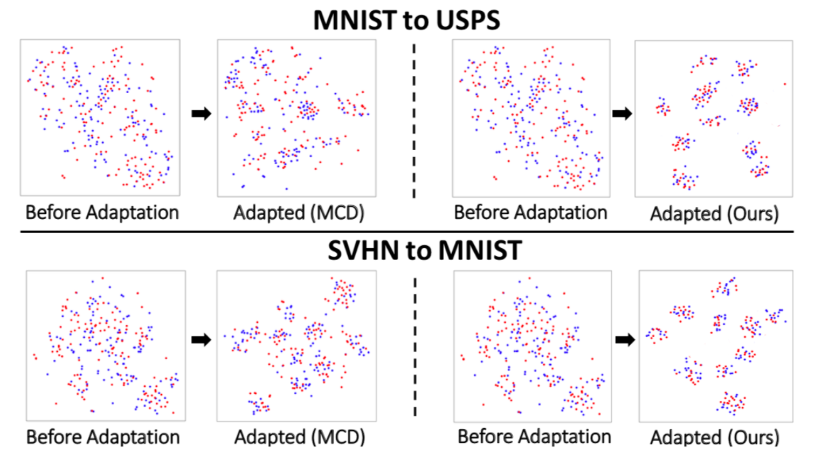

The application of this to our dataset as desired would be the following.

* Represent both images and CSV files as a NumPy array (pre-processing on CSV data) so that their initial representations are the same
* Learn best feature representation and modify both source and target data accordingly (such that on our latent space representation we will have one clear class).
* Train source model, test on target data on the new representation
* Testing can be done with any one class classifier

**Autoencoder**

Autoencoder is the most basic feature representation implementation. A single connected layer attempts to determine a minimum representation for some input data, such that it can reconstruct it from the fewest number of nodes possible. Through doing this it learns a representation of the data that belongs to a single class. If we then apply this model to some new data, alongside a conditional calculation such as Euclidean distance, we can determine whether a new data point belongs to this one class.

An implementation of this can be found in the GitHub repository and it presents a standard autoencoder architecture. With our CSV data the following loss data can be achieved on the target data. The loss represents the distance of the data points when used as the input in the initial model. A low loss means there is very little deviation and that it likely belongs to the ‘home’ class. In this instance the target domain data consisted only of ‘home’ data.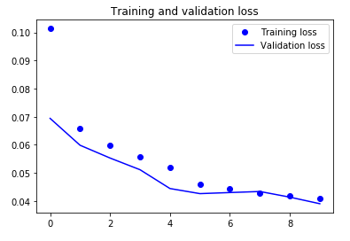

This is not an application of transfer learning as no interaction between the source and target domain has occurred yet, we are simply transferring the model that was initially created. The concept of autoencoder could be extended to use transfer learning as we will explore in the next application.

**Neural Network (Shallow)**

This experiment involved looking at the binary classification of a single device coupled with the data of multiple other devices. It is like anomaly detection in that we are identifying whether it belongs to this known class or now. The known class was represented by a 1. The confusion matrix from this experiment can be seen below.

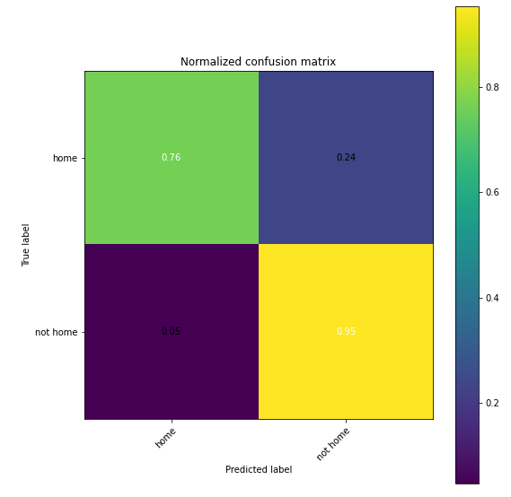

We can observe that this neural network is able to identify both classes to a high degree of accuracy. This is not an example of transfer learning; however we can achieve transfer learning by freezing some layers of the neural network and retraining the model on this data.

**EXPERIMENTATION**

This section will expand upon some of the transfer learning approaches tried, including some interpretations of papers that exist on the subject.

**TLDA (Deep Autoencoder)**

While a basic autoencoder attempts to learn a good representation of the input data such that it can reconstruct it with high accuracy, an autoencoder approach that seeks to apply transfer learning must learn a representation that is good for both domains. This can be achieved by using some new data in the target domain in concurrence with the data that already exists in the source domain.

We train a stacked autoencoder on both the source and target domain to learn good representations of both individually. This supplies us with the weights for some layers as an initial basis. This model can be created at any time and saved as the source model until some target data exists to train a target autoencoder. After these are initialized, we will calculate some partial derivatives (this is the basis of most deep learning models where a gradient is calculated) to iteratively update values that will be tested against KL-convergence conditions. KL-divergence is a method of evaluating the differences between two probability distributions, therefore when this condition is satisfied, we can assume some convergence between the two domains. The process outlined in the paper is shown below, and an initial Python implementation of this can be found on the GitHub repository.

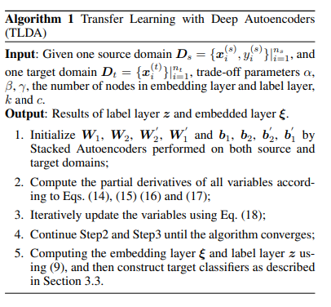

**Discriminative Feature Alignment**

Initially based on a paper to classify handwritten numbers from 0 to 9 this code is based on the paper by Jing Wang and is written in Python. The paper outlines some methods for the application of domain adaptation. From the survey of transfer learning we discovered that domain adaptation is the correct paradigm for our problem as the task (classification) is the same however the domains differ in their feature distributions. There are two approaches for a domain adaptation problem, and these are instance transfer and feature representation transfer.

The solution offered in the ‘TLwithDomainAdaptation’ folder uses an encoder and decoder approach to align features between two similar but different datasets. The paper outlines various algorithms to reach this target. The code written here is an adaptation of earlier work in domain adaptation.

The code includes various python files for data processing, creating training and testing sets including their proper labeling. The code also contains a setup for the encoder and decoder model with specifications for all layers

**Transfer Component Analysis**

Transfer component analysis, or TCA, is another feature representation method for performing transfer learning. This transfer learning is well suited to handle both image and textual data as it functions like an autoencoder with many features. The theory behind this method of transfer learning involves techniques to achieve dimensionality reduction. When only a source domain is involved this is essentially a technique that is the same as an autoencoder based classifier. However, the transfer of knowledge comes into play when there are multiple domains involved, and there is a lack of labels in the target domain.

The exact steps taken performing TCA on some datasets involve reducing the statistical distribution differences between the concerned datasets.

The first method to do this is called the Maximum Mean Discrepancy (MMD) which is a method for computing the overall differences in the means of features. This method is not as sensitive to feature size which makes it applicable to transfer learning for images. Typical approaches such as the KL divergence for calculating differences In distributions are extremely difficult to perform when the number of features are too high. From the paper the goal or cost function that we are seeking to minimize can be demonstrated within the following image:

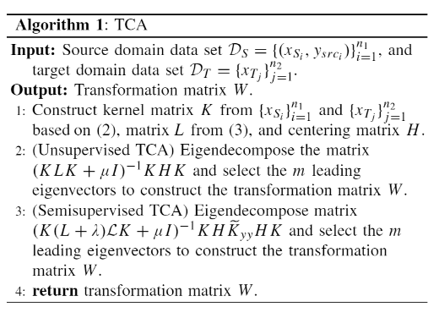

or:

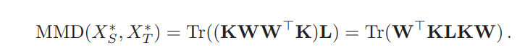

To reduce the differences between two distributions, it is very intuitive to seek a shared feature representation across domains, but it is not a simple process. Such a representation is intended to mitigate the shift occurred between the source and target datasets. To this end, we present the TCA technique (in its unsupervised form, i.e. not requiring any labeled target data) designed to extract meaningful transfer components from the original data belonging to different but related domains. The purpose of algorithms in a DA setting is to find a mapping function φ, practically a transformation matrix W, whose aim is to preserved the main properties of the two distributions while also reducing the distances between them. The core mechanisms to achieve this is by performing eigen decomposition and statistical analysis of the datasets iteratively until the function previously mentioned is minimized.

The results obtained for this method of transfer learning is early, however through using various mixes of data sizes and domains for IoT devices the detection of google home has been as high as 80%. This result is promising and merits further exploration with the transfer component analysis paradigm.

**DISCUSSIONS**

**CONCLUSIONS**

**FUTURE WORK**

# REFERENCES

[1] S.J. Pan and Q. Yang, “A survey on transfer learning,” IEEE Trans. Knowl. Data Eng., vol. 22, no. 10, pp. 1345–1359, Oct. 2010.

[2] Z. Wang, Z. Dai, B. Poczos, and J. Carbonell, “Characterizing and ´ avoiding negative transfer,” in Proc. IEEE Conference on Computer Vision and Pattern Recognition, Long Beach, Jun. 2019, pp. 11293– 11302.

[3] S.J. Pan, I.W. Tsang, J.T. Kwok, and Q. Yang, “Domain adaptation via transfer component analysis,”IEEE Trans. Neural Netw., vol. 22, no. 2, pp. 199–210, Feb. 2011.

[4] C. Chen, Z. Chen, B. Jiang, and X. Jin, “Joint domain alignment and discriminative feature learning for unsupervised deep domain adaptation,” in Proc. 33rd AAAI

[5] F. Zhuang, X. Cheng, P. Luo, S.J. Pan, and Q. He, “Supervised representation learning with double encoding-layer autoencoder for transfer learning,” ACM Trans. Intell. Syst. Technol., vol. 9, no. 2, pp. 1–17, Jan. 2018.

[6] Kouw, W. M., & Loog, M. (2018). An introduction to domain adaptation and transfer learning. *arXiv preprint arXiv:1812.11806*.

[7] Russell, S., & Norvig, P. (2002). Artificial intelligence: a modern approach.