PLANNING DOCUMENT

For the ecoPineapple Project

*Team Values: Support each other | Free to speak | Push the boundaries | Skill development*

*Byron Chen - 92019472*

*Charles Tsao - 92019797*

*Trent Williams - 92019562*

**Table of Contents**

User Stories 3

Website 3

Mobile Application 3

Mini Game 3

Meeting Minutes 1 4

Revised Design 6

Updated User Stories for Minigame 7

Sprint Planning 8

Sprint Tasks 8

Timeline 11

Scrum Master (SM) 11

Kanban Board 12

Links to Trello 12

Story Weights and Priority 12

Trello Screenshots 13

Development Tools 15

Meeting Minutes 2 16

Changes to Address Feedback 17

# User Stories

The following user stories were created during our Project Kickstart Meeting. These reflect all the client’s initial requirements.

## Website

As a customer, I want to:

* View a Home Page
* View a Login Page
* View a Product List Page
* View a Product Details Page
* View a Staff Contracts Page
* Be able to add/edit products

As a staff member, I want to:

* Be able to login in and see contact information

## Mobile Application

As a customer, I want:

* To navigate to the pages via tabbed navigation
* Consistent styling for the page layouts that suit the topic
* A page that describes general sustainability issues
* A page that describes eco-friendly solutions
* A page showing space travel as an alternative to sustainability
* The application to be user accessible

## Mini Game

As a customer, I want to play:

* As a character
* Level 1 of the Game
* Level 2 of the Game
* Level 3 of the Game

# Meeting Minutes 1

The following are the meeting minutes recorded from the initial client meeting. This meeting involved the team clarifying and revising our design to match the client’s expectations.

**29/08/19 - Client Meeting 1**

**Meeting Scheduled for 11:00 am (30 minutes)**

**Actual time spent (11:00 – 11:30) am**

**Present – Byron, Charles, Trent, Clera**

Things we discussed in this meeting were:

* The creative control over the developed tools. Our team members will have most of the control, but the Client/Product Owner will need to approve these.
* The overall project schedule was discussed. It currently follows the default project schedule of 3 weeks for Project Proposal; 5 weeks for Project Execution; 2 weeks for Project Presentation.
* We requested if the name of the company can be changed from GreenWorld to ecoPineapple. This was approved by the Client.

**Trent Questions**

1. Should site be mobile friendly? Yes, it should be responsive.

2. How many photo’s per product? No set amounts. You can decide.

3. How long have you been about? 2 years

4. Why did you start? Bored of current job

5. Do you have different product categories? Yes. Categories such as kitchen, bathroom, food, fill your own (e.g. refill bottles).

6. Do you have any colour preference? No. Just keep the colours consistent.

7. Do you like the logo we propose and the name? Yes, I do.

8. For privacy, what details do you need to record about your staff? First name, last name, email, and phone. Department – log what they add etc.

9. What is your target market? Anyone interested in being eco-friendly. There is no age limit.

**Byron Questions**

1. What platforms do you want the game to run on? Preferably run on Windows 10. If implementation is straightforward, the Android platform is to be considered.

2. What should the target audience/age be for the game? Anyone who is a customer for ecoPineapple. Ages 3+.

3. What OFLC rating should the game strive for? G (General). This should be consistent throughout all created programs.

4. The unique selling points for this game is that coupon codes can be collected from the game to be used for the website. Is this okay? Yes.

5. You require at least 3 levels for the game. Is it okay to have these levels act as checkpoints for one single level? Yes, this is okay. But what if I wanted to play level 2?

**Charles’ Questions**

1. The application will focus on sustainability via the eco-friendly solutions that the store provides. A general definition of sustainability will also be provided. Is this content okay? Yes

2. The user groups for the mobile app are assigned as follows: Targeted – Customers of ecoPineapple; Supported – Visually impaired customers; and Non-Supported – Customers requiring localisation. Are these user groups defined correctly? Yes

3. I am suggesting adding a ‘hamburger’ button for flyout root navigation and a user accessibility page. Should I implement these features? Yes

# Revised Design

After the client meeting, the feedback provided was considered and addressed.

The following changes were applied to our overall design.

* The company name was changed from ‘GreenWorld’ to ‘ecoPineapple’.
* The number of planned Sprints is assigned to 5. For each sprint, the team members will spend an equal amount of time as Scrum Master.

For the mobile application, the following features were approved by the client.

* A product list of what the store offers is displayed.
* Product details for each product can be displayed.
* Social media integration will be available for products to be shared.
* Staff account access that allows staff to perform CRUD operations on announcements, products, and new staff users.

For the minigame, the following was clarified.

* Levels do not have to be a single individual scene, but levels can be a point that we reach in the game (e.g. Level 1 would be to fly to the moon and level 2 would be to fly to mars)

For the website, there were no additional changes that needed to be made.

# Updated User Stories for Minigame

After working through the GDD, new user stories were created for the minigame.

* Create character model (spaceship)
* Provide code for website products discount
* First prototype for the game
* Rocket launch and basic controls
* Money given based on how high the rocket reaches
* UI for purchasing and adding parts to the ship
* Basic models created
* Moon with spaceport added
* More planets added into space
* Tourists can go on the ship for money
* More controls for the ship to dock to space port
* Polish up UI
* More parts added to building the rocket
* Pickups and collectibles added
* Enemies added (alien ships and asteroids)
* Music and sound added
* Final models added
* Loading screen menu
* Save system

*Note: This section is included here in the Planning document as it does not belong in the Game Overview or GDD documents.*

# Sprint Planning

## Sprint Tasks

The following is an initial plan of the tasks that will be included in each of the sprints.

**SPRINT 1**

**Mobile application**

Set up the development environment and rapidly prototype a skeleton for the mobile application. This will involve setting up the development environment; set up the base project; implementing simple UI layout; set up tabbed navigation; set up flyout shelf; set up staff access and functionality; etc.

**Mini-Game**

First I will create a prototype version of the game. This will include a basic rocket launch with basic controls, a moon with a starport attached to it, money system, and a simple UI for adding parts to the rocket. The models for all the designs will be basic shapes.

**Website**

1. Base structure pages created
2. Base data structure created
3. Some basic navigation functionality
4. Some static content

**SPRINT 2**

**Mobile application**

Tasks will building upon the skeleton prototype and finish off any features that has not been implemented. Will also start creating content for the application and making sure it is implemented properly and is responsive. Content will involve text bodies of sustainability information, announcements, products, and staff users.

**Mini-Game**

The game will have more planets added to the map for the player to fly to. Tourists system will be added in. More controls will be added for the rocket to dock to a space port.

**Website**

1. Static content finished
2. All primary user stories working on desktop version
3. Mobile responsiveness development started

**SPRINT 3**

**Mobile application**

Tasks will involve implementing any major changes provided by the client; continue with creating responsive content; and polishing the UI with consistent styling/colours.

**Mini-Game**

Polishing up the UI. More parts will be added into the rocket ship design phase. Parts that you can collect will be added for during launch phase. Polished models will be added to all the game objects.

**Website**

1. Mobile responsiveness development finished
2. User access
3. User access – customizing content

**SPRINT 4**

**Mobile application**

Implement any leftover high/mid priority features.

**Mini-Game**

Enemies and asteroids will be added into game which the player needs to avoid. More polishing will be done to the design.

**Website**

* TBC as changes are considered and new user stories to be implemented, that we assume will come during the first 3 sprints.

**SPRINT 5**

**Mobile application**

Finalising application before presentation.

**Mini-Game**

An android version of the game will be created. UI and screen size will be adjusted to fit the game in.

**Website**

* TBC as changes are considered and new user stories to be implemented, that we assume will come during sprints 1-4.

## Timeline

This is the current planned timeline for our project. Each sprint is expected to last one week.

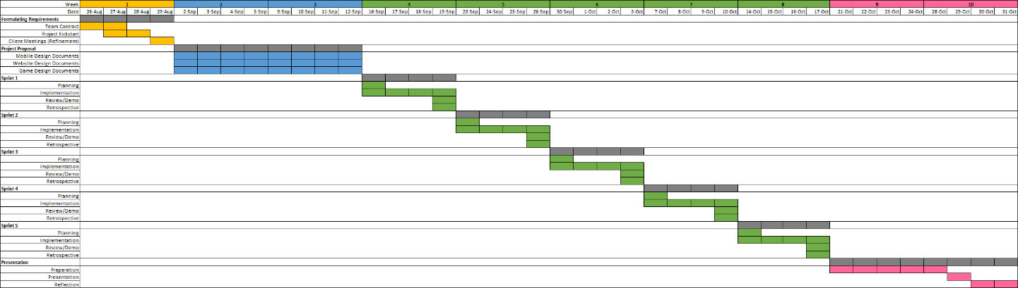

## Scrum Master (SM)

For our planned sprints, the role of Scrum Master will be assigned as follows:

* Sprint 1 – Charles and Trent
* Sprint 2 – Charles and Byron
* Sprint 3 – Trent
* Sprint 4 – Byron
* Sprint 5 – Charles

The reasoning for assigning two team members to share the Scrum Master role during the initial sprints is to help the team become familiar with the SM duties and provides a chance for us to optimise the SM tasks for future sprints. It also allows each team member to contribute as the Scrum Master at least twice during the project execution.

Some of the main SM duties will involve:

* Organising Scrum ceremonies for the team and Product Owner.
* Managing the Product Backlog
* Implement changes to increase team productivity
* Removing obstacles that hinders the team’s effectiveness

# Kanban Board

## Links to Trello

Project Link: <https://trello.com/ecopineapple/home>

Invite Link: <https://trello.com/invite/ecopineapple/1ce8f55ca9f9ae0a7a93bb6ba1ca4e15>

## Story Weights and Priority

Planning Poker was played using our mobile devices to assign a weight for all the user stories created. This was done once the design had been complete and before the final client meeting to confirm everything planned.

Each point is weighted as 1 hour and the amount of hours we will spend each week during project execution will be 20 hours per member. This will result in a planned sprint velocity of around 20 points for each app.

Also, we assigned each user story with one of the following priorities:

* 1 = High Priority (Red)
* 2 = Medium Priority (Orange)
* 3 = Low Priority (Green)
* 4 = On hold (Blue)

## Trello Screenshots

The following figures are a snapshot of the Kanban boards on Trello after all design and implementation tasks have been applied. The sprint tasks will be moved to the ‘In Progress’ column during the sprint planning meeting.

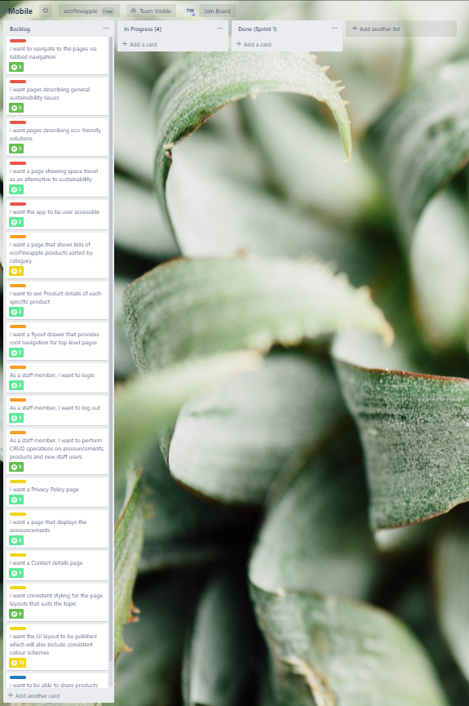

**Mobile Application Board**

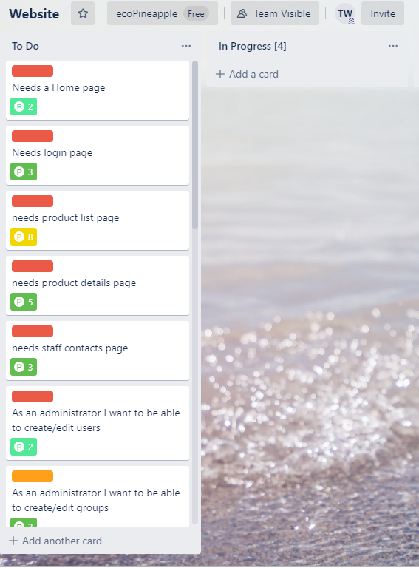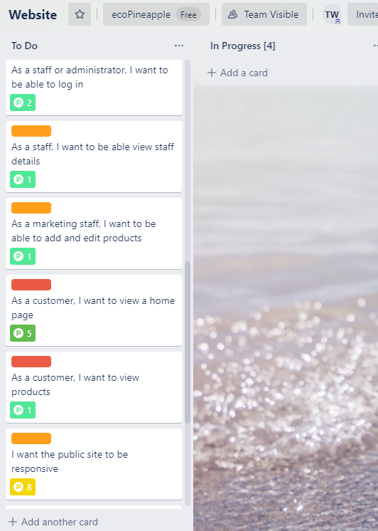

**Website Board**

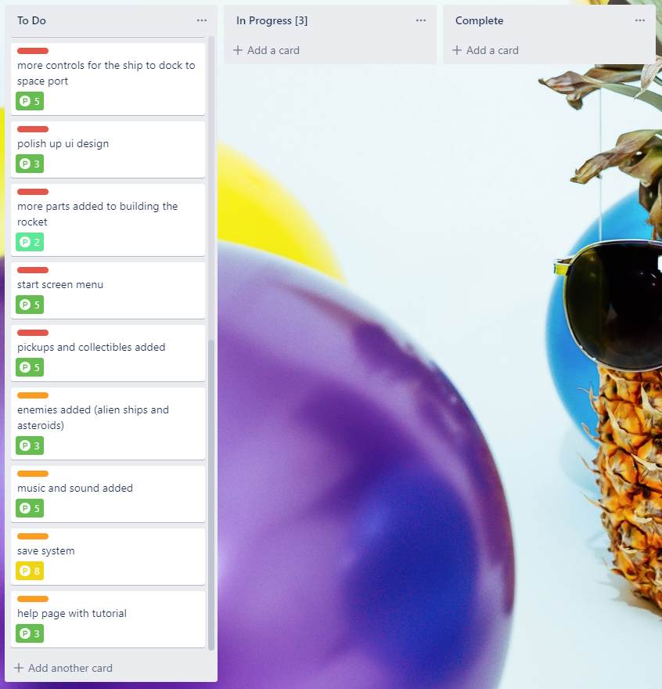

**Minigame Board**

# Development Tools

As a team, we agreed to use the following development tools to create our applications. These tools were selected as we have used them in previous projects.

|  |  |
| --- | --- |
| **Purpose** | **Development Tools** |
| Game Development | Visual Studio 2019, Unity 2019.1b |
| Mobile Development | Visual Studio 2019, Xamarin.Forms, Xamarin.Android, Android Studio, Mobile Development tools for Visual Studio |
| Website Development | Django, Node.Js, Visual Studio 2019, React.Js |
| Databases | SQLite3, MySQL |
| Planning | Trello |

# Meeting Minutes 2

The following are the meeting minutes that were recorded after presenting all the proposal documentation to the client. This meeting involved the team presenting a short overview of the proposal and provided another opportunity for the client to provide feedback for the team to address.

**11/09/19 - Client Meeting 2**

**Meeting Scheduled for 9:00 am (30 minutes)**

**Actual time spent (9:15 – 9:45) am ***Byron a bit late\*\*\***

**Present – Byron, Charles, Trent, Rob**

Things we discussed in this meeting were:

* Presented an overview of our applications.
* The schedule of weekly meetings involving sprint demos/retrospective
* Changes for the game – The discount codes offered for playing the game should be accessible to even users who are not great at playing games.
* Changes for the mobile app – No changes. Just make sure the content is meaningful.
* Changes for the website – The design will need to include functionality for how the warehouse team of ecoPineapple receives cart orders.

# Changes to Address Feedback

These changes were made to the design documents following Client Meeting 2. These are also documented in the IT6041_DevelopmentLog.

**IT6041_GDD**

Changes made on 16/09/2019 (following the client meeting)

* **Page 12**

An initial milestone will be provided that is easy to achieve. This is to help make discount codes more accessible to the general audience, who not all may be great at playing games. **– ADDED**

Added so that the discount codes offered for playing the game should be accessible to all users, even ones who are not great at playing games

**IT6041_WDD**

Changes made on 16/09/2019 (following the client meeting)

* **Page 3**

***In User Stories***

As warehouse staff, I want to see orders that need packing – **ADDED**

***In Stakeholder List***

Clients – Management, Marketing, Warehousing & IT Team - **UPDATED**

***In Identified user roles***

Warehouse Staff - who will process orders placed – **ADDED**

Note: Warehouse staff will be excluded from the development on this project, however included up until this point as they are part of the supply chain to get a product delivered to the customer. – **ADDED**

* **Page 4**

***In Context Diagram***

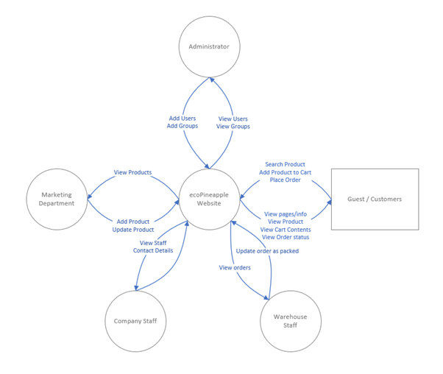

* **UPDATED**
* **Page 5**

***In User Functional Diagram***

Note: Warehouse staff have been excluded at this point as they are not being designed or catered for in the initial release. – **ADDED**

These changes were made to include functionality for how the warehouse team of ecoPineapple receives cart orders.