Minted Data Science  
Customer Segmentation Analysis

Prepared for: Cookie & Icing Bakery 4/9/2017

# Overview

Minted Data Science has completed a segmentation analysis for Cookie & Icing bakery using sales data from 1,000 customers that included 51 items. Five customer segments were identified and five sales opportunities were presented based on customer segment information.

## Customer Segments

Minted Data Science identified five different customer segments at Cookie & Icing. Five different versions of the segmentation analysis were considered with each analysis have a different number of segments. The smallest number of segments considered was four. Having four segments caused the segments to be more similar and provided less insight than a model including five segments. Including more than five segments provided more differentiated segments, but the segment sizes were too small to affect business decisions and made the analysis unnecessarily complicated. A description of the five different types of customers is below.

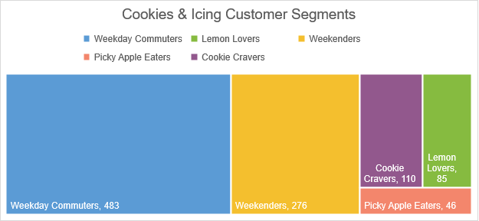

* **Weekday Commuters**
  + Never purchases items on the weekend.
  + Diverse product purchases so categories are easier to discuss rather than specific items.
  + Top three item categories are tarts (52%), cakes (42%), and cookies (34%).
  + Purchases more beverages than other segments.
* **Weekenders**
  + Never purchases on weekdays.
  + Diverse product purchases so categories are easier to discuss rather than specific items.
  + Top three item categories are tarts (53%), cakes (48%), and cookies (37%).
  + Customers in this segment on average have purchased more items than customers in the other segments.
* **Cookie Cravers**
  + 100% of these customers have purchased some type of cookie.
  + The top cookies are Tuile and Marzipan which have both been purchased by about 74% of these customers.
  + Cakes and tarts have been purchased by about 35% of these customers as well, but no specific type of cake or tart has proven to be more popular than another.
* **Lemon Lovers**
  + Loves lemon desserts. 74% have purchased lemon cake and 73% have purchased lemon tart.
  + Primarily visits on weekdays, but sometimes visits on the weekend.
* **Picky Apple Eaters**
  + Loves apple desserts and cherry soda. Top items are apple tart (98%), apple croissant (98%), apple Danish (91%), and cherry soda (67%).
  + Coffee and drinks other than soda are low priority.
  + Doesn't try new foods. Has not purchased half of the menu items, which is unlike other segments.

## Sales Opportunities

* Extend a promotion to the 50% of customers who only visit during the week. These customers clearly are within driving distance of the bakery, but tend to stay away during the weekend. Perhaps discounts, special weekend only items, or events may bring these customers in more frequently.
* Try advertising the apple pie. None of the Picky Apple Eaters segment have tried the apple pie yet.
* The segment that prefers cookies does not appear to purchase many additional items with their cookies. Perhaps beverages could be cross sold.
* Milk is frequently sold with sweet items, but is not on the menu at Cookie & Icing.
* Additional incentives around coffee appears to be a good opportunity. Only 16% of weekday visitors have purchased the coffee.

**UPDATE:**

After performing a market basket analysis additional recommendations of value have been identified:

* Blackberry Tart, Coffee Éclair, and Single Espresso are popular items being purchased together. When customer’s purchase the Espresso with either the Blackberry Tart or the Coffee Éclair, the likelihood of the customer purchasing the other desert is increased by more than 10 times what it normally would be.
* Customers who purchase lemon cookies or lemonade also tend to purchase raspberry cookie’s and/or raspberry lemonade.
* Although many customers who love apple deserts are already buying the cherry soda, the market basket analysis leads me to think additional apple loving customers would like cherry soda as well. A promotion or free samples could be used to test this.