Datasets and Training Model Comprehensive Explanation

1. Dataset Composition
The training data was created by merging multiple pig behavior datasets into a standardized 8-class format: lying, standing, walking, sitting, feeding, drinking, social_interaction, aggression. A total of 8,515 images were used in an 80/10/10 train/val/test split.

2. YOLOv8n Model Architecture
YOLOv8 Nano was selected for its balance between accuracy and performance on CPU-bound edge devices like the Raspberry Pi. It was trained on an RTX 4050.

3. Training Results & Metrics
The model achieved a high mAP50 (>0.82) on the evaluation set. Below are the visual results from the evaluation:
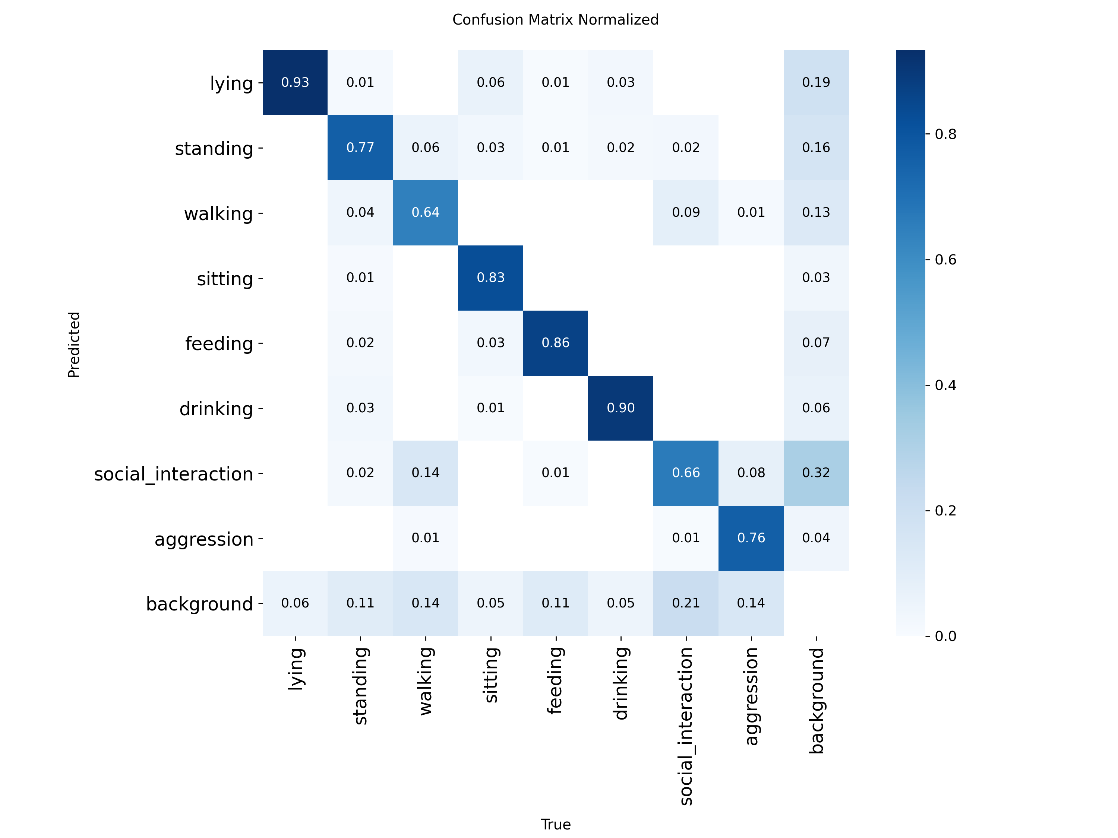
Normalized Confusion Matrix
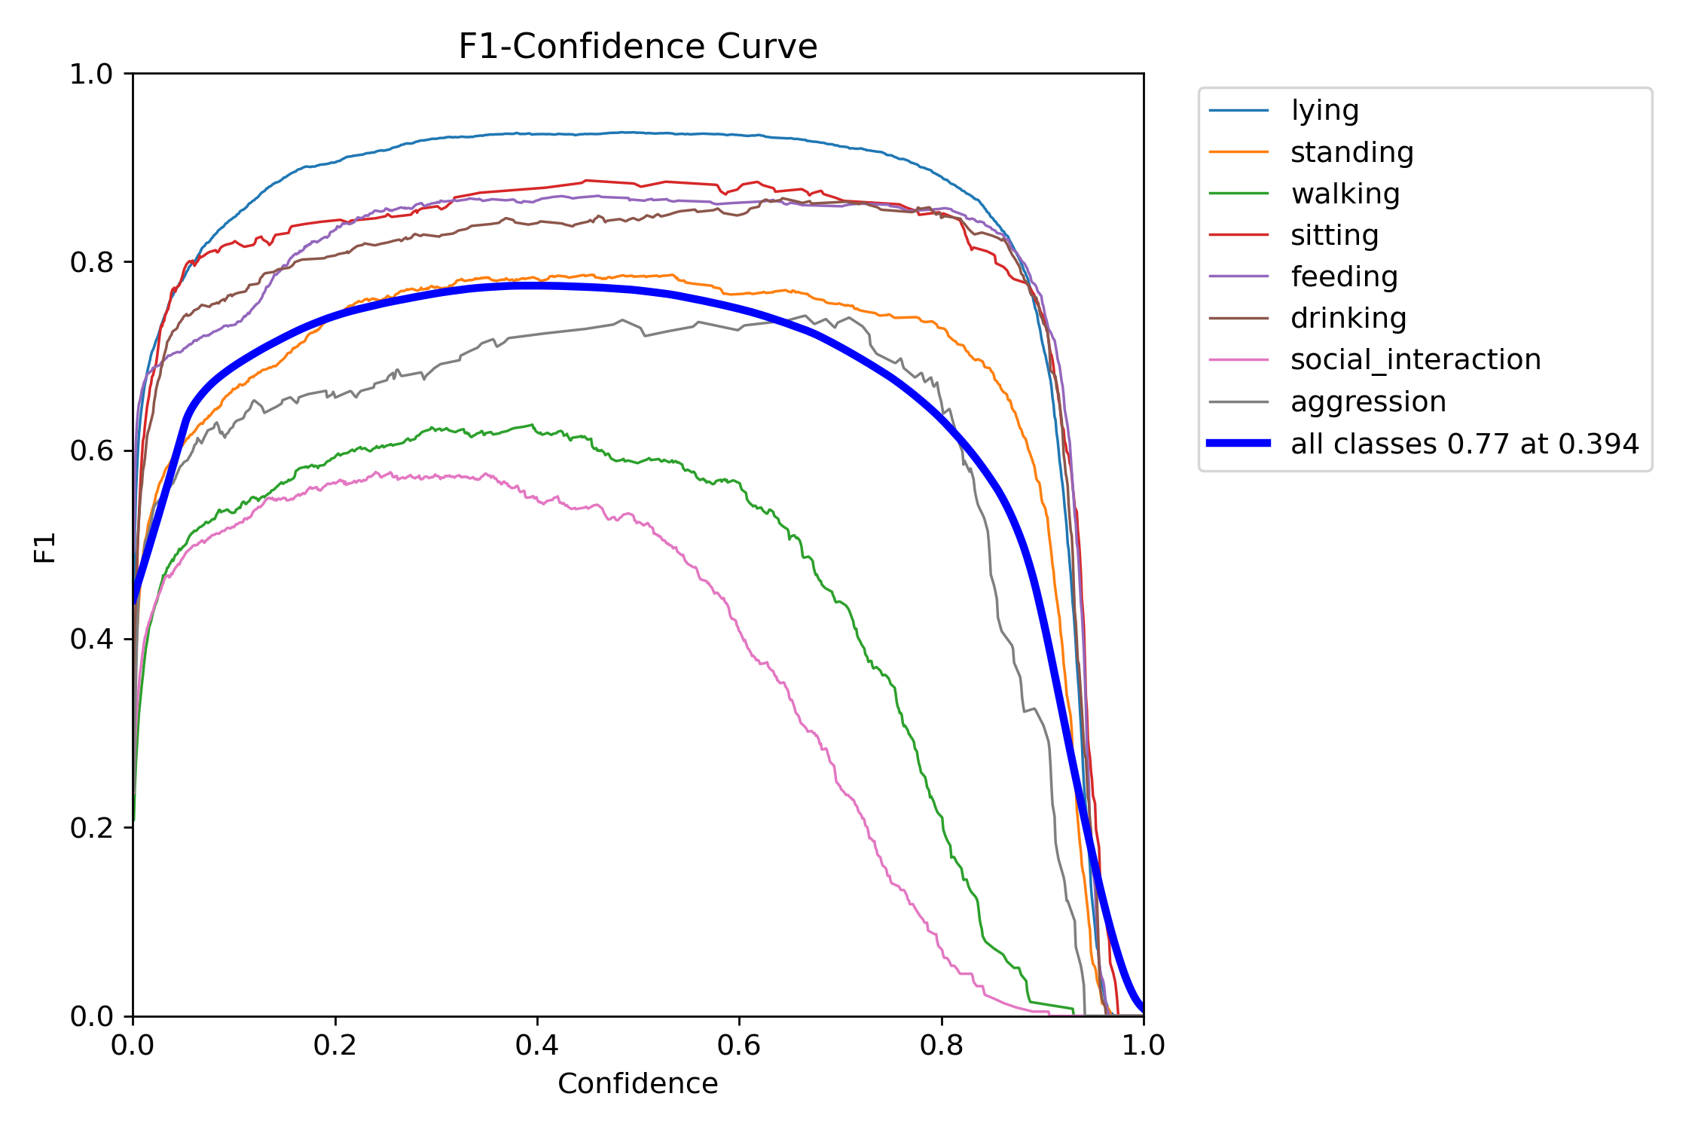
F1-Confidence Curve
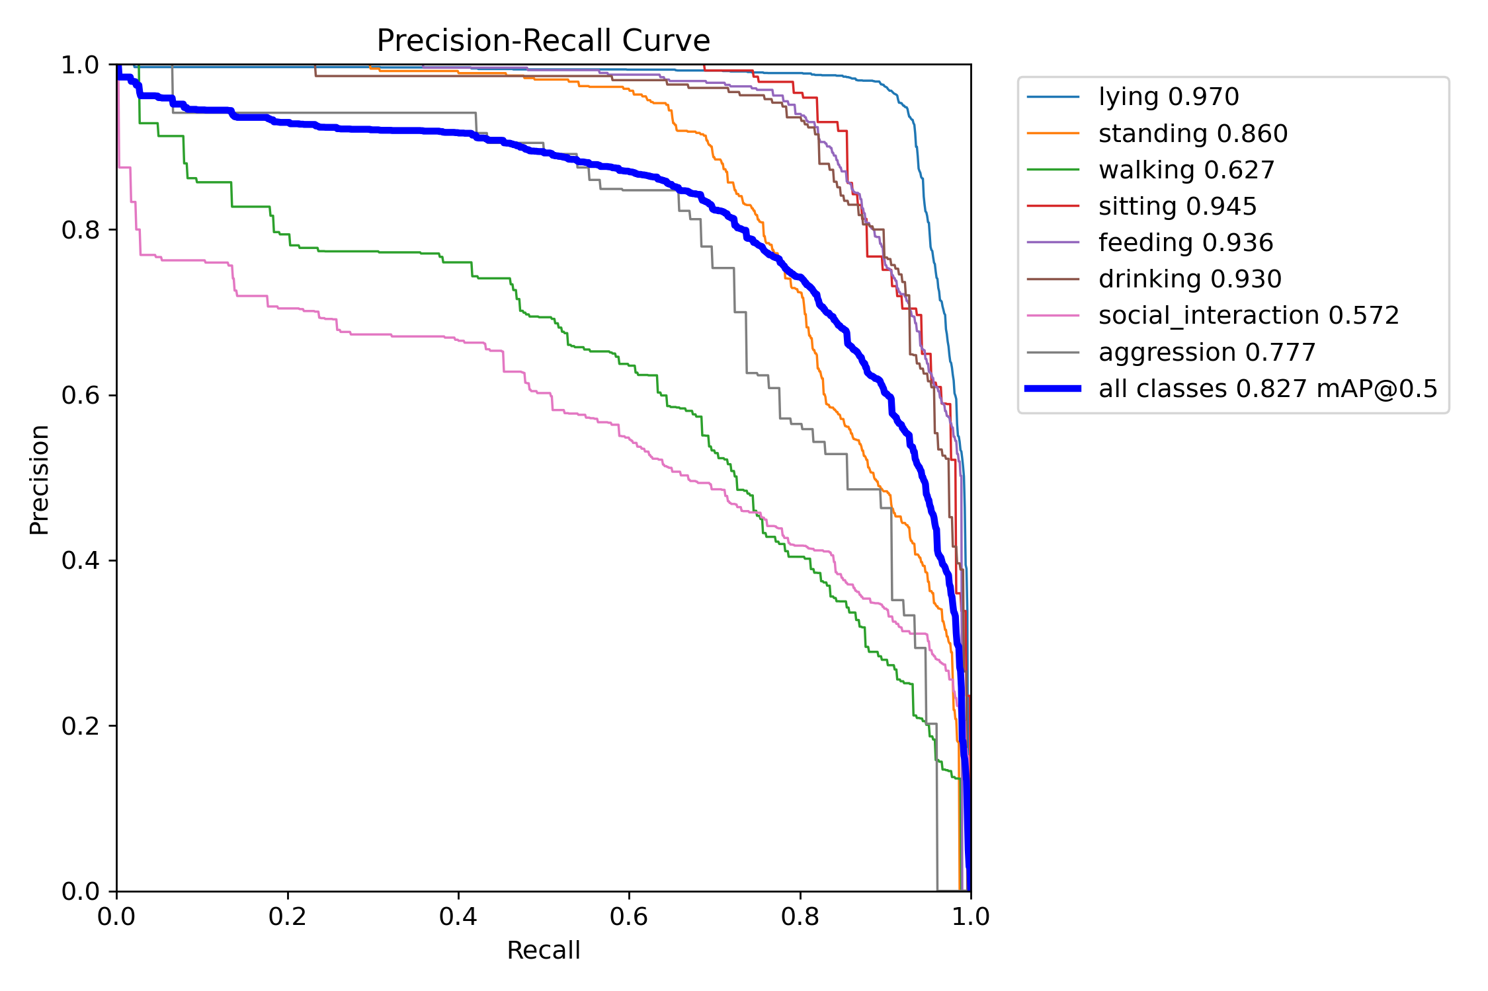
Precision-Recall Curve
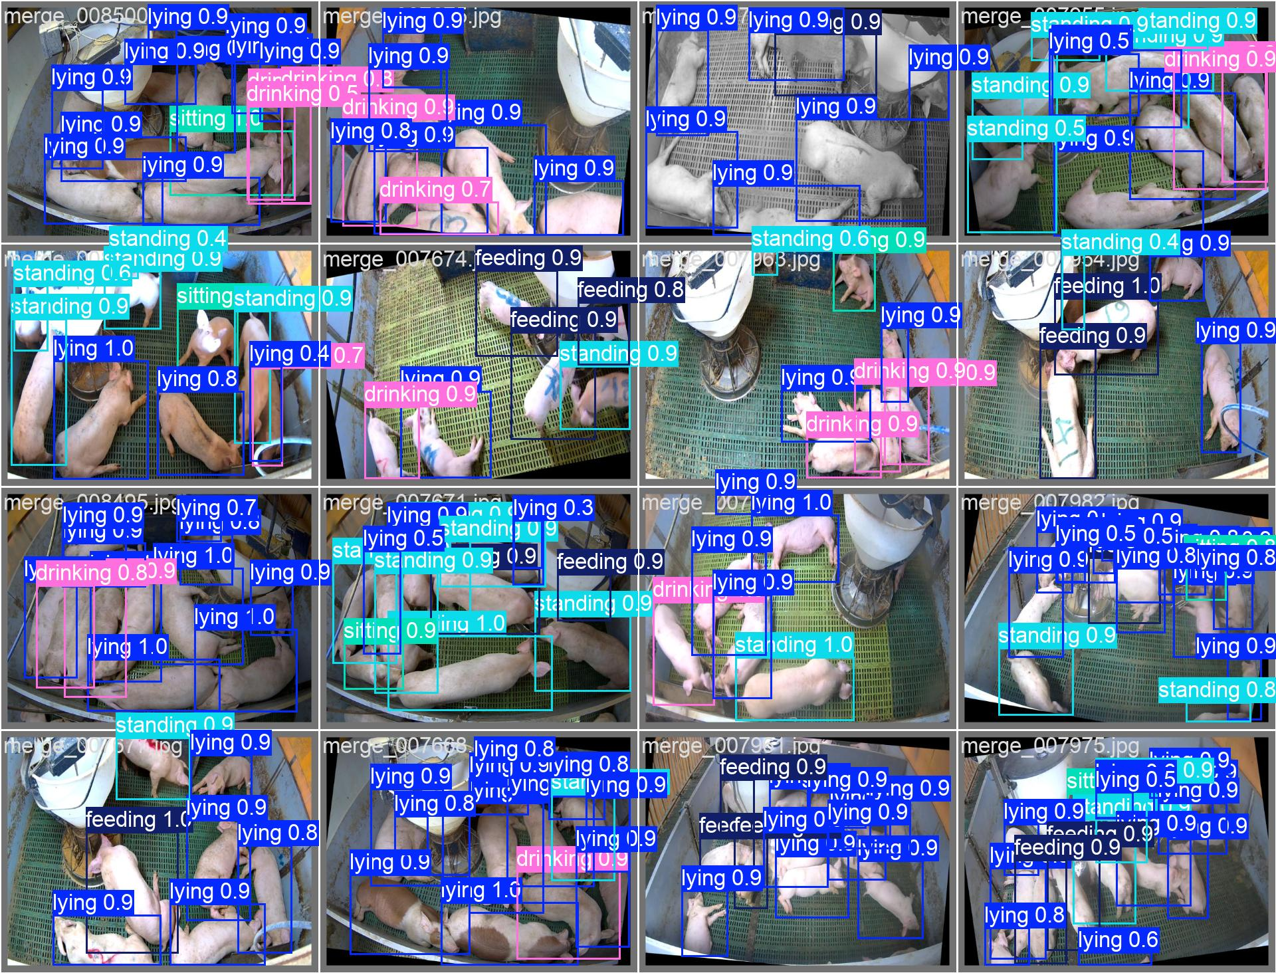
Validation Batch 0 Predictions

