Garbage Truck GPS Tracking System
Project Progress Report
Date: July 17, 2026
1. Executive Summary
The Garbage Truck GPS Tracking System is approaching its final phase of development. While several hardware components are still in transit, the development team has focused on completing and strengthening the web-based platform to maximize productivity during the waiting period. Significant improvements have been made to the tracking system, administrative dashboard, security, and route monitoring features, ensuring that the software is fully prepared for integration once the remaining hardware arrives.
2. Key Milestones Achieved
- Offline Reliability (Blackbox Mode):
The tracking system has been enhanced to operate reliably even in areas without cellular connectivity. The device can securely store up to 50 minutes of GPS location data in its internal flash memory and automatically synchronize the buffered records with the cloud once the internet connection is restored, preventing data loss.
- Automated Checkpoints and Geofencing:
A Checkpoint Management feature has been implemented, allowing administrators to create circular geofences on the map. The system automatically records when a garbage truck enters these designated areas, generating immutable route compliance logs that help verify completion of assigned collection routes.
- Enhanced Security Architecture:
Communication between the GPS tracking hardware and the cloud database has been secured using API key authentication, ensuring that only authorized devices can transmit location data and preventing unauthorized submissions.
- Command Center Dashboard:
The web-based administrative dashboard has undergone major improvements, including:
  - Real-time vehicle tracking
  - Historical route playback
  - Daily checkpoint compliance monitoring
  - Improved user interface and navigation
  - Administrative tools for fleet monitoring and management
- Web Application Development:
Since several hardware components have not yet arrived, development efforts have been concentrated on completing the software platform. Most web application features have been finalized and tested, allowing hardware integration and field testing to proceed immediately upon receipt of the remaining components.
3. Hardware Components for Final Deployment
The following hardware components will be used for the final GPS tracking device:
Component
Waterproof Enclosure
LilyGO T-Call A7670E
18650 Battery (3500 mAh)
TP5100 2A Charging Module
PCM HX-2S-A2 Battery Protection Module
15W Solar Panel
DC Step-Down Converter
GPS Antenna
Female Antenna Connector
Cable Gland PG9
2-Cell 18650 Battery Holder

4. Next Steps
- Receive the remaining hardware components.
- Assemble the GPS tracking hardware inside the waterproof enclosure.
- Flash the latest firmware to the LilyGO T-Call A7670E device.
- Integrate the hardware with the completed web platform.
- Conduct field testing to verify:
  - GPS accuracy
  - Offline data synchronization
  - Geofence checkpoint detection
  - Solar-powered charging performance
  - Overall system reliability

5. Documentation Progress
Initial Design and Local host testing
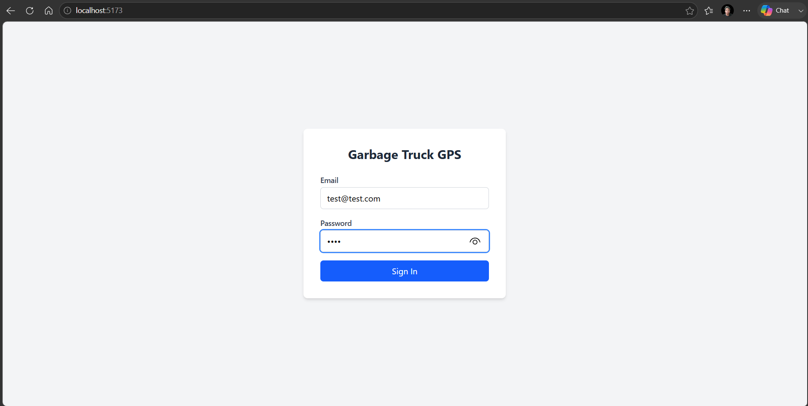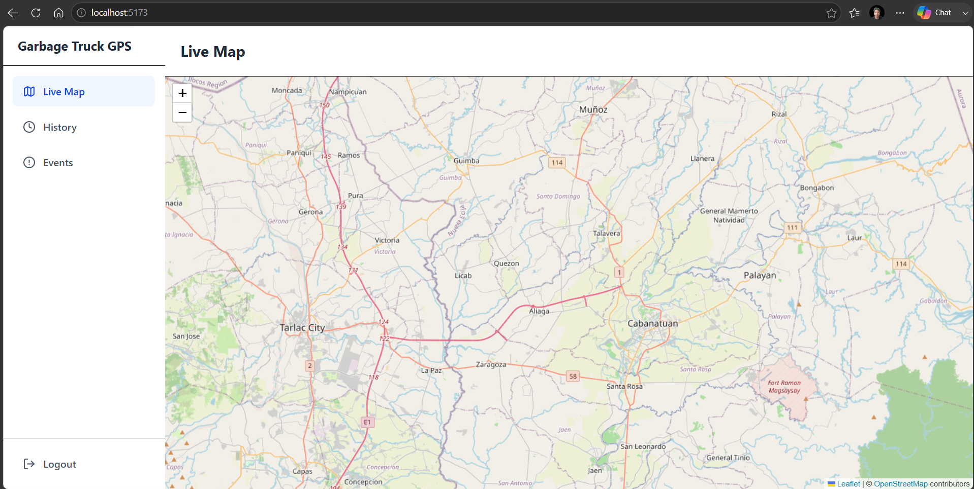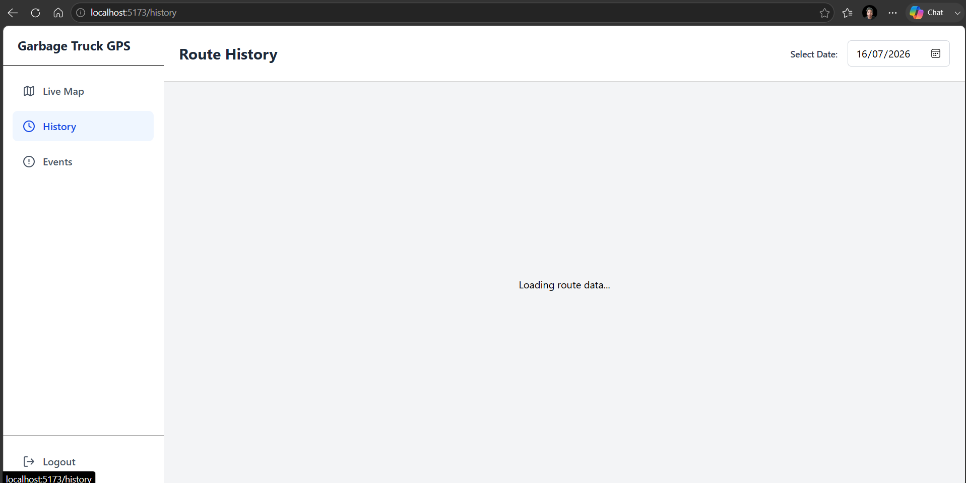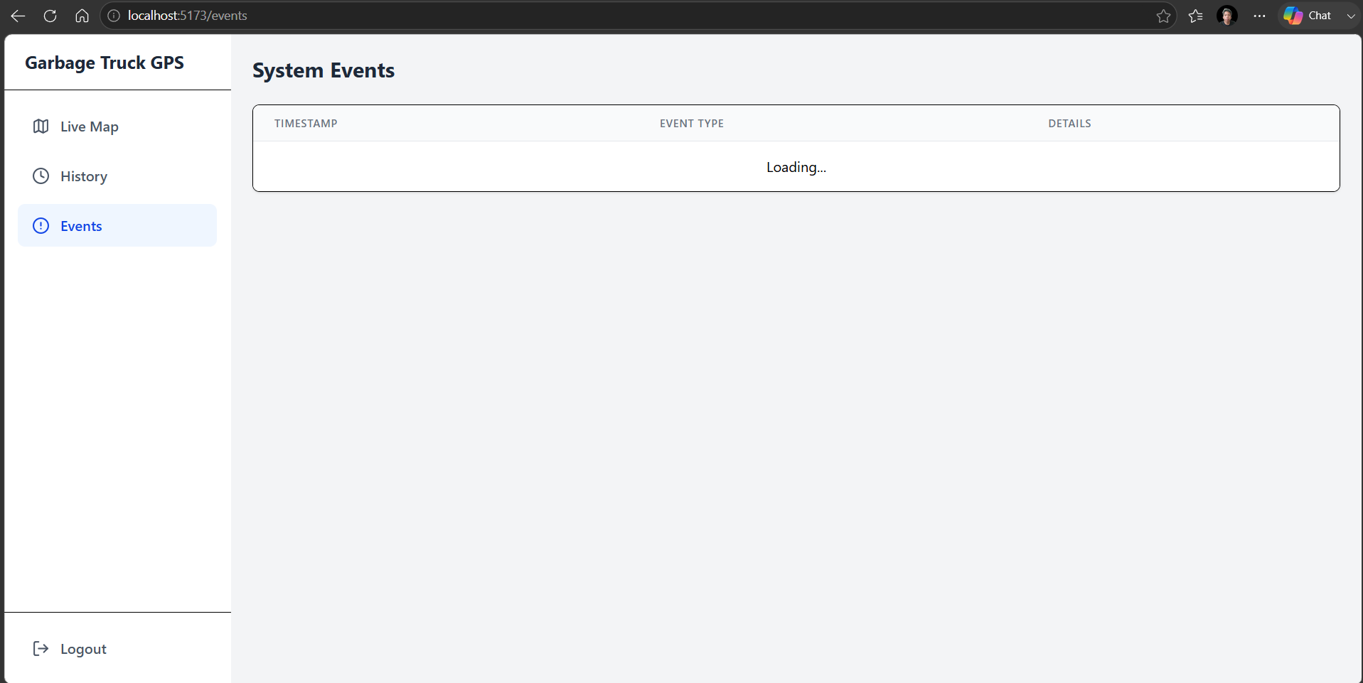

Dashboard V2

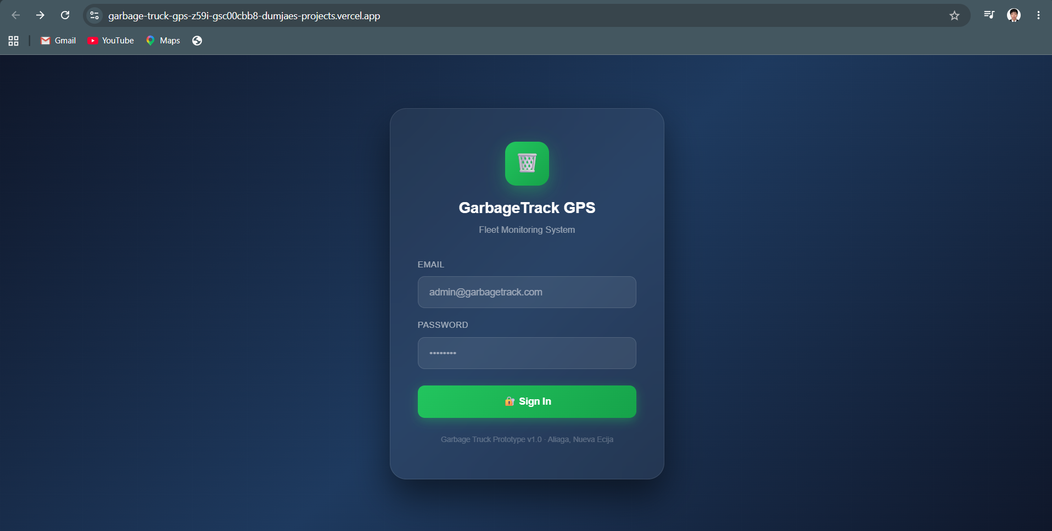
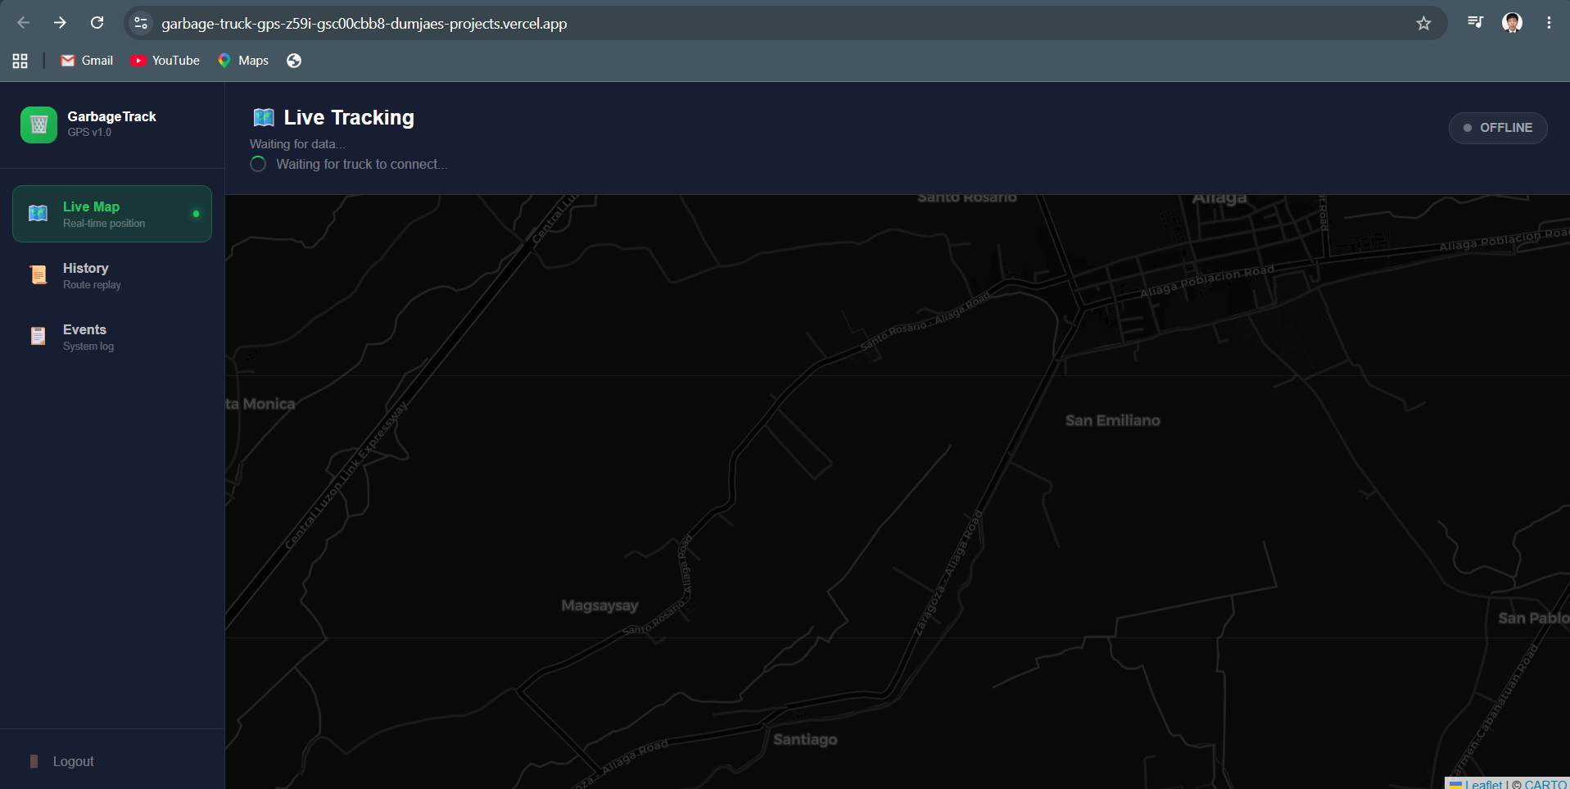

Dashboard V3
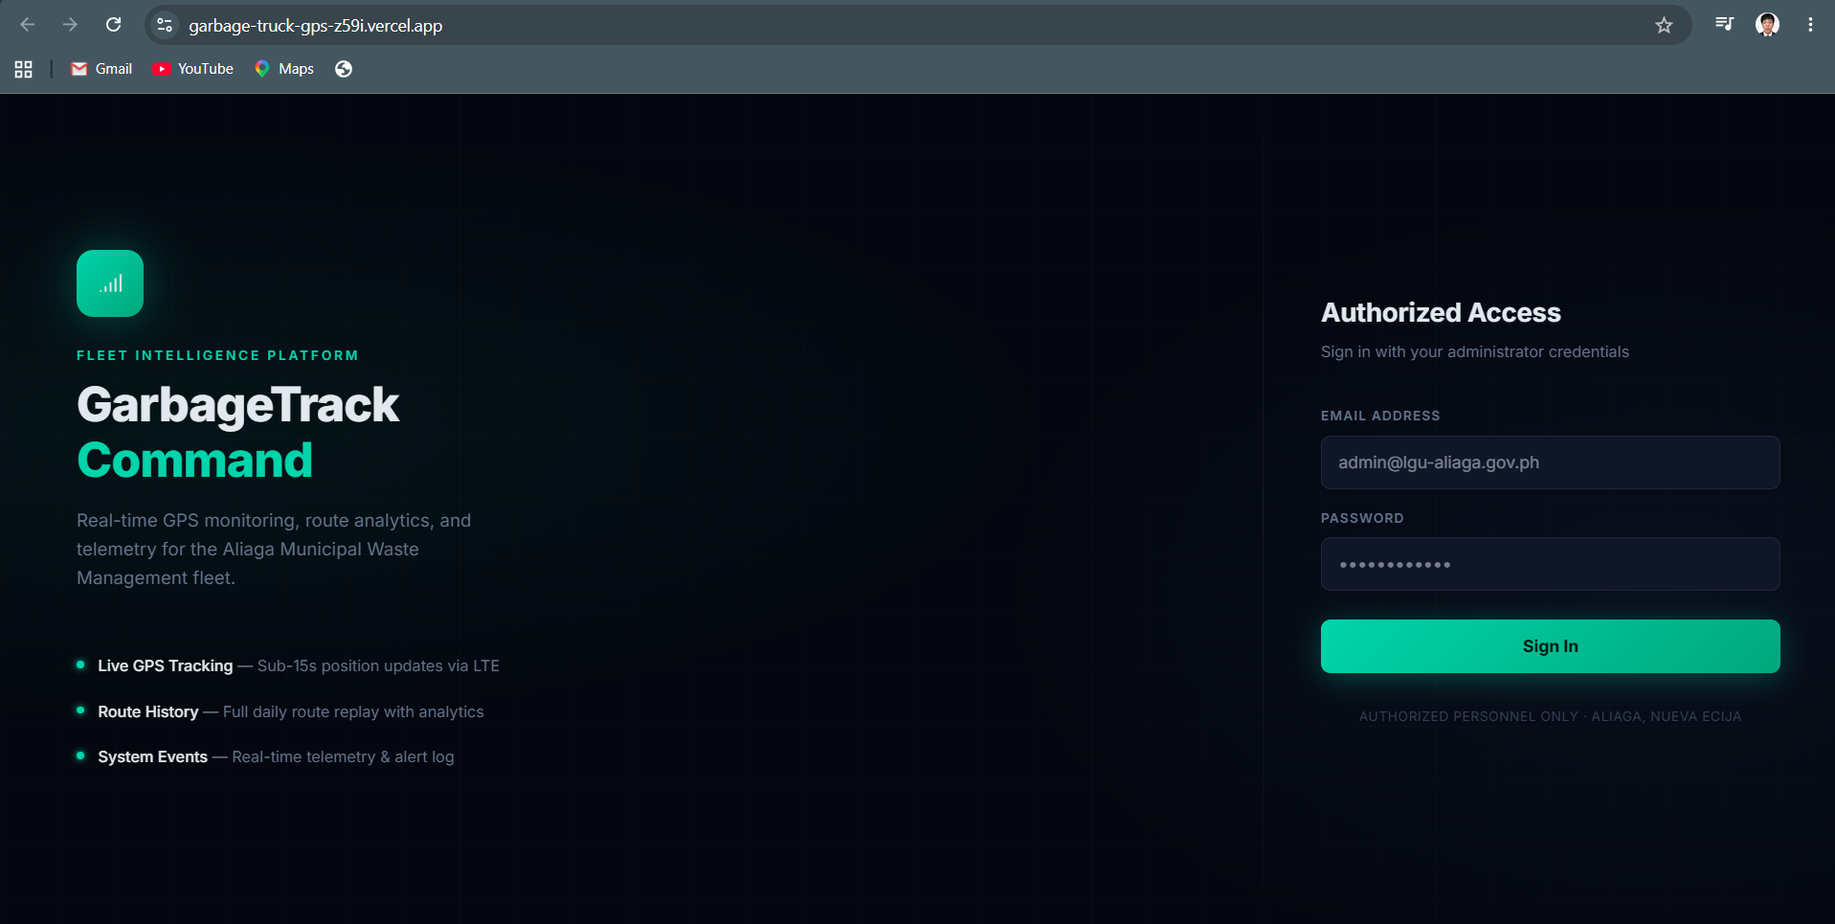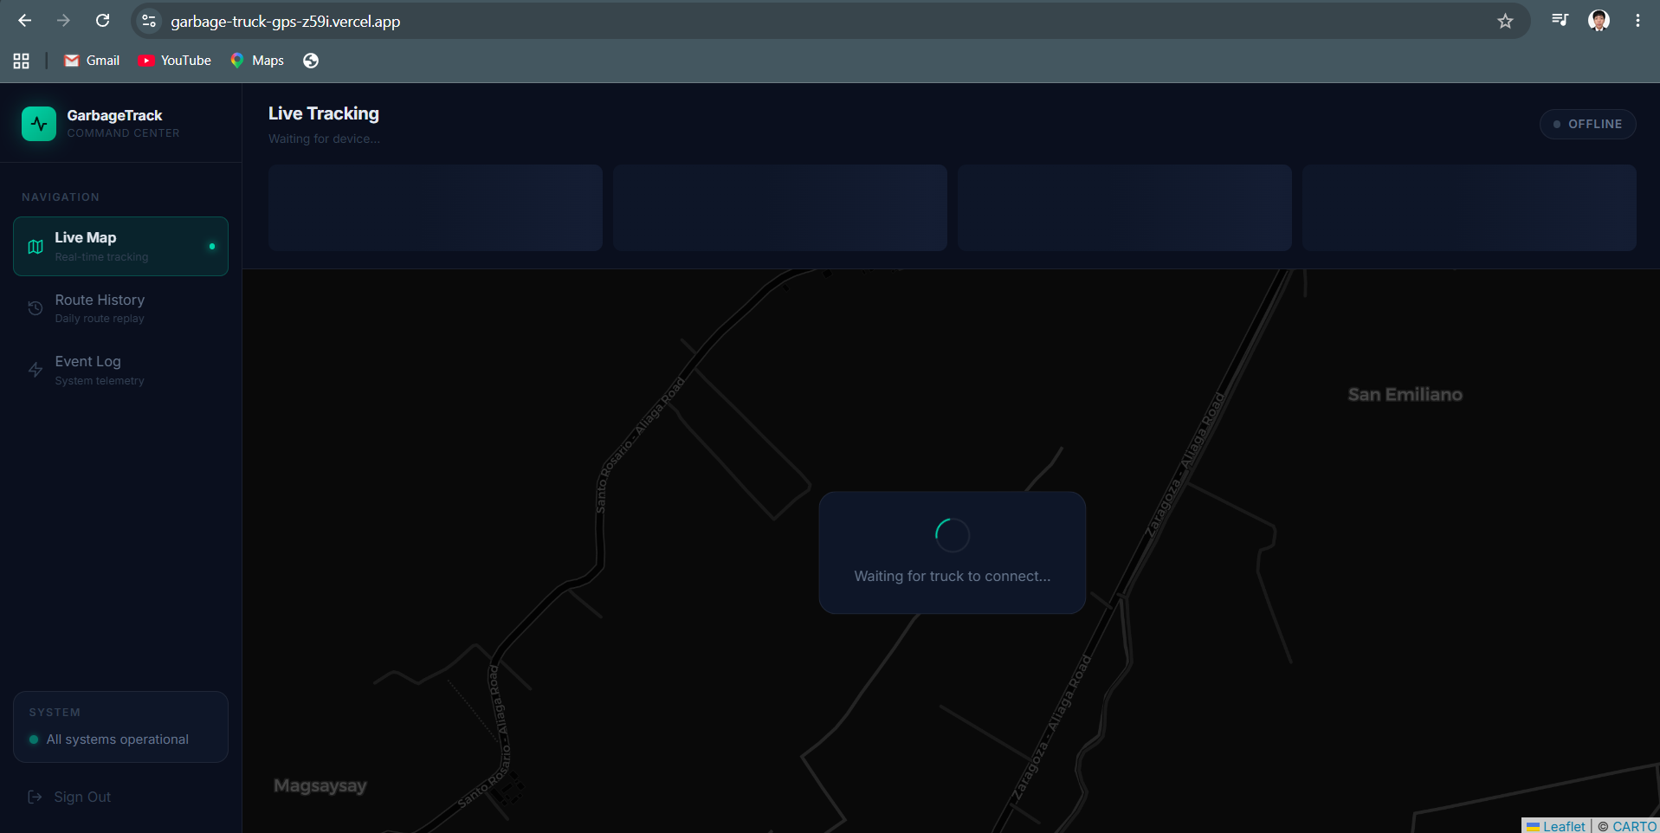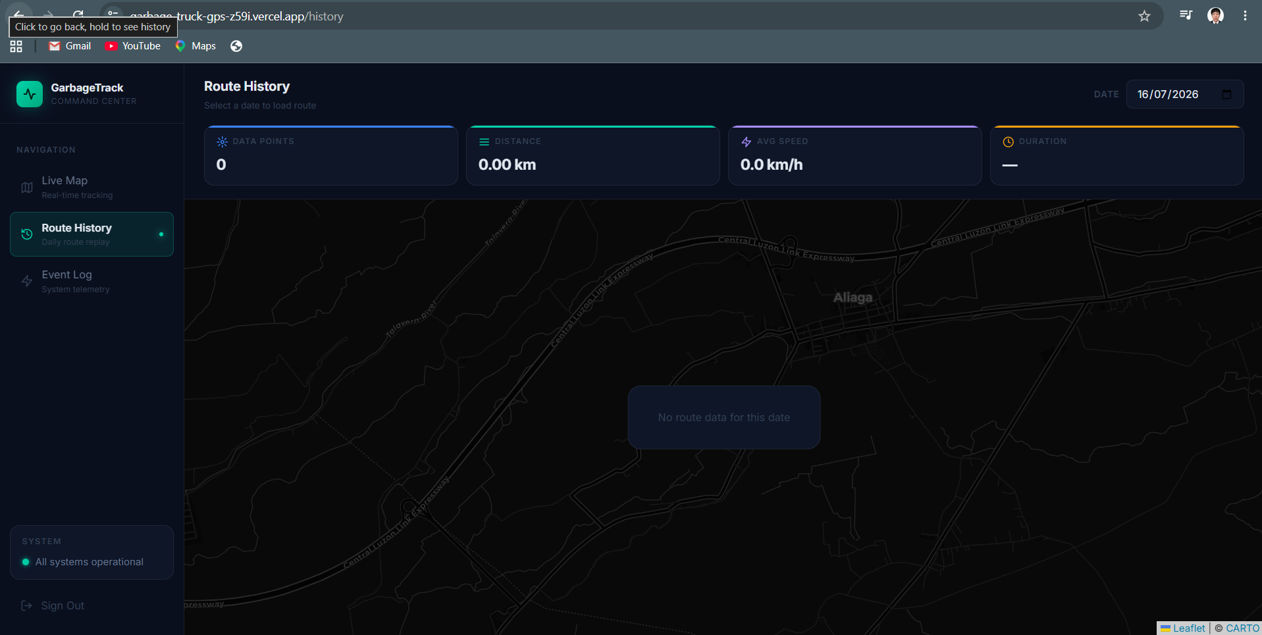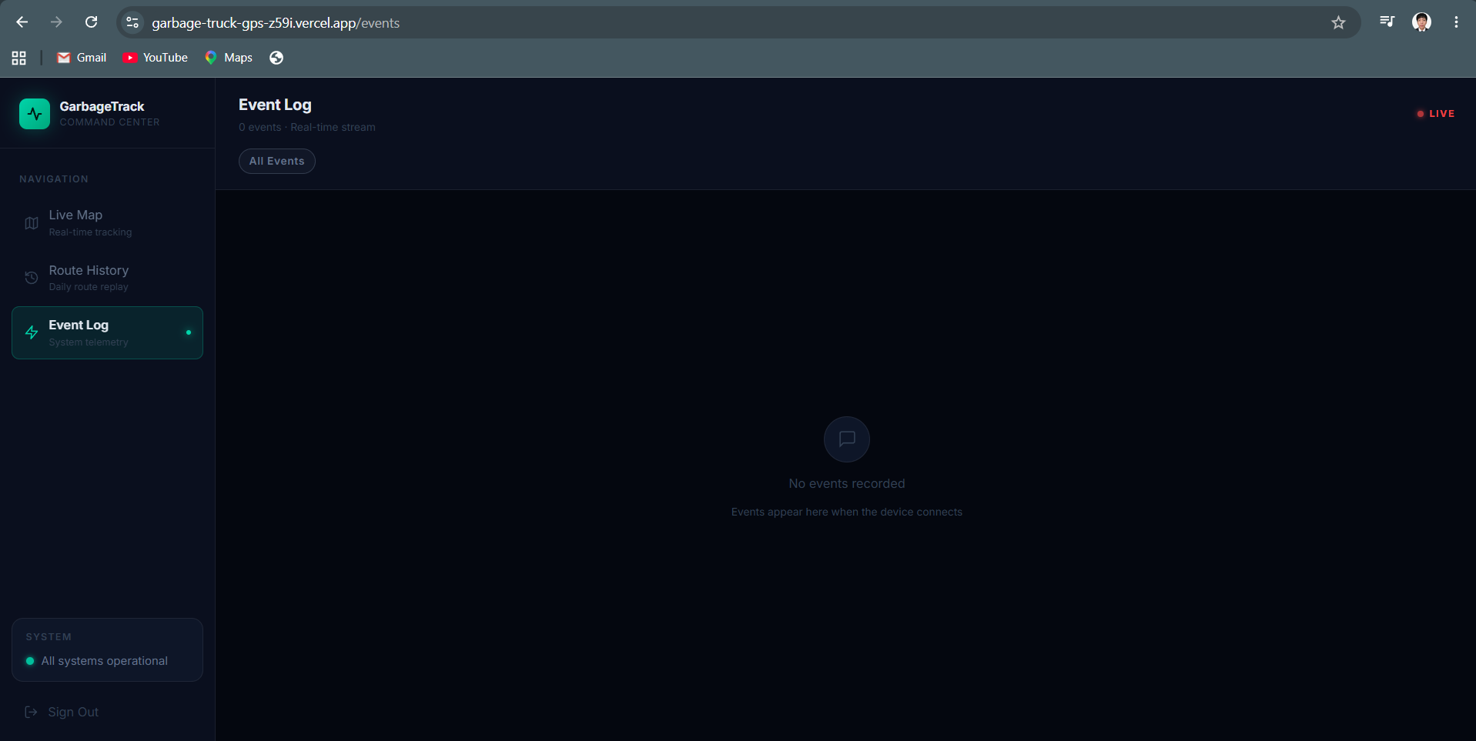

Dashboard V4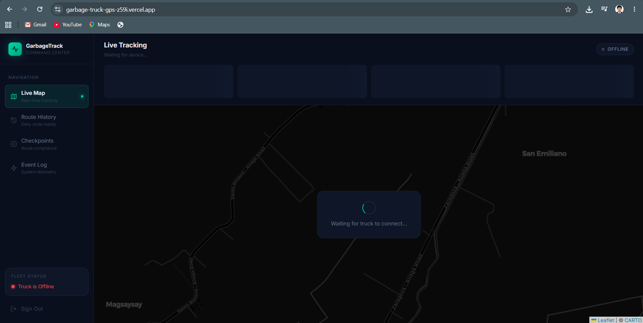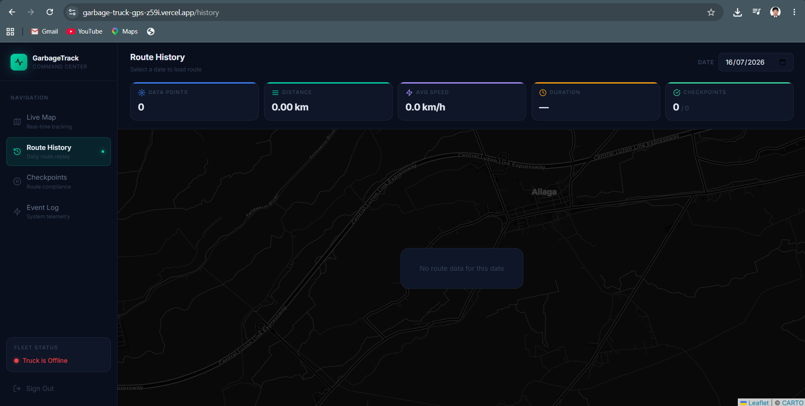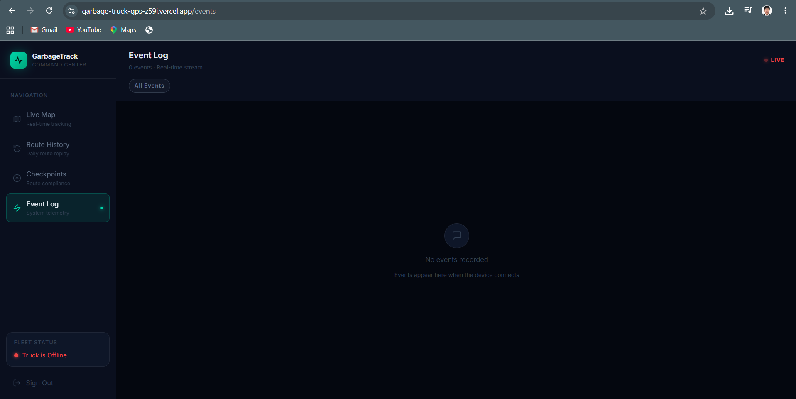

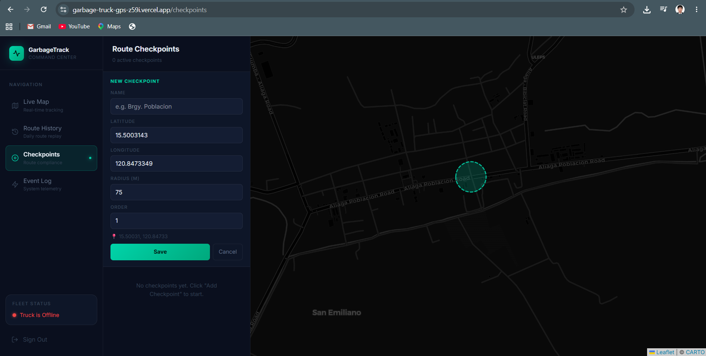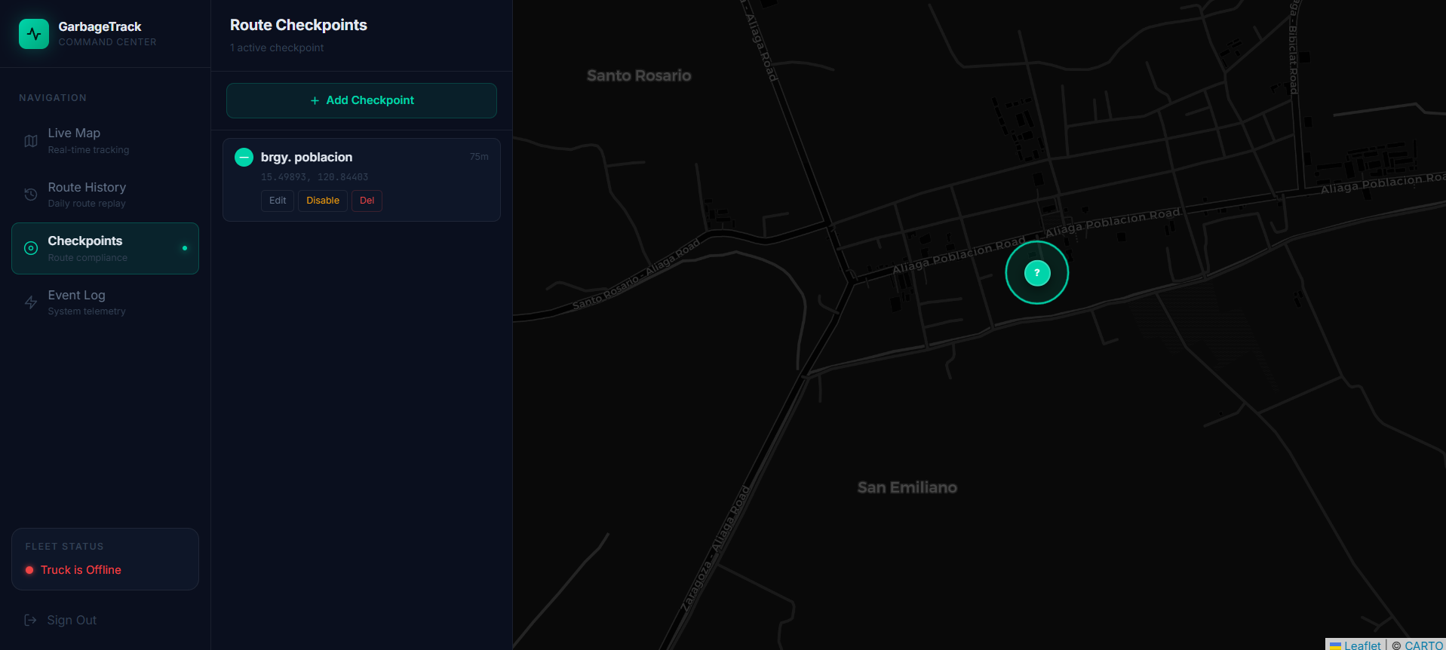
6. Conclusion
Despite delays in receiving several hardware components, the project has maintained steady progress by prioritizing the completion of the web application and backend infrastructure. The software component is now largely complete, incorporating robust offline data handling, secure communications, geofencing capabilities, and an enhanced monitoring dashboard. Once the remaining hardware arrives, the team will proceed with device assembly, firmware deployment, and comprehensive field testing. Overall, the project remains on schedule and is well-positioned for successful completion and final evaluation.

