Assignment for **Oracle E- Business Suite General Ledger**

Date:15th Nov-2024

[Provide screenshots of each step (which performed in a live environment).  
As evidence all the activity screens shot needs to be attached]

1.Create Your Own user ID from System Administrator Responsibility.  
 Assign the following responsibilities to your Oracle User ID

* **Vision Operation General Ledger.**
* **Vision Operation Inventory**.
* **Vision Operation Procurement**

2. For your user ID password expiration day should be 60 days

The following screenshot is for steps 1 and 2 above. First click on hat icon to switch responsibility to System Administrator. Then on navigation window click on **SECURITY > USER > DEFINE** which will pop open the Users window. Here you will define your users username and password(enter twice the same value). Then in same window, in Direct Responsibilities tab you will choose your roles. Also as mentioned, set password expiration Days = 60 . When everything is done click **SAVE**  and can close the window. Try opening same window again and search for newly created user and verify everything is set as you want it.

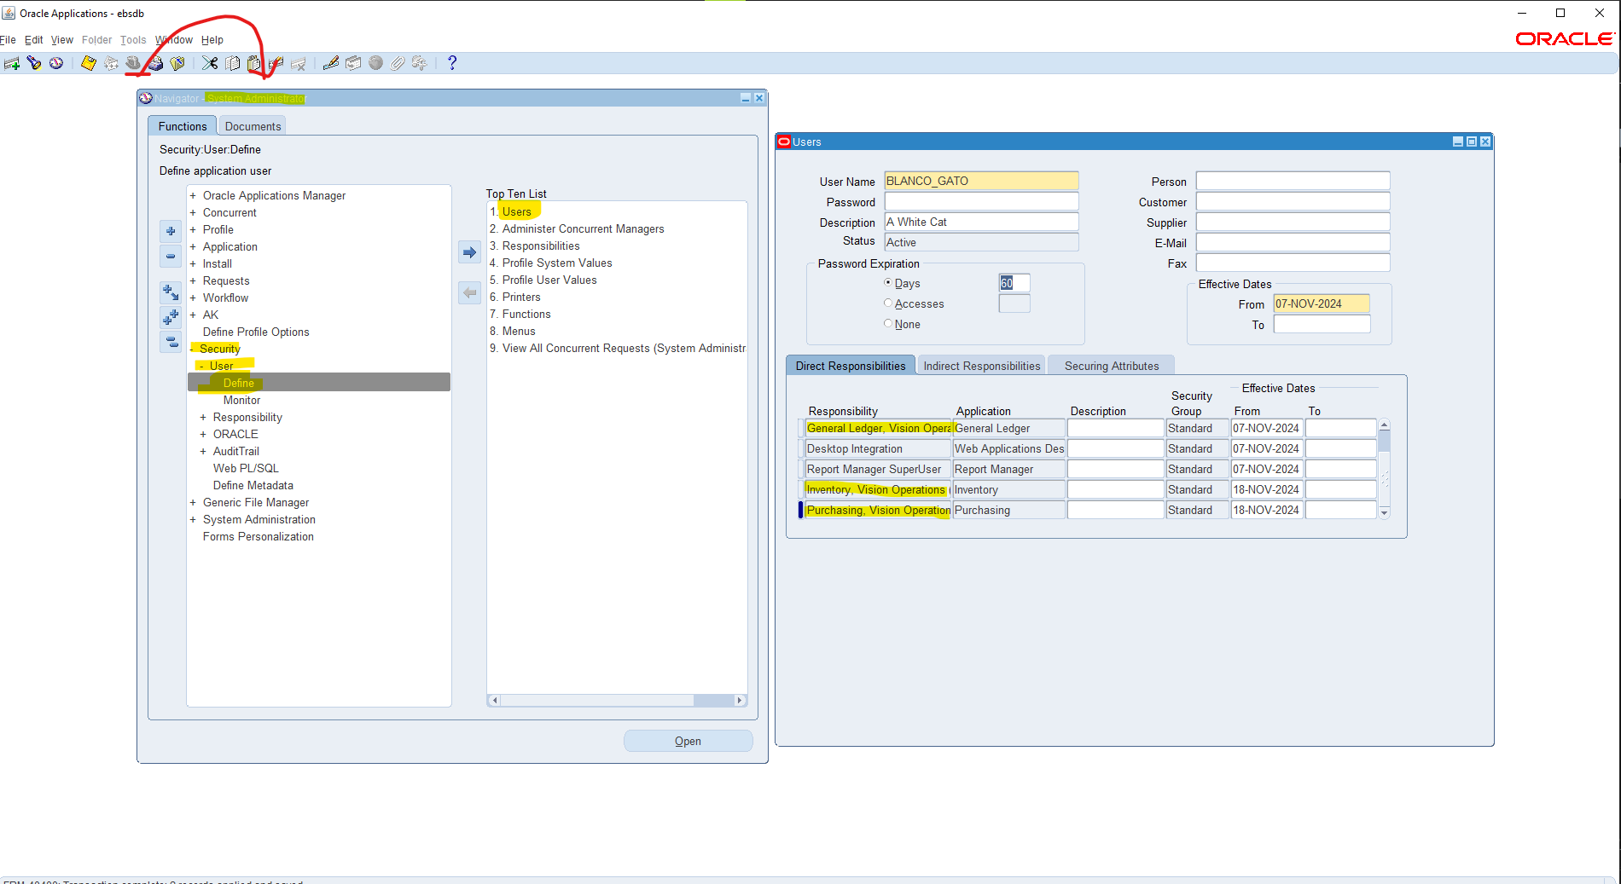

3. In **Vision Operation General Ledger** responsibility.

Form Accounting Setup Manager> Find the **Vision Operation [Primary Ledger]**

Following screenshot shows how to switch to required responsibility (General Ledger, Vis...) Then in navigation window click on **SETUP > FINACIALS > ACCOUNTING SETUP MANAGER > ACCOUNTING SETUP** which will open up an html page further described in next screenshot.

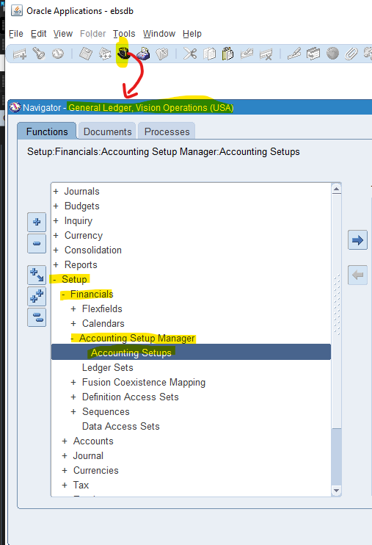

This html page for Accounting Setup Manager pops open and search for Vision Operations (I use wild cards % to make this easier as shown) and click GO. The correct one as shown should appear in search results and click on yellow pencil all the way on the right of this row under Update Accounting Options

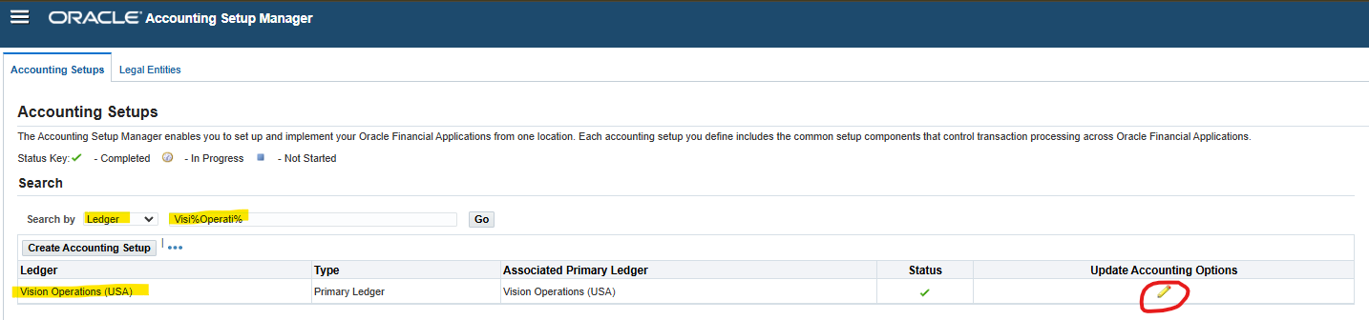

When you are in Accounting Options, look in the primary ledger section and find the row for Vision Operations (USA) and click on the right most side the yellow pencil for update

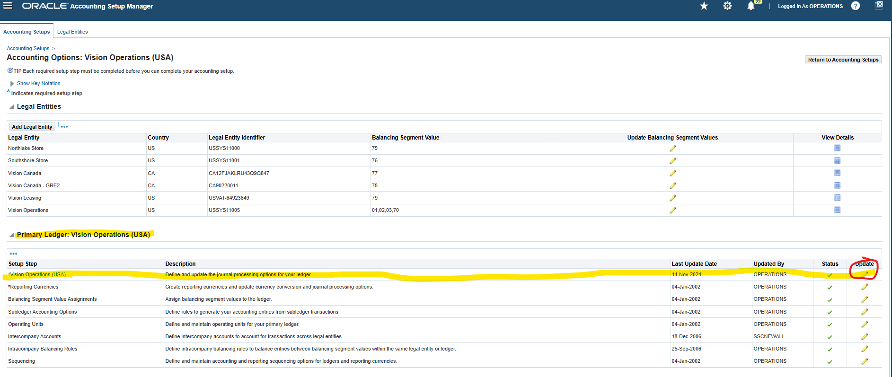

Here you can see the 4 c’s

**Currency**, **Chart of Accounts**, **Calendar** (Accounting Calendar), **Accounting Convention** (Subledger Accounting Method)  
  
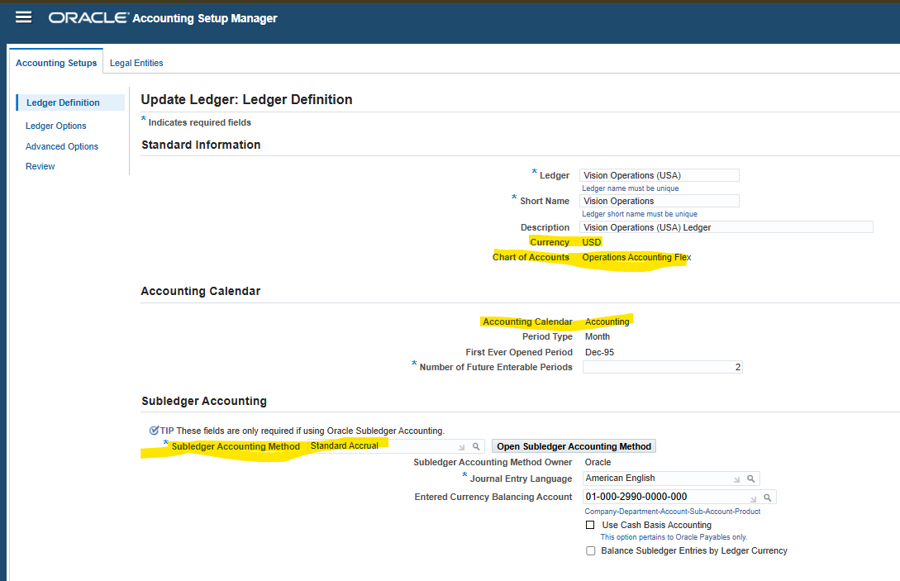

In this Ledger finds the **4C** Component, mentions the 4C name & take the screen shot as Evidence.

1. Find the Respective Calendar **Vision Operation [Primary Ledger].**

The calendar is in the previous screenshot in the field called Accounting Calendar.

4.Find all the **Account Code Combinations.**

In the following screenshot, make sure your responsbility is set to General Ledger , Vision Operations (USA). Then in the navigation window click through **SETUP>ACCOUNTS>COMBINATIONS**  which will pop open the GL ACCOUNTS window. Here press ctr+f11 (or ctrl+fn+f11 if on laptop or special keyboard if necessary) and this should populate all defined accounting combinations. There are many so there is a scroll bar you can pull down

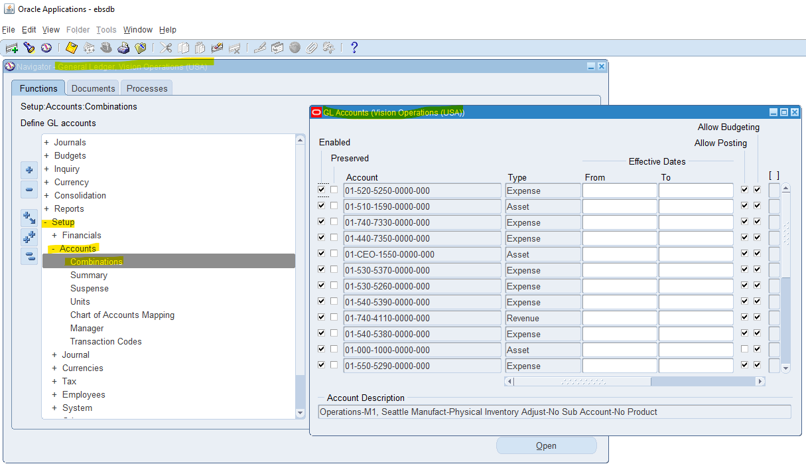

5.Find all the Journals [**SOURCE: Payables].**

Once again we are still in the GL (general ledger) responsibility, and click on navigation window and click through JOURNALS > ENTER and this opens the Find Journals window. In the Ledger field just click on the three dots and it should auto populate Vision Operations (USA). Then click FIND

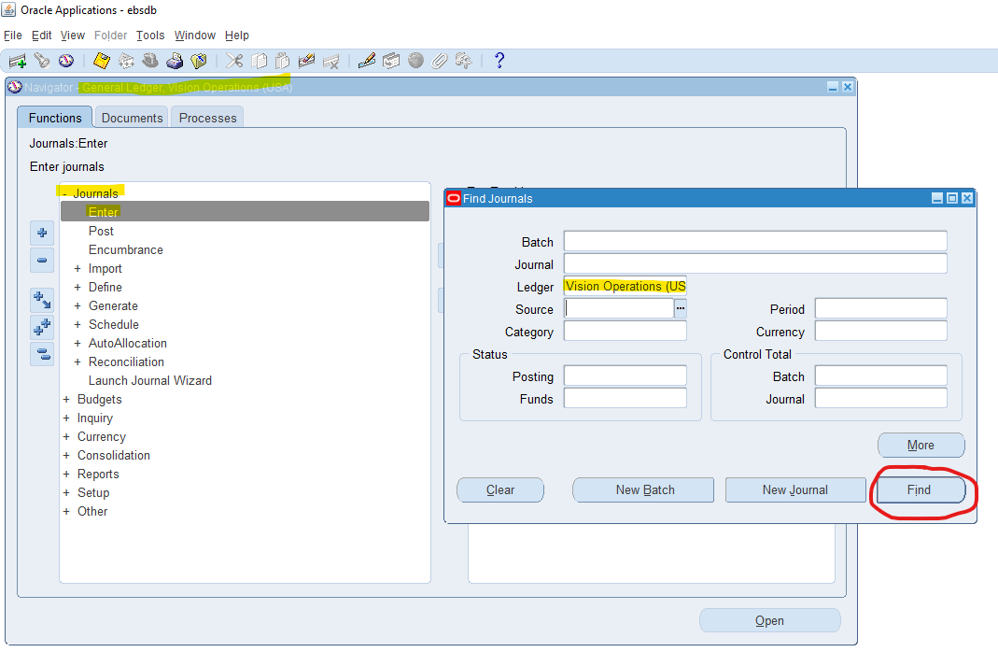

This will autopopulate the other window titled “Enter Journals..” where all journals are shown.

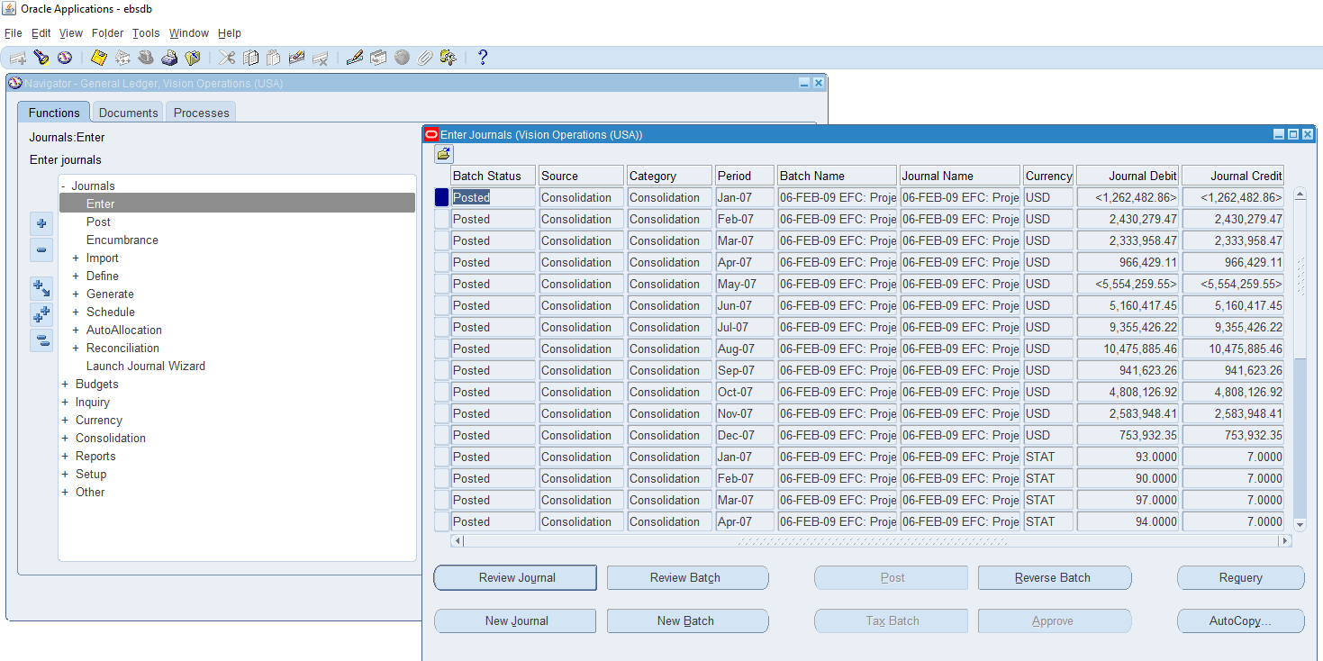

6. In Journal Header from record History find the respective **Data base Table name.**

Make sure to have the previous window highlighted in the previou screenshot. Then on top of application window click on Help > Record History to find the table name that holds the respective data base table name

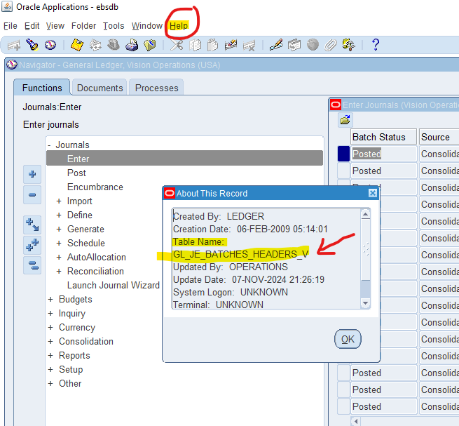

7. Find the one Manual [Source] & one Payable [Source].

This task is similar to finding all the journal entries from step 5 above. The screenshot shows the navigation but we will query based on the field called Source as shown. Make sure ledger field has the field Vision Oper...

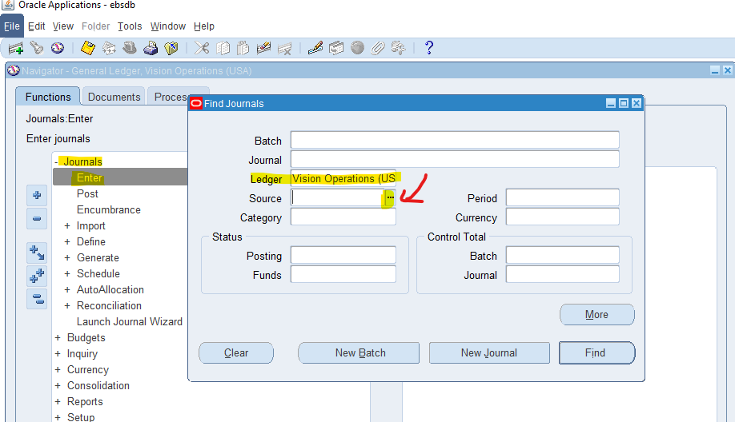

Now here we can search for either Manual or Payables and when inputted for either click on Find to execute the query.

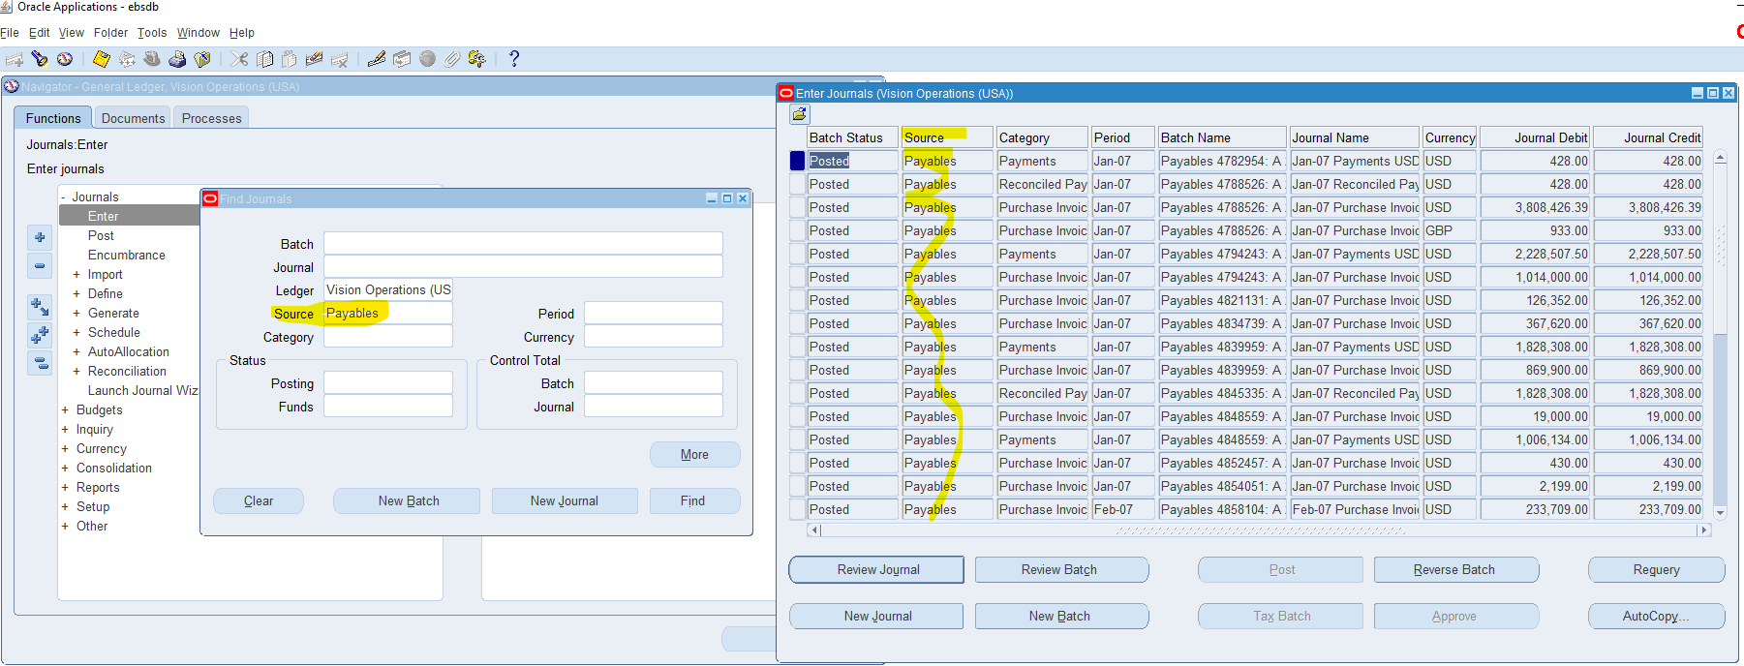

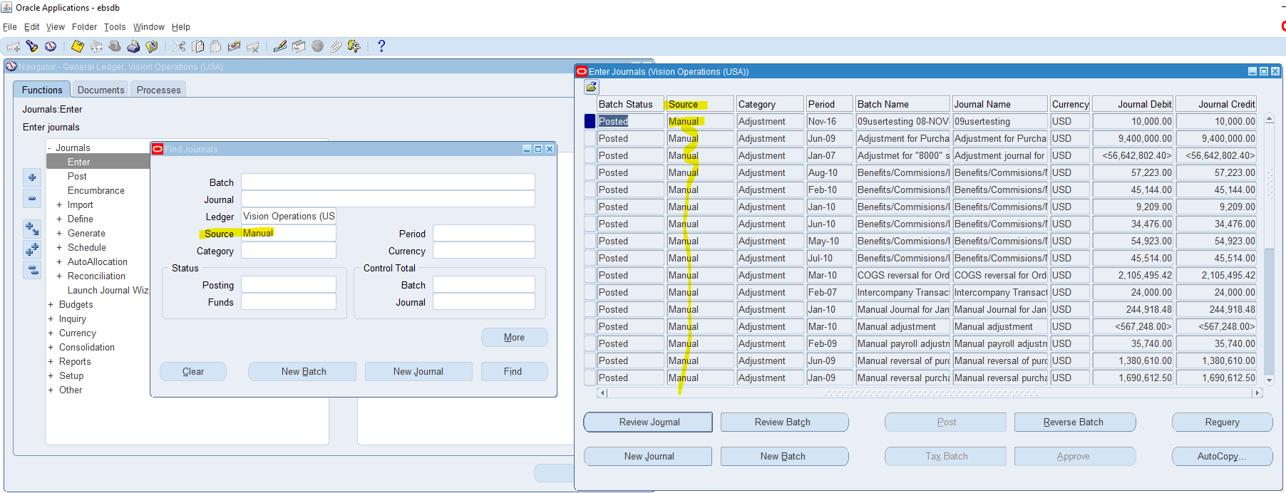

8.How can you review posted journal entries in Oracle GL? Steps & screen shots

This is very similar as steps 7 and 5 but now we want “POSTED” journals as mentioned in this step definition. In the Find Journals window make sure to have the same ledger as mentioned before, and in Status > Posting make sure to have the valued Posted as shown in following screenshot. And finally hit Find.

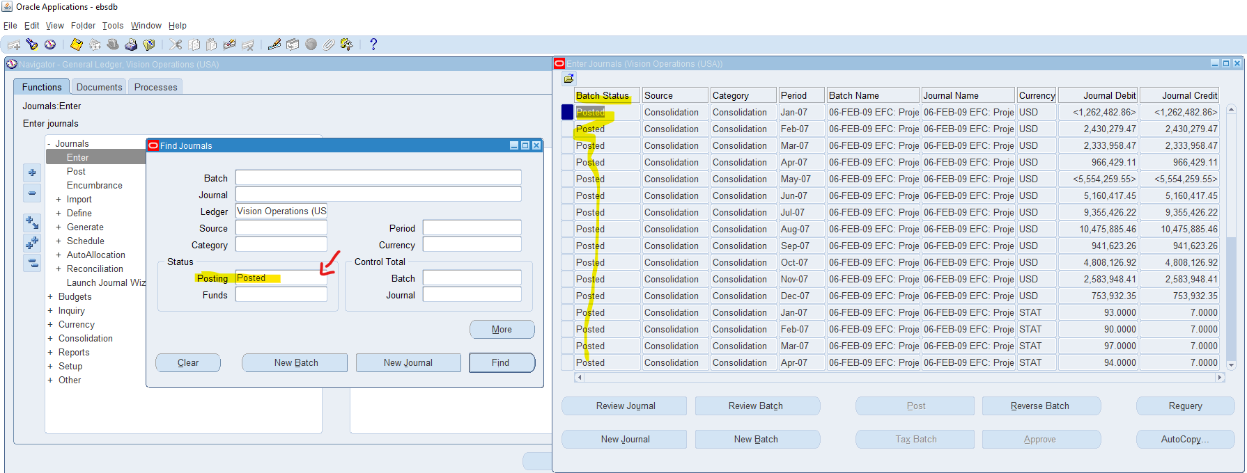

9. Find the **Chart of Accounts [COA]** Structure in General Ledger.

In the following screenshot, make sure your responsibility is set to General Ledger , Vision Operations (USA). Then in the navigation window click through **SETUP>FINANCIALS>FLEXFIELDS>KEY>SEGMENTS**  which will pop open the Key Flexfield Segments window. Here press ctr+f11 (or ctrl+fn+f11 if on laptop or special keyboard if necessary) and this should populate all defined accounting flexfield structures. There are many so there is a scroll bar you can pull down

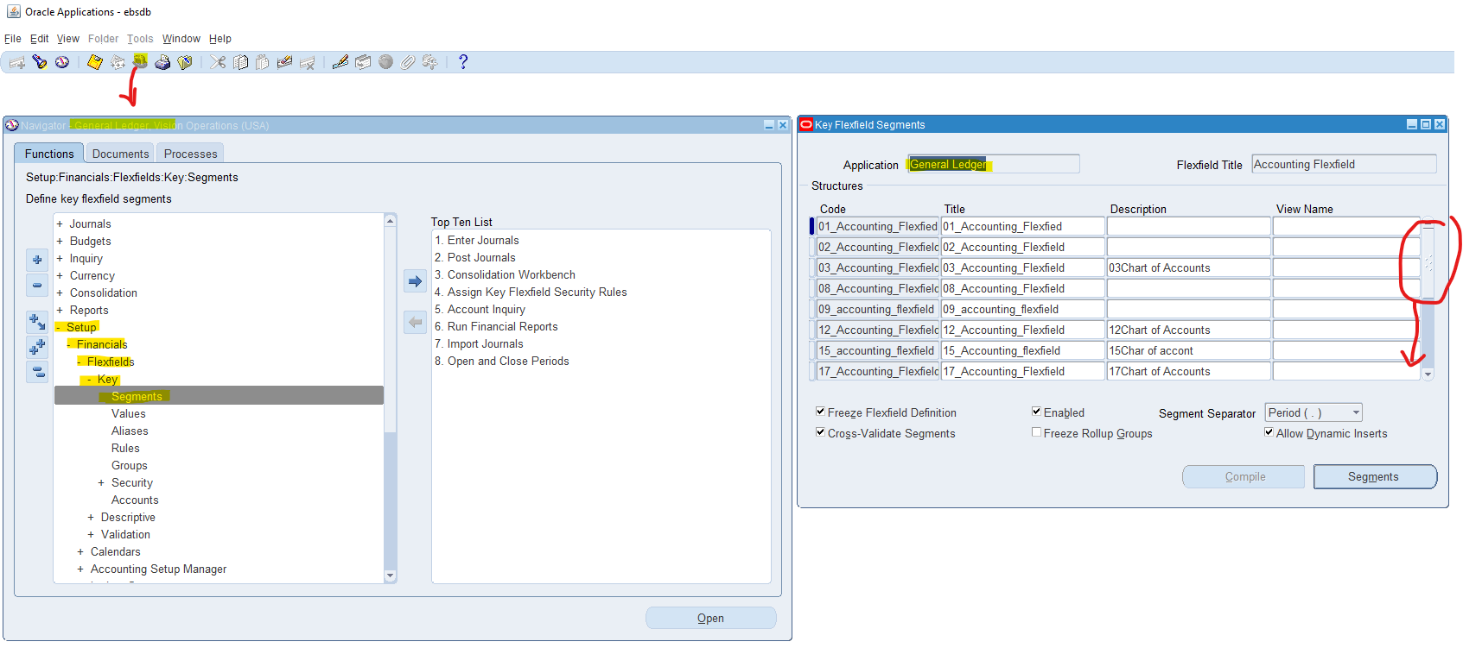

I will focus on Operations Accounting Flex in the next screenshot since this is the chart of accounts Vision Operations (USA) uses for its General Ledger. Once I have it selected I click on the Segments button and it shows the structure in terms of what each segment represents.

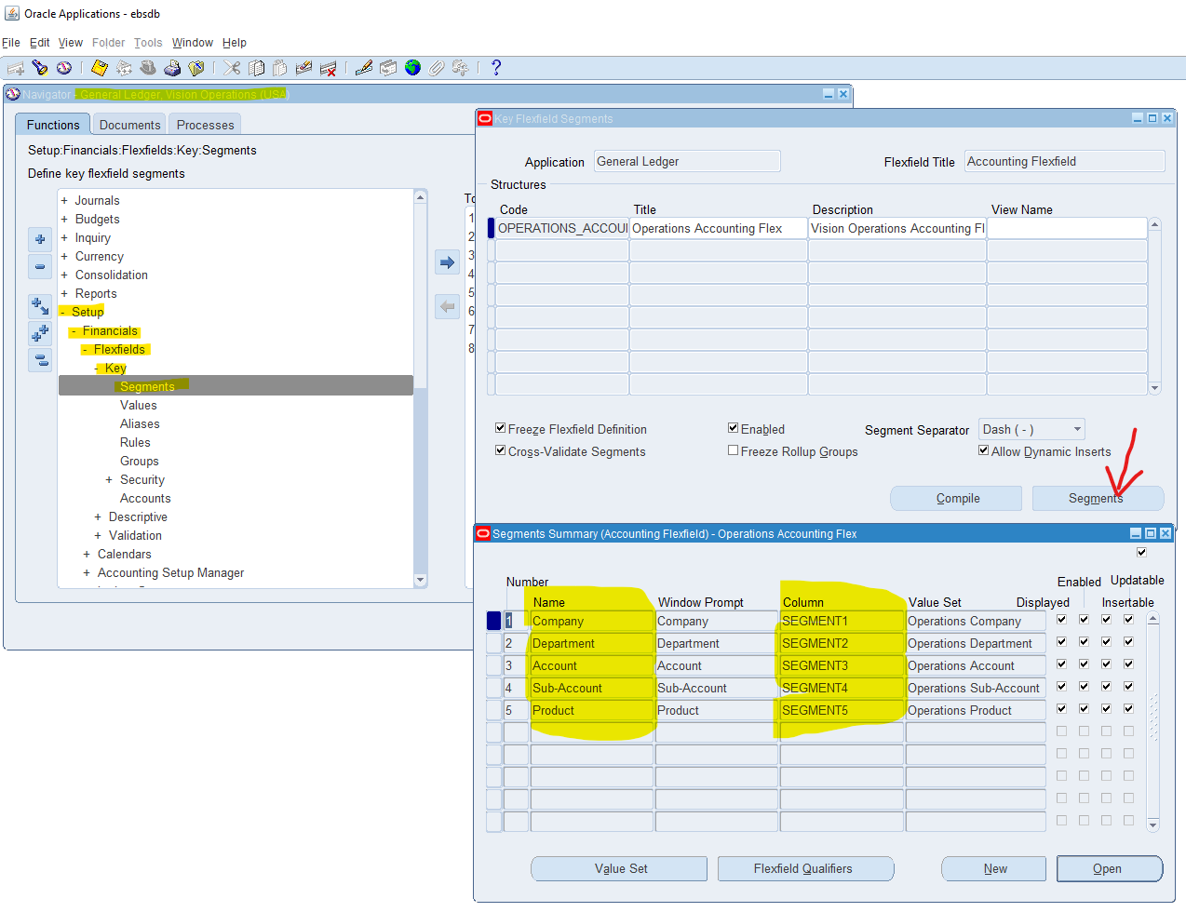

10.How are you going to run one **Concurrent Request** from General Ledger (Navigation).

First click on View> Requests

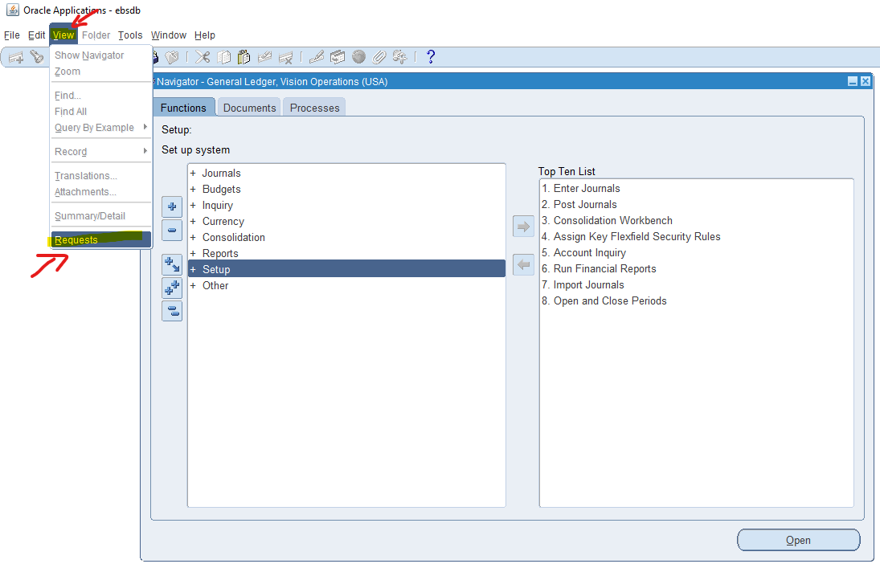

Here you will click on Submit New Request

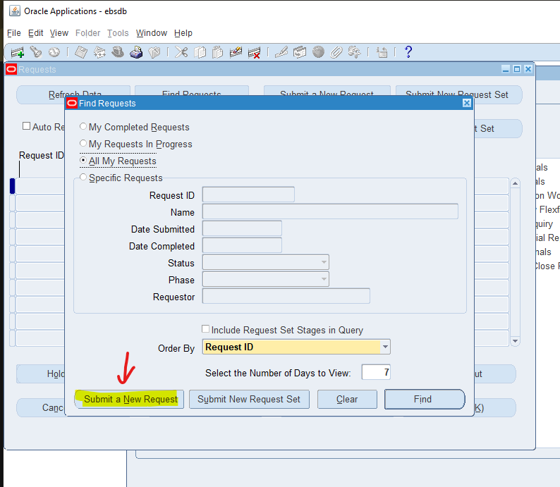

Then finally fill in the name of the defined program or executable you want to request in the field in yellow and hit submit

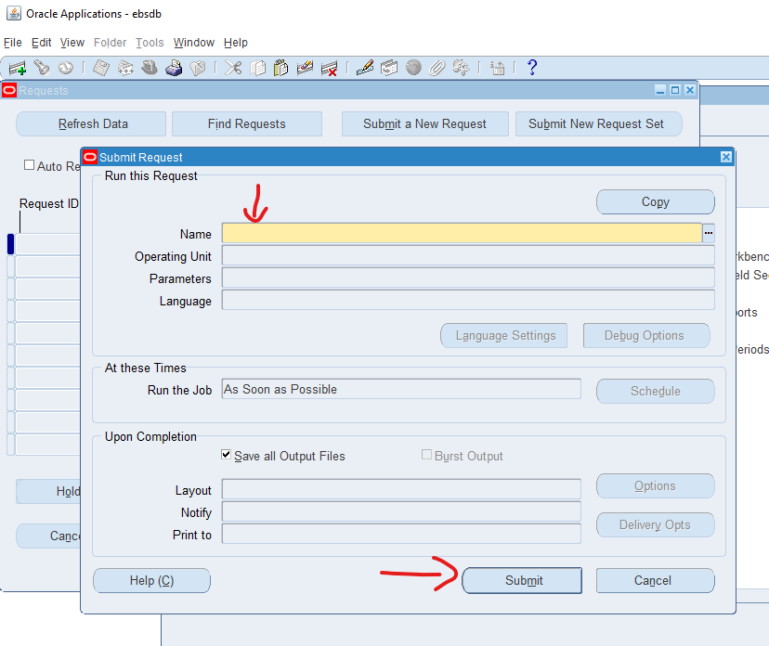

You can make a note of the request id to track this request later.

11. In One Ledger Set what are all components common in all the Ledger?

As mentioned in the reference training document, ledger sets have ledgers that share the same Chart of Accounts and calendar combination. 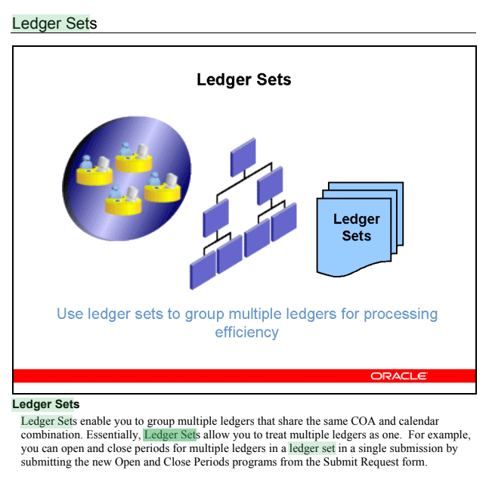

12. Find how many types of accounts in Oracle GL [Account Code Combination]?

I ran the following SQL in the EBSDB to find out that there are 8 Account types in Oracle GL. The wording of this question does not clarify any further specification.

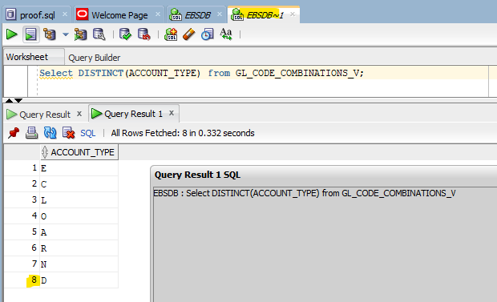

13. Check & show the Structure of Chart of Account segment structure.

The is very similar to “9. Find the Chart of Accounts [COA] Structure in General Ledger.” so I will not repeat here just refer to that step please.