Assignment for **Oracle E- Business Suite Inventory**

Date:15th Nov-2024

[Provide screenshots of each step (which performed in a live environment).  
As evidence all the activity screens shot needs to be attached]

1. What is the Oracle Inventory module?

The Oracle Inventory module is a submodule to the core module of Supply Chain Management module. As the name suggests it deals with inventory which is made of items and the item organizations those items belong to. It allows us to track how much of an item we have in stock and where they are located. All this information can help a business realize what item(s) they are low on and will need to procure/purchase.

2.With you User id switch to: **Vision Operation Inventory**. Responsibility.

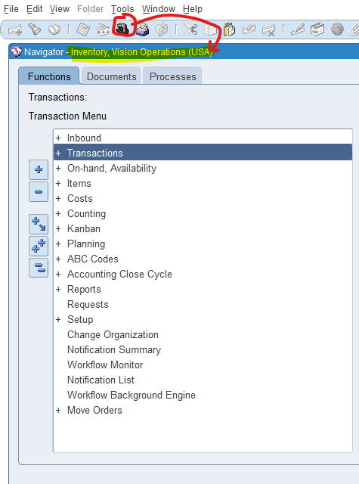

3.Choose **VI Inventory Org & Find the master Items.**

The navigation is ITEMS>MASTER ITEMS. This will open a window to pick the organization and we input V1 for Vision Operations. Then Master Items window pops open and hit ctrl+f11 on item field to populate it with items assigned to this organization.

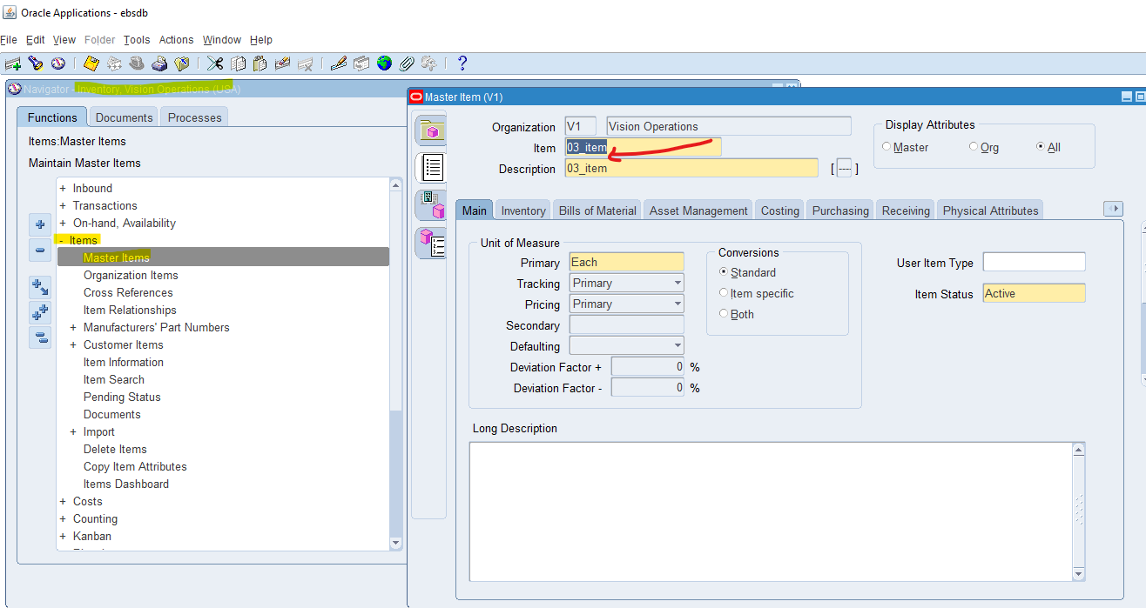

4.Take any Item & assign the same Item for all the **Inventory Org.**

Using the previous screenshot as a starting point we see we have the item called 03_item selected. Then in the same Master Items window click on the tab with the blue and pink objects as shown in this screenshot.

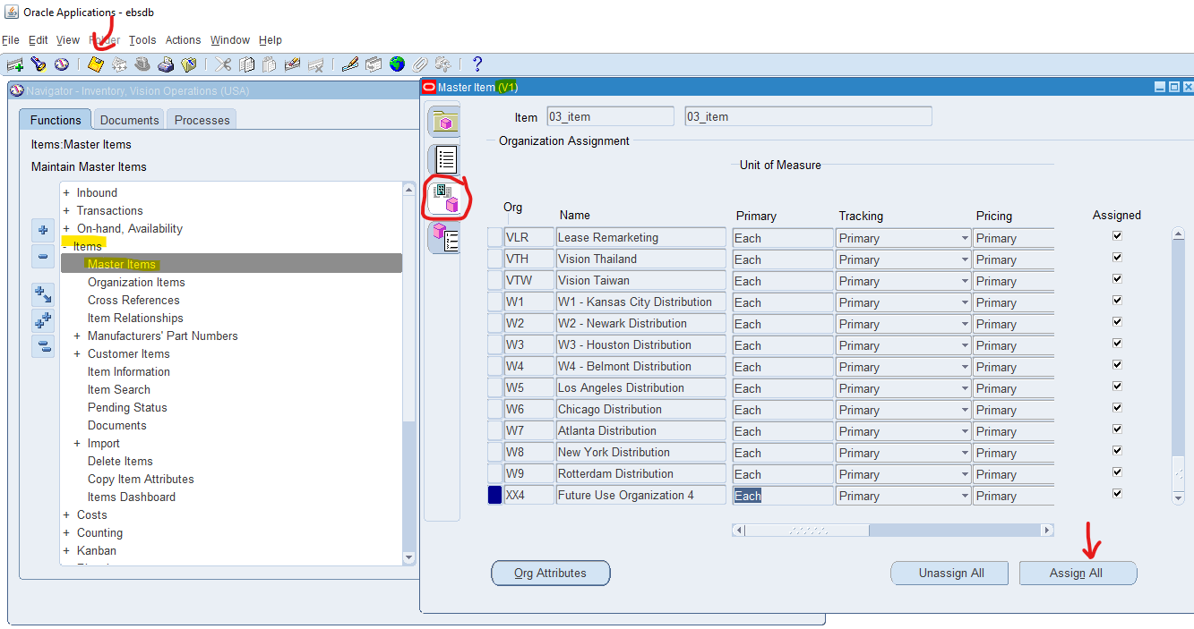

This opens up organization assignment and then click the button on the bottom right called Assign All and finaly hit the yellow floppy disk icon to save this.

5. And Un assign the same Item for all the **Inventory Org.**

To perform this, it is the same steps as in question 4... but instead we hit the unassgin all button and then hit save afterwards again. Obviously make sure it is the same item as before as well.

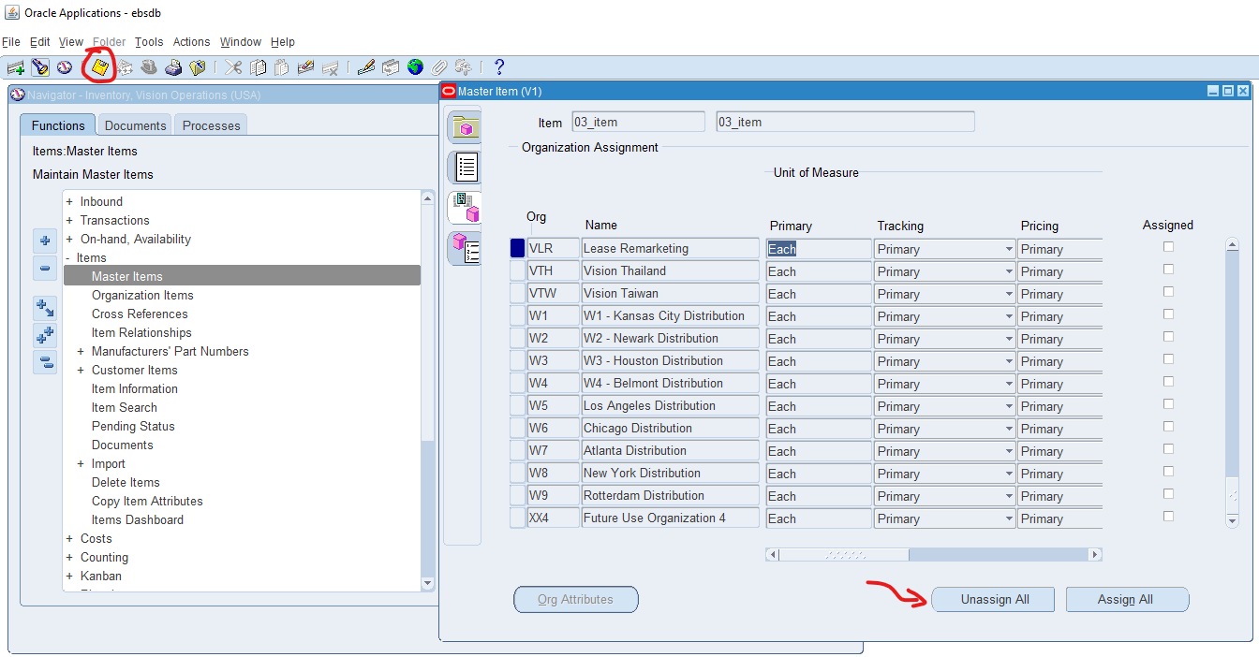

6**.** Any of the existing Item [VI Inventory org] Check the on-hand quantity.

As the following screenshot demonstrates the navifation is **ON-HAND AVAILABILITY > ON-HAND QUANTITY which will open a window called query material. Organization should be V1 and autopopulated and materical location also should automatically be On-hand as well. View By Item is what I have selected but you can also view by location if you wanted to. Then hit Find on the bottom right.**

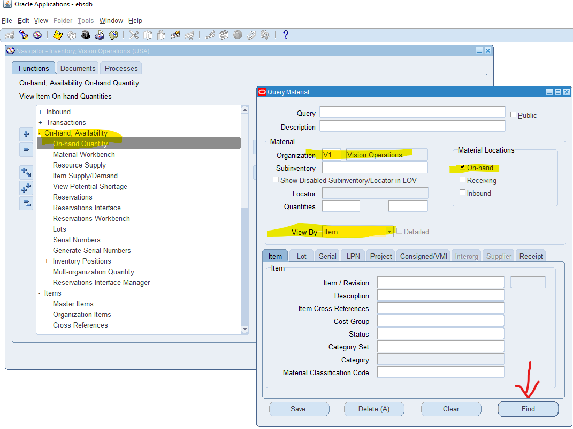

Here you can see the On-Hand quantity for each item

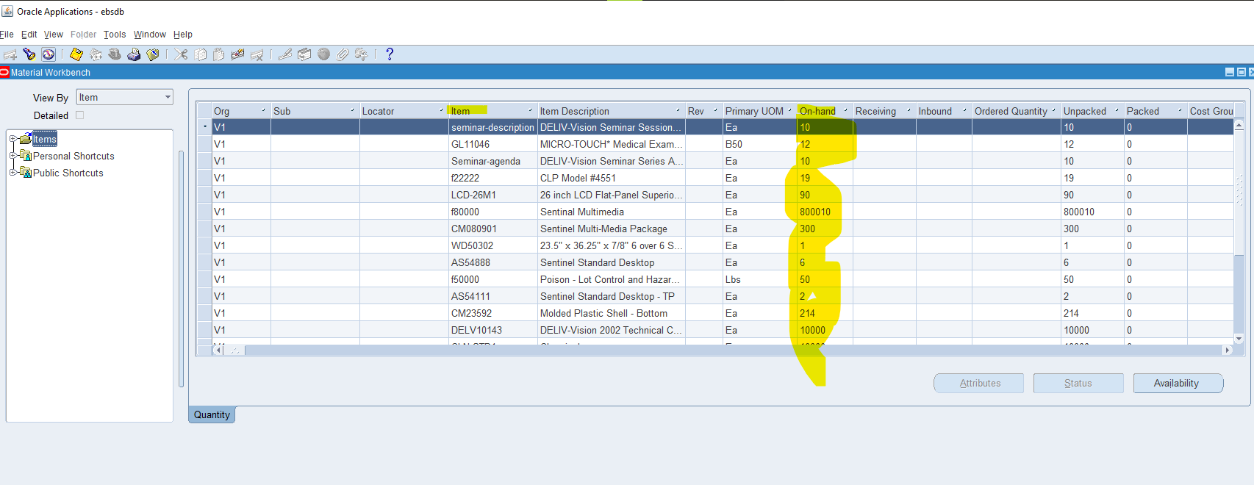

7. Unit of Measure (UOM)... with Navigation show where UOM has been defined.

In the navigation go to SETUP > UNITS OF MEASURE > UNITS OF MEASURE which will open the Units of Measure window. Here you can create a new row and define a new unit of measure or look up an existing one.

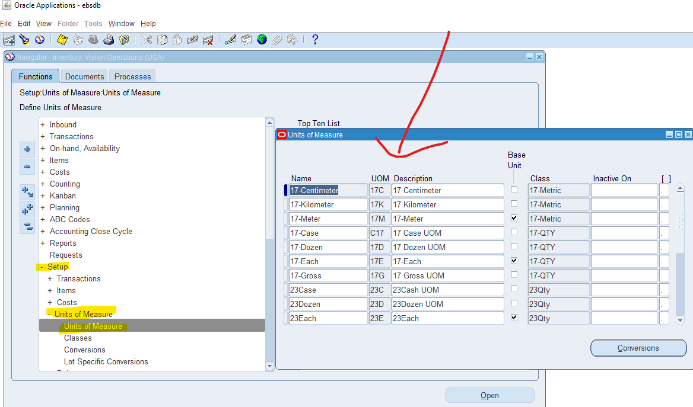

8. How do you create a new inventory item?

The navigation here is very similar to question 2... when the Master Items window is opened the yellow blank fields for Item and description must be filled in. You can click through the tabs below like Costing, Purchasing, and Physical Attributes to set the parameters for the item in these categories. I myself have created a couple of items in the past when learning about this called Pencil2,Pencil3, Pencil4.

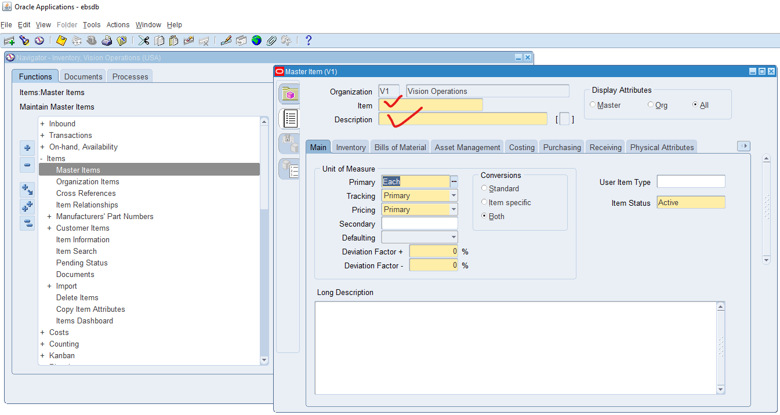

9. How to run Inventory Valuation Report?

There are a couple of way of running a report in Oracle EBS. The easiest way if you know the name of the report is to go to View>Requests> and then find the report name if you know what it is called. In this case I am not sure, so I stay in my Inventory responsibility and click the navigation in the following manner REQUESTS>ALL and then hit submit new request.

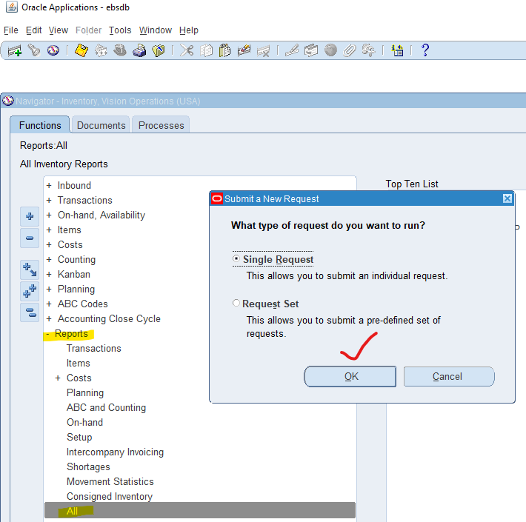

From here I click on the three dots and then try to find the report named “Inventory Valuation Report” but there is none with that exact name so I am going to assume it is the one in the following screenshot called “All Inventories Value Report”. Once you select this report it will prompt you for parameters and all yellow (required) fields must have a value. After this you submit the request on the All Requests window.

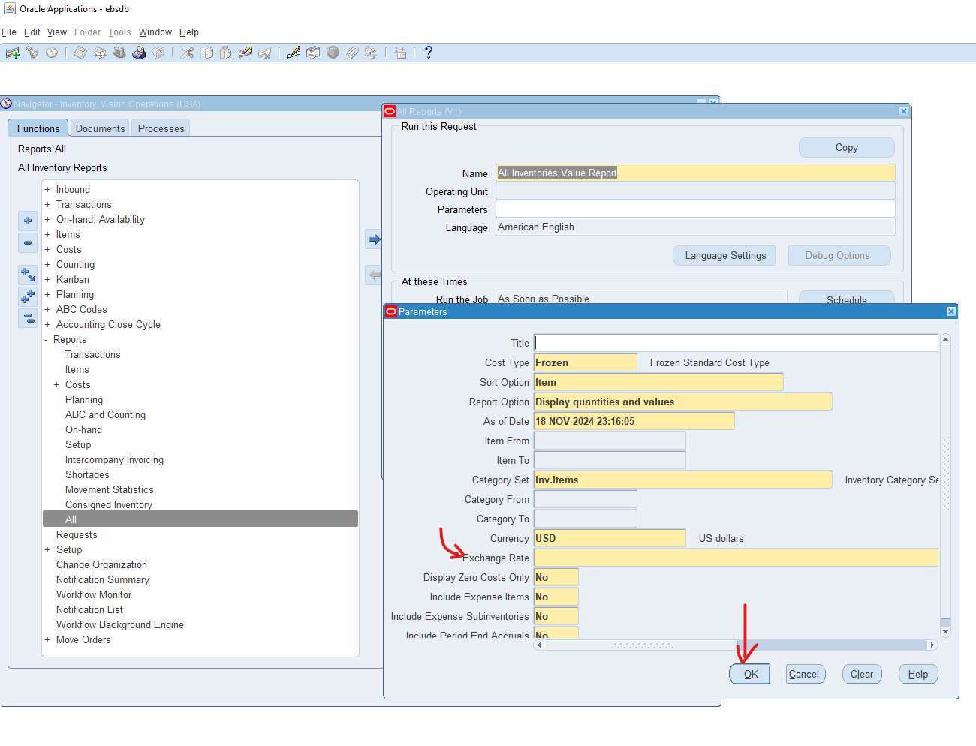

10.How to change Inventory Organization in the Current responsibility.

As shown in following screenshot, just go to change organization in the navigation window and change to your preferred organization.

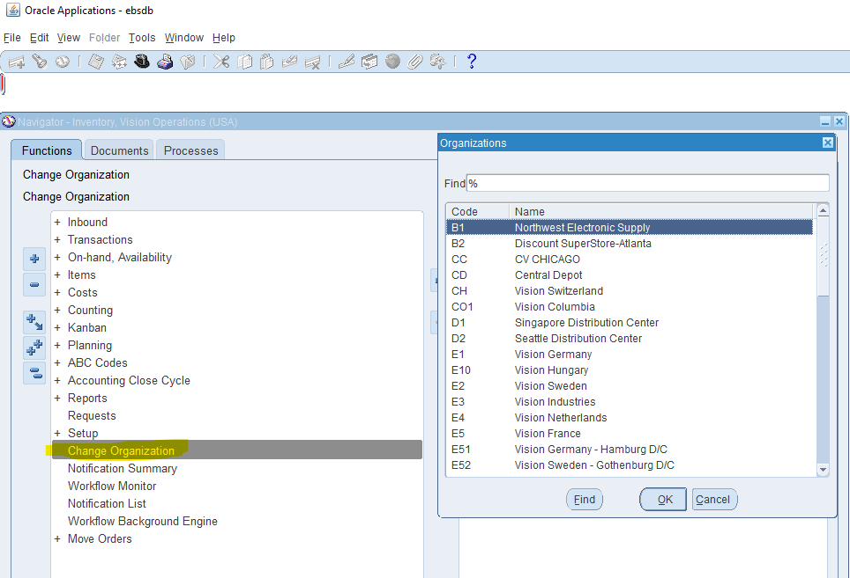

11. What is **Master Data** in Oracle Inventory?

Master Data refers to the core data objects that must be defined in order for a module to properly function. For Inventory this is of course the items themselves. The whole point of Inventory is to track items so they are considered master data. Another master data are inventory organizations as this is where the items will be located.

12.Show the existing ORG with navigation.

The existing ORG in question here I believe refers to Vision Operations as an inventory organization. The following screenshot shows the navigation to this SETUP > ORGANIZATIONS > ORGANIZATIONS . Here the Find Organization window will pop open and search for Vision Operations and hit Find. Then you will see Vision Operations appear in the Organizations window. Here it is highlighted that this ORG is classified as an inventory organization amongst other classifications.

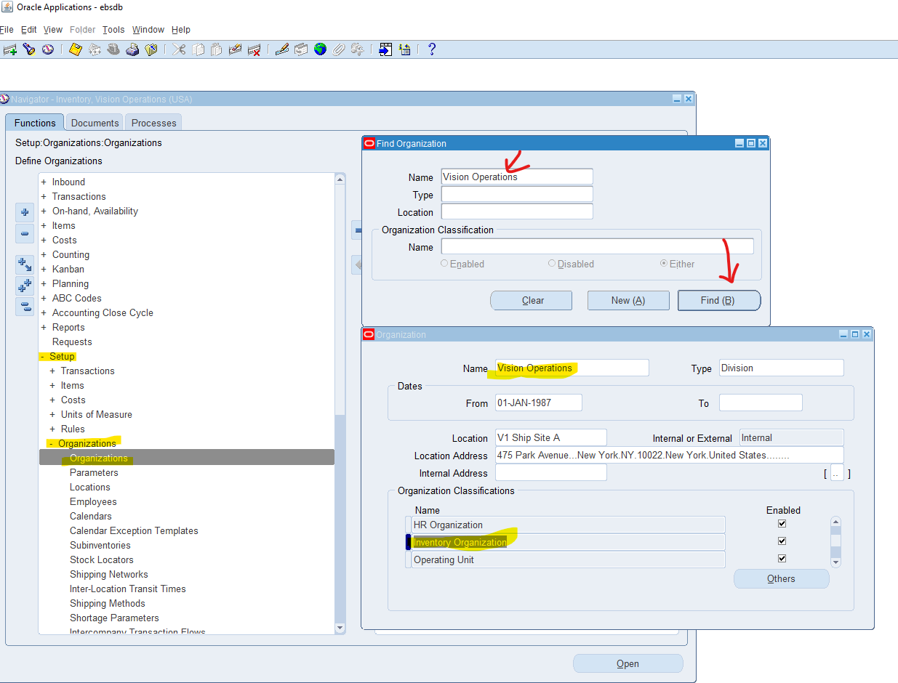

13: You can manage only finished goods in **Oracle Inventory**?

No, other item types can be tracked like raw materials etc. In this screenshot I navigate to Master Items like I did before but I search the User Item Types field and you can see “Finished Goods” is only one type of many.

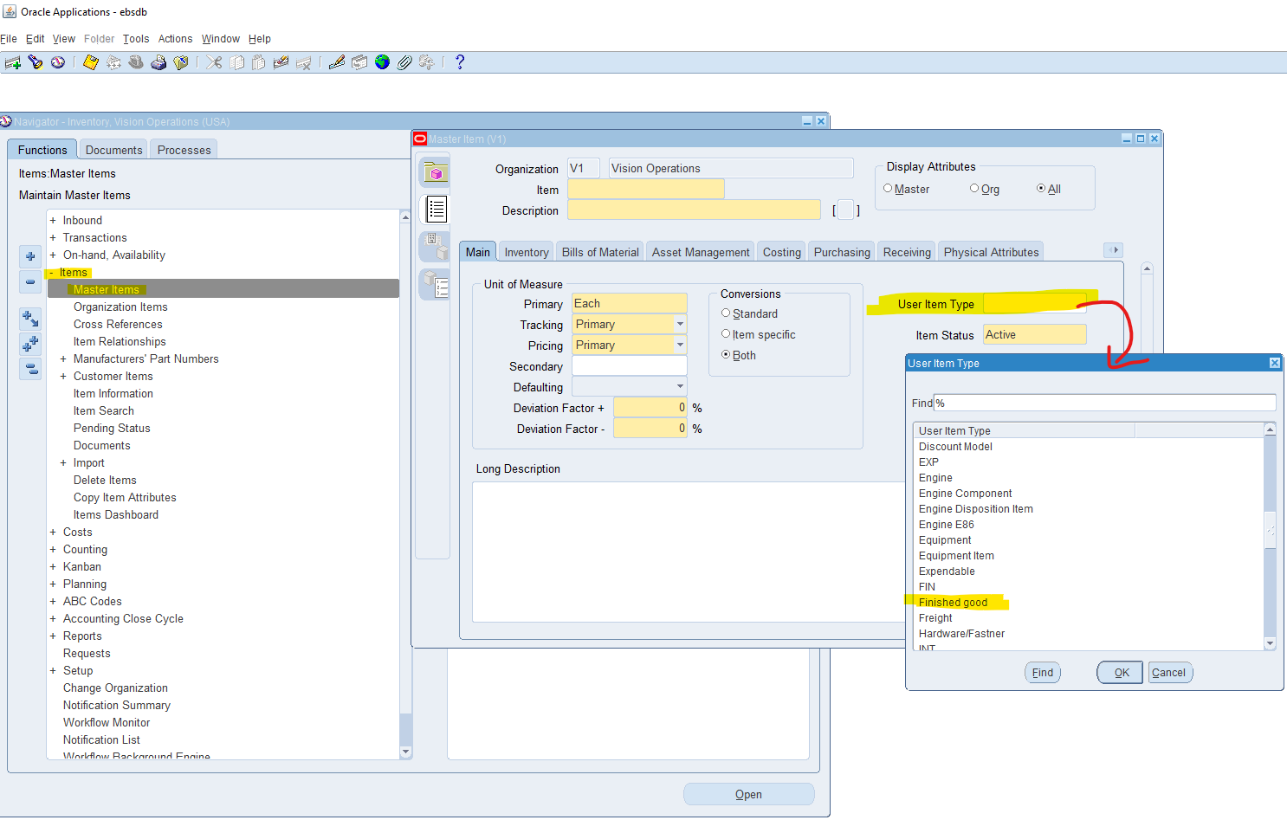

14. You need to create an item before performing inventory transactions **[Ture/False].**

**True. An item transaction is used whenever an item’s quantity or status is altered. This means you can receive more of it, or you can ship some amount out as examples. Logically it does not make sense to receive an item for which no definition exists**

15. Sub inventories are optional in Oracle Inventory. **[Ture/False].**

**True, you actually can have an inventory organization without a sub inventoryas mentioned in the reference material. However, you cannot transact material in this case. Please see attached screenshot for reference. It is generally advised to have at least one sub inventory for each inventory organization**

