Release One  
1. Creation of Acceptance Criteria  
**#2 Register to become part of the community.**  
As a potential community member I would like to be able to register to become part of the community and have a page to login.

**Acceptance Criteria**

**User Registration Page with at least:**

Username

Password

Email (with email confirmation)

**User Login Page with:**

Username

Password

Forgot Password Button

2. I allocated user stories into sprints by identify what features would have dependencies on other features and then ordering the user story’s in such a way that would increase productivity and workflow.

3. Once users register to our website we greet them with a welcome email. I created a plain text email template so we could send new users an email.  
  
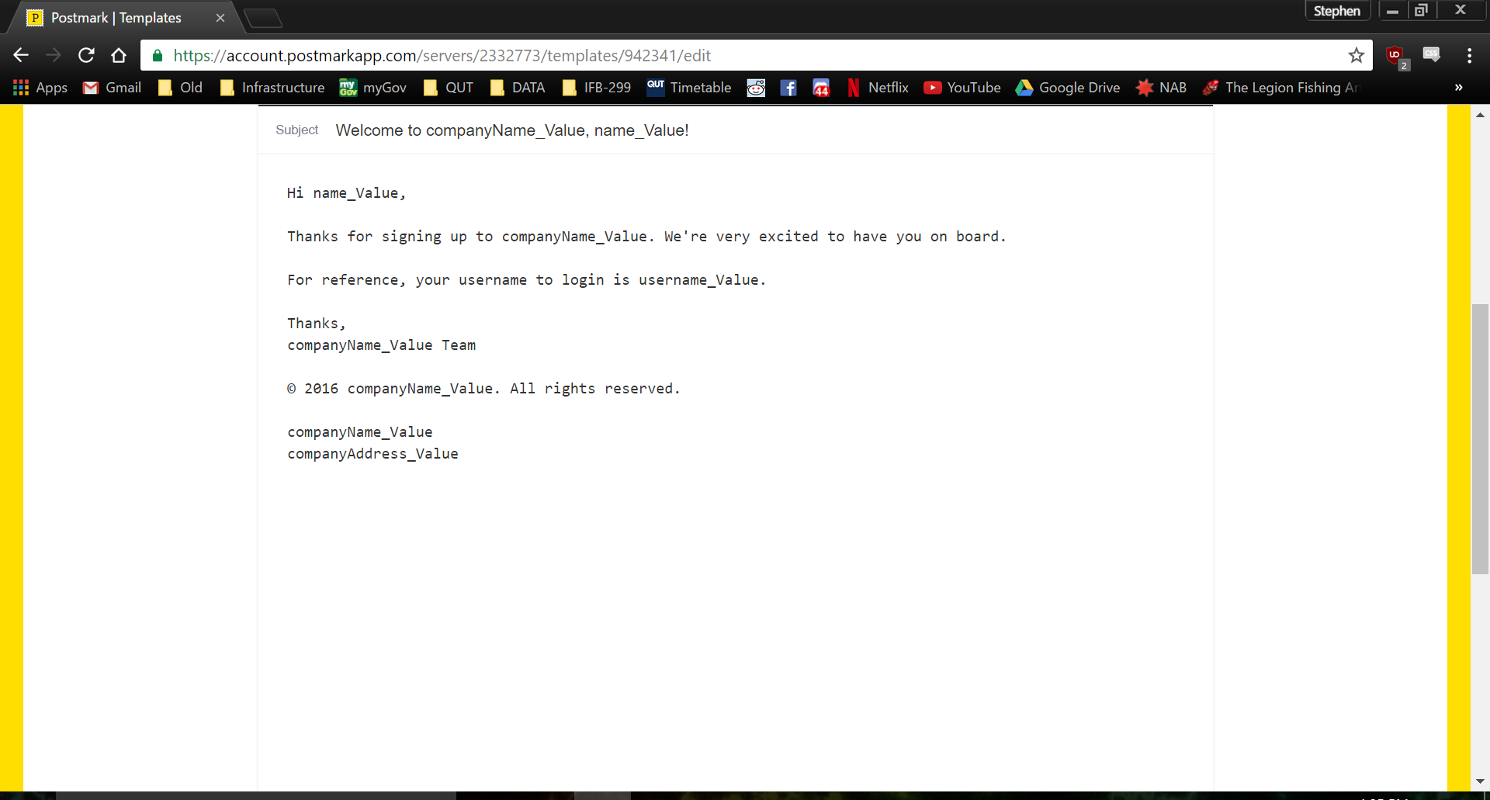  
  
4. Created the helper method to automatically fill and send the template to our new users.

5.The creation of the business letter was done collaboratively after release 1 to ensure that everybody could voice their opinions about the project and ensure the highest quality.

Release Two1. The welcome email is one of the first things people see when joining our website so we decided as a group that some nicely formatted emails would be beneficial so I created a html template for our welcome email.  
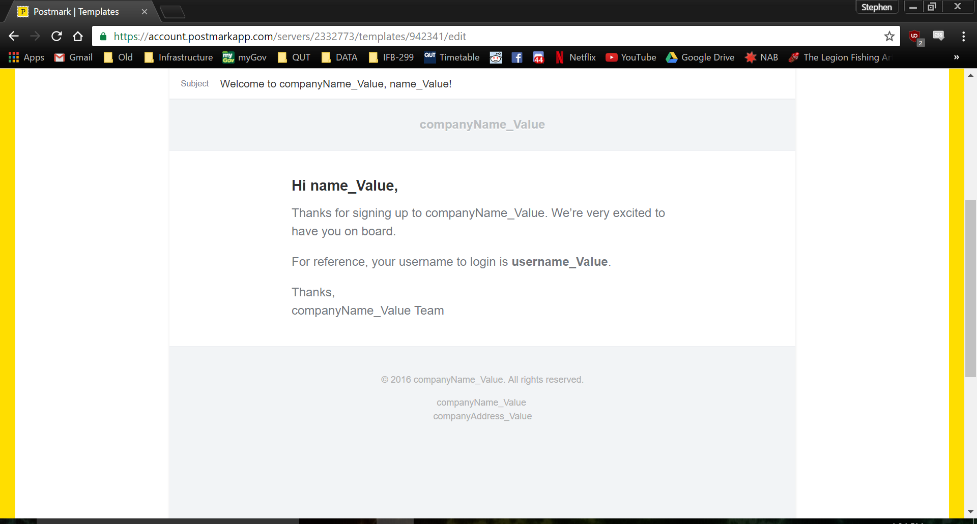  
2. Our initial project only had 3 emails that were being sent however after some group discussion we decided that when the details of an event were changed all the people enrolled in the event receive an email containing the updated details.   
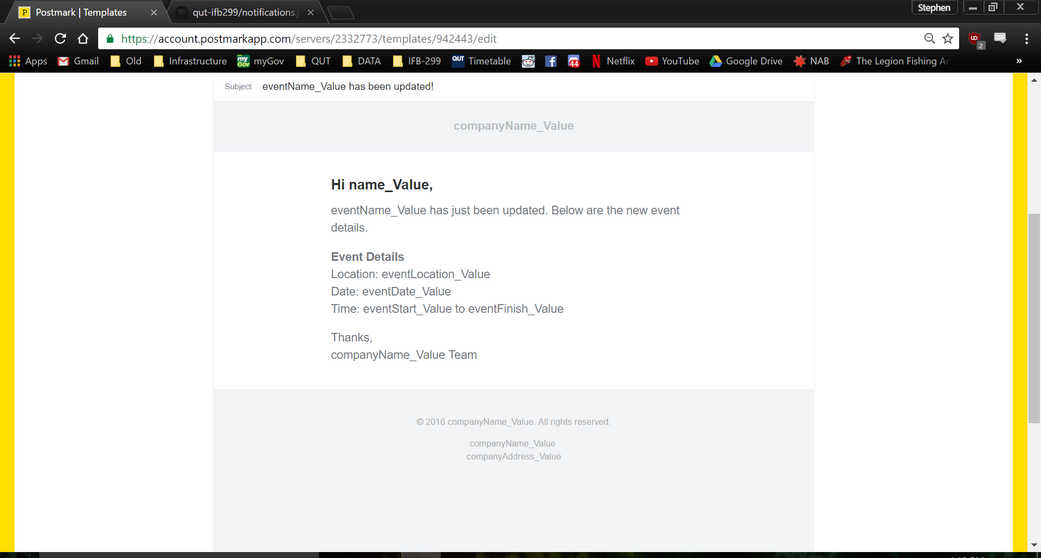  
3. This email template also required an additional helper method to allows the emails to be automatically filled out and be sent out when required.  
  
4. After a meeting with our client I was responsible for updating the acceptance criteria and reordering the user stories so the features our client wanted included in release 2. This also meant some of the user stories got moved into sprint 5.  
  
5. The creation of the business letter was done collaboratively after release 2 to ensure that everybody could voice their opinions about the project and ensure the highest quality.