R_laser_ << 0.225, 0,

0, 0.225;

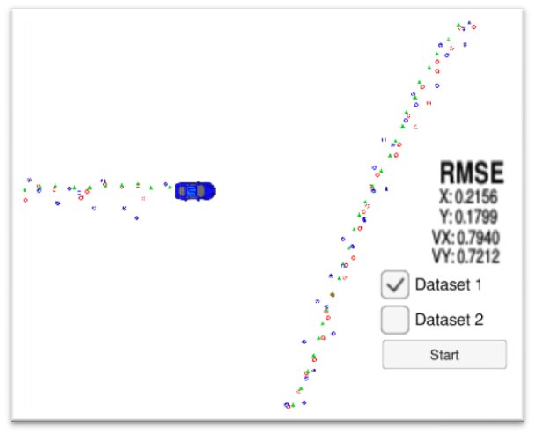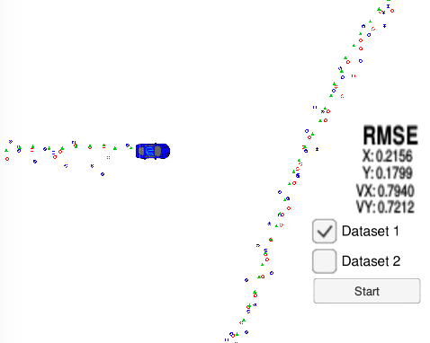

R_laser_ << 0.0225, 0,

0, 0.0225;

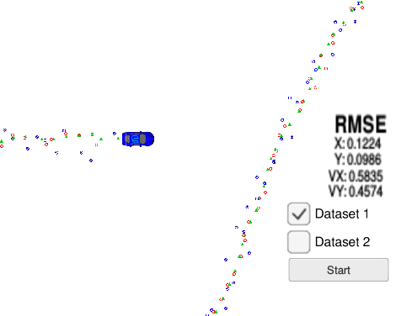

R_laser_ << 2.25, 0,

0, 2.25;

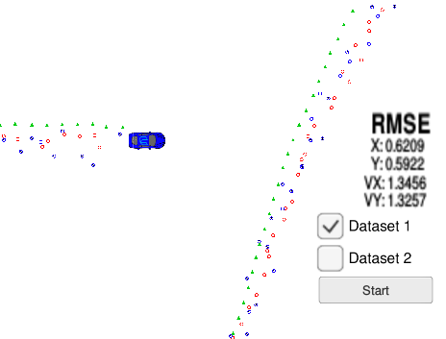

R_radar_ << 0.09, 0, 0,

0, 0.0009, 0,

0, 0, 0.09;

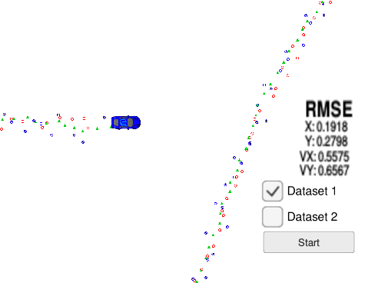

// 10 times

R_radar_ << 0.9, 0, 0,

0, 0.009, 0,

0, 0, 0.9;

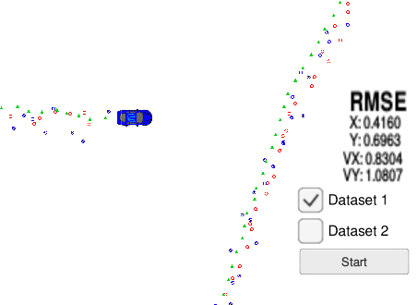

R_radar_ << 9, 0, 0,

0, 0.09, 0,

0, 0, 9;

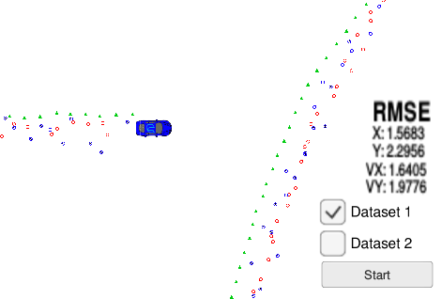

Lidar + radar

R_laser_ << 0.0225, 0,

0, 0.0225;

R_radar_ << 0.09, 0, 0,

0, 0.0009, 0,

0, 0, 0.09;

