18.4 vehicle model

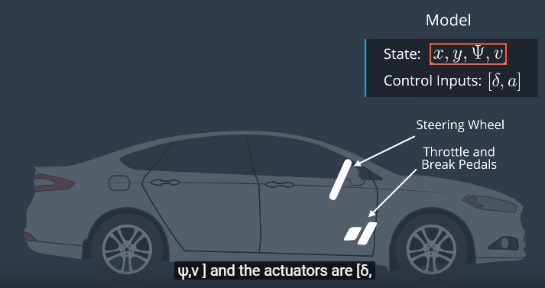

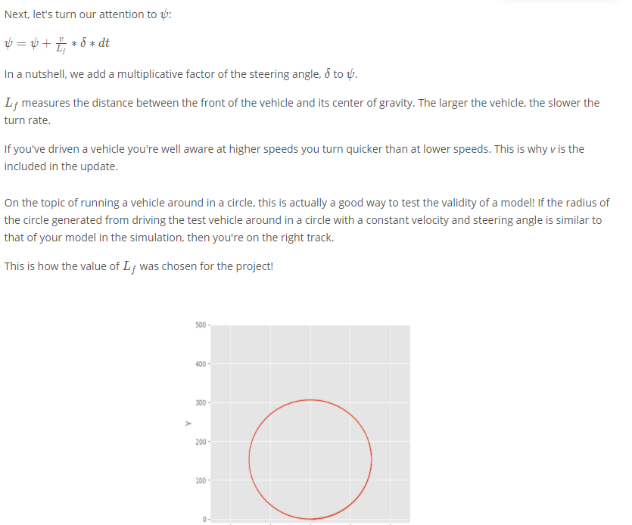

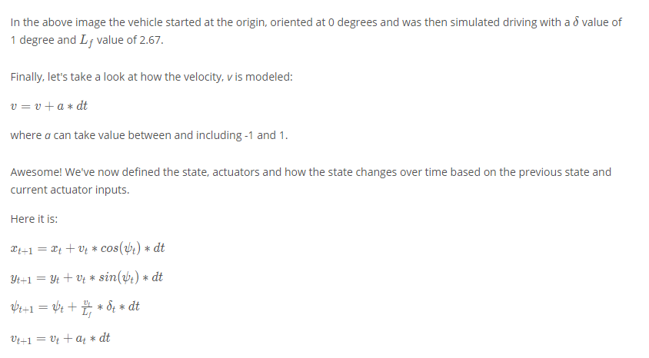

[*x*,*y*,*ψ*,*v*] is the state of the vehicle, *L*​*f*​​ is a physical characteristic of the vehicle, and [*δ*,*a*] are the actuators, or control inputs, to our system.

**18.7 Fitting Polynomials**

1. Use polyfit to fit a 3rd order polynomial to the given x and y coordinates representing waypoints.
2. Use polyeval to evaluate y values of given x coordinates.

18.8 errors

Predict -> correct error overtime

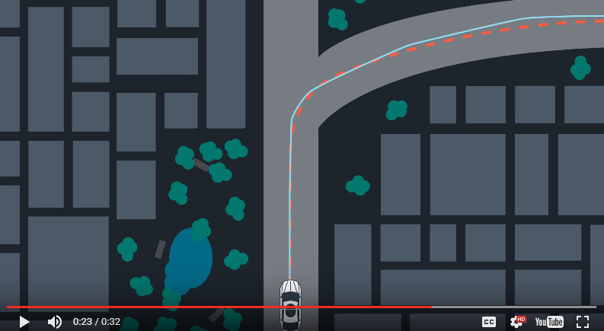

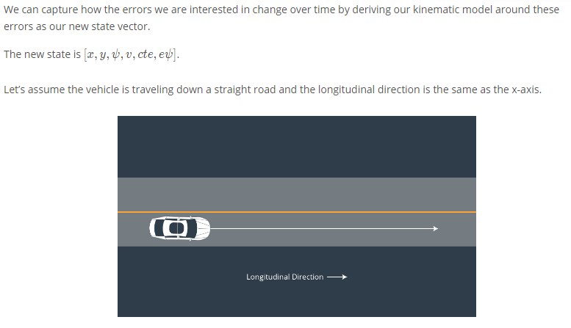

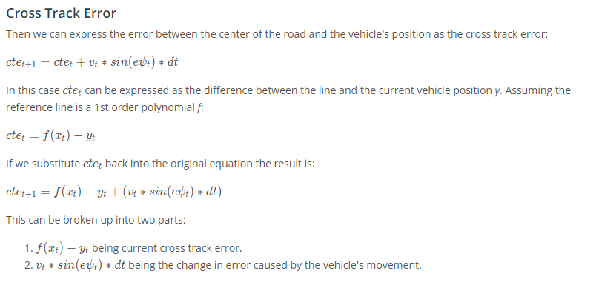

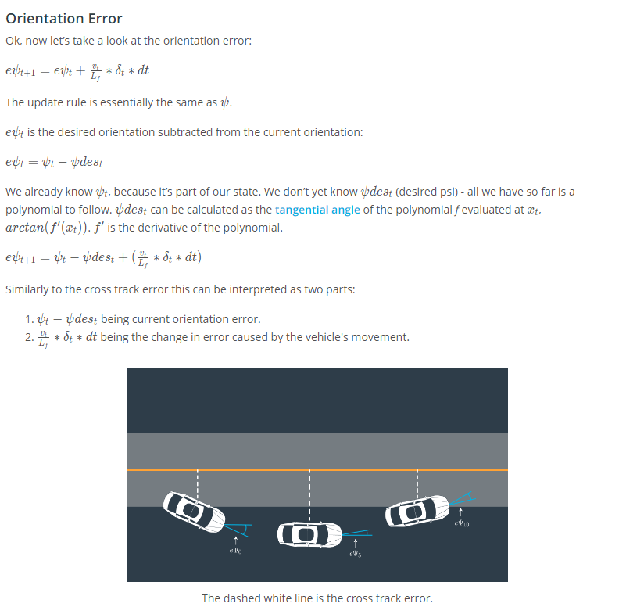

18.9 Dynamic Models

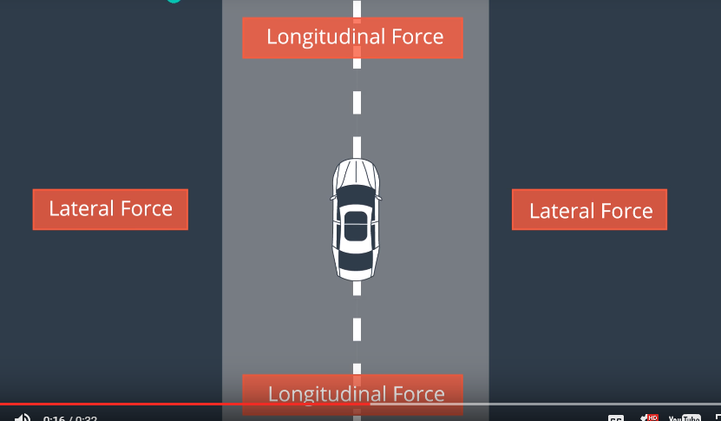

18.10 Slip Angle

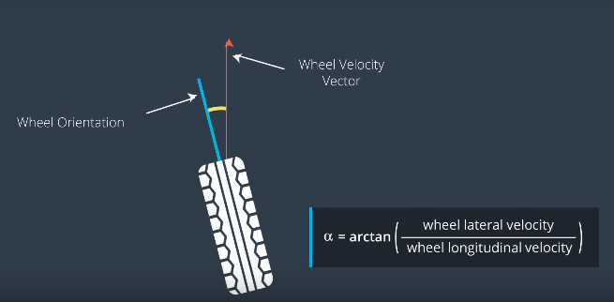

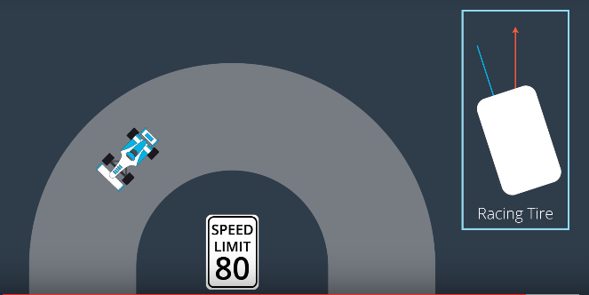

18.11 Slip ratio

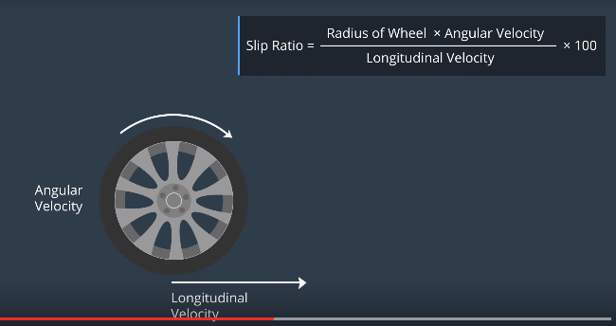

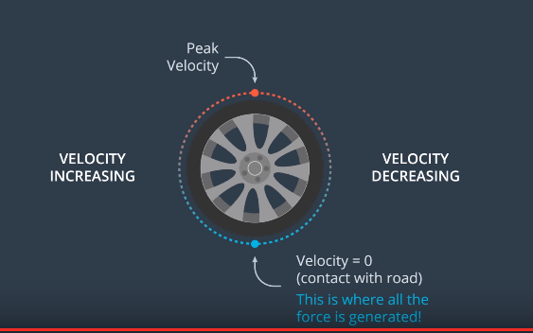

18.12 Tire Models

Slip angle VS. lateral force:

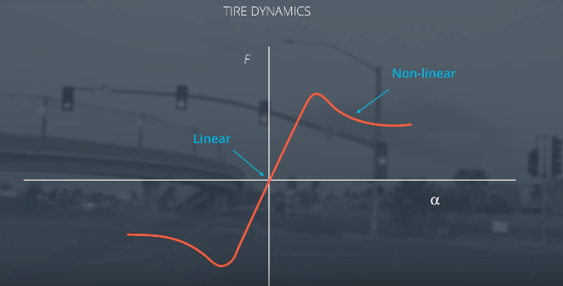

Pacejka Tire Model = Magic Tire Formula

18.13 Actuator Constraints

Nonholomonic: cannot move in arbitrary directions , limited by steer angle constraints, solve by setting lower and upper bounds for the actuators

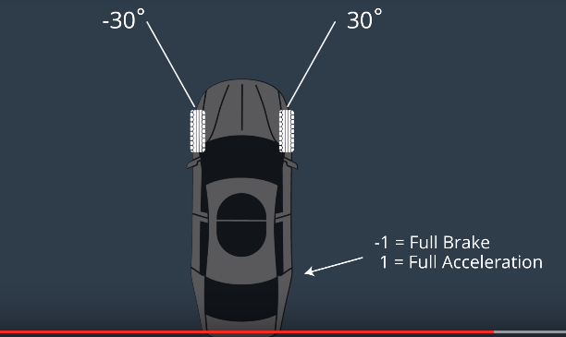

19.6 MPC

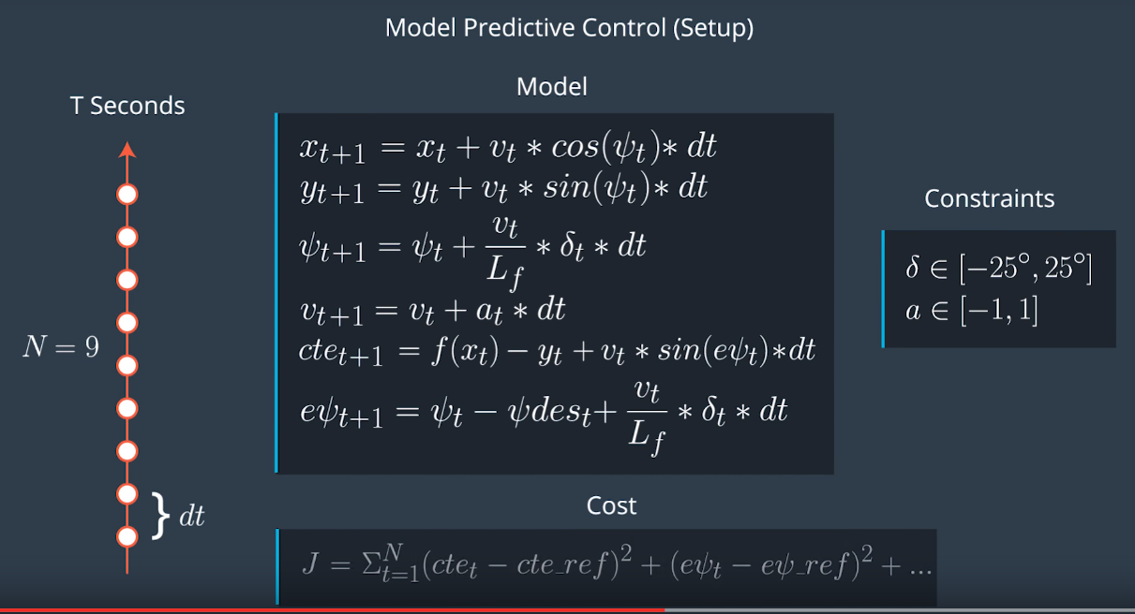

IPOPT solver

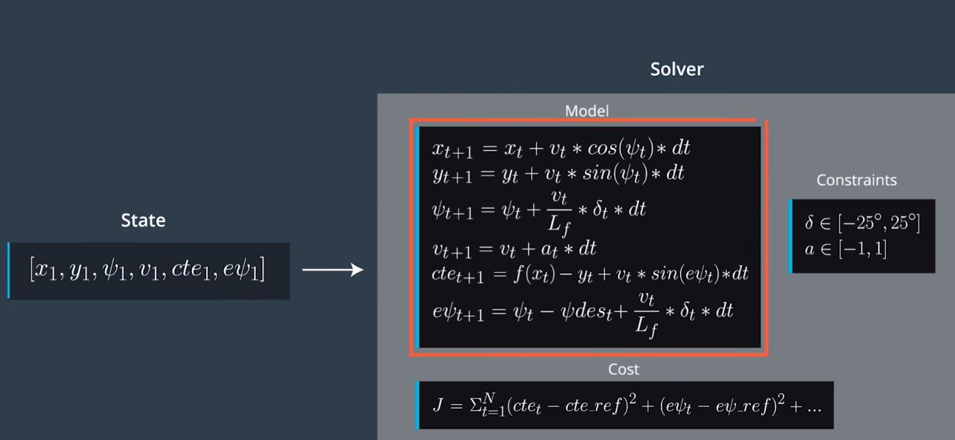

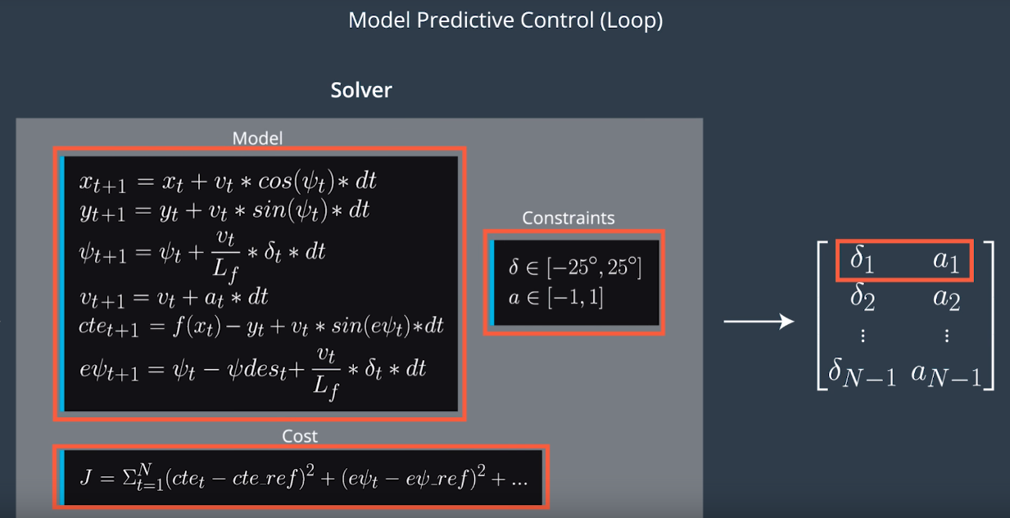

19.7 Latency

**PID Controller**

PID controllers will calculate the error with respect to the present state, but the actuation will be performed when the vehicle is in a future (and likely different) state. This can sometimes lead to instability.

The PID controller could try to compute a control input based on a future error, but without a vehicle model it's unlikely this will be accurate.

**Model Predictive Control**

A contributing factor to latency is actuator dynamics. For example the time elapsed between when you command a steering angle to when that angle is actually achieved. This could easily be modeled by a simple dynamic system and incorporated into the vehicle model. One approach would be running a simulation using the vehicle model starting from the current state for the duration of the latency. The resulting state from the simulation is the new initial state for MPC.

Thus, MPC can deal with latency much more effectively, by explicitly taking it into account, than a PID controller.