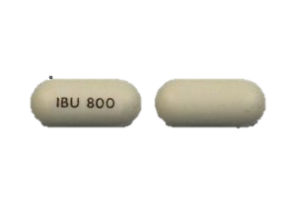

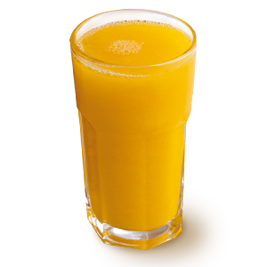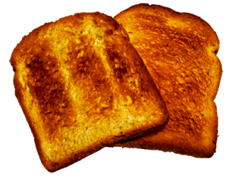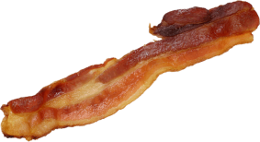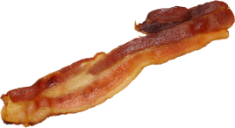

Elimination

Bolus Input of Ibuprofen (800 mg tablet)

MG OF IBUPROFEN IN BLOOD PLASMA

MG OF IBUPROFEN IN DIGESTIVE TRACT

MG OF IBUPROFEN IN FOOD

Simple Carbohydrates and Sugars

Proteins and Fats

Fasted (No Food)