Ibuprofen Tracking – Fasted vs Carbohydrates vs Proteins

Fasted (No food)

Stock and Flow

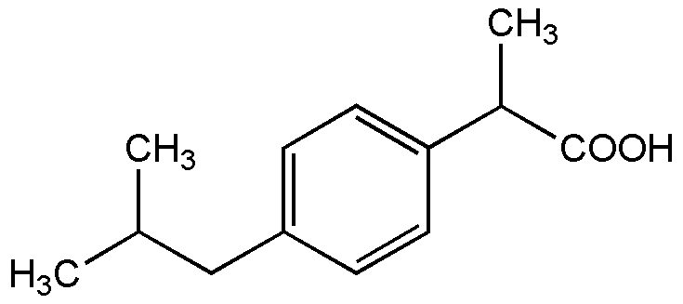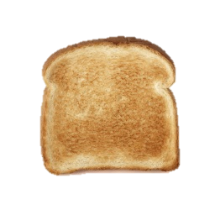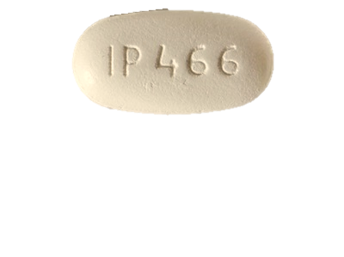

Bolus Input of Ibuprofen (800mg tablet)

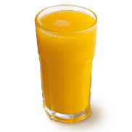

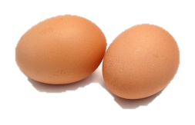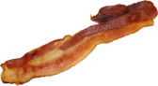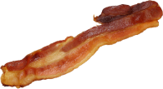

Elimination

Simple Carbohydrates and Sugars

Proteins

**+**

**+**

**Blood Plasma Concentration**

**Digestive Tract Percentage**