**🎧 MP3 Cleaner Installation and Usage Guide**

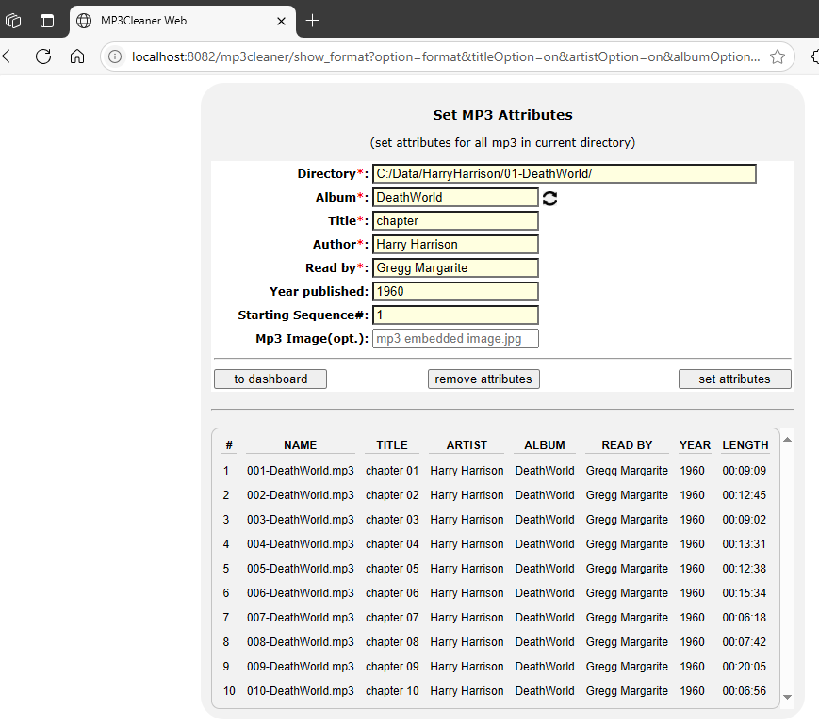

The **MP3 Cleaner** is a Java-based web application designed to help you efficiently manage your audiobook library. You can use it to update common MP3 file attributes and perform bulk file renaming.

**Requirements**

* **Java Development Kit (JDK) 17 or higher** is required to run the application. You can download it for free from [OpenLogic](https://builds.openlogic.com/downloadJDK/openlogic-openjdk/17.0.16+8/openlogic-openjdk-17.0.16+8-windows-x64.msi).

**Installation and Launch**

1. **Install the JDK**. If you haven't already, install JDK 17 or higher on your system.
2. **Copy the application files**. From the project package, copy the MP3Cleaner-0.0.1-SNAPSHOT.war file and the MP3Cleaner-shortcut to your desktop.
3. **Launch the application**. Double-click the **MP3 Cleaner** shortcut. This will start a local web server and automatically open the application's user interface in your default web browser.
4. **Initial Setup**. The first time you run the application, you'll be prompted to select the columns you want to be displayed. You can adjust these settings later from the **Dashboard/Options** menu.

**Using the Application**

The MP3 Cleaner offers two main functions: updating attributes and renaming files.

**Updating MP3 Attributes**

To update the metadata of your audio files, follow these steps:

1. From the dashboard, click on **"MP3 attributes"** to open the working panel.
2. **Set the local working directory** to the folder containing the MP3 files you want to edit. Your files will be listed in the panel.
3. **Enter the attribute values** you wish to add or update (e.g., Artist, Album, etc.).
4. Click **"set attributes"** to apply the changes to all the files in the directory.

**Bulk File Renaming**

To rename multiple files at once:

1. From the dashboard, select **"Rename files"**.
2. **Enter the directory path** of the files you want to rename.
3. **Set the new file name** to be used for the bulk rename operation.
4. Click the appropriate button to update the names of all the selected files.