

**Tribhuvan University**

**Faculty of Humanities and Social Sciences**

**Real Estate Management System**

**A PROJECT REPORT**

**Department of Computer Application**

**BIRENDRA MULTIPLE CAMPUS**

Bharatpur,Chitwan

***In partial fulfillment of the requirements for the Bachelors in Computer Application***

Submitted by:

**Name: Hem Bahadur Shrestha (6-2-19-9-2020)**

**Name: Bishwanath Sharma Poudel (6-2-19-5-2020)**

Submitted on: **August 25,2024**

**Under the supervision of**

**Mr. Govinda Sharan Gupta**



**Tribhuvan University**

**Faculty of Humanities and Social Sciences**

**Birendra Multiple Campus**

**Supervisor’s Recommendation**

I hereby recommend that this project prepared under my supervision by **Mr. Hem Bahadur Shrestha** and **Mr. Bishwanath Sharma Poudel** entitled “**Real Estate Management System**” in partial fulfillment of the requirements for the project of Sixth Semester of Bachelor of Computer Application is recommended for the final evaluation.

**……………….......................**

**Mr**. **Govinda Sharan Gupta**

SUPERVISIOR

**LETTER OF APPROVAL**

This is to certify that this project prepared by **Hem Bahadur Shrestha** and **Bishwanath Sharma Poudel** entitled “**Real Estate Management System**” in partial fulfillment of the requirements for project of Sixth Semester in Computer Application has been evaluated. In our opinion it is satisfactory in the scope and quality as a project for the required degree.

|  |  |
| --- | --- |
| **SIGNATURE OF SUPERVISIOR**  Mr. Govinda Sharan Gupta | **SIGNATURE OF COORDINATOR**  Mr. Sobaraj Poudel |
| **SIGNATURE of Internal Examiner** | **SIGNATURE of External Examiner** |

**Acknowledgement**

We would like to express our appreciation to all those who provided us the possibility to complete the project. A special gratitude we want to give to our project supervisor, **Mr. Govinda Sharan Gupta** whose contribution in providing suggestions and encouragement that helped us to coordinate our project from first to last phase.

Furthermore, we are highly indebted **to Birendra Multiple Campus** for constant guidance and supervision, as well as for providing all the necessary ICT infrastructure and friendly environment for the successful completion of the project of developing a website called “**Real Estate Management System**”. We are also appreciative of the efforts of **Mr. Sobaraj Poudel**, evaluating team, without their supporting role, the project would have been nowhere near completion. Special thanks go to our team mate, who were of great help to assemble the parts and gave their time and effort to accomplish the project. We would like to express our gratitude to our project supervisor **Mr. Govinda Sharan Gupta** who took keen interest in our project and guided us throughout the project by providing all the necessary ideas, information and knowledge for developing web-based Application. He has supervised us well especially in our project presentation, report writing etc. which helped to improve our skills in this sector.

We are thankful and fortunate enough to get constant support from every teaching staff of Bachelors in Computer Application department which helped us to successfully complete our project. We would also like to extend our regards to all the staff of BCA department for their timely support (Hem Bahadur Shrestha, Bishwanath Sharma Poudel).

**Abstract**

The **"Real Estate Management System"** is a user-friendly web-based platform designed to streamline the process of buying, selling, and renting properties. The system made according to waterfall model facilitates the registration of Admin and User accounts, allowing users to access a centralized database containing comprehensive details of available lands, houses, and flats. In this system, prospective buyers and sellers can log in to view property listings, making the search for suitable properties more convenient. Additionally, administrators have the authority to remove users and manage the platform efficiently with the implementation of linear search algorithm and security feature of SHA-5.

**Keyword: HTML, CSS, Javascript, PHP, MySql**

**Table of Contents**

Chapter 1: Introduction 1

1.1 Introduction 1

1.2 Problem Statement 2

1.3 Objectives 2

1.4 Scope and limitations 2

1.5 Development Methodology 3

1.6 Report Organization 4

Chapter 2: Background Study and Literature Review 5

2.1 Background Study 5

2.2 Literature Review: 5

Chapter 3: System Analysis and Design 7

3.1 System Analysis 7

3.1.1 Requirement Analysis 7

3.1.2 Feasibility Analysis 10

3.1.3 Data Modeling (ER-Diagram) 11

3.1.4 Process Modeling (DFD) 12

3.2 System Design (Structured Approach) 13

3.2.1 Architectural Design 13

3.2.2 Database Schema Design 14

3.2.3 Interface Design (UI/UX) 15

3.3 Algorithm: 18

Chapter 4: Implementation and testing 20

4.1. Implementation 20

4.1.1. Tools Used 20

4.1.2 Implementation Details of Module 21

4.2. Testing 21

4.2.1 Test Cases for Unit Testing 22

4.2.2 Test Cases for System Testing 25

Chapter 5: Conclusion and Future Recommendation 26

5.1 Conclusion 26

5.2 Lesson Learnt/Outcome 27

References 28

**List of Figure**

Figure 1: 1.5 WaterFall Model of Real Estate Management System 3

Figure 2: 3.1.1.1 Use Case Diagram of Real Estate Management System 9

Figure 3: 3.1.3 ER-Diagram of Real Estate Management System 11

Figure 4: 3.1.4 Level 0 DFD of Real Estate Management System 12

Figure 6: 3.2.1 Architectural design of Real Estate Management System 13

Figure 7: 3.2.2 Database Schema of Real Estate Management System 14

Figure 8: 3.2.3 Home page from where user can register 15

Figure 9: 3.2.3 Login page for the admin 15

Figure 10: 3.2.3 Admin Dashboard 16

Figure 11: 3.2.3 Property List 16

Figure 12: 3.2.3 Admin Panel 17

Figure 13: 5.3 Gantt chart of Real Estate Management System 27

**List of Table**

**Table 1: 4.1 Test Case for Successful User Registration** 22

**Table 2: 4.2 Test Case for User Registration Fail** 23

**Table 3: 4.3 Test Case for User Login** 23

**Table 4: 4.4 Test Case for Successful Booking** 24

**Table 5: 4.5 Test Case for Booking Failure** 24

**List of Abbreviations**

CSS: Cascading Style Sheet

DFD: Data Flow Diagram

HTML: Hyper Text Mark-up Language

MySQL: My Structured Query Language

PHP: Hypertext Preprocessor

# Chapter 1: Introduction

## Introduction

The Real Estate Management System (REMS) is a comprehensive software solution designed to streamline and optimize the operations and processes involved in real estate management. The real estate industry is dynamic and complex, with numerous stakeholders, including property owners, tenants, agents, and maintenance personnel. Managing real estate assets efficiently requires effective communication, data management, and task coordination. REMS aim to address these challenges by providing a centralized platform that enables overall efficiency in real estate management.

In recent years, the real estate market has experienced significant growth and diversification, resulting in increased demand for effective management tools. Traditional methods of managing properties, such as paper-based documentation and manual tracking systems, are no longer sufficient to handle the complexities of today's real estate industry. REMS offer a digital solution that leverages the power of technology to automate processes, enhance productivity, and enhance the overall management of real estate assets.

The primary objective of REMS is to provide a user-friendly interface that simplifies various real estate management tasks. Property owners can utilize the system to efficiently handle property listings, tenant management, and financial transactions. Tenants can access the platform to search for available properties.

REM incorporates essential features that facilitate effective real estate management. These features include property listing and search functionalities, Transaction functionalities, OREMS eliminate the need for manual coordination and reduce the likelihood of errors or data inconsistencies.

Overall, REMS offers a comprehensive solution to the challenges faced by the real estate industry. By providing a centralized platform for efficient property management. REM empowers stakeholders to navigate the complexities of the real estate market with ease and maximize the value of their real estate assets.

## Problem Statement

1. Lack of property options.
2. Have to travel to see each property.

## 1.3 Objectives

The main objective of our project Real Estate Management System is mentioned below:

1. To make available many options for clients.
2. To develop a system this manages transaction of property.

## 1.4 Scope and limitations

**Scope:**

1. **Property Listings:** Allow property owner to list and manage properties for sale or rent, including details such as property type, location, price and images.
2. **Property Search and Filters:** Enable users to search for properties based on criteria like location, price range, and property type.
3. **Communication:** Provide messaging features for property owners, customers and admin to facilitate communication.

**Limitations:**

1. **Dependency on Third Parties:** Relying on third-party services ( property data providers) introduces dependency and potential risks.
2. **Server Downtime:** Technical issues or server outages can disrupt user access and operations.
3. **Data Accuracy:** Relying on user input and external data sources can lead to inaccurate property information, affecting decision-making.

## 1.5 Development Methodology

We have used the Waterfall methodology while building this web application. This project has fixed specification, time and enough resources so Waterfall methodology has been used to build this system. We had a fixed goals to achieve and the deadlines were provided. So Waterfall model fits perfectly with these requirements.

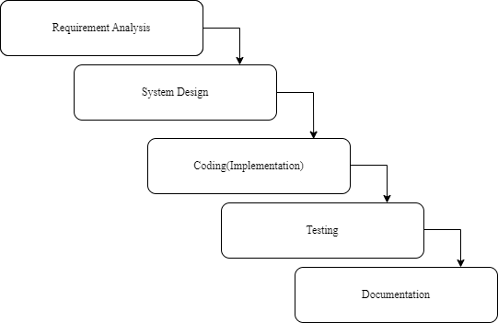

**Figure 1: 1.5 Waterfall Model of Real Estate Management System**

## 1.6 Report Organization

**Chapter 1: Introduction**

This chapter deals with the introduction of the system with its objectives and limitations along with the reason why the system is made.

**Chapter 2: Background Study and Literature Review**

This chapter summarizes the work that has been carried out in the field of data mining and also describes the related research done while designing the project.

**Chapter 3: System Analysis and Design**

This chapter focuses on the different requirement of the system, which describes about the functional, non-functional, feasibility analysis, Entity Relational diagram, Data Flow Diagram, design of the system with system architecture, database schema, and interface design.

**Chapter 4: Implementation and Testing**

This chapter emphasizes tools used in system development, implementing details and result of test performed.

# Chapter 2: Background Study and Literature Review

## 2.1 Background Study

Finding room, flat for rent was also challenging when we moved to city for study, job or any other work and we use to suffer a lot just to find the best properties (flat, house, land). In order to eliminate the problem, we develop a online platform to ease the people to find room, flat, house and other estates and started working on the plan.

Real Estate Management System is related to online application of estate which aims to eliminate the problem of current system to access the property at great difficulty and hassle at the reduced effort. It is the advanced solution for his/her estate problem for acquiring the house, land, flat, room and land for lease. In this module the buyer or the interested party for selling, renting and leasing advertise their products on the site and the possible buyer, tenant, leaser or any interested party can get the required information form the site and the listed sites are verified by the admin panel of the site which therefore are secure for acquiring and providing comfortable sleep and hassle-free purchasing. Here the registration process is free of cost. After the validation of the user by the admin the user is listed as the valid user and can perform the operations which are available at the user end. This system is very useful for the companies who develop apartment, hotels, villa, residential properties and commercial properties. Company, individual agents or any group of people are equally benefitted by this system. This system also provides the medium for the agents to advertise their property.

## 2.2 Literature Review:

There are so many systems that are related to real estate. There are similar applications like this that can be studied in articles, websites, blogs, magazines and journals. Residing in the same place is not possible for the people involved in the job, business, or an organization we are completely unknown for new places we are travelling and finding the house, land, flat or room become very tedious. Buying property at the new place is full of risk and uncertainty, due to the busy schedule of the people. People didn’t have enough time for searching for a good property and perform necessary investigation before investing huge amount. Property management is also tough and absorbing a lot of time for seller too.

Aawash is one of the companies that provides a service for renting, buying house, leasing land, sharing room, buying/selling flats in Nepal. [1] In today’s busy schedule people are in search of the quick alternative to perform their task and manage their works efficiently. Difficult access and control over data of the user which is very hard to predict, due to improper and little knowledge people are not able to search and tally to the recent trend and the database which causes improper decision while investing huge capital. Having a solution to all the housing-related problems is the need of the today’s people but the gap is not filled by the alternatives available in the market today.[1]

99aana is another online housing system providing services related to estates through their web-based application and believe that it is not just concerned about buying and selling but related with the lifetime journey of the customer from renting room to buying land building house and so on. [2] It's about the journey itself; the experiences you can have along the way you treat and provide services to the people. [2]

Housing Nepal is another company established 7 years back with a common goal of dealing with the property and providing the satisfactory services to the people to build the long-term customer loyalty. They are performing well in the industry and have recently increased the services they provide through their online and offline platforms.[3] They are currently dealing with renting room, house, flat, selling land, house, flats and on the construction relates works of the estates. [3]

In a market where proper decision-making is crucial due to the significant capital involved, Aawash, 99aana.com, and Housing Nepal emerge as trusted partners. They bridge the gap in the market, ensuring that people are well-informed, empowered, and satisfied throughout their housing journeys. With their online and offline presence, these companies are reshaping the real estate landscape in Nepal, offering innovative solutions and building lasting relationships with their clients.

# Chapter 3: System Analysis and Design

## 3.1 System Analysis

Considering the fact that this project involves design and implementation of a software system regardless that is web-based, it will be important to mention and consider some models used in software development and deployment.

It is a process of collecting and interpreting facts, identifying the problems, decomposition of a system into its components.

System Analysis is conducted for the purpose of studying a system or its part in order to identify its objectives. It is a problem-solving technique that improves the system and ensures that all the components of the system work efficiently to accomplish their purpose.

### 3.1.1 Requirement Analysis

Requirement analysis is done while developing a system and before implementing it, it is necessary to analyze the whole system requirement. It is categories into mainly two parts:

I. Functional requirements II. Non-functional requirements

For any system, there are functional and non-functional requirements to be considered while determining the requirements of the system. The functional requirements are user “visible” features that are typically initiated by stakeholders of the system, such as generate report, login, and signup. On the other hand, nonfunctional requirements are requirements that describe how the system will do what it is supposed to do, for example, Usability, Reliability & Availability, Performance, Security and maintainability.

1. **Functional Requirements**

A functional requirement describes what a software should do when it is given input. This system interface is divided into three sections:

1. Admin interface
2. Client interface

**Admin Interface**

* Admin can view users/agents/builders.
* Admin can remove/delete property.
* Admin can check the listings and price as well as can delete it.

**Client Interface**

* Client can register by themselves.
* Client can view property.
* Client can check his/her booked listings.

**3.1.1.1 Use Case Diagram**

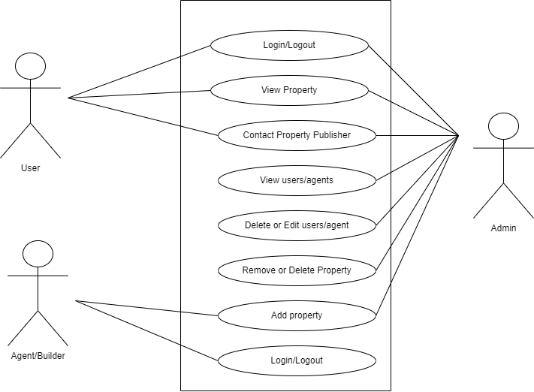

**Figure 2: 3.1.1.1 Use Case Diagram of Real Estate Management System**

**II. Non-Functional Requirements**

Online Real Estate Management System on providing quality functions by specifying following features:

1. **Security**

This system has accounts for its users and only authorized users can access the system with username and password.

1. **Availability**

This system is available to users anytime, anywhere, just need a PC and Internet Connection.

1. **Reliability**

The system has to be 100% reliable due to the importance of data and the damages that can be caused by incorrect or incomplete data. The system will run 7 days a week, 24 hours a day. This system provides a quick and efficient way to find a house/flat, land through online.

1. **Maintainability**

The system will be easily maintained by the developer or other authorized trained person and Backup for database are available.

### 3.1.2 Feasibility Analysis

Feasibility analysis is a part of system analysis carried to confirm that the system being developing is actually feasible or not. This is the phase where any system designer is able to know whether to start the project or not.

We performed some study and analyzed the system and got to know that is feasible to make the system. Mainly three types of feasibility such as Economic feasibility, technical feasibility, and Operational feasibility.

1. **Technical Feasibility**

The system is developed by using PHP, as we require some time to learn all these technologies. All these technologies are easy to learn and can develop the system very rapidly. It will be technically feasible as the requirement of system is easily accessible.

1. **Operational Feasibility**

Proposed projects are beneficial only if they are feasible into real world implemented system, which will meet the user requirements. This system provides a simple user interface, which can be easily used by any type of users having a basic idea of using a smart phones and PCs. This system will provide correct results according to the way the system needs to do. Hence, this system is operationally feasible.

1. **Economic Feasibility**

The system is economically feasible and cost effective. After the installation of the software, it reduced the paperwork and quality of data was improved. Using this system there will not be need of additional technology and software.

1. **Schedule Feasibility**

A system is said to be scheduled feasible if it is implemented within the planned schedule. We carried out the study on how much it will take to complete the task after studying the requirements and proposed plan.

**System Modeling:**

### 3.1.3 Data Modeling (ER-Diagram)

This ER (Entity Relationship) Diagram represent the model of this project. The entity-relationship diagram of project shows all the visual instrument of database table and the relations between admin, client and property owner. It uses structured data to define the relationship between structured data group of Online real estate management system functionalities.

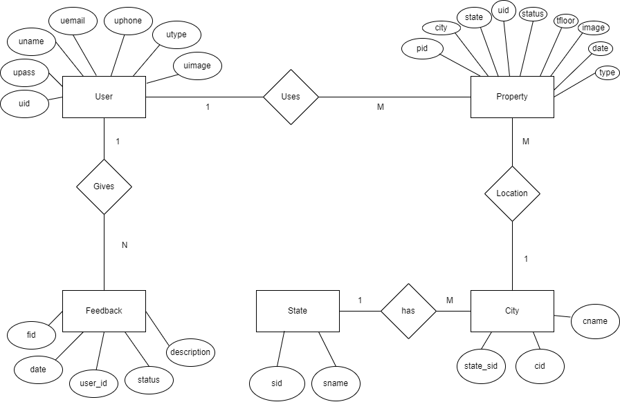

**Figure 3: 3.1.3 ER-Diagram of Real Estate Management Syste****m**

### 3.1.4 Process Modeling (DFD)

Data Flow Diagrams show the flow of data from external entities into the system, and from one process to another within the system. Below figure shows the Data Flow Diagrams for the current system.

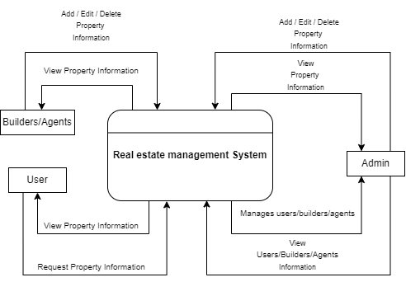

**Figure 4: 3.1.4 Level 0 DFD of Real Estate Management System**

## 3.2 System Design (Structured Approach)

### 3.2.1 Architectural Design

The next phase of design will be planning the architecture of the application. There will be in some cases a separation of the user interface and data. The business layer will be totally independent and not embedded in the views of the website. Data will be stored in an SOL database. To query the database and code behind for server-side scripting will be in Java. The other business objects will have their own layer. The architecture of the application is shown below in figure:

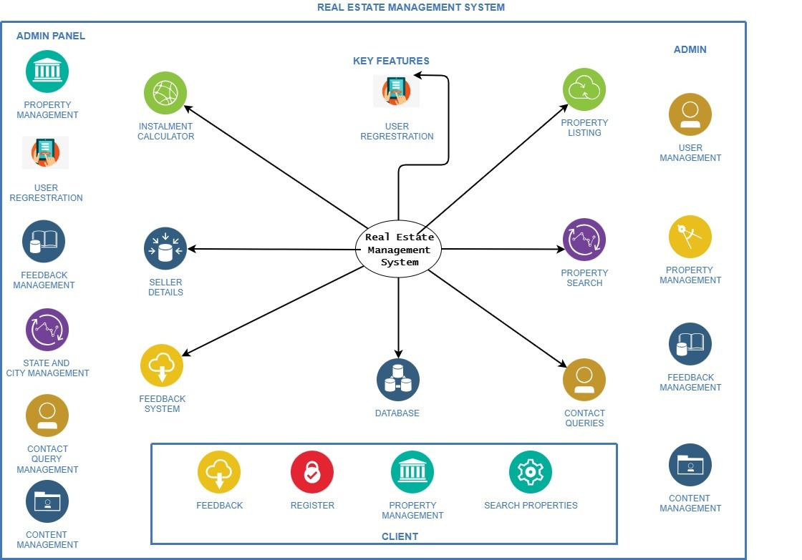

**Figure 5: 3.2.1 Architectural design of Real Estate Management System**

### 3.2.2 Database Schema Design

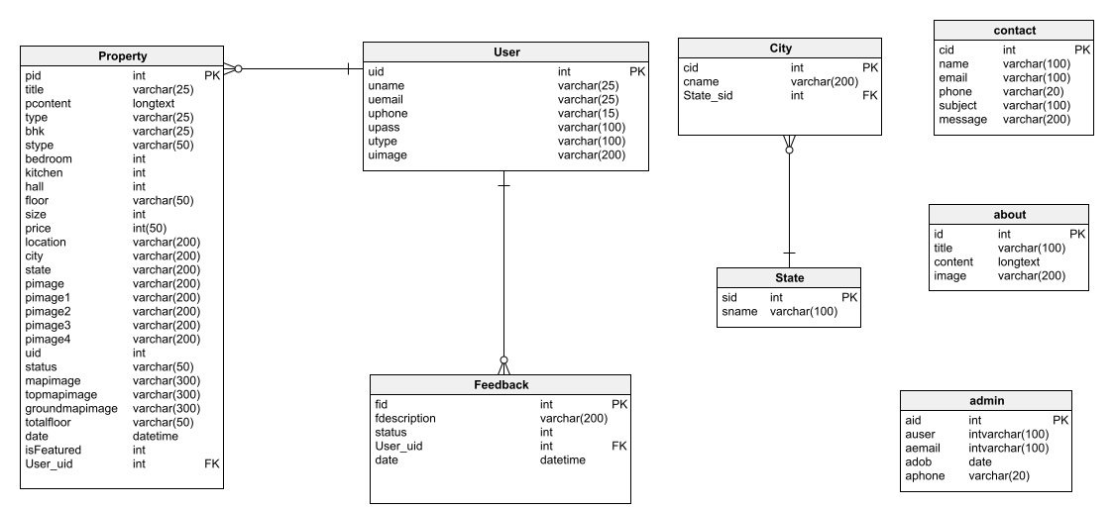

**Figure 6: 3.2.2 Database Schema of Real Estate Management System**

### 3.2.3 Interface Design (UI/UX)

**Figma Designs**

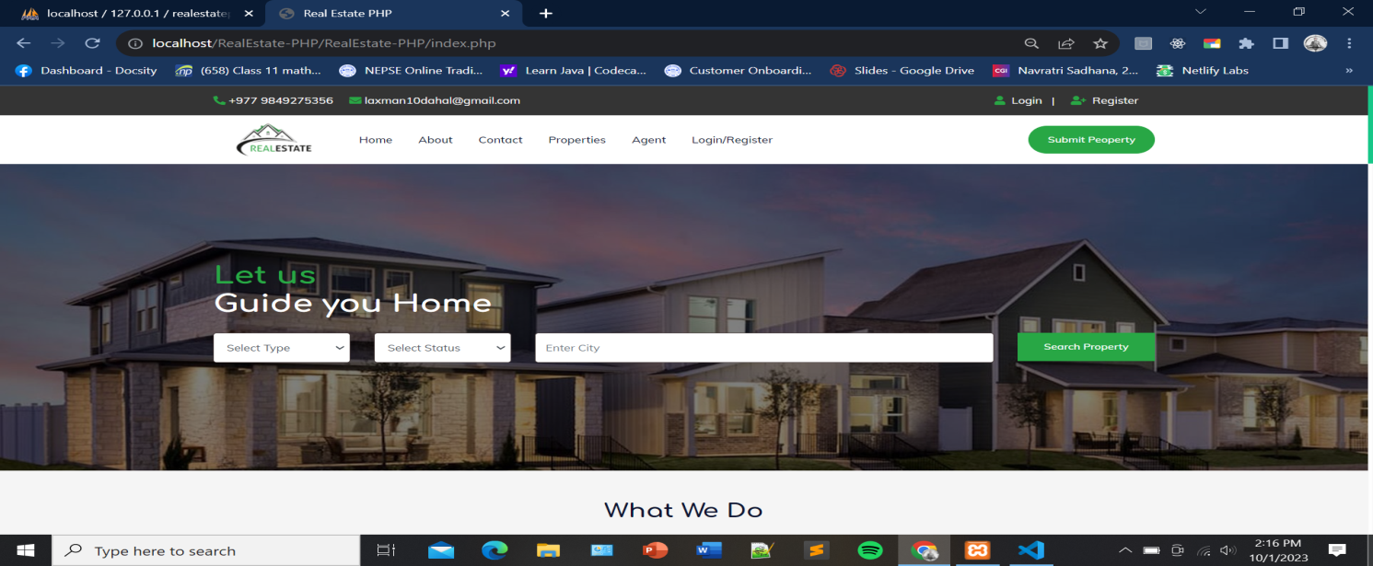

**Figure 7: 3.2.3 Home page from where user can register**

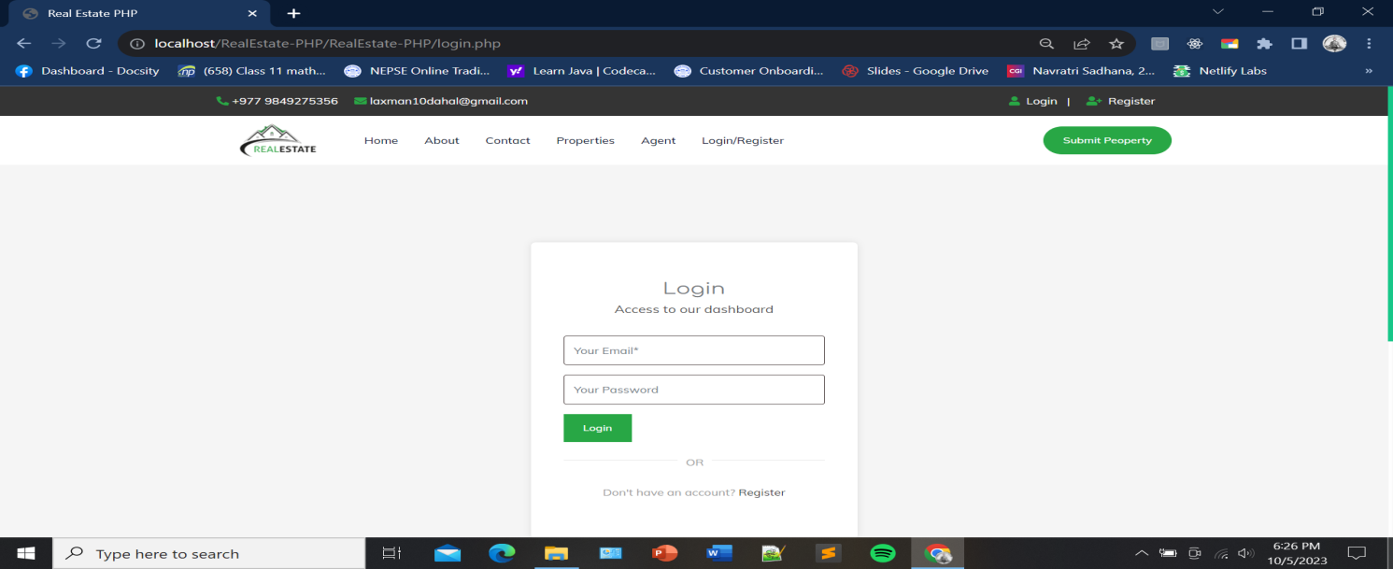

**Figure 8: 3.2.3 Login page for the admin**

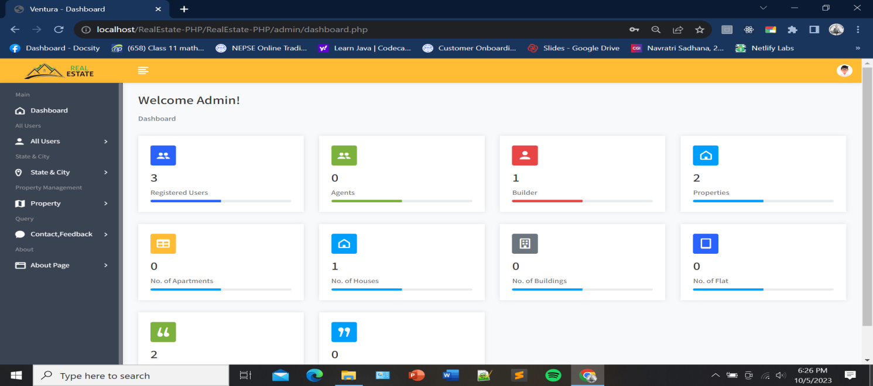

**Figure 9: 3.2.3 Admin Dashboard**

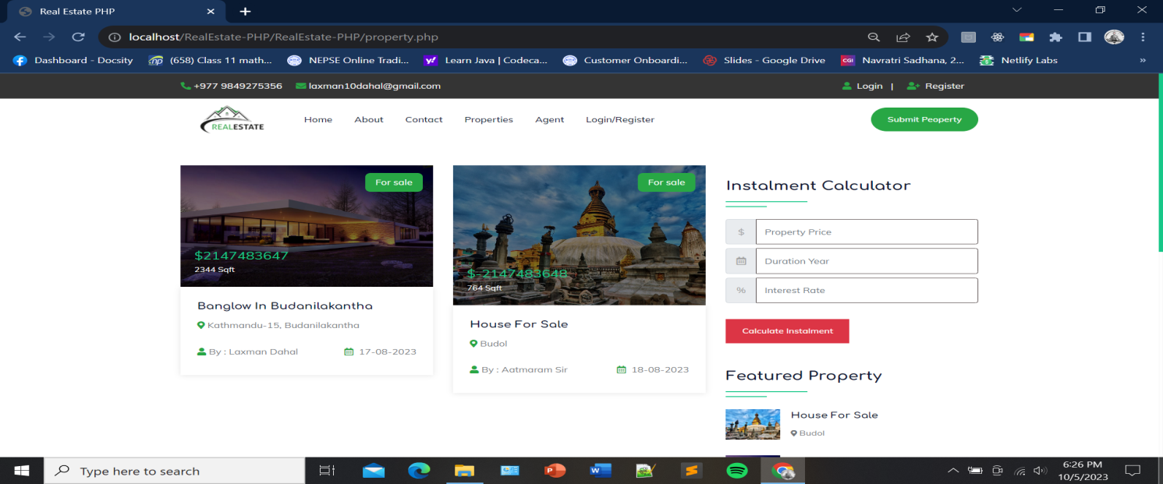

**Figure 10: 3.2.3 Property List**

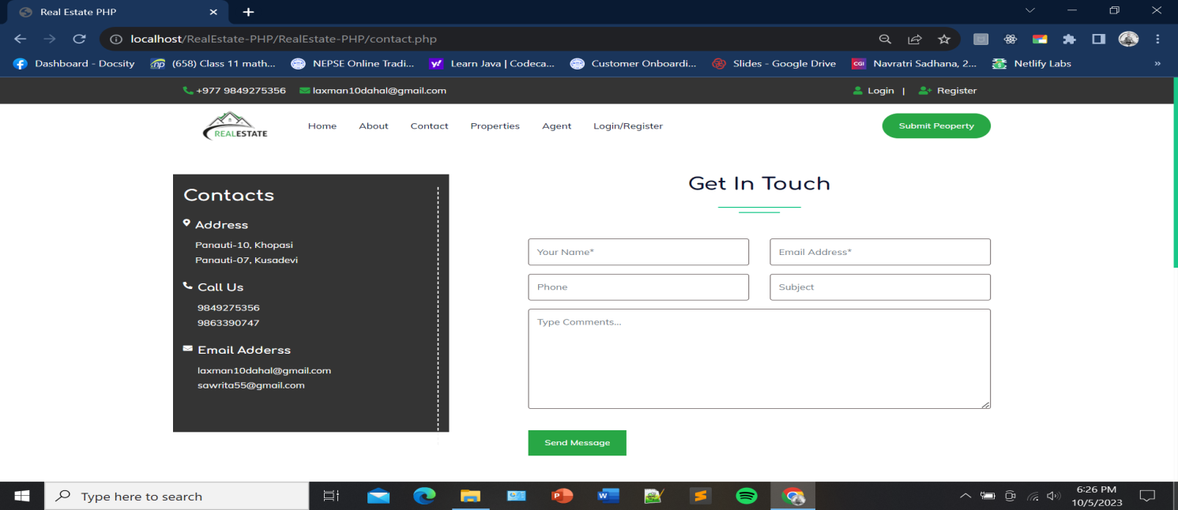

**Figure 11: 3.2.3 Admin Panel**

## 3.3 Algorithm:

**Binary Search Algorithm:** A binary search is the simplest approach employed to search for an element in a data set. It examines each element until it finds a match, starting at the beginning to data set, until the end. The search is finished and terminated once the target element is located.

**Code:**

<?php

function binarySearch(

    $arr,

    $low,

    $high,

    $x

) {

    while ($low <= $high) {

        $mid = $low + ($high - $low) / 2;

        if ($arr[$mid] == $x)

            return floor($mid);

        if ($arr[$mid] < $x)

            $low = $mid + 1;

        else

            $high = $mid - 1;

    }

    return -1;

}

**Security Algorithm**

**SHA (Secure Hash Algorithm):** SHA is a family of cryptographic hash functions published by the National Institute of Standards and Technology (NIST). SHA-1, SHA-256, SHA-384, and SHA-512 are examples of SHA algorithms. These algorithms take an input (message) and produce a fixed-size hash value, which appears random. Even a small change in the input data should result in a significantly different hash value.

**Code:**

<?php

session_start();

include("config.php");

$error="";

if(isset($_POST['login']))

{

$user=$_REQUEST['user'];

$pass=$_REQUEST['pass'];

$pass= sha1($pass);

if(!empty($user) && !empty($pass))

{

$query = "SELECT auser, apass FROM admin WHERE auser='$user' AND apass='$pass'";

$result = mysqli_query($con,$query)or die(mysqli_error());

$num_row = mysqli_num_rows($result);

$row=mysqli_fetch_array($result);

if( $num_row ==1 )

{

$_SESSION['auser']=$user;

header("Location: dashboard.php");

}

else

{

$error='* Invalid User Name and Password';

}

}else{

$error="* Please Fill all the Fileds!";

}

}

?>

# Chapter 4: Implementation and testing

## 4.1. Implementation

Implementation basically means the phase where the system is actually being built. Firstly, all the information that we gathered is studied and analyzed and implemented a system in operation for users. It is one of the most important phases of any project. Implementation usually consists of coding, testing, installation, documentation, training and support. Different tools and technologies that have been used to develop the system which are already discuss in the previous chapter. It is basically converting system design specification into working software.

### 4.1.1. Tools Used

The various system tools that have been used in developing both the front-end and back-end of the project are being discussed in this chapter.

1. **HTML:** In Real Estate Management System, html is used for creating different web page and sites. It is used to create and structure sections, headings, links, paragraphs using various tags and elements. This system has also defined headers, paragraphs, links and images by using html.
2. **CSS:** In Real Estate Management System, CSS is used for designing different tags of html. It is also used to design different component by the help of class and id. Different CSS are used such as inline CSS, internal CSS and external CSS to design this system. It is used for defining the styles for web pages. By using CSS, we can control the text colour, font style, the spacing between paragraphs, sizing of columns, layout designs and many more.
3. **JAVASCRIPT:** In Real Estate Management System, JavaScript is used for client-side validation and to make dynamic, interactive and responsive web pages. It is used to add dynamic behaviour to the webpage and add special effects to the webpage.
4. **PHP:** In Real Estate Management System, PHP is used for the backend purpose and for making dynamic web pages. It is used for server-side scripting purpose to add connectivity to the database and also used to encrypt the data, validate the user data confirm user to go to certain pages, login pages. It also includes add, update and delete the data from the database.
5. **Apache Server:** In Real Estate Management System, Apache server is used to run php files and creating dynamic web pages.
6. **MYSQL:** In our project Real Estate Management System, MYSQL is used for storing all the information required to the database. It is also used for performing CRUD operation such as create, delete, retrieve and update data from the database as required by users.

### 4.1.2 Implementation Details of Module

Algorithms Used

<?php

function binarySearch($arr,$low,$high,$x) {

    while ($low <= $high) {

        $mid = $low + ($high - $low) / 2;

        if ($arr[$mid] == $x)

            return floor($mid);

        if ($arr[$mid] < $x)

            $low = $mid + 1;

        else

            $high = $mid - 1;

    }

return -1;

}

## 4.2. Testing

In this phase, testing be conducted in accordance with the Software Requirement specification to meet the standards. The prime focus remains on the empty field’s submission, direst passing the query string. The test will be performed for each module for its proper functionality.

### 4.2.1 Test Cases for Unit Testing

In unit testing, we designed the entire system in modularized pattern and each module is tested. Until we get the accurate output from the individual module, we work on the same module. The input form is tested so that they do not accept invalid input.

**Successful User Registration**

|  |  |
| --- | --- |
| Test Case 1 | Successful User Registration |
| Test Data | Full Name: Hem Bahadur Shrestha  Mobile number:9808140638  Email Id:hbshrestha07@gmail.com  Password:user123 |
| Expected Result | A message should be displayed saying  “Registration Success” |
| Test Result | Registration Success |

**Table 1: 4.1 Test Case for Successful User Registration**

**User Registration Fail**

|  |  |
| --- | --- |
| Test Case 2 | User Registration Fail |
| Test Data | Full name: Hem Bahadur Shrestha  Mobile: 9808140639  Email id: [hbshres@gmail.com](mailto:hbshres@gmail.com) |
| Expected Result | A message should be displayed saying “password field is required, invalid email,  number should be equal to 10 digits.” |
| Test Result | “password field is required, invalid email, number should be equal to 10 digits.” |

**Table 2: 4.2 Test Case for User Registration Fail**

**Successful user Login**

|  |  |
| --- | --- |
| Test Case 3 | Successful User Login |
| Test Data | Email:hbshrestha07@gmail.com  Password:user123 |
| Expected Result | The page is directed to dashboard |
| Test Result | The page is directed to dashboard |

**Table 3: 4.3 Test Case for User Login**

**Test Case for Successful Booking**

|  |  |
| --- | --- |
| Test Case 1 | Successful Booking |
| Test Data | Property type: Flat Property Location: Nawalparasi  Comment: Urgently need to shift. |
| Expected Result | A message should be displayed saying “Booking is confirmed” |
| Test Result | Booking is confirmed. |

**Table 4: 4.4 Test Case for Successful Booking**

**Test Case for Booking Failure**

|  |  |
| --- | --- |
| Test Case 2 | Booking failure |
| Test Data | Property type: Flat Property Location: Nawalparasi |
| Expected Result | A message should be displayed saying “Comment field is required” |
| Test Result | “Comment field is required” |

**Table 5: 4.5 Test Case for Booking Failure**

### 4.2.2 Test Cases for System Testing

* Integration of all the modules in the system.
* Preparation of the test cases.
* Preparation of the possible test data with all the validation checks.
* Actual testing done manually.
* Recording of all the reproduced errors.

# Chapter 5: Conclusion and Future Recommendation

## 5.1 Conclusion

Our goal was to create an application where clients can add their property/land which they want to sell and if another client like the property/land they can contact to the agent without physical presence. The current application has fulfilled these goals. We followed the specifications strictly but enhanced some of the features when there was need for it to be done. With the goals achieved the basis of the application and this project has been achieved. Building this system has been challenging and enriching because throughout the project we learnt a lot about PHP, MySQL and understand what it takes to build a fully functional system. There have been challenges especially when it came to backend and making sure that the application responses in a predictable. Careful planning made our job easier because we had to carefully think about the type of architecture, the design, the database types to use and what type of business objects to create. When this was done, we proceeded with implementation.

Choosing the PHP programming language for this project is because it is very simple and easy to use, compared to another programming language for building Online Applications, this is widely used all over the world. it is Open source; we can freely download and use. And it is platform independent as well.

As we came to the end of the project, we realized that there are many enhancements that can be made on the application. Some of these ideas came from those who tested the application and some of them from both of us. We decided to follow the specification because there were realistic to achieve in this given amount of time. Any other enhancements to the application can be done in future development of the application.

## 5.2 Lesson Learnt/Outcome

From this project, users can be able to see land/property without physical presence, also can see the location of land/property if they want to buy it or like it they can directly contact to the agent from anywhere whenever they want.

**5.3 Gantt chart**

|  |  |  |  |  |  |  |  |  |  |  |  |  |
| --- | --- | --- | --- | --- | --- | --- | --- | --- | --- | --- | --- | --- |
| Week  Activity | 1 | 2 | 3 | 4 | 5 | 6 | 7 | 8 | 9 | 10 | 11 | 12 |
| Requirement Analysis |  |  |  |  |  |  |  |  |  |  |  |  |
| System Design |  |  |  |  |  |  |  |  |  |  |  |  |
| Coding  (Implementation) |  |  |  |  |  |  |  |  |  |  |  |  |
| Testing |  |  |  |  |  |  |  |  |  |  |  |  |
| Documentation |  |  |  |  |  |  |  |  |  |  |  |  |

**Figure 12: 5.3 Gantt chart of Real Estate Management System**

# References

|  |  |
| --- | --- |
| [1] | Aawash, "Aawash," 2023. [Online]. Available: https://www.aawash.net/about-us. [Accessed 08 10 2023]. |
| [2] | 99aana, "99 aana," 2023. [Online]. Available: https://99aana.com/. [Accessed 28 09 2023]. |
| [3] | Housing Nepal, "Housing Nepal," 2023. [Online]. Available: https://www.housingnepal.com/. [Accessed 25 09 2023]. |