DEEP LEARNING APPLICATION IN DATA SCIENCE
Fashion-MNIST Clothing Classification Using a Neural Network
Week 5 Internship Project Report
Project Overview
This project focuses on applying deep learning techniques to classify clothing images into different categories using the Fashion-MNIST dataset. A neural network was developed using TensorFlow and Keras to recognize patterns in grayscale images and predict the corresponding clothing category.
The dataset contains 70,000 images divided into 10 clothing categories, including T-shirts, trousers, dresses, coats, sandals, sneakers, bags, and ankle boots. Each image has a resolution of 28 × 28 pixels.
Project Objectives
- Understand the basic structure and working of a neural network.
- Preprocess image data for deep learning.
- Train a neural network to classify clothing images.
- Evaluate model performance using standard classification metrics.
- Visualize training performance, the confusion matrix, and sample predictions.
Methodology
The project uses a feedforward neural network built with TensorFlow and Keras. The images were normalized to a range of 0 to 1 before training. The model contains a Flatten layer, two hidden Dense layers using ReLU activation, a Dropout layer to help reduce overfitting, and a final Softmax output layer for classifying the 10 categories.
The model was trained for 15 epochs using the Adam optimizer and sparse categorical cross-entropy loss. Its performance was evaluated on the test dataset.
Key Result
Test Accuracy: 87.83%
The model correctly classified approximately 88 out of every 100 test images. Additional evaluation included weighted precision, weighted recall, weighted F1-score, training and validation curves, a confusion matrix, and sample predictions.
Tools Used: Python, Google Colab, TensorFlow, Keras, NumPy, Matplotlib, Pandas and Scikit-learn.
Submitted by: Shreya Dolui
Introduction
Deep learning is a branch of machine learning that uses artificial neural networks to learn patterns from data. It is widely used in image classification, speech recognition, object detection, and other data-driven applications.
Image classification is the process of identifying the category to which an image belongs. In this project, deep learning is applied to classify clothing images into ten different categories using the Fashion-MNIST dataset.
The Fashion-MNIST dataset contains grayscale images of clothing items, each measuring 28 × 28 pixels. A neural network is trained on these images to learn visual patterns and predict the correct category for previously unseen images.
The model is developed using TensorFlow and Keras in Google Colab. The project covers data preprocessing, neural network design, model training, performance evaluation, and visualization of predictions.
The main purpose of this project is to understand how a neural network can solve a practical image classification problem and to evaluate its performance using appropriate metrics.
Dataset Description
The Fashion-MNIST dataset was used for this project. It is a publicly available dataset designed for image classification tasks and serves as an alternative to the traditional MNIST handwritten-digit dataset.
The dataset consists of 70,000 grayscale images divided into 10 clothing categories. Each image has a size of 28 × 28 pixels, with pixel intensity values representing different shades of gray.
The dataset is divided into two parts:
- Training dataset: 60,000 images used to train the neural network.
- Testing dataset: 10,000 images used to evaluate the trained model on unseen data.
The ten categories are T-shirt/top, Trouser, Pullover, Dress, Coat, Sandal, Shirt, Sneaker, Bag, and Ankle boot. Each image has a corresponding numerical label from 0 to 9.
The dataset was loaded directly using TensorFlow's Keras API, so no manual dataset download was required. This dataset is suitable for learning image preprocessing, neural network training, and multiclass classification.
Data Preprocessing
Data preprocessing is an important step in deep learning because it prepares raw data for efficient model training. In this project, the Fashion-MNIST images were preprocessed before being passed to the neural network.
1) Image Normalization
The original pixel values range from 0 to 255. These values were converted to floating-point numbers and divided by 255, scaling the pixel intensities to a range between 0 and 1. Normalization helps the neural network learn more efficiently during training.
2) Dataset Preparation
The training and testing images were loaded separately. The training dataset contained 60,000 images, while the testing dataset contained 10,000 images. Each image had a resolution of 28 × 28 pixels, and each label represented one of the ten clothing categories.
3) Validation Split
During training, 10% of the training data was used for validation. This allowed the model's performance on unseen validation images to be monitored after each epoch.
No additional manual image resizing or feature extraction was required because the dataset was already provided in a consistent image format.
Neural Network Architecture
A feedforward neural network was developed using TensorFlow and Keras to classify the Fashion-MNIST images into ten clothing categories. The model consists of an input layer, a flattening layer, two hidden dense layers, a dropout layer, and an output layer.
1) Model Layers
Input Layer: Accepts grayscale images with dimensions of 28 × 28 pixels.
Flatten Layer: Converts each two-dimensional image into a one-dimensional array containing 784 pixel values.
First Dense Layer: Contains 128 neurons and uses the ReLU activation function to learn important patterns from the image data.
Dropout Layer: Uses a dropout rate of 0.2, randomly disabling a portion of neurons during training to help reduce overfitting.
Second Dense Layer: Contains 64 neurons and uses ReLU activation to learn additional patterns.
Output Layer: Contains 10 neurons, one for each clothing category. The Softmax activation function produces class probabilities, and the category with the highest probability is selected as the prediction.
2) Model Compilation
The model was compiled using the Adam optimizer and sparse categorical cross-entropy loss. Accuracy was selected as the primary metric for monitoring performance during training.
The architecture combines feature learning through dense layers with dropout regularization to support multiclass image classification.
Model Training
After defining the neural network architecture, the model was trained using the Fashion-MNIST training dataset. During this process, the network learned patterns from the clothing images by adjusting its weights to reduce classification errors.
The model was trained for 15 epochs with a batch size of 64. A validation split of 10% was used to monitor the model's performance on data not used for weight updates.
The Adam optimizer updated the network weights during training, while sparse categorical cross-entropy measured the difference between the predicted class probabilities and the actual labels.
Training accuracy, validation accuracy, training loss, and validation loss were recorded for each epoch. These values were visualized using line graphs to observe how the model learned over time and to identify possible signs of overfitting.
The training and validation graphs provide useful information about the learning process and help assess whether the model's performance remains consistent on data not used for training.
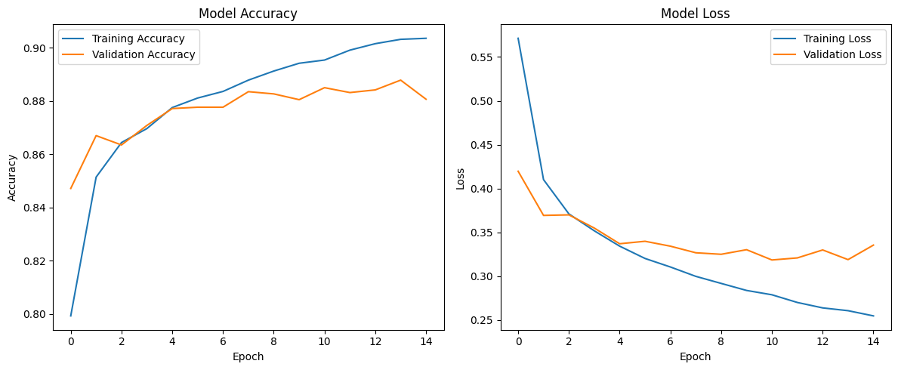
Model Evaluation and Performance Metrics
After training, the model was evaluated using the 10,000 images in the test dataset. These images were not used to update the model's weights during training, allowing its classification performance to be assessed on unseen data.
The model achieved a test accuracy of 87.83%, indicating that it correctly classified approximately 88% of the test images.
The following metrics were used to evaluate its performance:
- Test Accuracy (87.83%): Measures the proportion of test images classified correctly.
- Weighted Precision (87.99%): Measures the reliability of the model's positive class predictions, weighted according to the number of samples in each category.
- Weighted Recall (87.83%): Measures the proportion of actual class instances correctly identified, using a weighted average across categories.
- Weighted F1-Score (87.65%): Combines precision and recall into a single measure using their harmonic mean, with weighting across categories.
The model's performance was also examined using a classification report and a confusion matrix. These helped compare actual and predicted clothing categories and identify classes that were more difficult to distinguish.
The evaluation results indicate that the neural network learned useful patterns from the image data, although some clothing categories may still be misclassified due to similarities in their appearance.
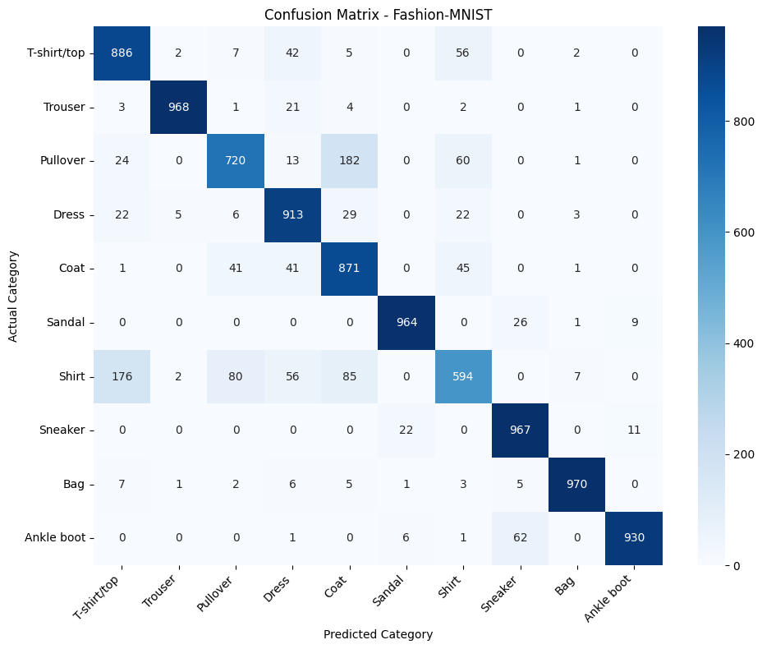
Results and Discussion
The trained neural network achieved a test accuracy of 87.83% on the Fashion-MNIST dataset. This result indicates that the model can recognize and classify most clothing images into their correct categories.
The weighted precision of 87.99%, weighted recall of 87.83%, and weighted F1-score of 87.65% show that the model achieved reasonably balanced classification performance across the dataset.
The training and validation graphs helped illustrate the model's learning behavior over the 15 epochs. The confusion matrix provided a more detailed view of correct classifications and errors across the ten clothing categories. The sample predictions also demonstrated how the model assigned predicted labels to individual images.
Some categories may be harder to distinguish because their shapes and visual patterns are similar. For example, shirts, T-shirts, coats, and pullovers can share certain visual features in low-resolution grayscale images.
Overall, the results demonstrate that a relatively simple feedforward neural network can perform clothing image classification effectively. However, further improvements may be possible through convolutional neural networks, hyperparameter tuning, and additional experiments.

Limitations and Future Improvements
1) Limitations
Although the model achieved a test accuracy of 87.83%, some limitations remain:
- Low image resolution: The images are only 28 × 28 pixels, which limits the visual details available to the model.
- Similar clothing categories: Categories such as shirts, T-shirts, coats, and pullovers may have similar visual patterns, leading to classification errors.
- Model architecture: The feedforward neural network uses flattened pixel values and does not explicitly preserve the spatial relationships between neighboring pixels.
- Classification errors: The model does not classify every test image correctly, as reflected in the confusion matrix and evaluation metrics.
2) Future Improvements
The model could be improved by using a Convolutional Neural Network (CNN), which is designed to learn spatial features from images. Other possible improvements include testing different network architectures, tuning hyperparameters, and experimenting with data augmentation.
These improvements could help the model recognize more detailed image patterns and potentially increase classification accuracy. However, further experiments would be required to confirm any improvement.
Conclusion
This project demonstrated the application of deep learning to clothing image classification using the Fashion-MNIST dataset. A feedforward neural network was developed and trained using TensorFlow and Keras, with image normalization applied during preprocessing.
The trained model achieved a test accuracy of 87.83%, along with a weighted precision of 87.99%, weighted recall of 87.83%, and weighted F1-score of 87.65%. Training graphs, a confusion matrix, and sample predictions were used to examine the model's learning behavior and classification performance.
The project provided practical experience in data preprocessing, neural network design, model training, performance evaluation, and visualization. It also highlighted the challenges of distinguishing visually similar clothing categories in low-resolution images.
Overall, the project demonstrates how deep learning can be applied to a practical multiclass image classification problem and provides a foundation for exploring more advanced image classification techniques.
References
1. Fashion-MNIST Dataset — Zalando Research: https://github.com/zalandoresearch/fashion-mnist
2. TensorFlow Documentation — https://www.tensorflow.org/
3. Keras Documentation — https://keras.io/
4. Scikit-learn Documentation — https://scikit-learn.org/stable/
Project Resources
Google Colab Notebook: [https://colab.research.google.com/drive/1JBejRmGGbi4I-F4PahpLrZ_jlxV9MOZT?usp=sharing]

