WEEK 3 PROJECT REPORT

Unsupervised Learning and Clustering Analysis
Customer Segmentation Using K-Means Clustering

Submitted by: Shreya Dolui

Dataset: Mall Customers Dataset
Programming Language: Python
Development Environment: Google Colab
Libraries Used: Pandas, NumPy, Matplotlib and Scikit-learn
Machine Learning Technique: K-Means Clustering
Project Focus: Customer Segmentation and Behaviour Analysis

Introduction
Customer segmentation is an important technique in data analysis that helps businesses understand different groups of customers based on their characteristics and spending behaviour. Instead of treating all customers in the same way, businesses can identify groups with similar patterns and develop suitable marketing strategies.
This project applies unsupervised machine learning to a mall customer dataset using the K-Means clustering algorithm. The analysis considers customer age, annual income and spending score to identify meaningful customer groups. Since the dataset does not contain predefined cluster labels, the algorithm identifies groups based on similarities in the selected features.
The project includes data exploration, feature selection, data standardization, selection of the number of clusters, clustering, visualization and interpretation of the results. The findings are also discussed in terms of their potential usefulness for customer relationship management and marketing decisions.
Objectives
The main objectives of this project are:
1. To explore and understand the structure of the Mall Customers dataset.
2. To check the dataset for missing values, duplicate records and data-quality issues.
3. To select suitable numerical features for customer segmentation.
4. To standardize the selected features before applying K-Means clustering.
5. To use the Elbow Method and Silhouette Score to evaluate different numbers of clusters.
6. To apply the K-Means clustering algorithm and group customers based on their characteristics.
7. To visualize the resulting clusters and compare their characteristics.
8. To interpret the identified customer groups and discuss their potential business applications.
9. To identify the limitations of the analysis and suggest possible improvements.
Dataset Description
The Mall Customers dataset is a publicly available dataset used for customer segmentation and exploratory data analysis. It contains demographic and spending-related information about 200 customers.
The original dataset consists of 200 rows and five columns. It includes customer identification, gender, age, annual income and spending score. These attributes provide a basic overview of customer characteristics and shopping behaviour.
A) Dataset Features
The dataset contains the following five features:
1. CustomerID: A unique identifier assigned to each customer.
2. Gender: The recorded gender category of the customer.
3. Age: The customer's age in years.
4. Annual Income (k$): The customer's annual income expressed in thousands of dollars.
5. Spending Score (1–100): A score assigned to customers to represent their shopping behaviour.
B) Features Selected for Clustering
Three numerical features were selected for the clustering analysis:
- Age
- Annual Income (k$)
- Spending Score (1–100)
CustomerID was excluded because it is an identifier and does not represent a meaningful customer characteristic. Gender was also excluded from the initial model because this analysis focuses on numerical features.
These three selected features were used to identify groups of customers with similar demographic and spending characteristics.

Data Preprocessing
Data preprocessing is an important step in machine learning because it helps ensure that the dataset is suitable for analysis. Before applying the clustering algorithm, the Mall Customers dataset was inspected and prepared using Python and Pandas.
A) Data Inspection
The dataset was loaded into a Pandas DataFrame. Its dimensions, column names, data types, missing values, duplicate records and descriptive statistics were examined.
The initial inspection showed that the dataset contained 200 records and five columns. No missing values or duplicate records were detected.
B) Feature Selection
Three numerical features—Age, Annual Income (k$) and Spending Score (1–100)—were selected for the clustering process. CustomerID was excluded because it is an identifier rather than a meaningful measure of customer behaviour. Gender was not included in the initial clustering model.
C) Feature Standardization
The selected features were standardized using the StandardScaler method from Scikit-learn.
Standardization transforms the features so that they have approximately zero mean and unit variance. This step is important for K-Means because the algorithm uses distances to group similar observations. Without standardization, features with larger numerical scales could have a greater influence on the clustering results.
After standardization, the transformed features were used as input for the K-Means clustering algorithm.
Methodology
The project followed a systematic workflow to identify meaningful customer segments from the Mall Customers dataset. Python and Scikit-learn were used to implement the clustering process.
A) Exploratory Data Analysis
Exploratory Data Analysis (EDA) was performed to understand the dataset's structure and distribution. Bar charts and histograms were created to examine gender distribution, customer age, annual income and spending scores. These visualizations helped identify the characteristics and variation present in the dataset.
B) Selection of the Clustering Algorithm
The K-Means clustering algorithm was selected because it is a widely used unsupervised learning technique that groups observations according to their similarity. It assigns each observation to a cluster based on its distance from the cluster centroids.
K-Means was suitable for this project because the objective was to identify groups of customers with similar demographic and spending characteristics without using predefined labels.
C) Determining the Number of Clusters
The Elbow Method and Silhouette Score were used to evaluate different numbers of clusters.
The Elbow Method examines how the within-cluster sum of squared distances, known as inertia, changes as the number of clusters increases. The preferred value is often near the point where the reduction in inertia begins to slow.
The Silhouette Score measures how well each observation fits within its assigned cluster compared with other clusters. Its value ranges from -1 to 1, with higher values generally indicating better-separated clusters.
Both methods were considered when selecting the number of clusters for the final model.
D) K-Means Model Configuration
The K-Means model was implemented using Scikit-learn with the following parameters:
- Number of clusters (n_clusters): 5
- Random state: 42
- Number of initializations (n_init): 10
The random state was fixed to support reproducibility, while 10 initializations allowed the algorithm to try different initial centroid positions and select a better solution.
E) Cluster Evaluation
After fitting the model, each customer was assigned a cluster label. The average age, annual income and spending score were calculated for each cluster. Cluster sizes and visualizations were also examined to understand the differences between the resulting customer groups.
Results and Selection of the Number of Clusters
The number of clusters is an important parameter in K-Means clustering because it determines how the observations are grouped. In this project, the Elbow Method and Silhouette Score were used to examine suitable cluster counts before fitting the final model.
A) Elbow Method
The Elbow Method was applied to evaluate K-Means inertia for different values of K, ranging from 2 to 10. Inertia measures the sum of squared distances between observations and their assigned cluster centroids.
As the number of clusters increases, inertia generally decreases. The Elbow Method helps identify a point where adding more clusters produces a smaller improvement. This provides guidance when choosing a suitable number of clusters.
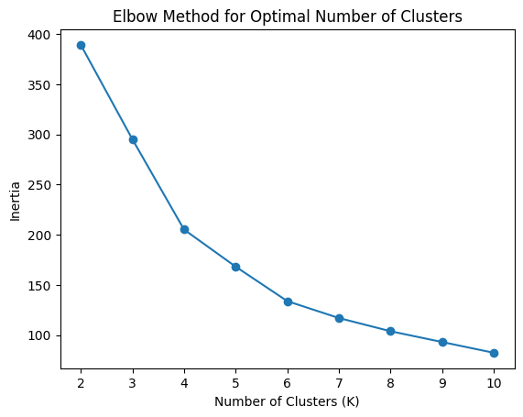
B) Silhouette Score Analysis
Silhouette Scores were calculated for different cluster counts between 2 and 10. The score measures how well observations fit within their assigned clusters compared with other clusters.
The final model with five clusters achieved a Silhouette Score of 0.4166. This indicates moderate separation between the clusters, suggesting that the groups have some meaningful structure, although they are not perfectly separated.
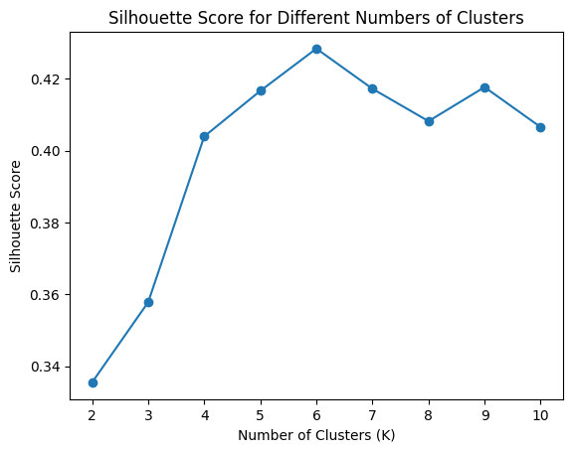
C) Selection of Five Clusters
Five clusters were used for the final K-Means model. This choice allows the customer groups to be examined in detail and compared according to age, annual income and spending score.
The selection should be considered alongside the Elbow Method graph, the Silhouette Score graph and the interpretability of the resulting groups. The Silhouette Score of 0.4166 provides evidence of moderate clustering quality rather than perfect separation.
The resulting clusters were then analysed to understand the characteristics of different customer segments and their potential business relevance.
Cluster Analysis and Interpretation
After applying K-Means clustering with five clusters, each customer was assigned to one of the five groups. The clusters were compared using their average age, annual income and spending score. The number of customers in each group was also examined to understand the distribution of the segments.
A) Summary of Cluster Characteristics
The following table presents the average characteristics of the five customer clusters obtained from the analysis.
Cluster | Customer | Average Age | Average Annual Income (k$) | Average Spending Score
0 | 20 | 46.25 | 26.75 | 18.35
1 | 54 | 25.19 | 41.09 | 62.24
2 | 40 | 32.88 | 86.10 | 81.53
3 | 39 | 39.87 | 86.10 | 19.36
4 | 47 | 55.64 | 54.38 | 48.85
Table 1: Average characteristics and customer counts for the five clusters.
B) Interpretation of Individual Clusters
Cluster 0: Lower-Income, Low-Spending Customers
This cluster contains 20 customers, with an average age of 46.25 years, average annual income of 26.75 thousand dollars and average spending score of 18.35. The group is characterized by relatively low income and low spending scores. Businesses could explore value-oriented offers and affordable product options for this segment.
Cluster 1: Younger, Relatively High-Spending Customers
This is the largest cluster, containing 54 customers. Its average age is 25.19 years, average annual income is 41.09 thousand dollars and average spending score is 62.24. The group consists of younger customers who show relatively high spending scores compared with the other clusters. Businesses could consider trend-oriented promotions and loyalty programmes for this segment.
Cluster 2: High-Income, High-Spending Customers
This cluster contains 40 customers, with an average age of 32.88 years, average annual income of 86.10 thousand dollars and average spending score of 81.53. It has the highest average spending score among the five clusters, along with a high average annual income. Businesses could consider premium products, personalized offers and exclusive loyalty benefits for this group.
Cluster 3: High-Income, Low-Spending Customers
This cluster contains 39 customers. Its average age is 39.87 years, average annual income is 86.10 thousand dollars and average spending score is 19.36. Although the group has a high average annual income, its spending score is low. Businesses could investigate possible reasons for this pattern and test relevant product recommendations or targeted promotions.
Cluster 4: Older Customers with Moderate Spending Scores
This cluster contains 47 customers, with an average age of 55.64 years, average annual income of 54.38 thousand dollars and average spending score of 48.85. It has the highest average age among the five clusters and a moderate average spending score. Businesses could explore customer preferences and provide suitable product recommendations or loyalty benefits.
C) Customer Segmentation Visualization
The customer segmentation scatter plot visualizes the five clusters identified by the K-Means algorithm. Annual income is represented on the X-axis, while spending score is represented on the Y-axis. Each colour represents a different cluster, allowing the groups to be compared based on their income and spending patterns.
The visualization helps identify groups such as customers with high income and high spending scores, as well as customers with high income but low spending scores. These patterns can help businesses understand customer behaviour and explore suitable marketing strategies.
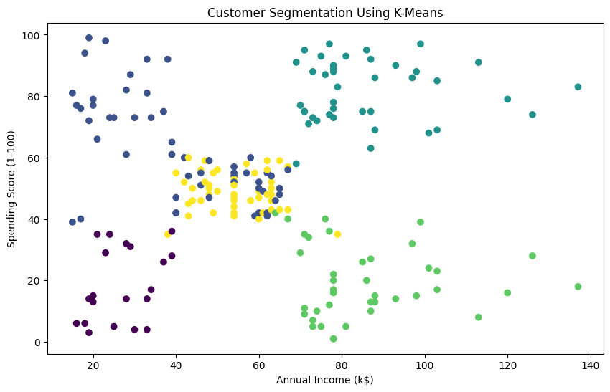
Customer Segmentation Using K-Means Based on Annual Income and Spending Score.
Business Implications
Customer segmentation can help businesses understand different customer groups and develop suitable marketing strategies. The results of this project show five customer segments with different age, annual income and spending score patterns.
- Cluster 0 — Lower Income and Low Spending: Businesses could explore budget-friendly products, discounts and value-based offers for this group.
- Cluster 1 — Younger Customers with Relatively High Spending: Trend-based promotions, loyalty programmes and personalized recommendations could be tested for this segment.
- Cluster 2 — High Income and High Spending: Businesses could explore premium products, exclusive offers and personalized shopping experiences for these customers.
- Cluster 3 — High Income and Low Spending: Businesses could investigate why this group has a low spending score and test suitable offers to encourage engagement.
- Cluster 4 — Older Customers with Moderate Spending: Businesses could explore loyalty benefits and conduct further research to understand the preferences of these customers.
- Overall, the clustering results can support customer-focused marketing and decision-making. However, these suggestions are potential strategies rather than guaranteed outcomes. Businesses should validate them using additional customer data and actual campaign results.
Limitations of the Project
Although the K-Means clustering algorithm helped identify five customer segments, this project has some limitations.
1. Limited Dataset Size: The dataset contains only 200 customer records. Therefore, the identified patterns may not represent the behaviour of all mall customers.
2. Limited Features: The clustering analysis used age, annual income and spending score. Other factors, such as purchase frequency, product preferences and transaction history, were not available for analysis.
3. Choice of Number of Clusters: The Elbow Method and Silhouette Score were used to evaluate different cluster counts. Although five clusters were selected for this project, this does not guarantee that they are the only or universally optimal grouping.
4. Moderate Cluster Separation: The final silhouette score was approximately 0.4166. This indicates some separation between clusters, but the groups are not perfectly distinct.
5. Dependence on the Algorithm: K-Means is sensitive to feature scaling, centroid initialization and the chosen number of clusters. Different settings may produce different results.
6. Limited Generalization: The cluster interpretations are based on group averages and the available dataset. They should not be treated as exact descriptions of every customer or as proof of customer behaviour.
Future work could use a larger dataset, include additional relevant features and compare K-Means with other clustering algorithms to evaluate whether the segmentation can be improved.
Conclusion
This project applied unsupervised machine learning to perform customer segmentation using the Mall Customers dataset. The dataset was explored and checked for missing values and duplicate records before selecting age, annual income and spending score as the clustering features. StandardScaler was used to standardize these features before applying the K-Means algorithm.
The Elbow Method and Silhouette Score were used to evaluate different numbers of clusters. Five clusters were selected for the final analysis, producing a silhouette score of approximately 0.4166. The resulting groups showed different patterns in customer age, income and spending behaviour.
The analysis demonstrated how clustering can help identify customer segments and support exploratory business analysis. These findings may help businesses consider targeted promotions and customer-focused marketing strategies. However, the results are limited by the dataset size and the moderate separation between clusters. Further analysis using additional customer information and alternative clustering techniques could help improve the results.
Overall, this project provided practical experience in data preprocessing, feature standardization, K-Means clustering, model evaluation, visualization and interpretation of unsupervised machine learning results.
References
1. Dataset: Mall Customer Segmentation — Kaggle
https://www.kaggle.com/datasets/vjchoudhary7/customer-segmentation-tutorial-in-python
2. Google Colab Notebook: Customer Segmentation Analysis
[https://colab.research.google.com/drive/1aypHDy90YjC-JHh3zYuWjAP4svpurf88?usp=sharing]

