Java Lab – Session 2: The Structure of Java Programs

Assignment 1 – Student.java

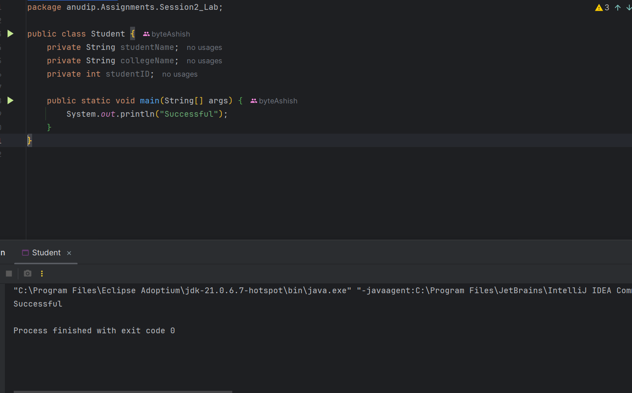

Assignment 2 – Employee.java

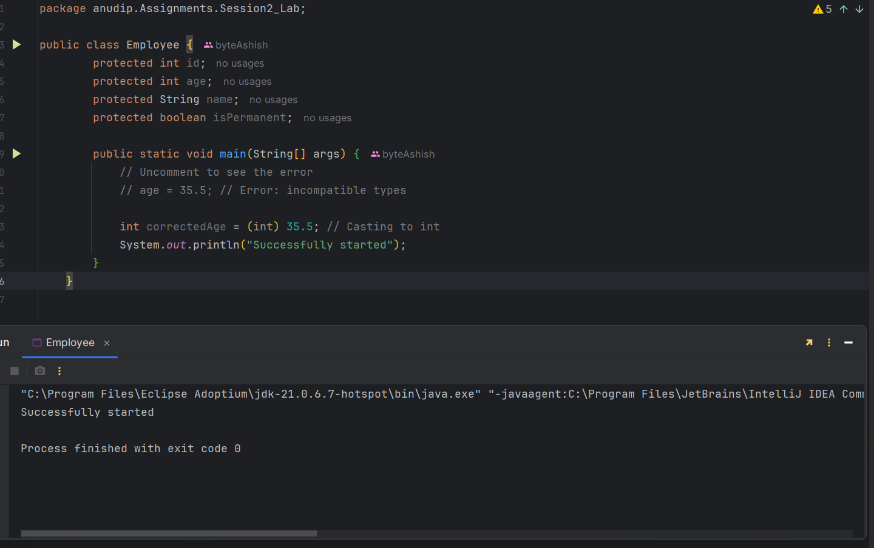

Assignment 3 – Person.java

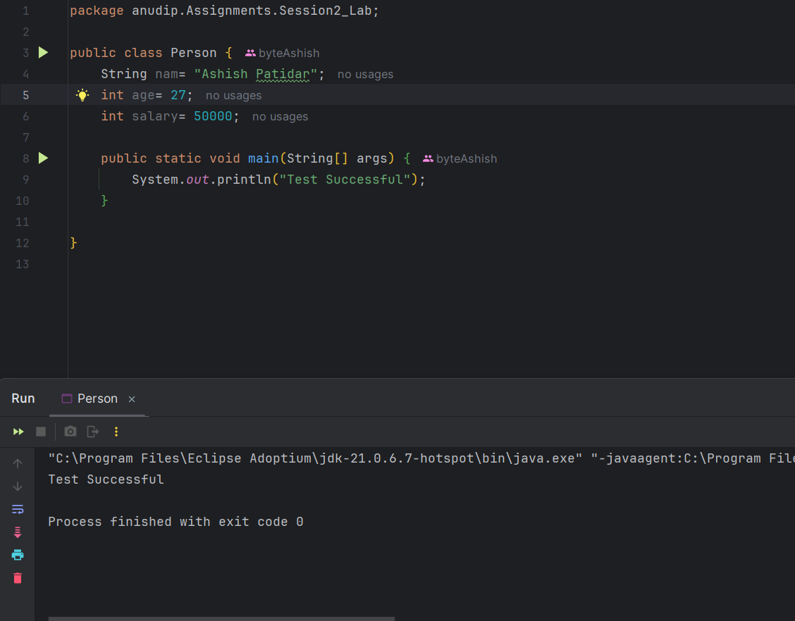

Assignment 4 – Rectangle.java

