## 第一题

### 第一问

如果要使各村庄村民到医疗点的距离总和S1最小，请问这3个医疗点分别建立在何处最好？总距离S1是多少？

#### 方法一：暴力递归

# -*- coding: utf-8 -*-  
  
import networkx as nx  
import pandas as pd  
import multiprocessing  
import itertools  
  
# 读取位置表单  
locations = pd.read_excel("data1.xlsx", sheet_name="位置", header=0,index_col=0)  
  
# 读取连接道路表单  
roads = pd.read_excel("data.xlsx", sheet_name="连接道路")  
  
# 创建空图  
G = nx.Graph()  
  
# 添加节点  
for node in locations.index:  
 G.add_node(node, pos=(locations.loc[node, "X"], locations.loc[node, "Y"]))  
  
# 添加边  
for i, row in roads.iterrows():  
 G.add_edge(row["起点"], row["终点"], weight=row["距离"])  
file=open('res1.txt','w')  
  
  
# 定义函数，计算每个村庄到其对应医疗点的距离，并计算距离总和S1  
def calculate_distance_sum(G, medical_centers):  
 distance_sum = 0  
 for node in G.nodes:  
 min_distance = float("inf")  
 for center in medical_centers:  
 distance = nx.shortest_path_length(G, source=node, target=center, weight="weight")  
 if distance < min_distance:  
 min_distance = distance  
 distance_sum += min_distance  
 return distance_sum  
  
  
  
# 定义函数，找到距离总和S1最小的医疗点组合  
def find_best_medical_centers(G):  
 nodes = list(G.nodes)  
 min_distance_sum = float("inf")  
 best_centers = None  
 # 枚举所有可能的组合情况  
 combinations = [c for c in itertools.combinations(nodes, 3)]  
 a=combinations  
 for centers in a:  
 distance_sum = calculate_distance_sum(G, centers)  
 data=str(centers)+str(distance_sum)+'\n'  
 # 记录距离总和最小的组合  
 file.write(data)  
 if distance_sum < min_distance_sum:  
 min_distance_sum = distance_sum  
 best_centers = centers  
 return best_centers, min_distance_sum  
  
best_centers, min_distance_sum = find_best_medical_centers(G)  
print("最优的医疗点组合为：", best_centers)  
print("距离总和为：", min_distance_sum)  
file.close()

注意：在进行暴力递归之前，需要根据X，Y坐标先算出边的权值。在进行暴力递归。暴力递归的数据已给出。最后求出的结果为：

(10, 50, 57)316598.7433864181

医疗站为10 ，50，57 最短距离为：S1=316598.7433864181

### 第二问：

各村庄村民都选择最近的医疗点看病，请问应该维修哪些道路，维修道路总里程S2是多少？作图用不同颜色标记各村庄到对应医疗点使用的道路。

import numpy as np  
import pandas as pd  
import networkx as nx  
  
# 读取位置表单  
locations = pd.read_excel("data1.xlsx", sheet_name="位置", header=0, index_col=0)  
  
# 读取连接道路表单  
roads = pd.read_excel("data.xlsx", sheet_name="连接道路")  
  
# 构建距离矩阵  
dist_mat = np.zeros((len(locations), len(locations)))  
for i, row in roads.iterrows():  
 start_loc = row["起点"]  
 end_loc = row["终点"]  
 distance = row["距离"]  
 start_idx = locations.index.get_loc(start_loc)  
 end_idx = locations.index.get_loc(end_loc)  
 dist_mat[start_idx, end_idx] = distance  
 dist_mat[end_idx, start_idx] = distance  
  
# 创建连通图  
G = nx.Graph()  
  
# 添加节点  
for node in locations.index:  
 G.add_node(node, pos=(locations.loc[node, "X"], locations.loc[node, "Y"]))  
  
# 添加边  
for i, row in roads.iterrows():  
 G.add_edge(row["起点"], row["终点"], weight=row["距离"])  
mapping = {node: int(node) for node in G.nodes()}  
G = nx.relabel_nodes(G, mapping)  
# 找到所有节点到10、50、57节点的最短路径  
shortest_paths_10 = nx.single_source_dijkstra_path_length(G,10)  
shortest_paths_50 = nx.single_source_dijkstra_path_length(G,50)  
shortest_paths_57 = nx.single_source_dijkstra_path_length(G,57)  
shortest_path = nx.shortest_path(G, 4, 10, weight='weight')  
print(shortest_path)  
  
# 计算每个节点到10、50、57节点的实际最短距离和路径  
result = {}  
road_map={}  
for node in G.nodes():  
  
 shortest_distance_10 =shortest_paths_10[node]  
 shortest_path_10 =nx.shortest_path(G,node,10,weight='weight')  
   
 shortest_distance_50 =shortest_paths_50[node]  
 shortest_path_50 = nx.shortest_path(G,node,50,weight='weight')  
  
 shortest_distance_57 = shortest_paths_57[node]  
 shortest_path_57 = nx.shortest_path(G,node,57,weight='weight')  
  
 shortest_distance = min(shortest_distance_10, shortest_distance_50, shortest_distance_57)  
 shortest_target = None  
 shortest_path = []  
 if shortest_distance == shortest_distance_10:  
 shortest_target = 10  
 shortest_path = shortest_path_10  
 elif shortest_distance == shortest_distance_50:  
 shortest_target = 50  
 shortest_path = shortest_path_50  
 elif shortest_distance == shortest_distance_57:  
 shortest_target = 57  
 shortest_path = shortest_path_57  
 # 计算路径上的权重之和  
 weight_sum = 0  
 for i in range(len(shortest_path)-1):  
 u, v = shortest_path[i], shortest_path[i+1]  
 weight_sum += G[u][v]['weight']  
 edges = [(shortest_path[i],shortest_path[i+1]) for i in range(len(shortest_path)-1)]  
 sorted_edges = [tuple(sorted(edge)) for edge in edges]  
  
 print(node,sorted_edges)  
 for i in range(len(sorted_edges)):  
 if sorted_edges[i] not in road_map:  
 road_map[sorted_edges[i]] = 1  
 else:  
 road_map[sorted_edges[i]] += 1  
 result[node] = {'target': shortest_target, 'distance': shortest_distance, 'path': shortest_path, 'weight': weight_sum}  
  
# 将结果存储到Excel文件中  
df = pd.DataFrame.from_dict(result, orient='index')  
df.index.name = 'node'  
df.to_excel('result.xlsx')  
with open('road_map.txt', 'w') as file:  
 for road in road_map:  
 file.write(f'{road}:{road_map[road]}\n')  
total_distance = 0  
for (a, b) in road_map:  
 distance =G.get_edge_data(a, b)['weight'] # 获取边的权值  
 total_distance += distance  
print("total_distance=",total_distance)

根据dijkstra算法算出最短路径，并将结果存入到excel表中去。将边去重得到一张map，对map进行求和即可

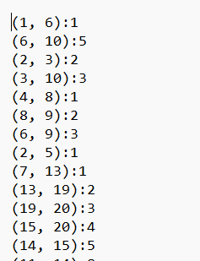

S2=total_distance= 95365.9386814891

## 第二题

由于每条道路维修都需要成本，因此站在道路维修公司角度出发，希望维修的成本尽量低。假定问题1中得到的医疗点不变，应该维修哪些道路，使得维修成本最低。给出维修道路的总长度S2，并作出图形。同时根据维修的道路，计算各村庄到医疗点的总距离S1。

思路：将整个大图划分为三个子图，划分的规则就是第一问所求的村庄和医疗站的关系，分别对三个子图应用最小生成树的规则即可:

根据result.xlsx按照target为10 50 57 分别生成三个excel文件,便于之后的读取:

# -*- coding: utf-8 -*-
  
import pandas as pd
  
  
# 读取 excel 文件
  
df = pd.read_excel('result.xlsx', sheet_name='Sheet1')
  
  
# 按照 target 分组
  
grouped = df.groupby('target')
  
  
# 遍历每个分组，将分组数据保存为单独的 Excel 文件
  
for target, group in grouped:
  
 # 构造文件名
  
 filename = f'target_{target}.xlsx'
  
 # 保存数据
  
 group.to_excel(filename, index=False)

### 第一组数据:

# -*- coding: utf-8 -*-
  
"""
  
Created on Tue May 2 10:03:10 2023
  
  
@author: wangyufan
  
"""
  
  
  
import networkx as nx
  
import pandas as pd
  
import numpy as np
  
  
res1 = pd.read_excel("target_10.xlsx", sheet_name="Sheet1", header=0,index_col=0).index
  
locations1 = pd.read_excel("data1.xlsx", sheet_name="位置", header=0,index_col=0)
  
# 读取连接道路表单
  
roads1 = pd.read_excel("data.xlsx", sheet_name="连接道路")
  
  
# 创建空图
  
G = nx.Graph()
  
  
# 添加节点
  
  
for node in locations1.index:
  
 #if node in res:
  
 G.add_node(node, pos=(locations1.loc[node, "X"], locations1.loc[node, "Y"]))
  
  
# 添加边
  
nodes1=res1
  
for i, row in roads1.iterrows():
  
  
 if int(row["起点"]) in nodes1 and int(row["终点"]) in nodes1:
  
 G.add_edge(row["起点"], row["终点"], weight=row["距离"])
  
# 对节点进行整数转换
  
mapping = {node: int(node) for node in G.nodes()}
  
G = nx.relabel_nodes(G, mapping)
  
  
import matplotlib.pyplot as plt
  
  
# 获取节点位置
  
pos = nx.get_node_attributes(G, "pos")
  
plt.figure(figsize=(15, 15))
  
# 绘制节点和边
  
nx.draw_networkx_nodes(G, pos, node_size=20)
  
nx.draw_networkx_edges(G, pos, width=5)
  
  
# 显示图
  
plt.axis("off")
  
plt.show()
  
  
T = nx.minimum_spanning_tree(G)
  
# 获取最小生成树的边
  
plt.figure(figsize=(15, 15))
  
  
tree_edges = list(T.edges())
  
node_colors = ['y' if node != 10 else 'g' for node in G.nodes()]
  
node_sizes = [1000 if node == 10 else 300 for node in G.nodes()]
  
# 绘制节点和边，并将最小生成树的边标记为红色
  
nx.draw_networkx_nodes(G, pos,node_color=node_colors, node_size=node_sizes)
  
nx.draw_networkx_labels(G, pos, {n: str(n) for n in G.nodes()})
  
nx.draw_networkx_edges(G, pos, edgelist=tree_edges, edge_color='g', width=5)
  
  
# 显示图
  
plt.axis("off")
  
plt.show()
  
  
s_10=0
  
for node in nodes1:
  
 distance = nx.shortest_path_length(T, source=node, target=10, weight='weight')
  
 s_10+=distance
  
  
print("最短距离",s_10)
  
  
length=0
  
for (a,b) in tree_edges:
  
 length+=G.get_edge_data(a,b)['weight']
  
  
  
print("最小生成树长度：",length)



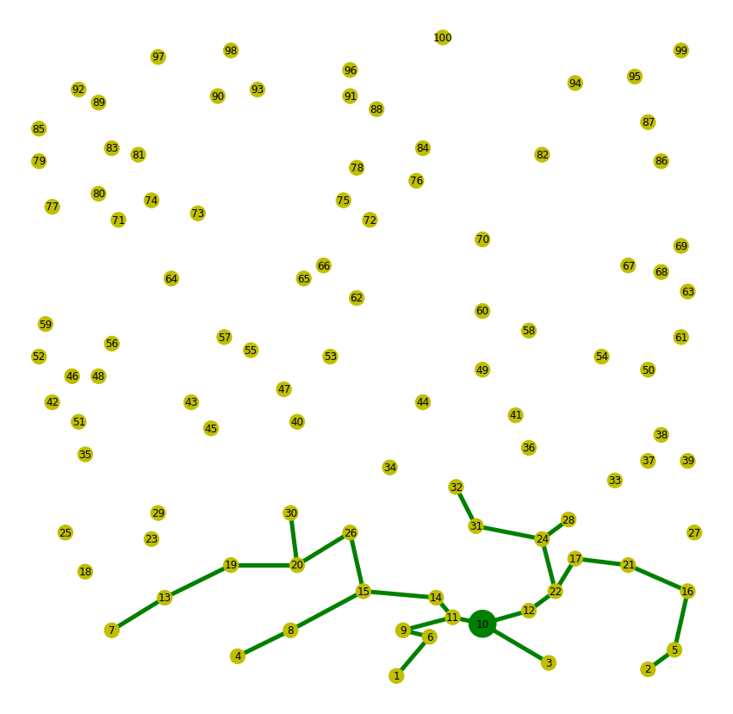

最短距离 76990.90151994597
  
最小生成树长度： 21011.612087891008

### 第二组

import networkx as nx
  
import pandas as pd
  
import numpy as np
  
  
res1 = pd.read_excel("target_50.xlsx", sheet_name="Sheet1", header=0,index_col=0).index
  
locations1 = pd.read_excel("data1.xlsx", sheet_name="位置", header=0,index_col=0)
  
# 读取连接道路表单
  
roads1 = pd.read_excel("data.xlsx", sheet_name="连接道路")
  
  
# 创建空图
  
G = nx.Graph()
  
  
# 添加节点
  
  
for node in locations1.index:
  
 #if node in res:
  
 G.add_node(node, pos=(locations1.loc[node, "X"], locations1.loc[node, "Y"]))
  
  
# 添加边
  
nodes1=res1
  
for i, row in roads1.iterrows():
  
  
 if int(row["起点"]) in nodes1 and int(row["终点"]) in nodes1:
  
 G.add_edge(row["起点"], row["终点"], weight=row["距离"])
  
# 对节点进行整数转换
  
mapping = {node: int(node) for node in G.nodes()}
  
G = nx.relabel_nodes(G, mapping)
  
  
import matplotlib.pyplot as plt
  
  
# 获取节点位置
  
plt.figure(figsize=(15, 15))
  
pos = nx.get_node_attributes(G, "pos")
  
  
# 绘制节点和边
  
nx.draw_networkx_nodes(G, pos, node_size=20)
  
nx.draw_networkx_edges(G, pos, width=5)
  
  
# 显示图
  
plt.axis("off")
  
plt.show()
  
  
T = nx.minimum_spanning_tree(G)
  
# 获取最小生成树的边
  
tree_edges = list(T.edges())
  
  
plt.figure(figsize=(15, 15))
  
  
tree_edges = list(T.edges())
  
node_colors = ['y' if node != 50 else 'purple' for node in G.nodes()]
  
node_sizes = [1000 if node == 50 else 300 for node in G.nodes()]
  
# 绘制节点和边，并将最小生成树的边标记为红色
  
nx.draw_networkx_nodes(G, pos,node_color=node_colors, node_size=node_sizes)
  
nx.draw_networkx_labels(G, pos, {n: str(n) for n in G.nodes()})
  
nx.draw_networkx_edges(G, pos, edgelist=tree_edges, edge_color='purple', width=5)
  
# 显示图
  
plt.axis("off")
  
plt.show()
  
  
s_50=0
  
for node in nodes1:
  
 distance = nx.shortest_path_length(T, source=node, target=50, weight='weight')
  
 s_50+=distance
  
  
print(s_50)
  
  
length=0
  
for (a,b) in tree_edges:
  
 length+=G.get_edge_data(a,b)['weight']
  
  
  
print(length)



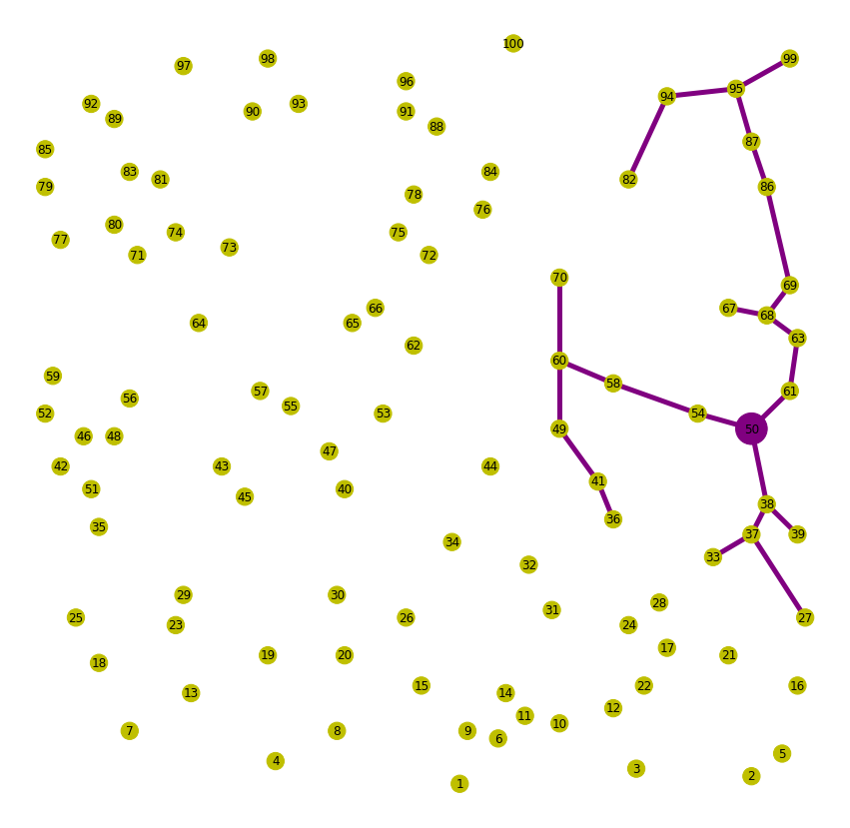

72143.11816199898
  
18517.26321880672

### 第三组数据

# -*- coding: utf-8 -*-
  
"""
  
Created on Tue May 2 10:03:10 2023
  
  
@author: wangyufan
  
"""
  
  
  
import networkx as nx
  
import pandas as pd
  
import numpy as np
  
  
res1 = pd.read_excel("target_57.xlsx", sheet_name="Sheet1", header=0,index_col=0).index
  
locations1 = pd.read_excel("data1.xlsx", sheet_name="位置", header=0,index_col=0)
  
# 读取连接道路表单
  
roads1 = pd.read_excel("data.xlsx", sheet_name="连接道路")
  
  
# 创建空图
  
G = nx.Graph()
  
  
# 添加节点
  
  
for node in locations1.index:
  
 #if node in res:
  
 G.add_node(node, pos=(locations1.loc[node, "X"], locations1.loc[node, "Y"]))
  
  
# 添加边
  
nodes1=res1
  
for i, row in roads1.iterrows():
  
  
 if int(row["起点"]) in nodes1 and int(row["终点"]) in nodes1:
  
 G.add_edge(row["起点"], row["终点"], weight=row["距离"])
  
# 对节点进行整数转换
  
mapping = {node: int(node) for node in G.nodes()}
  
G = nx.relabel_nodes(G, mapping)
  
  
import matplotlib.pyplot as plt
  
plt.figure(figsize=(15, 15))
  
# 获取节点位置
  
pos = nx.get_node_attributes(G, "pos")
  
  
# 绘制节点和边
  
nx.draw_networkx_nodes(G, pos, node_size=20)
  
nx.draw_networkx_edges(G, pos, width=5)
  
  
# 显示图
  
plt.axis("off")
  
plt.show()
  
  
T = nx.minimum_spanning_tree(G)
  
# 获取最小生成树的边
  
plt.figure(figsize=(15, 15))
  
  
tree_edges = list(T.edges())
  
node_colors = ['y' if node != 57 else 'red' for node in G.nodes()]
  
node_sizes = [1000 if node == 57 else 300 for node in G.nodes()]
  
# 绘制节点和边，并将最小生成树的边标记为红色
  
nx.draw_networkx_nodes(G, pos,node_color=node_colors, node_size=node_sizes)
  
nx.draw_networkx_labels(G, pos, {n: str(n) for n in G.nodes()})
  
nx.draw_networkx_edges(G, pos, edgelist=tree_edges, edge_color='r', width=5)
  
  
# 显示图
  
plt.axis("off")
  
plt.show()
  
  
print(len(nodes1))
  
print(nodes1)
  
s_57=0
  
for node in nodes1:
  
 distance = nx.shortest_path_length(T, source=node, target=57, weight='weight')
  
 s_57+=distance
  
  
print(s_57)
  
  
length=0
  
for (a,b) in tree_edges:
  
 length+=G.get_edge_data(a,b)['weight']
  
  
  
print(length)



317809.1693991888
  
40425.215152604505

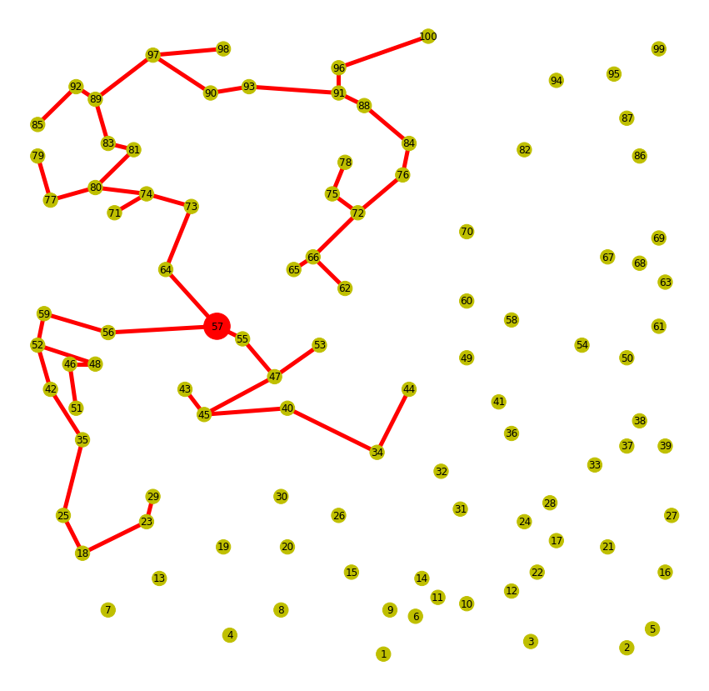

317809.1693991888
  
40425.215152604505

## 总和~哈哈哈画的有点丑

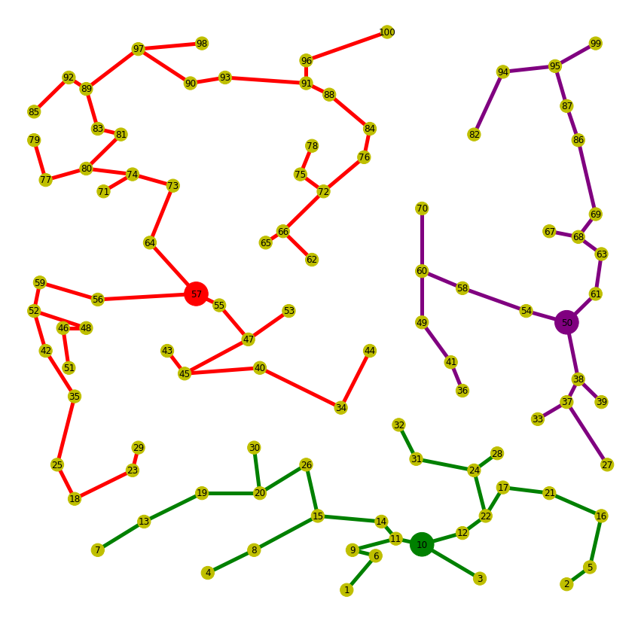

总距离:

s1=21011.612087891008+18517.26321880672+40425.215152604505=79954.09045930223

s2=76990.90151994597+72143.11816199898+317809.1693991888= 467943.18908113375