Cloud

Readiness

Introduction

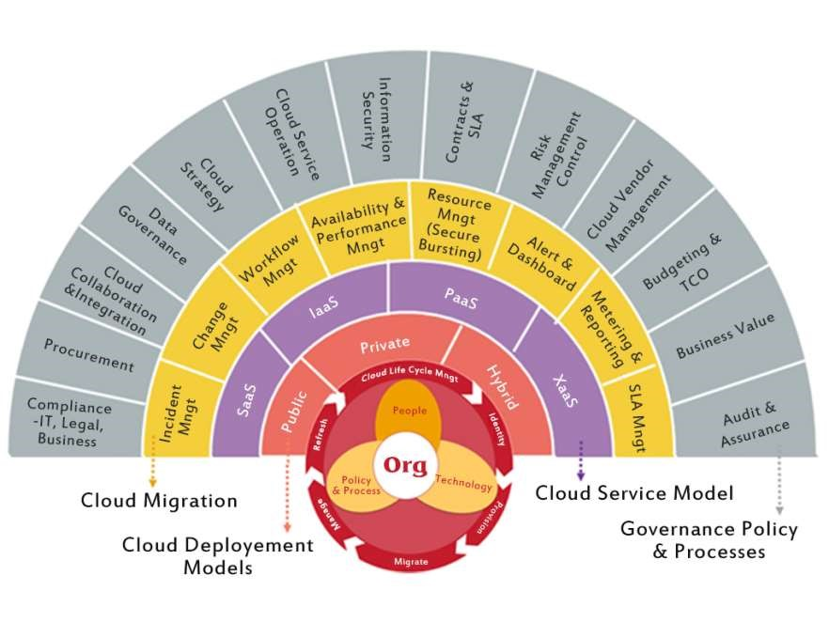

Presented by: Kinan Al Haffar

“Cloud Readiness represents the

**Maturity of an organization**, to identify

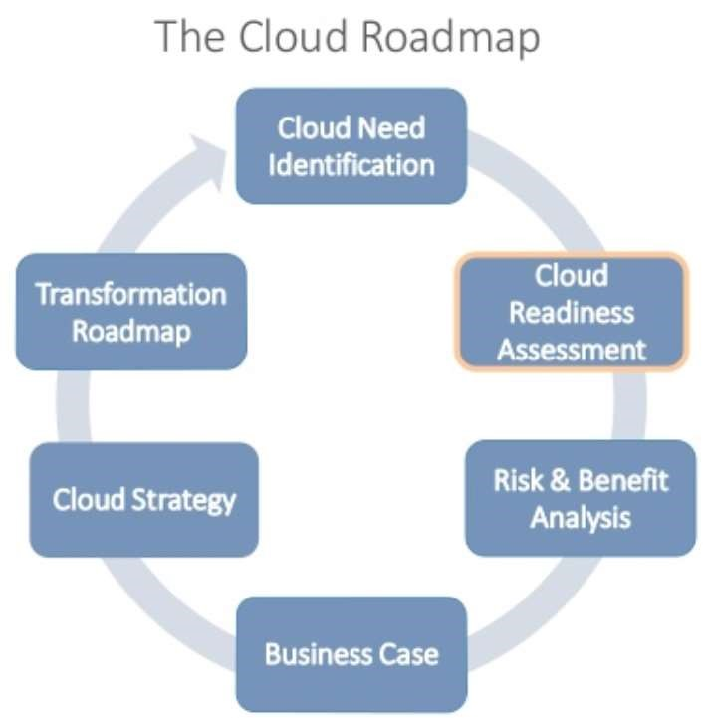Appropriate Cloud-services, which **Generate value**. Cloud-services have to be integrated efficiently and target oriented Within enterprises in order to be **able to Manage their use** and allows the agile change of Cloud-Service provider”

Why?

What? How?

There are many reasons to move to the cloud:

1. Agility

3

. Cost Savings and Flexibility

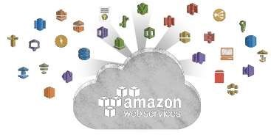

1. Platform Breadth

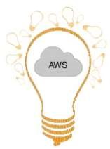

4. Continual Iteration and Innovation

Why?

What? How?

What workloads can be moved to the cloud:

1. Strategy & Business Goals:

Applications, Processes, Data &

Storage “SaaS, IaaS, PaaS”

1. 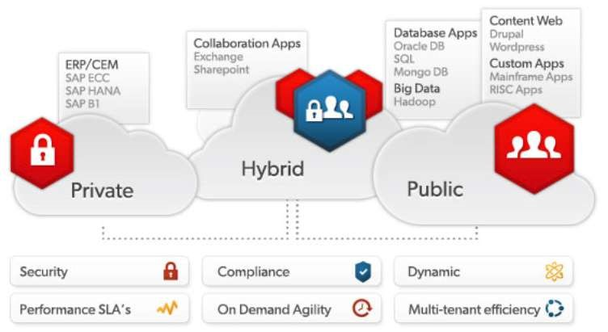What are the business priorities?
2. What technology is the business using?
3. What are the usage requirements?
4. What is the budget?

Why?

What? How?

**Cloud Migration Phases**

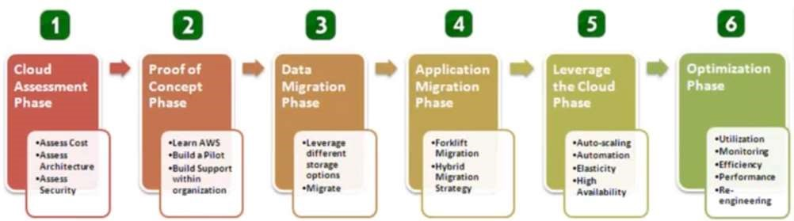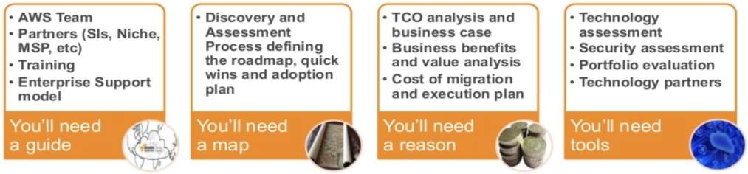

What you’ll need in this journey



Questions?

Thank you 