AI-Powered Fake News Detection Using Text Classification
bytebysam
Computer Science and Engineering

Abstract
The rapid growth of digital media and online news platforms has increased the spread of misinformation and fake news. Manual verification of large volumes of news articles is time-consuming and difficult. This project presents a machine learning-based fake news detection system using Natural Language Processing and text classification techniques. The WELFake dataset was used for model development. Text preprocessing, TF-IDF feature extraction, and four classification algorithms—K-Nearest Neighbors, Logistic Regression, Random Forest, and a Neural Network—were implemented and evaluated. Experimental results showed that Random Forest achieved the highest accuracy of 95.58%. The developed system demonstrates the effectiveness of machine learning and NLP techniques for automatic fake news classification.
Keywords—Fake News Detection, Natural Language Processing, Machine Learning, TF-IDF, Random Forest, Text Classification.

I. INTRODUCTION
Fake news refers to false or misleading information presented in the form of legitimate news. The widespread use of social media and digital news platforms has made the rapid distribution of misinformation a significant problem.
Manual fact-checking requires considerable time and human effort. Artificial Intelligence and Machine Learning can assist in automatically identifying linguistic patterns associated with fake and real news articles.
The objective of this project is to design and implement a machine learning pipeline capable of classifying news articles as fake or real using Natural Language Processing and text classification.

II. DATASET DESCRIPTION
The WELFake dataset was used in this project. The original dataset contained 72,134 news articles with article title, textual content, and a binary classification label.
Label 0 represents Fake News and label 1 represents Real News. The dataset contained 35,028 fake news articles and 37,106 real news articles.
The original data contained 558 missing title values and 39 missing text values. After preprocessing and removal of empty cleaned articles, 72,080 samples remained for model development.

III. METHODOLOGY

A. Text Preprocessing
The title and article text were combined into a single textual feature. Text was converted to lowercase, HTML tags and URLs were removed, and punctuation and special characters were eliminated. English stopwords were removed and WordNet lemmatization was applied using the NLTK library.

B. Feature Extraction
Term Frequency-Inverse Document Frequency (TF-IDF) was used to transform textual data into numerical feature vectors. The vectorizer was configured with a maximum of 5,000 features. The resulting feature matrix contained 72,080 samples and 5,000 features.

C. Train-Test Split
The processed dataset was divided into training and testing sets using an 80:20 ratio with stratified sampling. The training set contained 57,664 samples and the testing set contained 14,416 samples.

D. Classification Models
Four classification models were implemented: K-Nearest Neighbors (KNN), Logistic Regression, Random Forest, and a Multi-Layer Perceptron Neural Network.
The KNN classifier used K=5. Random Forest used 100 decision trees. The Neural Network contained one hidden layer with 100 neurons and used early stopping to reduce unnecessary training.

IV. EVALUATION METRICS
The models were evaluated using accuracy, precision, recall, and F1-score. Confusion matrices were also generated to analyze the classification performance of individual models.

V. RESULTS
Model | Accuracy | Precision | Recall | F1-Score
Random Forest | 95.58% | 94.57% | 96.98% | 95.76%
Neural Network | 94.76% | 94.55% | 95.30% | 94.93%
Logistic Regression | 94.58% | 94.32% | 95.18% | 94.75%
KNN | 71.37% | 65.29% | 94.56% | 77.25%
TABLE I. PERFORMANCE COMPARISON OF CLASSIFICATION MODELS
Random Forest achieved the highest classification accuracy of 95.58% and the highest F1-score of 95.76% among the evaluated models.
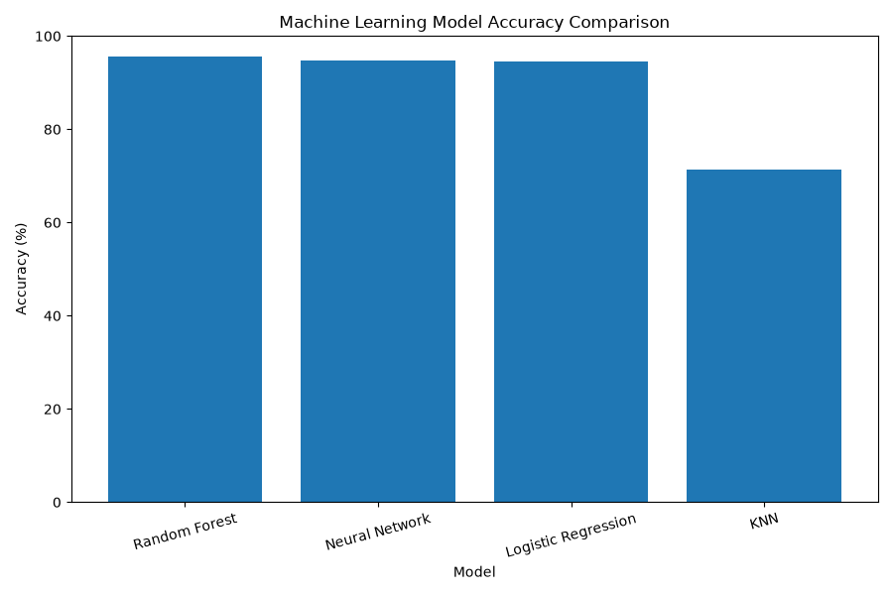
Fig. 1. Accuracy comparison of the evaluated models.

VI. DISCUSSION
The experimental results demonstrate that ensemble and linear classification techniques perform effectively on TF-IDF text features. Random Forest achieved the best overall performance. The combination of multiple decision trees enabled the model to identify complex patterns within the feature space.
Logistic Regression achieved strong performance despite its relatively simple architecture. The Neural Network achieved an accuracy of 94.76%, with early stopping terminating training after validation performance stopped improving.
KNN achieved the lowest accuracy of 71.37%. Its high recall and comparatively low precision indicate that distance-based classification is less suitable for the high-dimensional sparse TF-IDF feature space used in this project.

VII. APPLICATION DEVELOPMENT
A Streamlit-based web application named TruthLens AI was developed to provide an interactive interface for the trained classification system. Users can enter news article text and receive a fake or real news pattern prediction together with the model confidence.
The application uses the trained Random Forest classifier and the saved TF-IDF vectorizer. The application performs linguistic pattern classification and does not perform real-time factual verification.

VIII. LIMITATIONS
The system classifies articles based on linguistic patterns learned from the WELFake dataset. It does not verify claims against live news sources or external fact-checking databases. Predictions may also be less reliable for short headlines or text that differs significantly from the training distribution.

IX. CONCLUSION
This project successfully developed an AI-powered fake news detection system using Natural Language Processing and Machine Learning. A complete text classification pipeline was implemented, including preprocessing, TF-IDF feature extraction, model training, evaluation, comparison, and interactive application development.
Among the four evaluated models, Random Forest achieved the highest accuracy of 95.58%. The results demonstrate that NLP and machine learning techniques can effectively identify linguistic patterns associated with fake and real news articles.

X. FUTURE SCOPE
- Implementation of transformer-based models such as BERT.
- Integration with real-time fact-checking services.
- Development of multilingual fake news detection.
- Use of Explainable AI techniques.
- Online deployment of the TruthLens AI application.

REFERENCES
[1] WELFake Dataset, Fake News Classification Dataset.
[2] Scikit-learn, Machine Learning in Python.
[3] NLTK Project, Natural Language Toolkit.
[4] Streamlit, Open-source Python Application Framework.

