**SYSTEM BLOCK DIAGRAM**

The figure below shows the block diagram of the device. It employs the following sub-systems, all of which are described below:

1. DC Power supply
2. GPS module
3. LORA
4. GSM module
5. LCD display
6. ESP32 Microcontroller
7. LORA receiver
8. Buzzer
9. 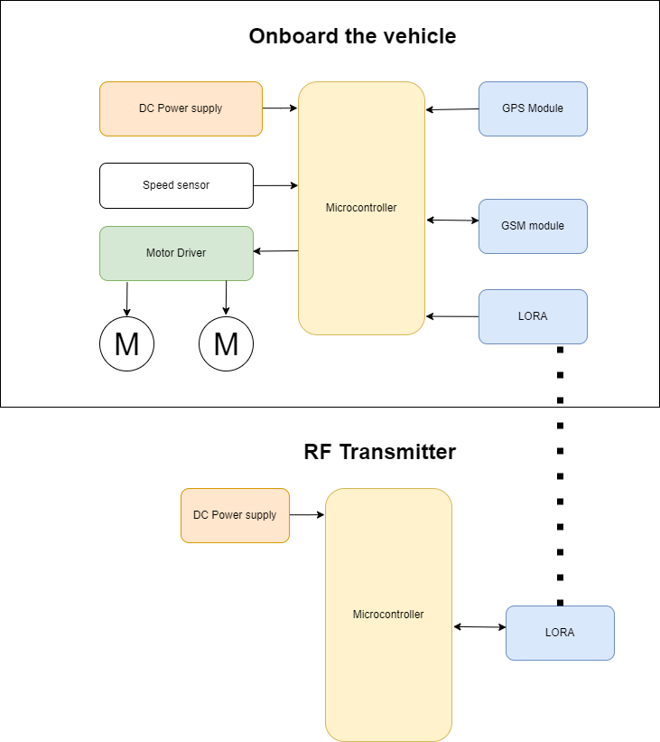Speed sensor
10. DC power supply

This is the main module that supplies the power to the system. The power supply converts the AC mains into a DC voltage at 12 V that can be used by the system without damaging the components

1. GPS module

GPS module is a sensor module used to read the location of the device in terms of the coordinates, latitude and longitude. It updates them into the system and they can be used to make logic decisions.

1. LORA

LORA stands for long range radio. It is a module that is used to transmit message over a long distance or range, typically 10km.

1. GSM module

GSM module is used to house the sim card to allow for communication to authorities through cellular network and SMSs

1. LCD display

LCD is used here to show messages to the driver of the vehicle. Messages shown regard the speed of the vehicle, current location, and if the road is clear or if there is a blackspot ahead.

1. ESP32 microcontroller

It is the heart of the system. It receives the readings from all the sensors and used them to make decision based on the data received. Then it produces actuation signals like reducing the speed of the vehicle and activating the communication modules to send alerts.

1. Buzzer

The buzzer provides auditory feedback to the driver in case of violation and in case of a blackspot ahead.

1. Speed sensor

The speed sensing is implemented in software as a module that polls for the speed of the motor and checks if speed limit has been exceeded or not.

**HARDWARE DESIGN**

**Schematic**