**Design and Implementation of a UML-Based Hotel Management System in Python**

Ahmed Abdelaziz Al Qahtani

student id 202206351

Program Fund

18/03/2025

Design and Implementation of a UML-Based Hotel Management System in Python

**UML Class Diagram**

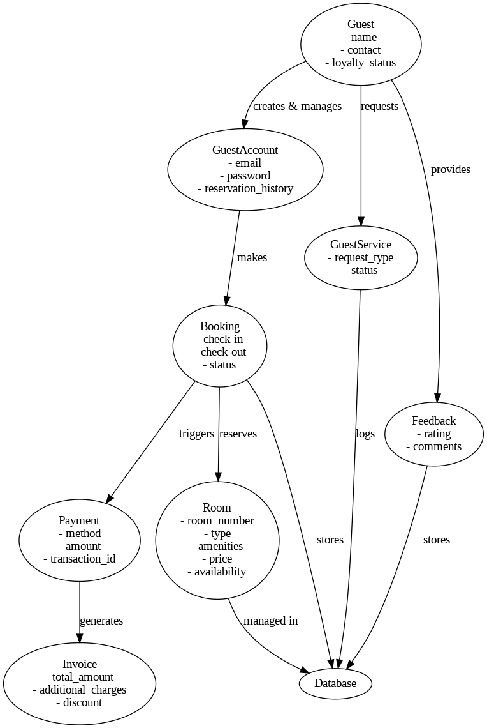

The Royal Stay Hotel Management System is designed using Object-Oriented Programming (OOP) principles, ensuring modularity and scalability. The key classes are:

**Guest** - Stores guest details such as name, and contact.

**GuestAccount** - Manages guest login and reservation history.

**Room -** Contains room attributes like number, type, price, and availability.

**Booking** - Handles reservation details, including dates and status.

**Payment** - Processes transactions for instance method, amount, and reference number.

**Invoice -** Generates billing details for bookings.

**Relationships**

**Composition** - GuestAccount owns multiple Booking objects.

**Association** - Booking is linked to both Guest and Room.

**Aggregation** - Invoice aggregates Booking details.

The Royal Stay Hotel Management System allowed me to further learn the Object-Oriented Analysis and Design (OOAD) principles. I structured the system with Unified Modeling Language (UML) to represent real-world hotel operations. The UML class diagram represented the interaction between different system components as a part of the critical step for efficient design without coding.

As for the Python implementation, it was built with modularity in mind, making each class a separate file. I used OOP concepts of inheritance, encapsulation, private attributes, getters, setters, and composition for maintainability. The method __str__() improved readability for the class, in addition, structured doc strings made it clear. The project was completely dependent on testing. I wrote code that uses unit testing and validated functionalities such as guest account creation, room reservations, invoice generation, payment processing, and booking cancellations. Writing test cases was also useful in locating potential errors as early as possible, resulting in a robust, and free of error, system.

Version control with GitHub also helped in project management because it allows for incremental progress to be tracked as well. Sharing the repository encourages collaboration and together, we can improve further. This project helped me gain a better grasp of correctly designing software so that one can use OOP best practices, and have the ability to create real world applications using modular code and structured documentation. The experience helped in bridging the gap between theoretical UML concepts and how they can be practically implemented using Python.

**Guest Code**

class Guest:

"""Represents a guest in the hotel system."""

def __init__(self, name: str, contact: str, loyaltyStatus: str = "Regular"):

self.__name = name

self.__contact = contact

self.__loyaltyStatus = loyaltyStatus

# Getters

def getName(self):

return self.__name

def getContact(self):

return self.__contact

def getLoyaltyStatus(self):

return self.__loyaltyStatus

# Setters

def setContact(self, newContact):

self.__contact = newContact

def setLoyaltyStatus(self, newStatus):

self.__loyaltyStatus = newStatus

def __str__(self):

return f"Guest: {self.__name}, Contact: {self.__contact}, Loyalty: {self.__loyaltyStatus}"

**Guest Account Code**

class GuestAccount:

"""Handles guest account login and profile updates."""

def __init__(self, email: str, password: str):

self.__email = email

self.__password = password

self.__reservationHistory = []

# Getters

def getEmail(self):

return self.__email

def getReservationHistory(self):

return self.__reservationHistory

# Methods

def addReservation(self, reservation):

self.__reservationHistory.append(reservation)

def __str__(self):

return f"GuestAccount: {self.__email}, Reservations: {len(self.__reservationHistory)}"

**Guest Service Code**

class GuestService:

"""Handles guest service requests."""

def __init__(self, requestType: str):

self.__requestType = requestType

self.__status = "Pending"

def completeRequest(self):

self.__status = "Completed"

def __str__(self):

return f"Service Request: {self.__requestType} - {self.__status}"

**Invoice Code**

class Invoice:

"""Represents an invoice for a booking."""

def __init__(self, booking, additionalCharges=0, discount=0):

self.__booking = booking

self.__totalAmount = booking._Booking__room.getPrice() + additionalCharges - discount

def __str__(self):

return f"Invoice: {self.__totalAmount} (Booking: {self.__booking})"

**Payment Code**

class Payment:

"""Handles payment transactions."""

def __init__(self, method: str, amount: float, transactionId: str):

self.__method = method

self.__amount = amount

self.__transactionId = transactionId

def __str__(self):

return f"Payment: {self.__method} | Amount: ${self.__amount} | Transaction ID: {self.__transactionId}"

**Feedback Code**

class Feedback:

"""Stores guest feedback and ratings."""

def __init__(self, guest, rating: int, comments: str):

self.__guest = guest

self.__rating = rating

self.__comments = comments

def __str__(self):

return f"Feedback from {self.__guest.getName()}: {self.__rating}/5 - {self.__comments}"

**Room Code**

class Room:

"""Represents a hotel room."""

def __init__(self, roomNumber: int, roomType: str, amenities: list, price: float):

self.__roomNumber = roomNumber

self.__roomType = roomType

self.__amenities = amenities

self.__price = price

self.__available = True # Initially available

# Getters

def getRoomNumber(self):

return self.__roomNumber

def getRoomType(self):

return self.__roomType

def isAvailable(self):

return self.__available

# Methods

def bookRoom(self):

"""Marks the room as unavailable."""

self.__available = False

def releaseRoom(self):

"""Marks the room as available again."""

self.__available = True

def __str__(self):

status = "Available" if self.__available else "Booked"

return f"Room {self.__roomNumber}: {self.__roomType} - {status}"

**Booking Code**

from datetime import datetime

class Booking:

"""Handles guest room reservations."""

def __init__(self, guest, room, checkIn: str, checkOut: str):

self.__guest = guest

self.__room = room

self.__checkIn = datetime.strptime(checkIn, "%Y-%m-%d")

self.__checkOut = datetime.strptime(checkOut, "%Y-%m-%d")

self.__status = "Confirmed"

# Methods

def cancelBooking(self):

"""Cancels the booking and releases the room."""

self.__status = "Cancelled"

self.__room.releaseRoom()

def __str__(self):

return f"Booking for {self.__guest.getName()} in Room {self.__room.getRoomNumber()} ({self.__status})"

**Main Code**

from Guest import Guest

from Room import Room

from Booking import Booking

from Payment import Payment

from GuestService import GuestService

from Feedback import Feedback

# Creating a guest

guest1 = Guest("James Alaine", "+1 787-456-823")

# Creating a room

room1 = Room(101, "Deluxe", ["WiFi", "TV", "Mini-Bar"], 150)

# Making a booking

booking1 = Booking(guest1, room1, "2025-03-10", "2025-03-15")

print(booking1)

# Processing payment

payment1 = Payment("Credit Card", 750, "TXN12345")

print(payment1)

# Guest leaves feedback

feedback1 = Feedback(guest1, 5, "Excellent service!")

print(feedback1)

Github link: <https://github.com/ByteKhalifa/royalhotel.git>