

TU850
Algorithms and Data Structures

Assignment 2

Project Report

Lea Stanisavljevic
A00046044

School of Computer Science
Technological University Dublin

21/04/2026

Declaration

I hereby declare that the work described in this report is, except where otherwise stated, entirely my own work and has not been submitted as an exercise for a degree at this or any other university.

Signed:

_____Stanisavljevic_____
Lea Stanisavljevic

21/04/2026

Table of Contents
1. Introduction 4
2. Dataset Description 4
3. Methodology 4
4. Experimental Design 5
5. Results 6
6. Conclusion 8
Appendices 9
References 27

Introduction

This assignment’s main goal is to implement and compare two data structures for efficient movie search, a hash map for exact lookups and a Prefix Tree (Trie) for prefix search and autocomplete. Both structures are applied to the MovieLens dataset from GroupLens research and benchmarked against each other and a linear scan baseline.

Hash Maps and Tries are some of the most common data structures used in search systems. A Hash Map uses a hash function to turn a key into an array index so you can retrieve values almost instantly. A Trie is a tree that stores strings character by character and is great for autocomplete, as it can find all words that share a prefix in O(k) time, where k is the length of the prefix. The main learning goal of this assignment is to understand when to use each structure and how their theoretical complexities translate into practice.

Dataset Description

The dataset that was used in this assignment is MovieLens dataset by GroupLens Research at the University of Minnesota. It was loaded from a csv file with 87,585 movie records. I used the PyChram IDE for this assignment. Each record contains a movie id (a unique numerical identifier), a title (with release year) and genres (one or more category labels separated by a pipe). A second file (ratings.csv) was used to compute an average user rating for each movie, which was attached to each movie object at load time.
The dataset was tested on 6 different sizes: 1000, 5000, 10000, 25000, 50000 and 87585 movies. This was done to clearly see the effect on performance when increasing the size of the dataset.

Methodology

Movie Data Model
We have a class called ‘Movie’ that has all the fields from the data set. It contains movie id, title, genres and the average rating. Both the HashMap and Trie store and return movie objects so the comparisons are fair and consistent.

Hash Table
The HashMap is based on an array of 262,144 slots. Collisions are resolved using separate chaining, where each slot has a linked list of HashMapEntry objects, each containing a key, a value and a pointer to the next entry in the chain. The hash function uses a polynomial rolling hash where the ASCII value of each character is multiplied by 31 raised to the power of its position, summed and then taken modulo the capacity. This is done manually, not with the hash() function built into python. The movies are listed twice, once by title and once by string movie id so you can look up a movie by either. With the full data set size the load factor is .667 and the average chain length is 1.18, so almost every lookup touches only one entry.
Trie
The Trie is composed of TrieNode objects, each containing a children dictionary mapping characters to child nodes, an is_end_of_word boolean flag and a reference to the movie object at the end of a title path. The insert() method iterates through the title character by character, creating new nodes where necessary and marking the last node with the movie object. Both search() and starts_with() use the internal traverse() helper which traverses down to the node at the end of any given string. The helper dfs() runs a recursive depth first search from a given node, collecting all complete movie objects that can be reached from below it. The autocomplete() method combines these two to achieve prefix search. All titles are stored in lower case so that matching is case insensitive.

Linear Scan
The baseline is a simple linear scan with complexity O(n). For exact search it searches through each movie until it finds a matching title. For prefix search it filters all movies that have a title starting with the given prefix. This is a benchmark for the structured approaches to be assessed against.

Experimental Design

Dataset Size Scaling
Both of the dataset structures were tested with increasing sizes: 1000, 5000, 10000, 25000, 50000, 87585 films. This helped see how each algorithm performed as the dataset got bigger.

Timing Method
The time taken to execute was measured using time.perf_counter() with sub-microsecond resolution. The insertion times are measured in milliseconds. The search times are measured in microseconds per query. All of these give precise runtime to measure how well the code performs.

Repetition and Averaging
An average of 10 repetitions of each experiment is shown. This reduces the impact of os scheduling, cpu cache state and other sources of timing noise on the results.

Operations Measured
For each size of the dataset 3 operations were tested. The insertion time is the full time to construct each structure from scratch. Exact search time is the average time per query to search a movie by full title measured over five queries: “Toy Story (1995)”, “Jumanji (1995)”, “Heat (1995)”, “Casino (1995)” and “Sense and Sensibility (1995)”. Prefix Search Time: average time per query to find all films starting with a given prefix. Tested with: "Toy", "Star", "The", "Lo" and "Bat". A linear scan is also included as the baseline for both search operations.

Results

TABLE 1 - Insertion time (ms) averaged over 10 trials

Dataset Size | HashMap (ms) | Trie (ms)
1000 | 32.567 | 622.734
5000 | 163.357 | 407.464
10000 | 420.654 | 826.635
25000 | 762.144 | 1964.942
50000 | 1746.986 | 3337.473
87585 | 3479.889 | 6438.610

Both structures grow approximately linearly with the size of the dataset during insertion which is as expected because building either structure requires inserting all n records sequentially. The Trie is always slower to build, taking about twice as long and longer as the HashMap at each dataset size. The HashMap builds at the full 87,585 movies in around 3,5 ms versus 6,4 ms for the Trie. The difference is that the Trie makes a new TrieNode object for every character of every movie title and at this size of data that is millions of individual node allocations in memory. But theHashMap computes a hash and adds a single entry for every insertion which is a much lighter operation. This build time difference also hints at the much higher memory consumption of the Trie than the HashMap, that is the trade-off we talked about in class a few weeks ago.

TABLE 2 - Exact search time (µs/query) averaged over 10 trials

Dataset Size | HashMap (µs) | Trie (µs) | Linear (µs)
1000 | 11.915 | 3.293 | 1.365
5000 | 13.323 | 2.902 | 1.260
10000 | 12.389 | 2.760 | 1.265
25000 | 11.202 | 2.727 | 1.274
50000 | 28.032 | 6.054 | 2.326
87585 | 11.501 | 2.938 | 2.803

The HashMap has near constant exact search times across all dataset sizes, from 11.2µs to 13.3µs for most sizes, with an outlier at 50,000 (28 µs) likely due to a temporary system load spike during that trial. This almost constant behaviour confirms the O(1) average case property of the HashMap. The measured load factor of 0.333 and average chain length of 1.18 at full dataset size means that virtually every lookup hits only one or two entries, regardless of how many films are stored. This is exactly what O(1) means, doubling or tripling the dataset would not significantly increase the time for searching. The Trie also works well for exact search, always finishing in 2-6ms. This is due to the fact that the exact search in the Trie also traverses only k nodes before reaching the endpoint, where k is the length of the title. This is the O(k) but if you need the exact lookup, HashMap is better because the constant factor in O(1) is smaller than O(k) for long movie titles.The most interesting result in this table is the linear scan. It outperforms structured approaches on all dataset sizes and finishes in only 1.3-2.8µs. This is a hardware effect, not an algorithm effect. At these dataset sizes the entire movie list fits in the L2 or L3 cache of the cpu and iterating through a cache resident list sequentially is extremely fast because memory access is predictable. By contrast the HashMap must dereference into a 262,144 slot array (most of which is not in cache) and the Trie must follow node pointers through a tree structure, both with poor cache locality. This shows an important difference between theoretical complexity and empirical performance. O(n) is not slow when n is small and memory access patterns are sequential. The advantage of O(1) vs O(n) structures only becomes significant at much larger scales than this dataset.

TABLE 3 - Prefix search time (µs/query) averaged over 10 trials

Dataset Size | Trie (µs) | Linear (µs)
1000 | 96.417 | 684.276
5000 | 393.778 | 2495.206
10000 | 1233.594 | 5078.615
25000 | 2830.414 | 12085.770
50000 | 12468.361 | 23554.266
87585 | 25756.433 | 41904.709

The clearest result in the whole experiment is produced in the 3rd table. Trie outperforms linear scan in prefix search for all dataset sizes and the gap widens with increasing dataset sizes. At 1000 movies the Trie is about 7x faster (96µs vs 684µs). It is about 1.6x faster at 87,585 movies (25,756µs vs. 41,904µs). For bigger sizes the difference gets smaller because the Trie depth first search has to get more matching results when more movies are stored and there are thousands of matches to get for a common prefix like "The" but the Trie always wins, no matter how big it is.
This result confirms the O(k) complexity of the Trie prefix search. No matter how many movies are stored, the Trie always reaches the prefix node in exactly k steps. It is only the result collection phase that grows with the number of matches. However the linear scan must look at all n films each time regardless of the prefix, making it O(n). The drawback of the linear scan builds up with n. One thing worth noting is that the HashMap is not efficient at all for prefix searching. If you want to find all the films starting with "Star" using a HashMap, then you will need to look through all 87,585 entries because the hash of "Star" has no mathematical relationship to the hash of "Star Wars (1977)" or any other title starting with that prefix. The hash function deliberately destroys alphabetical ordering to achieve fast exact lookup. This is the basic trade off between the two structures. The HashMap is best for exact search while the Trie is best for prefix search and a good system uses both.

HashMap Internals (Full Dataset)
total_entries | 87382
capacity | 262144
load_factor | 0.3333
non_empty_buckets | 74288
max_chain_length | 6
avg_chain_length | 1.1763

These internal log statistics show the HashMap is working well. At a load factor of 0.333 only 1/3 of the available slots are filled so there’s lots of room for keys to spread out without clustering. The average length of a chain of 1.18 shows that almost every lookup hits only one entry with the rare worst case of 6 entries in a single chain being an exception to the rule of a collision. This is the reason why the precise search times in the 2nd table are almost independent of the sizes of the datasets. The hash function is working well in distributing keys evenly over the array.

Conclusion

For this assignment, I implemented and benchmarked a HashMap and a Trie against the MovieLens dataset of 87,585 movies. The empirical results confirm the theoretical time complexities of both structures for all the six sizes of datasets tested.
The HashMap achieves approximately constant exact search times of about 11-13µs for all dataset sizes, consistent with O(1) average case time complexity. This is confirmed by internal statistics: a load factor of 0.333 and average chain length of 1.18 at full dataset size, indicating that the hash function is distributing the keys evenly and that almost every lookup requires examining only one entry. This shows that the HashMap is a clear winner for exact retrieval by title or movie id, especially at large scale where the constant time property becomes most valuable.
The Trie always performs better than the linear scan at each dataset size for prefix search, confirming the O(k) prefix traversal complexity. At 1000 films it is about 7x faster than the linear scan and at 87,585 films it is about 1.6x faster. The gap shrinks at larger sizes, as the depth first search must gather more matching results but the Trie wins at all sizes tested. The HashMap can’t do prefix search at all without a full scan because the hash function destroys the alphabetical ordering of keys. This is the fundamental trade off between the two structures.
The most interesting finding is that the linear scan outperforms both structured approaches for exact search across all dataset sizes due to cpu cache effects, not algorithmic superiority. This shows that for small dataset sizes and sequential memory access patterns theoretical complexity and practical performance might diverge. The advantage of O(1) and O(k) structures is only decisive at larger scales and this whole assignment showed me why the choice of the right data structure requires an understanding of both theory and hardware behaviour. The two structures are best understood as complementary to each other. Trie supports fast prefix search and autocomplete HashMap supports fast exact search. The system developed for this assignment uses both together.

Limitation
One limitation of this experiment is that the Trie build time and memory usage increase substantially as the dataset size grows because each character of each title necessitates a new TrieNode object. The Trie takes almost twice as long to build as the HashMap with 87,585 movies and consumes a lot more memory. It could become a constraint on a very large scale. Further work may consider compressed Tries or Patricia Tries to reduce the memory overhead while still retaining the O(k) advantage for prefix search.

Appendices
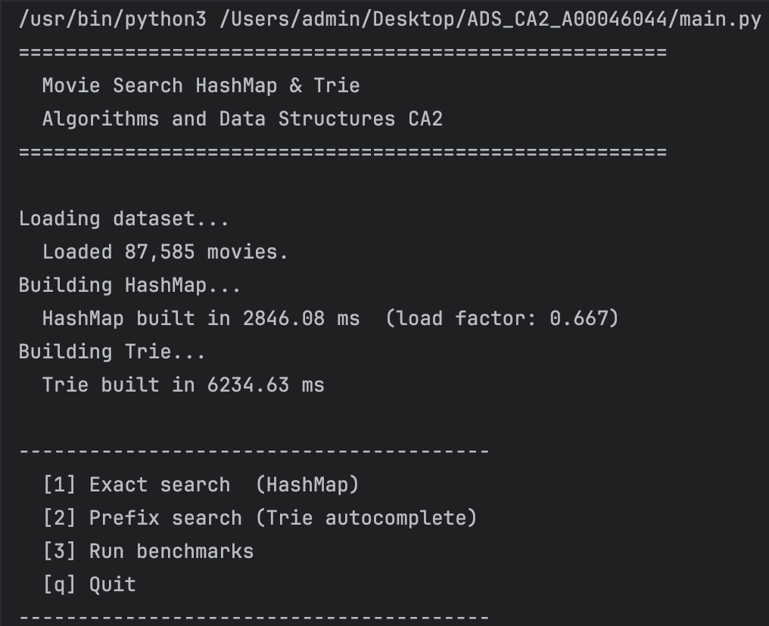

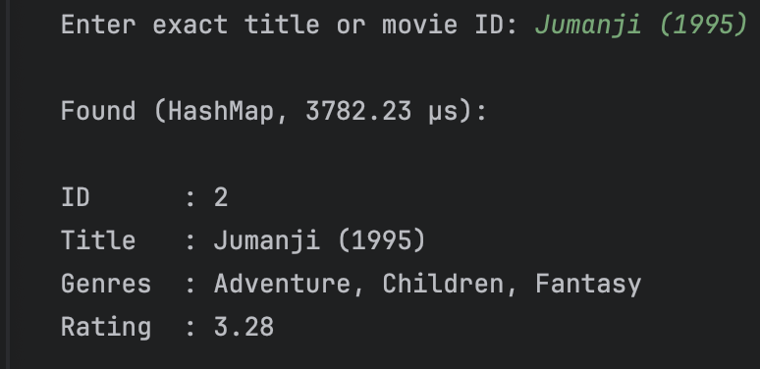
Choice 1
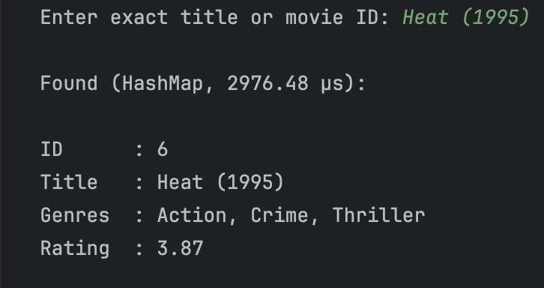
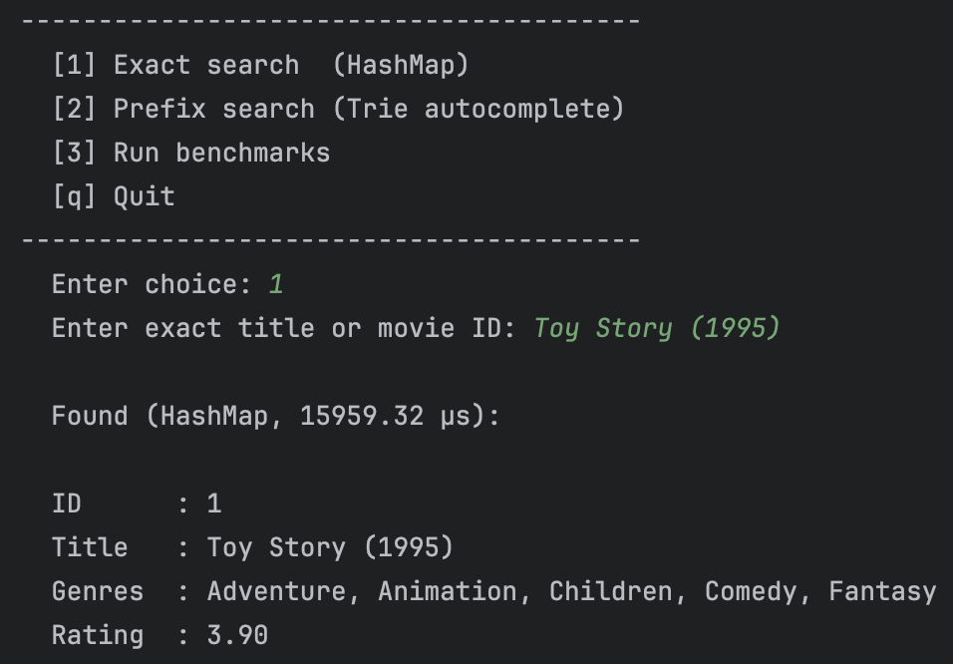
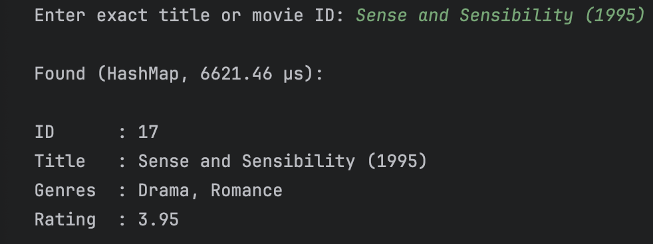
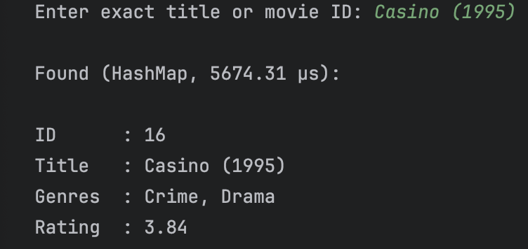

Choice 2
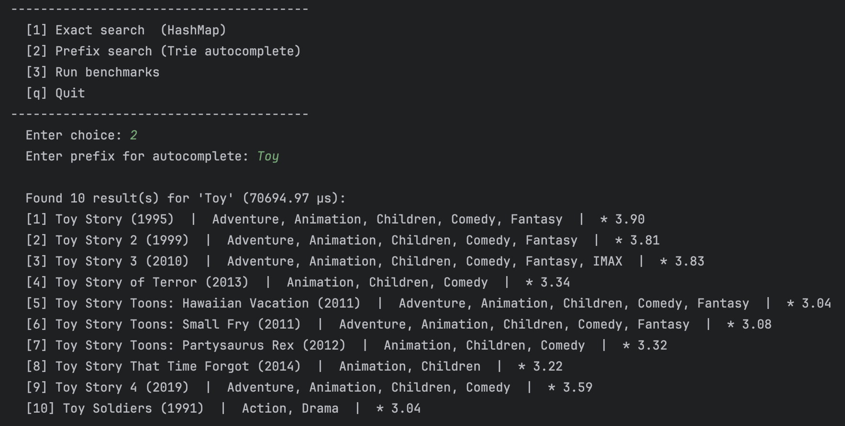

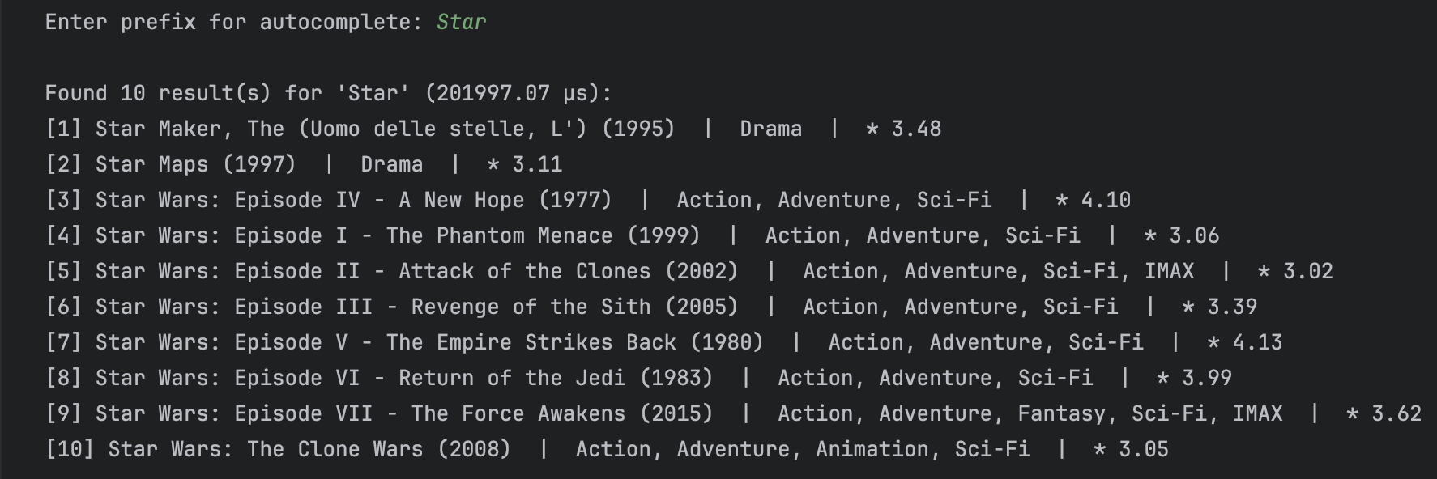

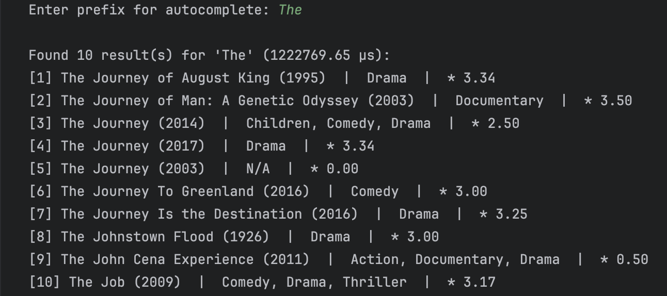

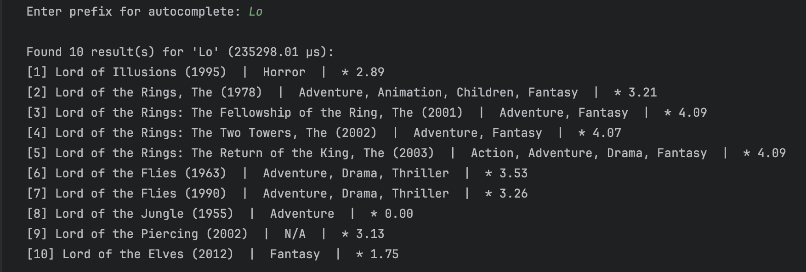

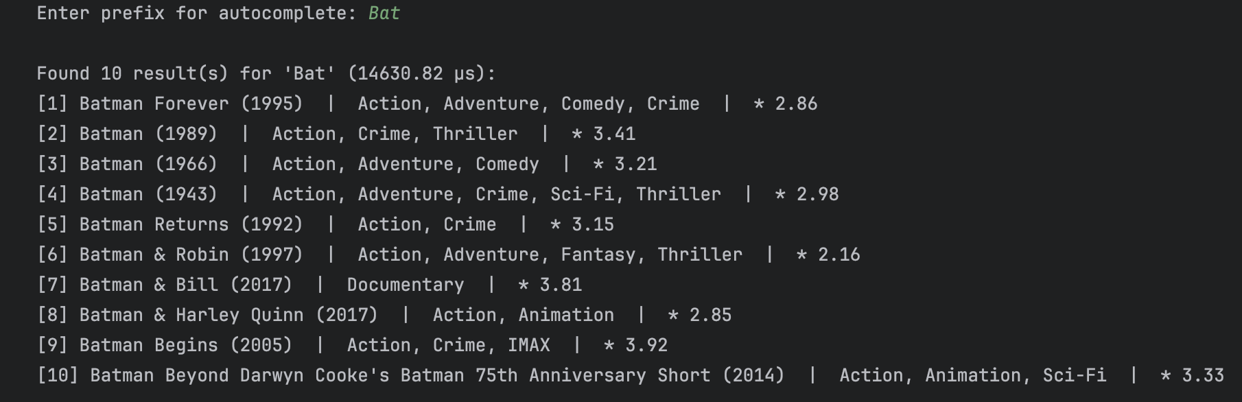

Choice 3
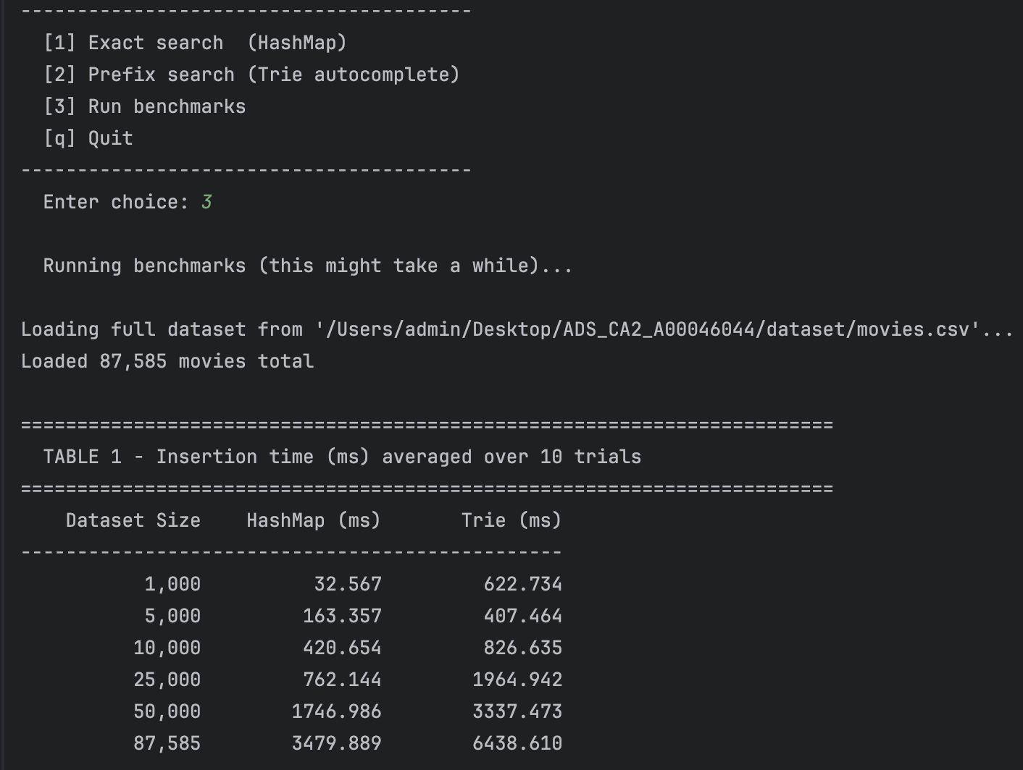

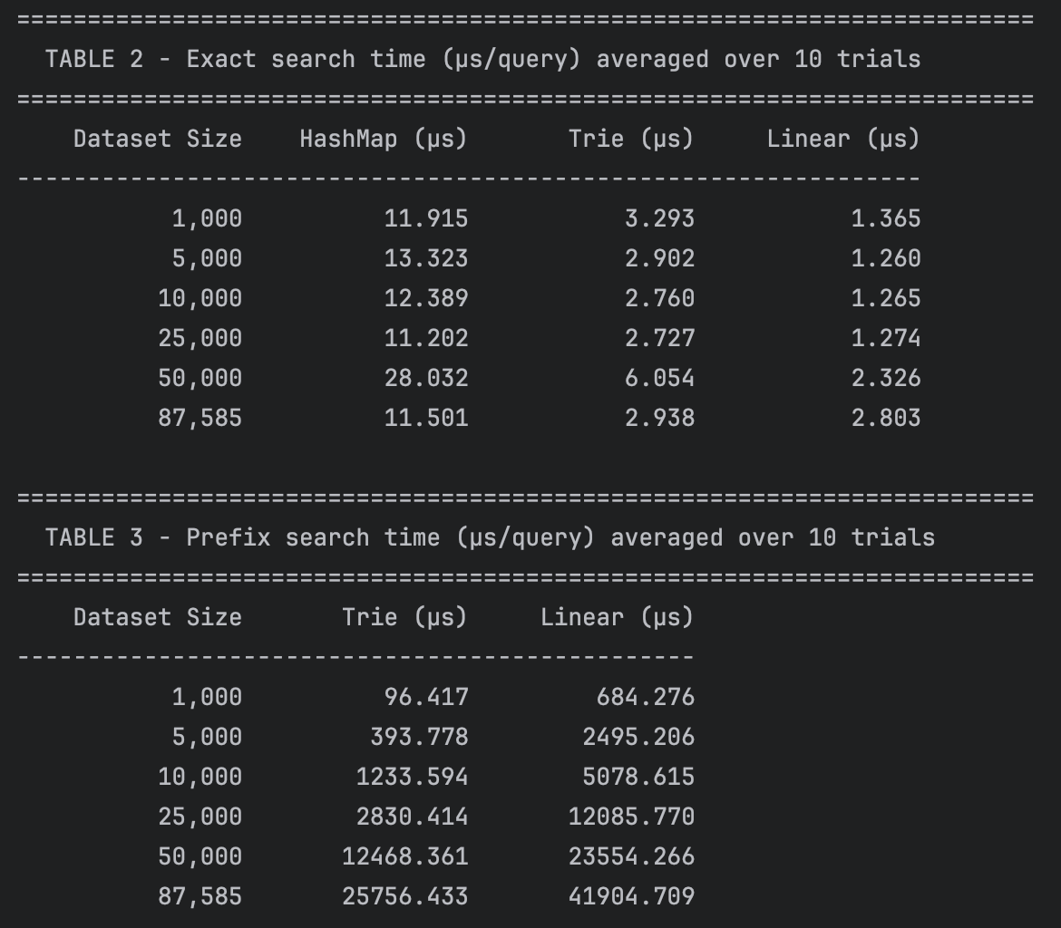
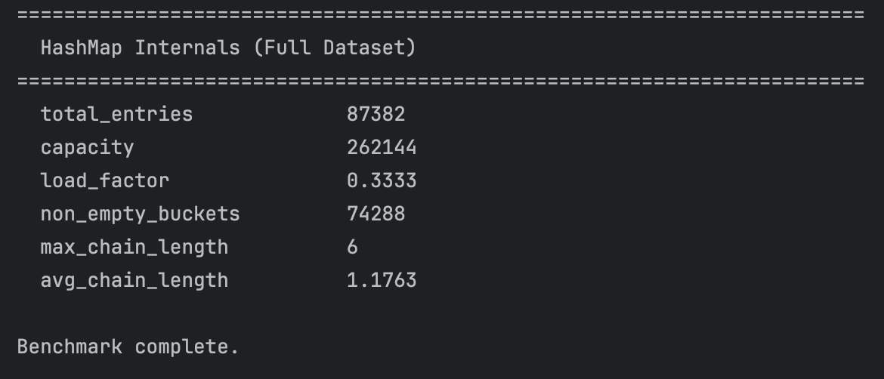

main.py
""" entry point for the project provides a simple command line interface allowing the user to search for a movie by
exact title (HashMap O(1) average), search by prefix/autocomplete (Trie O(k)), run the full benchmark
MovieLens dataset in folder called 'dataset/':
dataset/movies.csv
dataset/ratings.csv
dataset- https://grouplens.org/datasets/movielens/ """
import sys
import os
import time
from movie import Movie
from loader import load_movies
from hashmap import HashMap
from trie import Trie
from benchmark import run_benchmarks
# paths for dataset/folder
BASE_DIR = os.path.dirname(os.path.abspath(__file__))
MOVIES_PATH = os.path.join(BASE_DIR, "dataset", "movies.csv")
RATINGS_PATH = os.path.join(BASE_DIR, "dataset", "ratings.csv")
# build both structures from the dataset
def load_and_build(movies_path: str, ratings_path: str):
""" load the dataset and build both the HashMap and Trie
parameters
movies_path: str (path to movies.csv)
ratings_path: str (path to ratings.csv used only if the file exists)
returns
tuple(list[Movie], HashMap, Trie) """
ratings = ratings_path if os.path.isfile(ratings_path) else None
print("\nLoading dataset...")
movies = load_movies(movies_path, ratings)
print(f" Loaded {len(movies):,} movies.")
print("Building HashMap...")
start = time.perf_counter()
hm = HashMap()
for movie in movies:
hm.insert(movie.title, movie) # lookup by title
hm.insert(str(movie.movie_id), movie) # lookup by id
elapsed = (time.perf_counter() - start) * 1000
print(f" HashMap built in {elapsed:.2f} ms "
f"(load factor: {hm.load_factor():.3f})")
print("Building Trie...")
start = time.perf_counter()
trie = Trie()
for movie in movies:
trie.insert(movie.title, movie)
elapsed = (time.perf_counter() - start) * 1000
print(f" Trie built in {elapsed:.2f} ms")
return movies, hm, trie
# display helpers
def display_movie(movie: Movie) -> None:
""" print a formatted summary of a single movie """
genres = ", ".join(movie.genres) if movie.genres else "N/A"
rating = f"{movie.rating:.2f}" if movie.rating else "N/A"
print(f"\n ID : {movie.movie_id}")
print(f" Title : {movie.title}")
print(f" Genres : {genres}")
print(f" Rating : {rating}")
def search_exact(hm: HashMap, query: str) -> None:
""" perform an exact movie lookup using the HashMap, accepts either a full
movie title or a numeric movie id, displays the result and the time taken in microseconds """
start = time.perf_counter()
result = hm.search(query)
# fall back to numeric id lookup if title search found nothing
if result is None and query.isdigit():
result = hm.search(query)
elapsed = (time.perf_counter() - start) * 1_000_000
if result:
print(f"\n Found (HashMap, {elapsed:.2f} µs):")
display_movie(result)
else:
print(f"\n No exact match found for '{query}' ({elapsed:.2f} µs)")
def search_prefix(trie: Trie, prefix: str, limit: int = 10) -> None:
""" perform a prefix search using the Trie (autocomplete) returns up to 'limit'
movies whose titles begin with the given prefix displays each result and the total
time taken in microseconds """
start = time.perf_counter()
results = trie.autocomplete(prefix, limit=limit)
elapsed = (time.perf_counter() - start) * 1_000_000
if results:
print(f"\n Found {len(results)} result(s) for '{prefix}' ({elapsed:.2f} µs):")
for i, movie in enumerate(results, 1):
genres = ", ".join(movie.genres) if movie.genres else "N/A"
print(f" [{i}] {movie.title} | {genres} | * {movie.rating:.2f}")
else:
print(f"\n No titles found starting with '{prefix}' ({elapsed:.2f} µs)")
# main menu loop
def main():
""" run the interactive cli for movie search presents a menu for exact search, prefix search and benchmark """
print("=" * 55)
print(" Movie Search HashMap & Trie")
print(" Algorithms and Data Structures CA2")
print("=" * 55)
if not os.path.isfile(MOVIES_PATH):
print(f"\n[Error] movies.csv not found at: {MOVIES_PATH}")
print(" Download the MovieLens dataset from:")
print(" https://grouplens.org/datasets/movielens/")
print(" and place movies.csv in the dataset/folder.")
sys.exit(1)
movies, hm, trie = load_and_build(MOVIES_PATH, RATINGS_PATH)
while True:
print("\n" + "-" * 40)
print(" [1] Exact search (HashMap)")
print(" [2] Prefix search (Trie autocomplete)")
print(" [3] Run benchmarks")
print(" [q] Quit")
print("-" * 40)
choice = input(" Enter choice: ").strip().lower()
if choice == "1":
query = input(" Enter exact title or movie ID: ").strip()
if query:
search_exact(hm, query)
elif choice == "2":
prefix = input(" Enter prefix for autocomplete: ").strip()
if prefix:
search_prefix(trie, prefix)
elif choice == "3":
print("\n Running benchmarks (this might take a while)...")
run_benchmarks(MOVIES_PATH)
elif choice == "q":
print("\n Goodbye.")
break
else:
print(" Invalid choice - enter 1, 2, 3 or q")
if __name__ == "__main__":
main()

benchmark.py
# import libraries and packages needed for the project
import time
import os
import sys
from loader import load_movies
from hashmap import HashMap
from trie import Trie
# configuration
DATASET_PATH = "dataset/movies.csv" # path to MovieLens movies.csv
TRIALS = 10 # repetition per experiment (average)
DATASET_SIZES = [1000, 5000, 10000, 25000, 50000, 87585]
# search terms used for benchmarking
EXACT_QUERIES = ["Toy Story (1995)", "Jumanji (1995)", "Heat (1995)",
"Casino (1995)", "Sense and Sensibility (1995)"]
PREFIX_QUERIES = ["Toy", "Star", "The", "Lo", "Bat"]
# timing helpers
def time_insertion_hashmap(movies: list) -> float:
""" build a HashMap from a list of movies and return the average
insertion time in milliseconds over TRIALS runs """
times = []
for _ in range(TRIALS):
hm = HashMap()
start = time.perf_counter()
for movie in movies:
hm.insert(movie.title, movie)
hm.insert(str(movie.movie_id), movie)
end = time.perf_counter()
times.append(end - start)
return (sum(times) / len(times)) * 1000 # convert to ms
def time_insertion_trie(movies: list) -> float:
""" build a Trie and return average insertion time in ms """
times = []
for _ in range(TRIALS):
trie = Trie()
start = time.perf_counter()
for movie in movies:
trie.insert(movie.title, movie)
end = time.perf_counter()
times.append(end - start)
return (sum(times) / len(times)) * 1000
def time_exact_search_hashmap(hm: HashMap, queries: list[str]) -> float:
""" time exact lookup on a pre-built HashMap returns average time per query in microseconds """
times = []
for _ in range(TRIALS):
start = time.perf_counter()
for q in queries:
hm.search(q)
end = time.perf_counter()
times.append((end - start) / len(queries))
return (sum(times) / len(times)) * 1_000_000 # convert to µs
def time_exact_search_trie(trie: Trie, queries: list[str]) -> float:
""" time exact lookup on a pre-built Trie returns avg µs per query """
times = []
for _ in range(TRIALS):
start = time.perf_counter()
for q in queries:
trie.exact_search(q)
end = time.perf_counter()
times.append((end - start) / len(queries))
return (sum(times) / len(times)) * 1_000_000
def time_exact_search_linear(movies: list, queries: list[str]) -> float:
""" linear scan baseline - O(n) returns avg µs per query"""
times = []
for _ in range(TRIALS):
start = time.perf_counter()
for q in queries:
_ = next((m for m in movies if m.title == q), None)
end = time.perf_counter()
times.append((end - start) / len(queries))
return (sum(times) / len(times)) * 1_000_000
def time_prefix_search_trie(trie: Trie, queries: list[str]) -> float:
"""time prefix search on a pre-built Trie returns avg µs per query"""
times = []
for _ in range(TRIALS):
start = time.perf_counter()
for q in queries:
trie.search_prefix(q)
end = time.perf_counter()
times.append((end - start) / len(queries))
return (sum(times) / len(times)) * 1_000_000
def time_prefix_search_linear(movies: list, queries: list[str]) -> float:
""" linear scan prefix baseline - O(n) returns avg µs per query"""
times = []
for _ in range(TRIALS):
start = time.perf_counter()
for q in queries:
_ = [m for m in movies if m.title.lower().startswith(q.lower())]
end = time.perf_counter()
times.append((end - start) / len(queries))
return (sum(times) / len(times)) * 1_000_000
# table printers
def print_header(title: str):
print("\n" + "=" * 72)
print(f" {title}")
print("=" * 72)
def print_table(headers: list[str], rows: list[list], col_width: int = 16):
header_row = "".join(str(h).rjust(col_width) for h in headers)
print(header_row)
print("-" * (col_width * len(headers)))
for row in rows:
print("".join(str(cell).rjust(col_width) for cell in row))
# main benchmark runner
def run_benchmarks(dataset_path: str):
if not os.path.exists(dataset_path):
print(f"ERROR: Dataset not found at '{dataset_path}'")
print("Please place your MovieLens movies.csv in the same folder as this script")
sys.exit(1)
print(f"\nLoading full dataset from '{dataset_path}'...")
all_movies = load_movies(dataset_path)
available = len(all_movies)
print(f"Loaded {available:,} movies total")
sizes = [s for s in DATASET_SIZES if s <= available]
if available not in sizes:
sizes.append(available)
# table 1 (insertion time)
print_header("TABLE 1 - Insertion time (ms) averaged over 10 trials")
rows = []
for size in sizes:
movies = all_movies[:size]
hm_time = time_insertion_hashmap(movies)
trie_time = time_insertion_trie(movies)
rows.append([f"{size:,}", f"{hm_time:.3f}", f"{trie_time:.3f}"])
print_table(["Dataset Size", "HashMap (ms)", "Trie (ms)"], rows)
# table 2 (exact search time
print_header("TABLE 2 - Exact search time (µs/query) averaged over 10 trials")
rows = []
for size in sizes:
movies = all_movies[:size]
hm = HashMap()
for m in movies:
hm.insert(m.title, m)
trie = Trie()
for m in movies:
trie.insert(m.title, m)
hm_time = time_exact_search_hashmap(hm, EXACT_QUERIES)
trie_time = time_exact_search_trie(trie, EXACT_QUERIES)
linear_time = time_exact_search_linear(movies, EXACT_QUERIES)
rows.append([
f"{size:,}",
f"{hm_time:.3f}",
f"{trie_time:.3f}",
f"{linear_time:.3f}",
])
print_table(["Dataset Size", "HashMap (µs)", "Trie (µs)", "Linear (µs)"], rows)
# table 3 (prefix search time)
print_header("TABLE 3 - Prefix search time (µs/query) averaged over 10 trials")
rows = []
for size in sizes:
movies = all_movies[:size]
trie = Trie()
for m in movies:
trie.insert(m.title, m)
trie_time = time_prefix_search_trie(trie, PREFIX_QUERIES)
linear_time = time_prefix_search_linear(movies, PREFIX_QUERIES)
rows.append([
f"{size:,}",
f"{trie_time:.3f}",
f"{linear_time:.3f}",
])
print_table(["Dataset Size", "Trie (µs)", "Linear (µs)"], rows)
# HashMap collision stats at full size
print_header("HashMap Internals (Full Dataset)")
hm = HashMap()
for m in all_movies[:sizes[-1]]:
hm.insert(m.title, m)
stats = hm.collision_stats()
for k, v in stats.items():
print(f" {k:<25} {v}")
print("\nBenchmark complete.\n")
# entry point
if __name__ == "__main__":
path = sys.argv[1] if len(sys.argv) > 1 else DATASET_PATH
run_benchmarks(path)

hashmap.py
"""HashMap implemented from scratch using an array with separate chaining
for collision resolution but no built-in dict is used for the core structure
Supports:
insert(key, value) O(1) average case
search(key) O(1) average case
__len__ number of inserted entries """
INITIAL_CAPACITY = 262144 # sized for over 175k entries (dataset times 2)
class HashMapEntry:
"""single key value pair stored inside a bucket chain"""
def __init__(self, key: str, value):
self.key = key
self.value = value
self.next = None # pointer to the next entry in the chain
class HashMap:
""" hash map using open addressing with separate chaining, each slot in the internal array
holds a linked-list chain of HashMapEntry objects to handle hash collisions """
def __init__(self, capacity: int = INITIAL_CAPACITY):
self.capacity = capacity
self.buckets = [None] * self.capacity # the underlying array
self._size = 0
# hash function
def _hash(self, key: str) -> int:
""" convert a string key into a valid bucket index, it uses a polynomial rolling hash
each character's ASCII value is multiplied by a prime raised to its position, summed,
then reduced modulo the capacity this distributes keys evenly across buckets dnd minimises collisions
time complexity O(k) where k = len(key) """
hash_value = 0
prime = 31
for i, char in enumerate(key):
hash_value += ord(char) * (prime ** i)
return hash_value % self.capacity
# core operations
def insert(self, key: str, value) -> None:
""" insert a key-value pair into the HashMap, if the key already exists, its value is updated in place
collisions are handled by chaining new entries are prepended to the front of the bucket's linked list
evg time complexity is O(1) """
index = self._hash(key)
entry = self.buckets[index]
# walk the chain to check for an existing key
while entry is not None:
if entry.key == key:
entry.value = value # update existing
return
entry = entry.next
# prepend a new entry at the head of the chain
new_entry = HashMapEntry(key, value)
new_entry.next = self.buckets[index]
self.buckets[index] = new_entry
self._size += 1
def search(self, key: str):
""" look up a key and return its associated value, or None if not found
avg time complexity is O(1)
worst case is (all keys collide) O(n) """
index = self._hash(key)
entry = self.buckets[index]
while entry is not None:
if entry.key == key:
return entry.value
entry = entry.next
return None
# utility
def __len__(self) -> int:
return self._size
def load_factor(self) -> float:
"""ratio of entries to buckets indicates how full the map is"""
return self._size / self.capacity
def collision_stats(self) -> dict:
""" returns stats about chain lengths for analysis"""
chain_lengths = []
for bucket in self.buckets:
length = 0
entry = bucket
while entry is not None:
length += 1
entry = entry.next
chain_lengths.append(length)
non_empty = [l for l in chain_lengths if l > 0]
return {
"total_entries": self._size,
"capacity": self.capacity,
"load_factor": round(self.load_factor(), 4),
"non_empty_buckets": len(non_empty),
"max_chain_length": max(chain_lengths) if chain_lengths else 0,
"avg_chain_length": round(sum(non_empty) / len(non_empty), 4) if non_empty else 0,
}

loader.py
""" reading the MovieLens CSV files and producing Movie objects
handles two CSV files:
- movies.csv: movieId, title, genres
- ratings.csv: userId, movieId, rating, timestamp
DataLoader pre-computes an average rating per movie from ratings.csv and
attaches it to each movie object made from movies.csv"""
import csv
import os
from movie import Movie
def load_movies(movies_path: str, ratings_path: str = None, limit: int = None) -> list:
""" parse movies.csv and return a list of Movie objects also optionally reads ratings.csv to
attach an average rating to each movie but if ratings_path is not provided, rating defaults to 0.0
parameters
movies_path: str (path to the MovieLens movies.csv file)
ratings_path: str (path to the MovieLens ratings.csv file)
limit: int (maximum number of movies to load, lads all if theres none)
returns list[Movie] ordered list of movie objects parsed from the csv"""
if not os.path.isfile(movies_path):
raise FileNotFoundError(f"[Loader] movies.csv not found at '{movies_path}'")
# pre load avg ratings
avg_ratings = _load_average_ratings(ratings_path)
movies = []
with open(movies_path, encoding="utf-8") as f:
reader = csv.DictReader(f)
for i, row in enumerate(reader):
# respect the optional limit on dataset size
if limit is not None and i >= limit:
break
movie_id = int(row["movieId"])
title = row["title"].strip()
# genres are pipe separated in MovieLens
genres_raw = row["genres"].strip()
genres = genres_raw.split("|") if genres_raw != "(no genres listed)" else []
rating = avg_ratings.get(movie_id, 0.0)
movies.append(Movie(movie_id, title, genres, rating))
return movies
def _load_average_ratings(ratings_path: str) -> dict:
""" parse ratings.csv and compute the average rating per movie id which reads every row,
accumulates sum and count per movieId, then computes the mean.
Parameters - ratings_path (str or None)
Path to ratings.csv, or None if not available.
Returns
-------
dict[int, float]
Mapping of movieId to average rating.
"""
if ratings_path is None or not os.path.isfile(ratings_path):
return {}
totals = {} # {movie_id: sum of ratings}
counts = {} # {movie_id: number of ratings}
with open(ratings_path, encoding="utf-8") as f:
reader = csv.DictReader(f)
for row in reader:
mid = int(row["movieId"])
rating = float(row["rating"])
totals[mid] = totals.get(mid, 0.0) + rating
counts[mid] = counts.get(mid, 0) + 1
return {mid: round(totals[mid] / counts[mid], 2) for mid in totals}

movie.py
""" data model representing a single movie record from the MovieLens dataset acts as a simple
container for all relevant fields parsed from the csv file and its used across the HashMap and
Trie so that both structures store and return the same object type """
class Movie:
""" represents a single movie record
attributes
movie_id: int (nique numeric identifier from the MovieLens dataset)
title: str (full movie title including release year
genres: list[str] (one or more genre labels associated with the movie)
rating: float (avg user rating derived from the ratings cvs) """
def __init__(self, movie_id: int, title: str, genres: list, rating: float = 0.0):
""" initialises a Movie object
parameters
movie_id: int (unique identifier for the movie)
title: str (full title string including release year)
genres: list[str] (list of genre labels)
rating: float (avg rating across all user ratings defaults to 0.0) """
self.movie_id = movie_id
self.title = title
self.genres = genres
self.rating = rating
def __repr__(self) -> str:
"""return a readable string representation of the movie"""
genres_str = "|".join(self.genres)
return (
f"Movie(id={self.movie_id}, title='{self.title}', "
f"genres='{genres_str}', rating={self.rating:.2f})"
)
def __eq__(self, other) -> bool:
"""2 movies are equal if they share the same movie_id"""
if not isinstance(other, Movie):
return False
return self.movie_id == other.movie_id

trie.py
""" implements the Trie (Prefix Tree) data structure for efficient prefix-based search and autocomplete on movie titles
contains two classes TrieNode (fundamental building block of the Trie) and Trie (manages all insert, search and
autocomplete operations) adapted for the MovieLens dataset movie titles are stored in lowercase to make all searches case insensitive
time complexities
insert O(k) where k is the length of the movie title
search O(k) where k is the length of the query string
starts_with O(k) where k is the length of the prefix
autocomplete O(k + m) where m is the number of results collected"""
# TrieNode
class TrieNode:
""" single node within the Trie (Prefix Tree)
each node represents one character in a movie title path, nodes are connected to form paths from the root, where
each complete path from root to an end of word node spells out full movie titles
attributes
children: dict[str, TrieNode] (mapping of character,child TrieNode for all possible continuations) allows each node
to branch into multiple next characters
is_end_of_word: bool (true if the path from the root to this node forms a complete title
distinguishes a valid complete title from a prefix only path
movie: Movie or None (movie object stored at the end of a title path, none for intermediate nodes that are not the end of any complete title"""
def __init__(self):
""" initialise a TrieNode with an empty children dict and no end marker"""
# dictionary: character - TrieNode allows each node to branch to multiple next characters
self.children = {}
# flag to distinguish a complete title from a prefix only node
self.is_end_of_word = False
# stores the movie object once a complete title path is formed
self.movie = None
# trie
class Trie:
""" prefix Tree supporting insertion, exact search, prefix search and autocomplete on movie titles
all titles are stored and searched in lowercase to ensure case insensitive behaviour"""
def __init__(self):
"""initialise the Trie with an empty root node, the root node does not represent any character its just
the entry point to all possible title paths"""
self.root = TrieNode()
# insert
def insert(self, title: str, movie) -> None:
"""insert a movie title into the Trie, storing the Movie object at the terminal node
characters are inserted one by one from the root, if a node for a character does not yet exist, a new TrieNode
is created, when all characters have been inserted, the final node is marked as is_end_of_word and the Movie object is attached
time complexity O(k) where k = len(title)
parameters
title: str (movie title to insert)
movie: Movie (Movie object to store at the end of the title path)"""
# normalise to lowercase for case insensitive prefix matching
title = title.lower()
current = self.root
for char in title:
# create a new node if this character has no child yet
if char not in current.children:
current.children[char] = TrieNode()
# move down to the next node along the character path
current = current.children[char]
# mark the final node as the end of a complete movie title
current.is_end_of_word = True
current.movie = movie # attach the movie object
# internal helpers
def _traverse(self, string: str):
""" follow the path defined by 'string' through the Trie from the root, used internally by search() and
starts_with() to navigate to the node corresponding to the end of a given word or prefix
Returns None if any character in the string is not found, meaning the string or prefix does not exist in the Trie
time complexity O(k) where k = len(string)
parameters
string: str (string to traverse)
returns TrieNode or None (node at the end of the path, or None if not found) """
current = self.root
for char in string:
if char not in current.children:
return None # path breaks, string not in Trie
current = current.children[char]
return current # successfully reached the end of the path
def _dfs(self, node, path: str, results: list) -> None:
"""perform a depth first search from 'node', collecting all complete movie titles reachable
from this point recursive helper used by autocomplete() appends each complete movie object to
the results list when it reaches an end node
parameters
node: TrieNode (the node to start the dfs from)
path: str (the string built so far along the path from the prefix node)
results: list (accumulator complete movie objects are appended here) """
#if this node marks the end of a valid title, record the movie
if node.is_end_of_word and node.movie is not None:
results.append(node.movie)
# recursively explores all child nodes
for char, child_node in node.children.items():
# extend the current path with this character and recurse
self._dfs(child_node, path + char, results)
# search
def search(self, title: str):
""" check if exact movie title exists in the Trie uses _traverse() to reach the node at
the end of the title path,then checks whether that node is marked as is_end_of_word
returns the Movie object if found, or None if not, time complexity O(k) where k = len(title)
parameters
title: str (the exact movie title to search for) returns Movie or None """
node = self._traverse(title.lower())
# path must exist and the node must mark a complete title
if node is not None and node.is_end_of_word:
return node.movie
return None
# prefix/starts_with
def starts_with(self, prefix: str):
""" check whether any movie title in the Trie begins with 'prefix', returns the node at the end
of the prefix path if it exists, or None if the prefix is not present. Used as the starting point
for autocomplete(), time complexity O(k) where k = len(prefix)
parameters
prefix: str (prefix string to check, returns TrieNode or None """
return self._traverse(prefix.lower())
# autocomplete
def autocomplete(self, prefix: str, limit: int = 10) -> list:
"""return all movie titles in the Trie that begin with 'prefix' locates the prefix node using starts_with(),
then performs a dfs to collect all reachable complete titles and results are capped at 'limit' to avoid returning
big lists, time complexity O(k + m) where k = len(prefix) m = results found
parameters
prefix: str (prefix to search case-insensitive)
limit: int (maximum number of results to return default is 10)
returns list[Movie] (movie objects whose titles start with the prefix, up to 'limit' + an empty list if the prefix is not found """
prefix_node = self.starts_with(prefix)
if prefix_node is None:
return [] # prefix not found in the Trie
results = []
self._dfs(prefix_node, prefix.lower(), results)
return results[:limit]
# aliases for benchmark compatibility
def exact_search(self, title: str):
"""alias for search() used by the benchmark module"""
return self.search(title)
def search_prefix(self, prefix: str) -> list:
"""alias for autocomplete() used by the benchmark module"""
return self.autocomplete(prefix)

References

Brightspace. (2026). Lecture notes and lab tutorial materials.
Available via: TU Dublin Brightspace
Accessed: 28 April 2026

GitHub link: https://github.com/bytelea/Hash_Map_Trie_Analysis_in_Python

GroupLens Research, University of Minnesota. (2026). MovieLens Dataset 32M
Available at: https://grouplens.org/datasets/movielens/
Accessed: 26 April 2026

GeeksforGeeks. Hashing Data Structure
Available at: https://www.geeksforgeeks.org/hashing-data-structure/
Accessed: 28 April 2026

GeeksforGeeks. Trie Data Structure and Algorithm
Available at: https://www.geeksforgeeks.org/introduction-to-trie-data-structure-and-algorithm-tutorials/ Accessed: 29 April 2026

GeeksforGeeks. Separate Chaining Collision Handling Technique in Hashing
Available at: https://www.geeksforgeeks.org/separate-chaining-collision-handling-technique-in-hashing/ Accessed: 28 April 2026

GeeksforGeeks. Autocomplete feature using Trie
Available at: https://www.geeksforgeeks.org/auto-complete-feature-using-trie/
Accessed: 1 May 2026

GeeksforGeeks. Load Factor and Rehashing
Available at: https://www.geeksforgeeks.org/load-factor-and-rehashing/
Accessed: 1 May 2026

Real Python. Python Hash Tables: Understanding Dictionaries
Available at: https://realpython.com/python-hash-table/
Accessed: 1 May 2026

