1. Fill the following template and send it over to your point of contact.   
     
   Values in YELLOW are Mandatory

|  |  |
| --- | --- |
| **Phone** | Valid, numeric phone number that will receive OTP |
| **State** | The state to filter upon |
| **District** | The district to filter upon |
| **Age** | Only 2 values, either “18” or “45” |
| **Name** | Exact character matched name, that is there on the schedule page. This can be multiple names, separated by a comma. Add the value “All” if you want to book all under a particular number. **PLEASE NOTE: The candidates scheduled should have the same age, that is either 18 or 45. You cannot mix and match 18+ with 45+ and different dosage types.** |
| Covishield | Whether to filter on Covishield |
| Covaxin | Whether to filter on Covaxin |
| Paid | Whether to filter on Paid |
| Free | Whether to filer on Free |
| Hospital | A part of the hospital name, for example, “Nanavati” or “Kokilaben”, could be multiple hospitals |
| Pin | The pin code to filter by. Could be multiple PIN codes separated by a comma. |
| Slot | The time slot to book at. Numerical value between 1 and 4. 1 corresponds to 9am to 11am, 2 corresponds to 11am to 1pm, 3 corresponds to 1pm to 3pm and 4 corresponds to 3pm to 5pm |
| Dose | The dose number. Has to be either 1 or 2. Defaults to 1. |
| Device | Your mobile device, whether it is “iOS” or “Android” |

1. Download the android app “sms-forward-final-mod.apk” given by your contact
2. Go to your mobile’s file explorer, and you will find the app. Tap it.

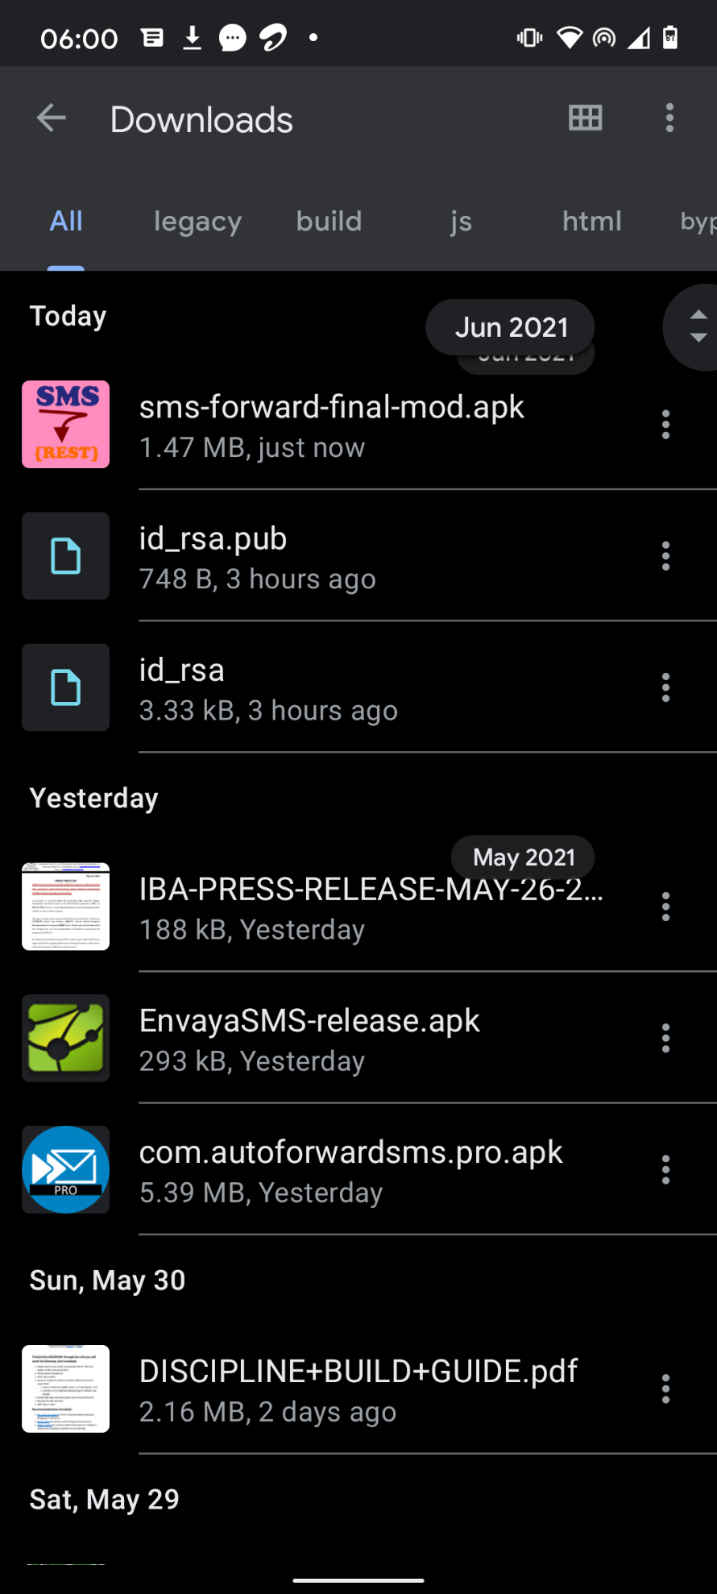

1. You’ll be prompted with a pop-up. Hit the “Install” button

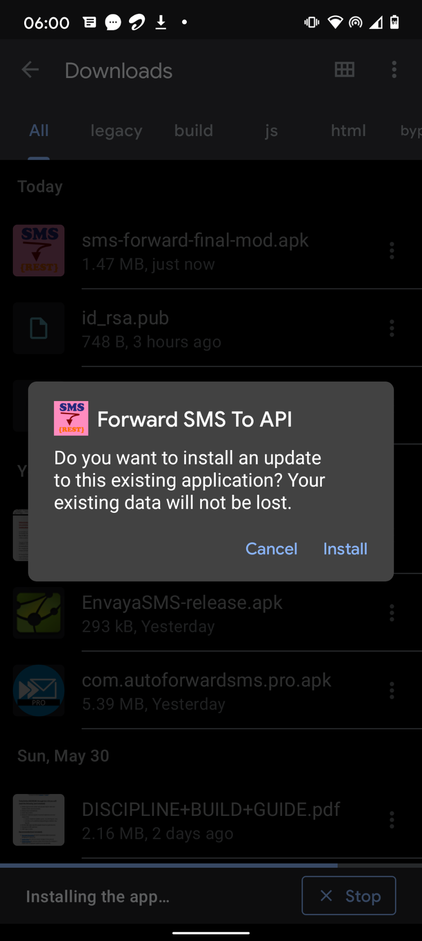

1. Then, another pop-up will show up. Hit “INSTALL ANYWAY” to continue.

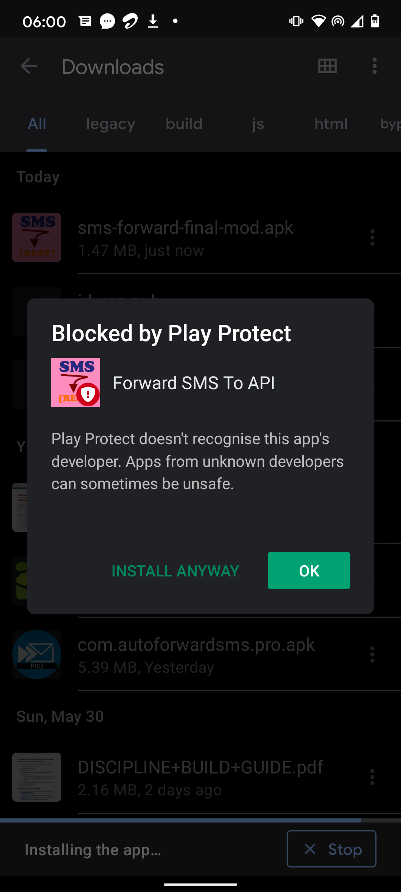

1. After installation, yet another pop-up will show. Hit “DON’T SEND” button

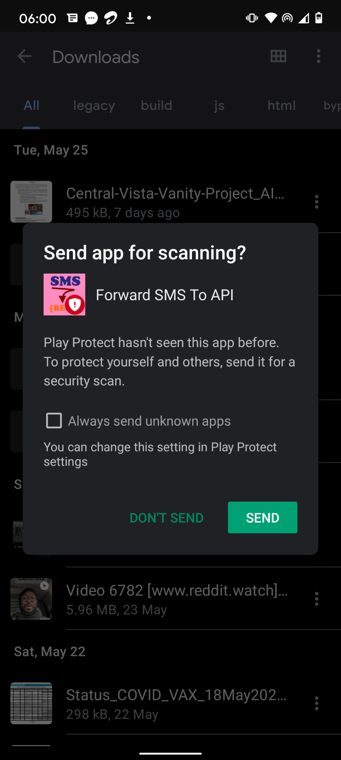

1. Open the app “Forward SMS To API” and hit “Allow” for the app to access messages

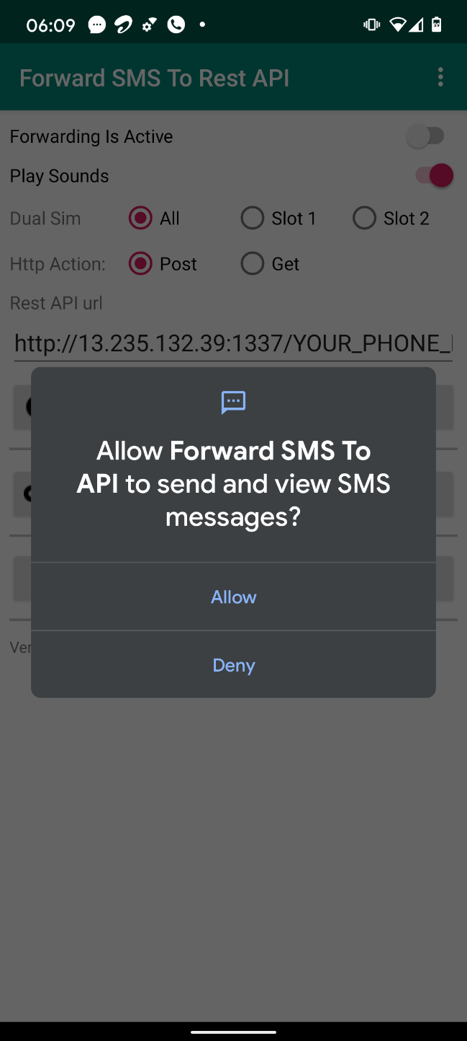

1. Hit the “Forwarding is Active” button

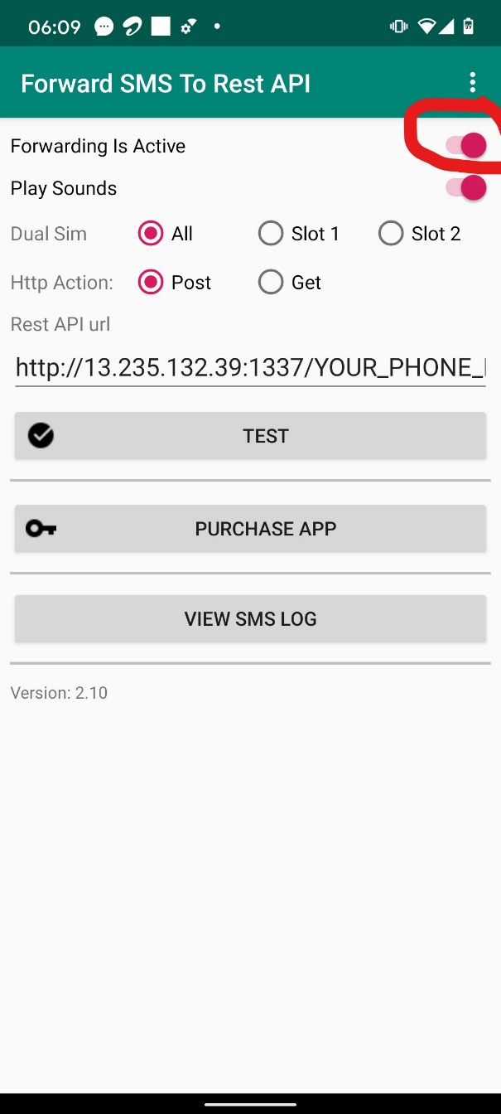

1. Replace “YOUR_PHONE_NUMBER” with your actual phone number. For example, if your number is “9867543210”, your “Rest API url” filed would be <http://1.235.132.39:1337/9867543210>

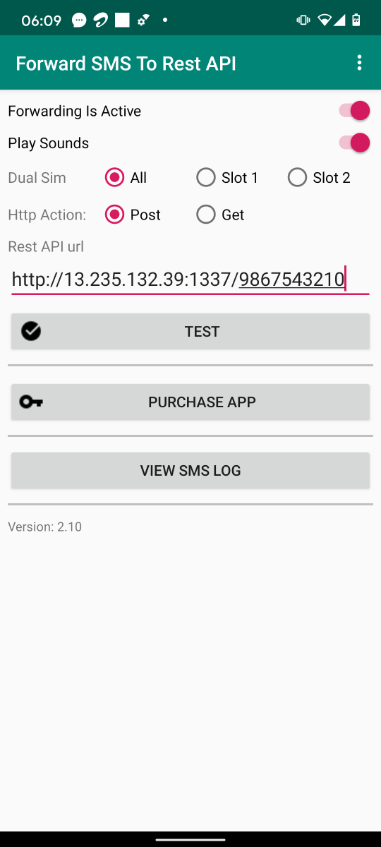

1. Tell your contact that you are all set up and ready