1. **Please make sure that the iOS device and your computer/mac are connected to the same WiFi network!**
2. Run the .exe, with “settings.txt” containing “Device: iOS”



1. Run the program, the console will prompt the IP address as such, and will wait perpetually.



1. Go to your iOS device, and head over to “shortcuts”

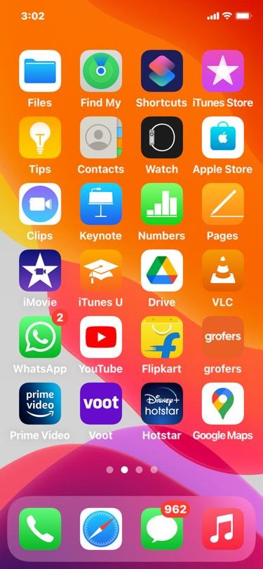

1. Head over to “Automation” and hit the “+” symbol.

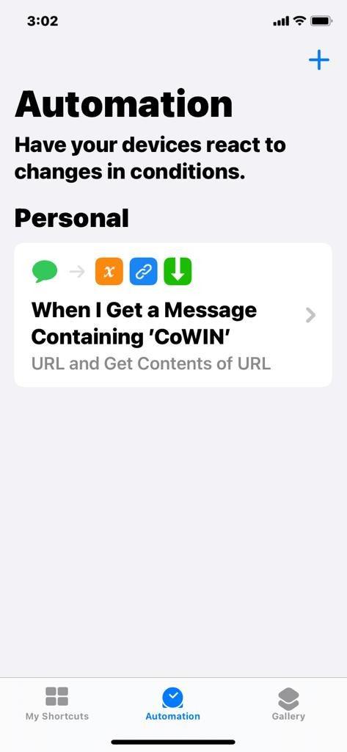

1. Hit “Create Personal Automation”

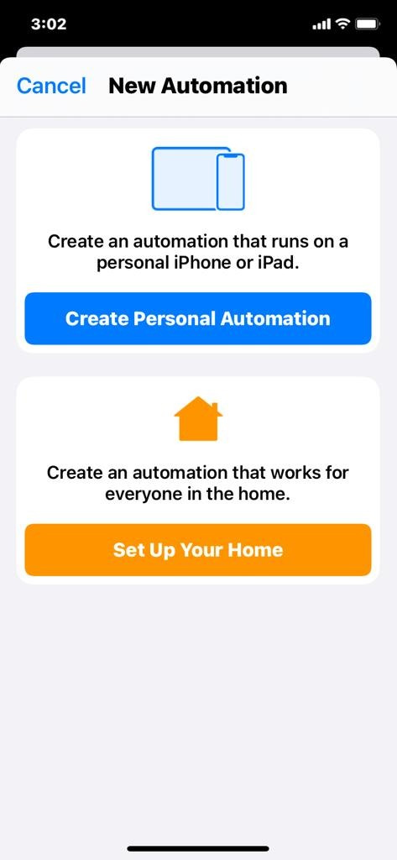

1. Serach for “Message” and hit “Message”

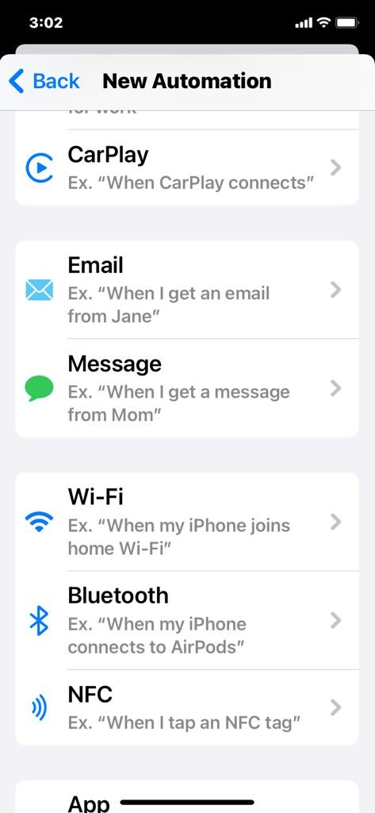

1. Put “CoWIN” as “Message Contains”

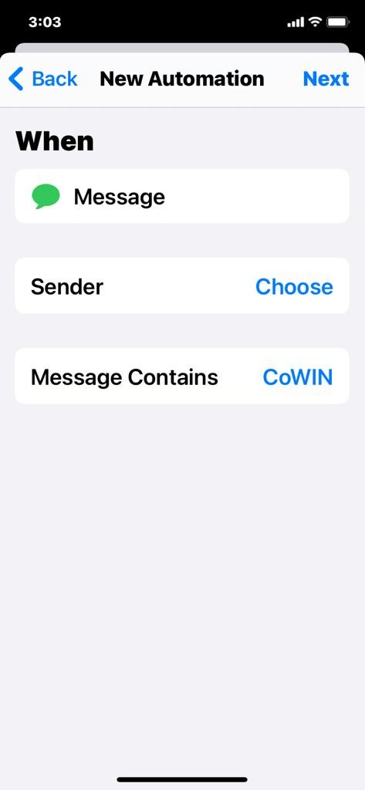

1. Hit “next” and tap “Add Action”

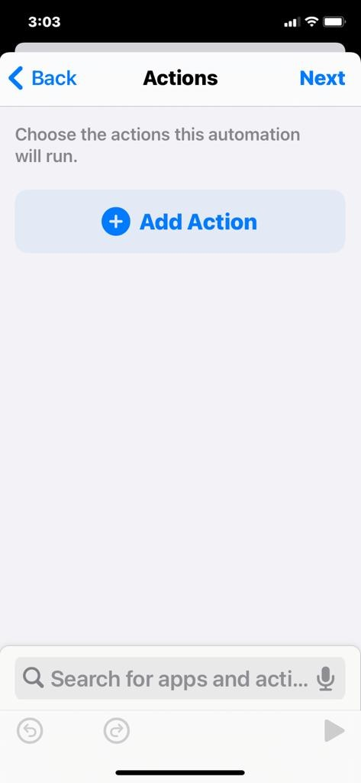

1. Search for “Variable” and hit “Set Variable”

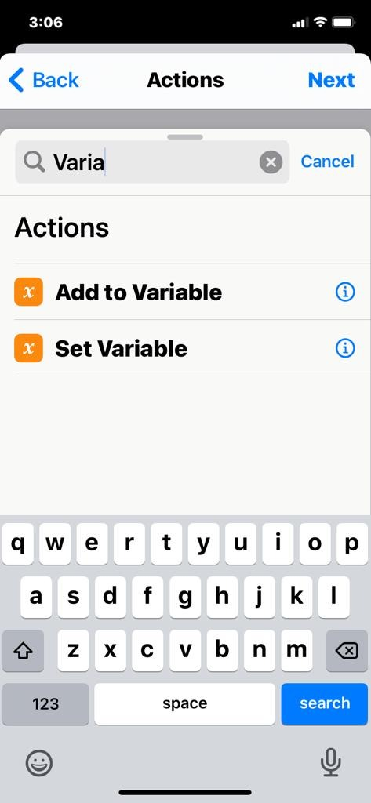

1. Set the variable to “body” and the Input as “Shortcut Input”

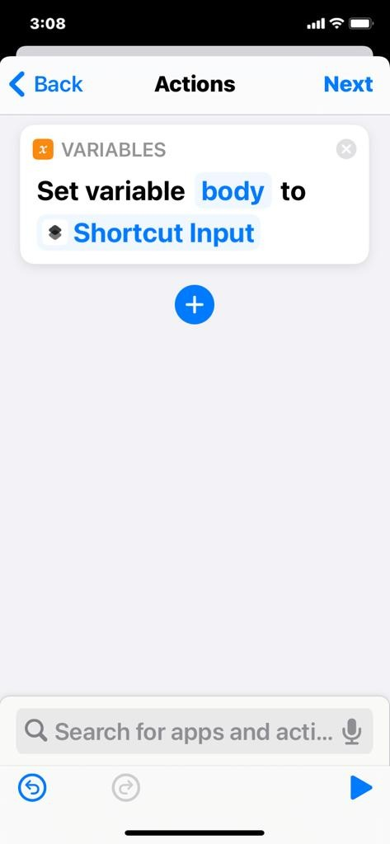

1. Hit the “+” button (below the “Variables” in the above screenshot) and search for URL, and select “URL” (The one in blue)

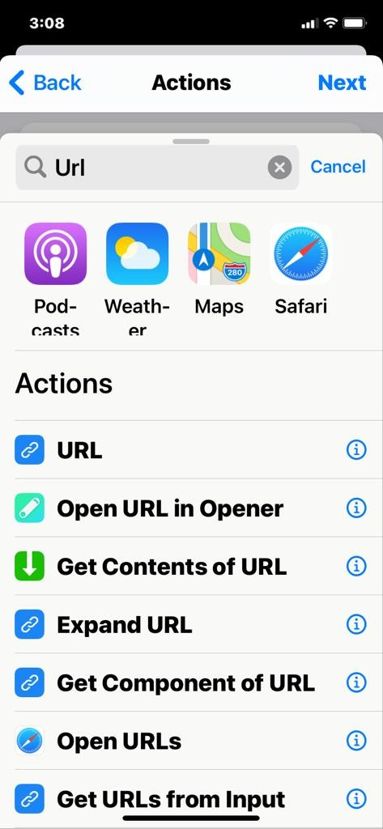

1. Add the IP address, followed by port as 1337/PHONE_NUMBER. For example, the IP is 192.168.0.5, and your phone number is 1234567890, then put, “http://192.168.0.5:1337/1234567890”

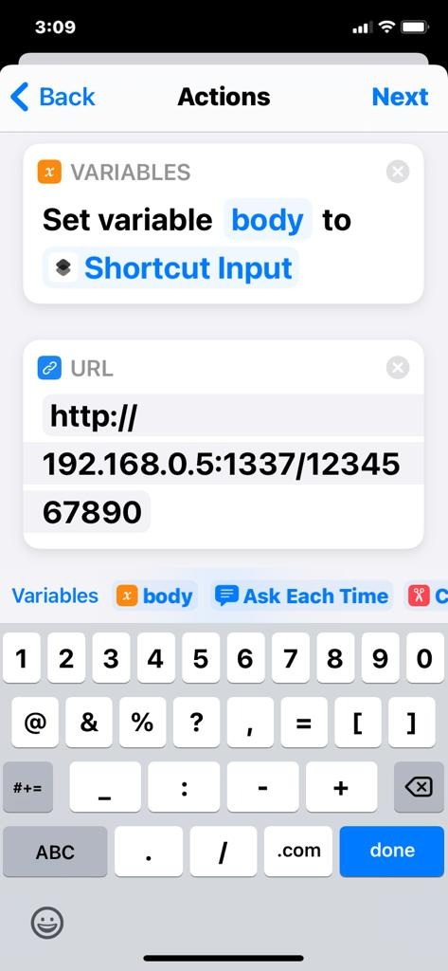

1. Again hit the small “+” button, search for “Get Contents of URL” and tap that

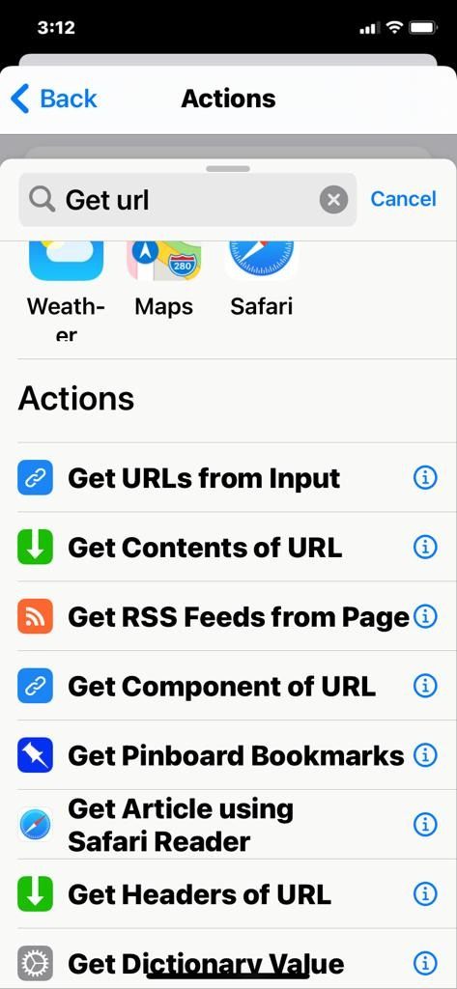

1. Set the method to “POST” and request body to “JSON”

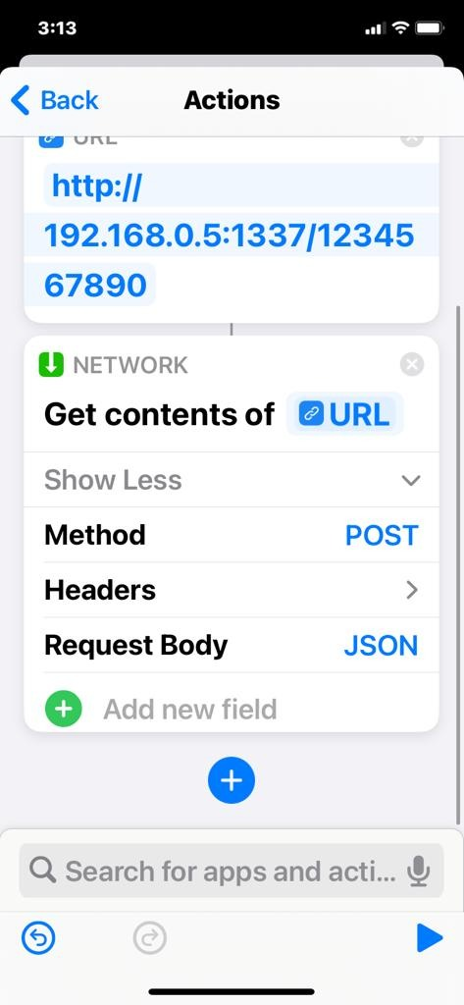

1. Click “Add a new Field” and select “Text”

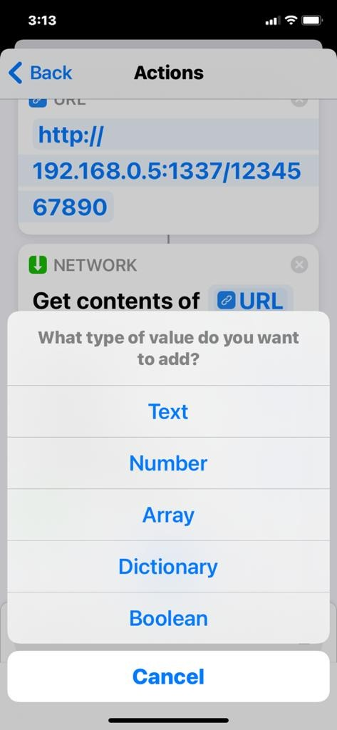

1. Put the key as “message” and value as “body” variable (The keyboard will hint you this, do not type it out)

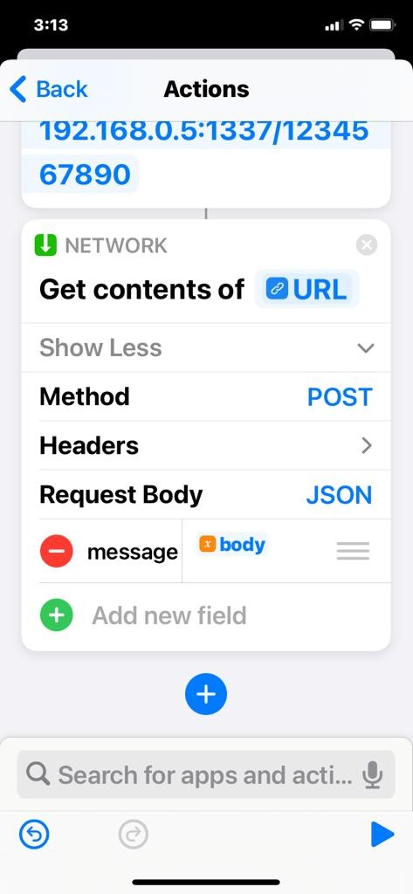

1. Press enter on the console window after this setup.
2. On the iOS, once you get the OTP, you’ll be prompted to “Run” shortcut, hit that.

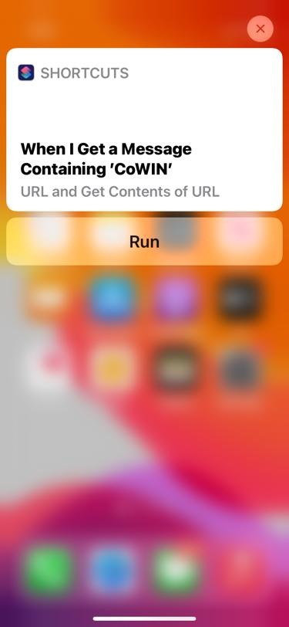

1. If there is some error, press “Ctrl + C” on the console, close chrome window and restart