1. Choice for the Commodity (COM-COPPER):

The Commodity was chosen for the following reasons:

1. Copper has had a downtrend for the past 5 years. An FFT over it would be feasible as it would detect cycles
2. Copper is a low valued industrial metal. I was curious to know how FFT would work on values which were very close to 0, and whether it was agnostic to the number spectrum, that is, it would produce a spiked resulted for trends even when they would be hard to find due the smaller increments in value (price)
3. Other commodities had good analysis on Piazza by other classmates, and Industrial Metals was one area which was left largely untouched.
4. Datasource Choice:

A direct Quandl connection API was not used because that would expose my API key. Secondly, Yahoo! has decommissioned their ichart API, which causes all direct connections to Yahoo! Finance (such as matplotlib.finance and pd.datareader) to fail. I could have connected to Google to fetch the Data, but opted for Quandl, as it had the best aggregation of commodity collection which is freely available. Therefore, the .csv contains data from Quandl, and the datasource should be irrelevant for this mini-project.

Step 1:

A Dataset was loaded and was plotted (here, the timeseries was converted because FFT is applied on continuous dataset, while a TS is a discrete dataset):  
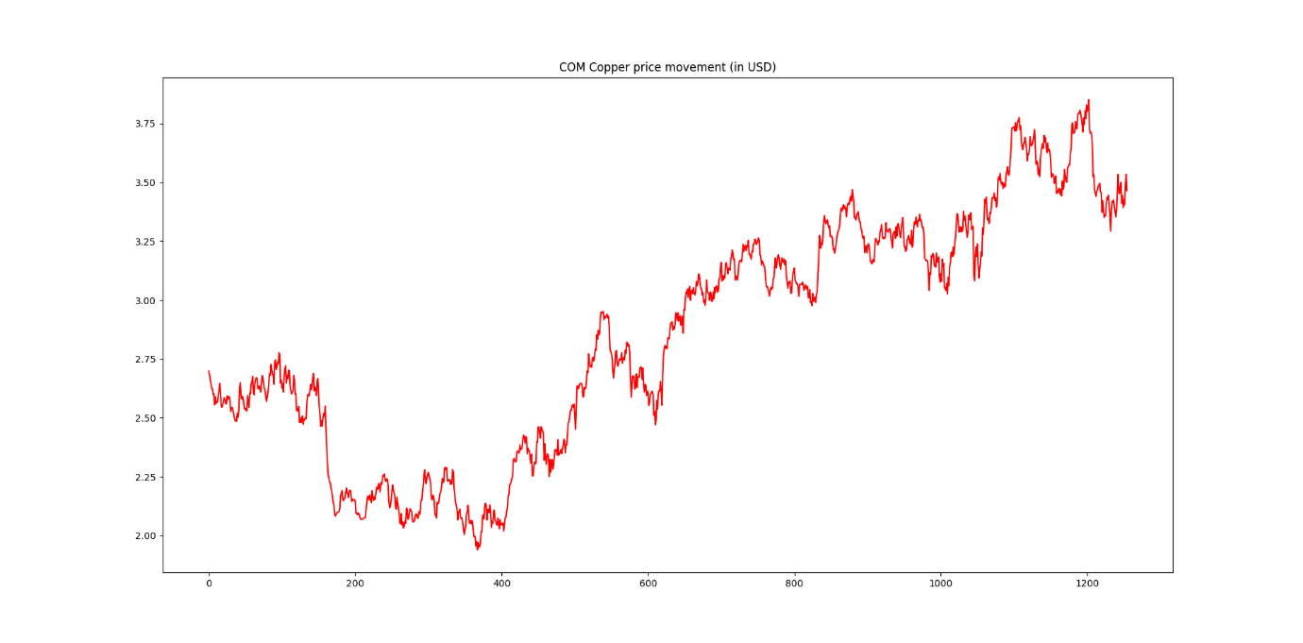

Step 2:

Detrend the Dataset -> Detrending is necessary for creating a null hypothesis, as pointed out by Prof. Douglas on piazza forums discussion for Unit 3

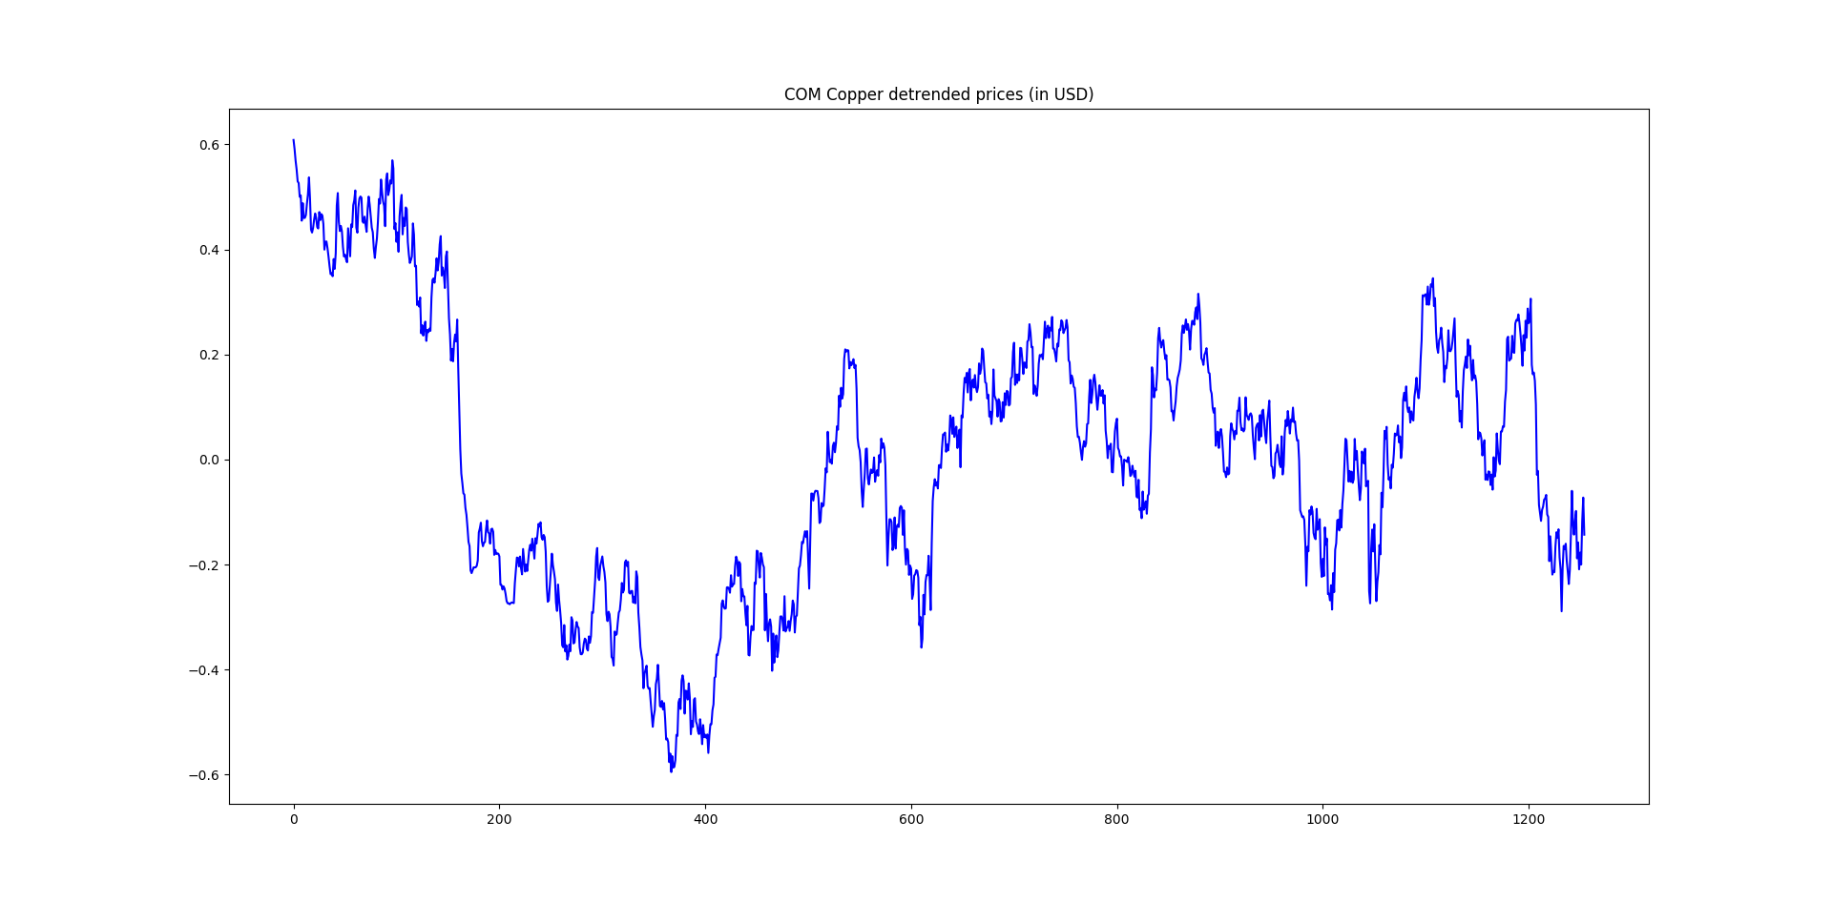

Step 3:

Form a Blackman window for FFT. Here, the number of points are 20, which is similar to that in the Lab.

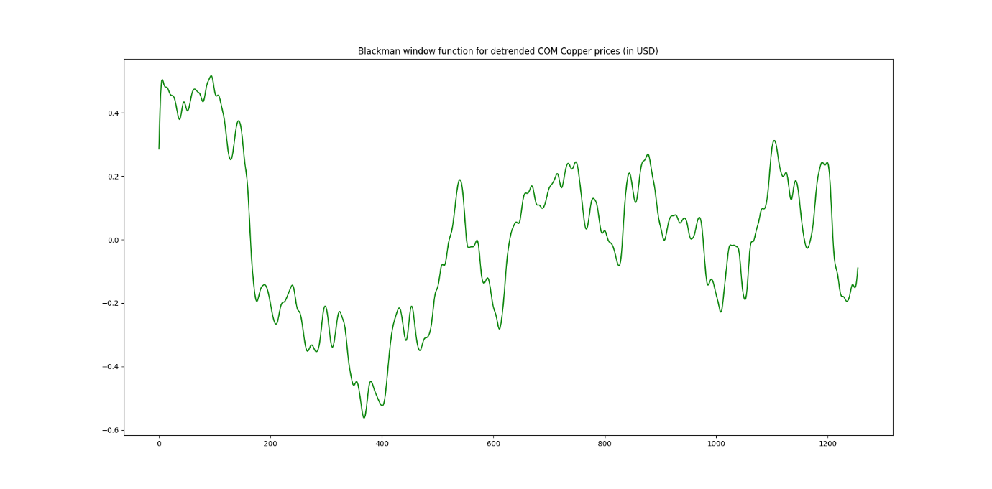

Step 4:

Plot the FFT

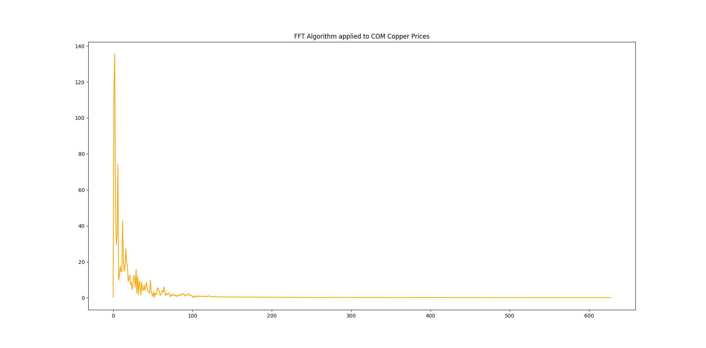

Step 5:

Get the amplitude (maximum magnitude)

The largest magnitude (y axis) of the Fast Fourier Transform is 135.576649:

The largest magnitude of the Fast Fourier Transform is located at frequency (x axis) 2.000000:

Step 6:

Analysis

1. There are multiple spikes in the final FFT plot, indicating that there are multiple sinusoidal waves
2. Multiple peaks or sine waves indicate that there are cycles present in the data under study, though this also means that security prices may not always be periodic
3. y(t) = A sin(f t) where y(t) is price change in dollars. Though a direct plugging in would ive me a large value and this will have to be normalized (Piazza discussion on Unit 3)
4. For translating frequencies into intuitive time periods, we need some const N, which can be divided by the freq. k, in the form of k/N.
5. Therefore, the closer the line of transformation is to the larger spikes, the more meaning can be drawn from them