**Assignment 5:**

**Installation**

1. Open a command prompt in the folder, and type ‘pip install –r requirements.txt’ to make sure that all the dependencies are installed
2. To run the file, on a command prompt type ‘python numpy_linalg.py’

**Explanation**

1. **Write the constraints in a matrix form.  Explain the result.  You can use Microsoft Word or Notepad**

The matrix form is as follows (written in Latex, rendered as an image and pasted in word)

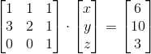

We take the co-efficient and make a matrix of that. A dot product of the co-efficient of the matrix with the variables will give us the left hand side of the equation. That is equated with a vector of the right hand sides of the equation. Therefore, the equation form can be converted into matrix form using the above steps. Whenever a variable is missing in the equation, it’s corresponding co-efficient is 0.

2. **Determine x, y, and z values using the Numpy linalg.solve function**

The following is the output of the program, which solves our equations, by first converting them into matrix form

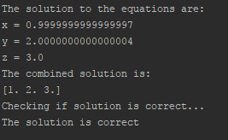

3. **Indicate a possible objective function in this case**

Since a company wants to invest in stocks, and have a portfolio, we must ‘Maxmize’ that portfolio, subjected to certain constraints in order to gain profits.

C:\Users\admin\Downloads\CodeCogsEqn.gif