**Assignment 1:**

**Installation**

1. To install all the relevant python packages, use the command on the command prompt as ‘pip install –r requirements.txt’ after extracting the zip folder
2. To run the file, on a command prompt type ‘python a1.py’
3. NOTE: Sometimes yahoo finance bugs out and returns an empty dataframe. This is a known bug. Please rerun the program if it does not give a successful run initially.

**Explanation**

1. **Download the historical data of Disney and S&P 500 over that periodCalculate the returns of Disney and the S&P 500 index**

This has been performed by connecting to Yahoo Finance API and downloading the OHLC values from 2008 to 2013 time period for Disney and S&P500. Then, a monthly returns is calculated using the following:

disney_monthly = data_disney.asfreq('BM').ffill().pct_change().dropna()

1. **Using Python, plot the monthly returns on Disney against returns on the S&P 500 index from October 2008 to September 2013**

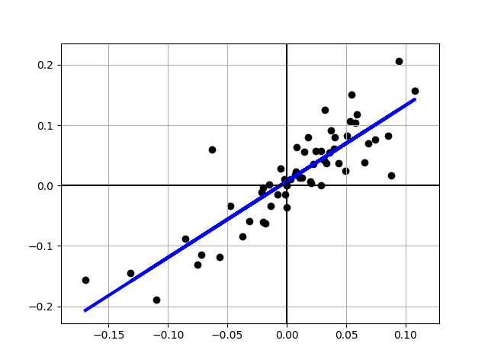

1. **Find the regression line for Disney return on S&P 500 index. What is the slop of the regression?**

The regression line is depicted in the above chart. The slope of the regression is:

Beta (Slope): 1.26087763362

1. **What is the meaning of this value?**

The slope of the regression corresponds to the beta of the stock, and measures the riskiness of the stock.

1. **What is the Intercept of the Regression?**

(Intercept): 0.00686875526833

1. **What is the meaning of this value?**

The intercept of the regression provides a simple measure of performance during the period of the regression, relative to the capital asset pricing model.

1. **Does Disney’s stock perform better or worse than expected? Why?**

The difference between the intercept and Rf (1-b) is Jensen's alpha. If it is positive, your stock did perform better than expected during the period of the regression.

For Disney, the Jenesen’s Alpha was **0.697745428233**, which means that Disney did 0.697% better than expected, per month, between October 2008 and September 2013.

1. **Find the annualized excess return?**

Annualized Excess Return: 8.70185723732 %

1. **What is the R squared of the regression?**

R^2: 0.746893521326

1. **What is the significance of this value?**

The R squared (R2) of the regression provides an estimate of the proportion of the risk (variance) of a firm that can be attributed to market risk. The balance (1 - R2) can be attributed to firm specific risk.

1. **What is Standard Error of Beta Estimate?**

Standard Error: 0.0972204882593

1. **What is the significance of this value?**

Regression parameters are always estimated with error. The error is captured in the standard error of the beta estimate, which in the case of Disney is 0.097 percent