1. Yahoo Finance API was used. This was done because it is easier to connect with PDR and YF fix package to retrieve the data. There were problems connecting to Google Finance, but the YF fix shines and retrieves data correctly. Plus it has additional methods to replace the close with adj. close etc.
2. Apple’s financial (Balance Sheets) were downloaded from MorningStar, for the past 5 years (That’s what the free version limits you to). These were then used to determine a trend.

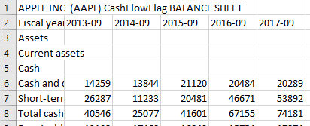

As one can observe, Apple releases its Fiscal reports in the month of September.

If we look at the Volatility Ratio for that month, that is, September, over the past years, one can say that it spikes in comparison to surrounding months, as depicted by running the program and observing the following graph (Major ticks are the years and minor ticks are the months)

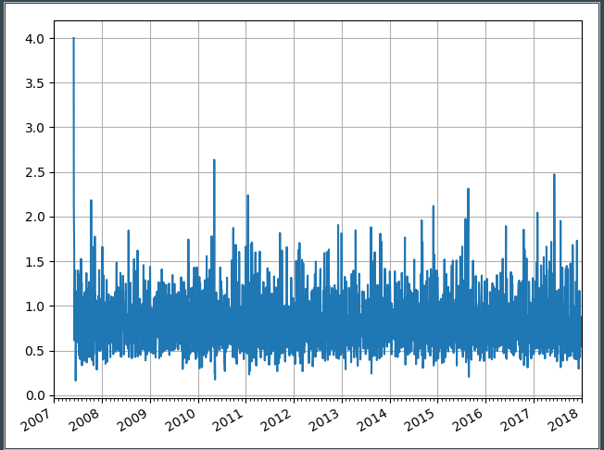

1. The Vol. Ratio was calculated using the formula:

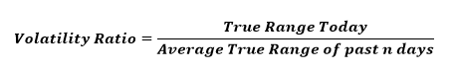

The Volatility , in comparison to ATR and Close price gives the following graph

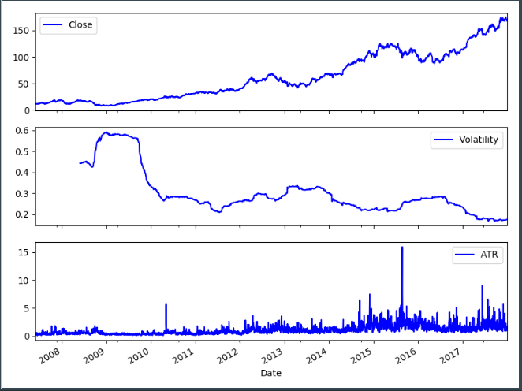

The Vol.Ratio and Close price comparison chart is as follows:

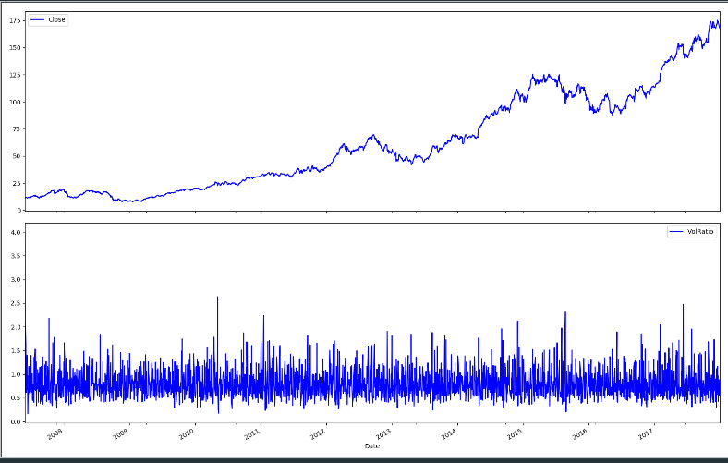

1. A signal strategy is then generated to trade on the vol ratio based on hitting upper band (1.4) anmd lower band (.4)

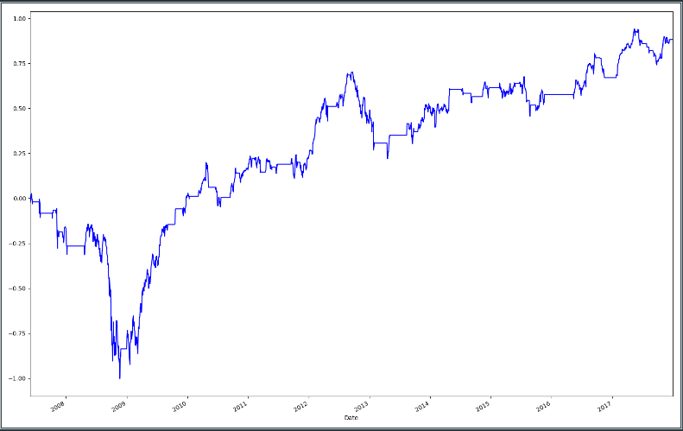

1. KPIs are then determined on this strategy, and drawdown is plotted

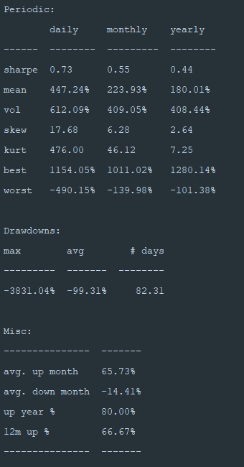

Drawdown:

