1. A custom function was written to fetch intraday data from Google.

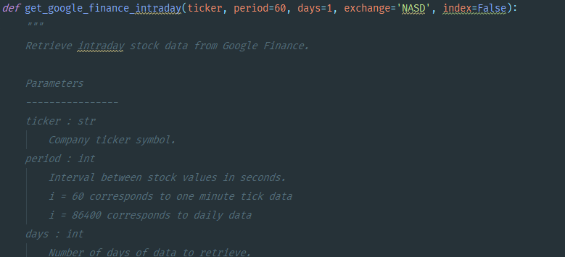

1. Dow Jones utilities was used, simply for the fact that it contains only 15 constituents. Easier to download data, and lends to quicker execution of programs. The constituents CSV was downloaded from Quandl. The constituents and it’s data are loaded in a for-loop as follows:

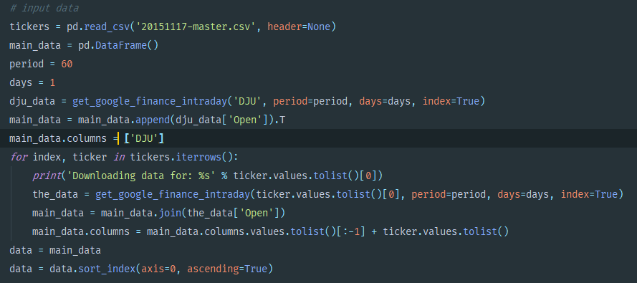

1. The correlation is then calculated, and the one with the largest correlation is chosen



1. The distance between the SMA of a window of 50 and the pair is calculated

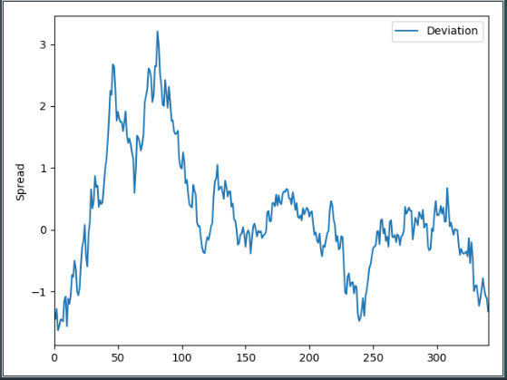

1. Signals for the pairs trading are then generated

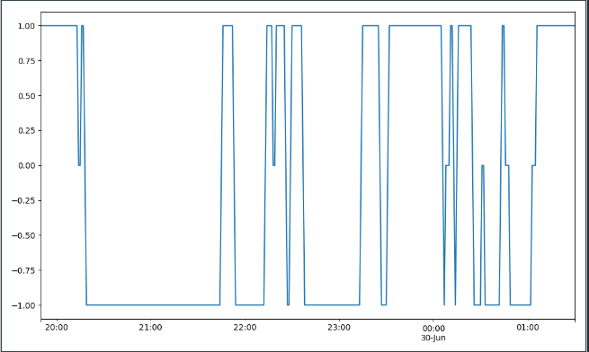

1. Based on signals the strategy is traded and compared against returns

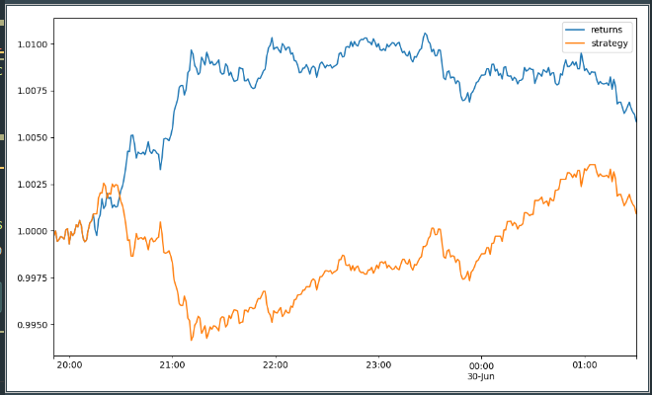

1. KPIs are calculated

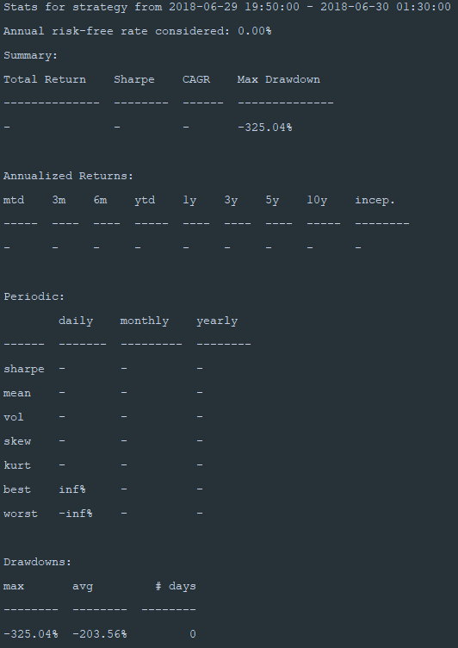

1. 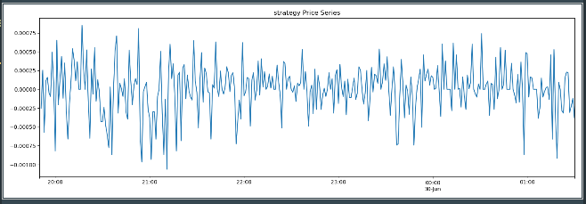
2. Drawdown is graphically represented

