1. Fetches data from Yahoo Finance, by using fix_yahoo_finance for the ticker supplied. Note that this only fetches data upt **5 years and not 25 years** to save memory space and I/O timings

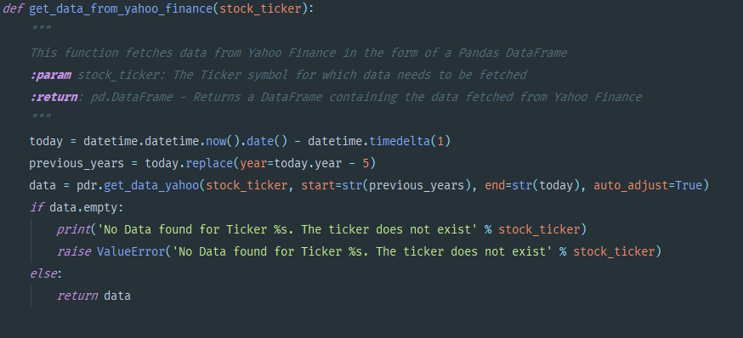

1. Calculate strategy number 1, mean reversion

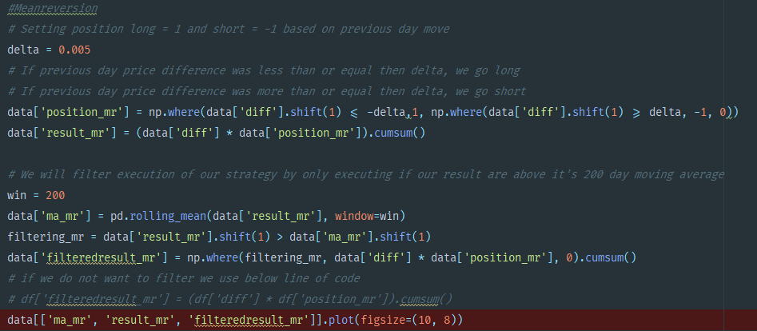

1. Calculate strategy number 2, breakout

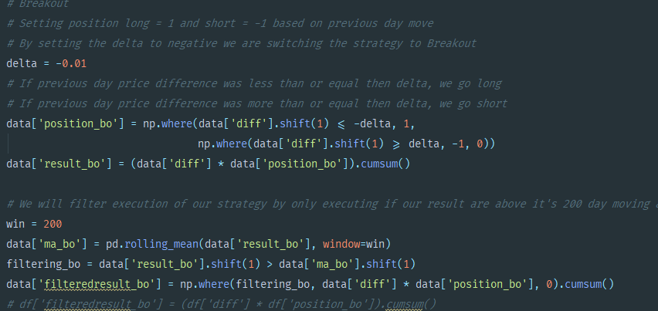

1. Upright pyramid is seen by constantly buying when in trend

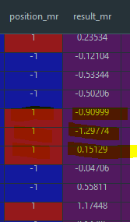

1. Backtest on 80% data, find optimal f

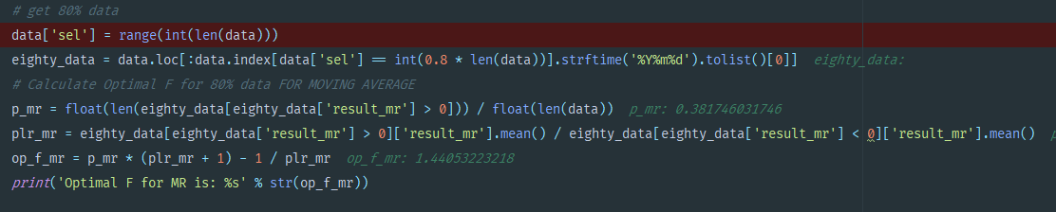

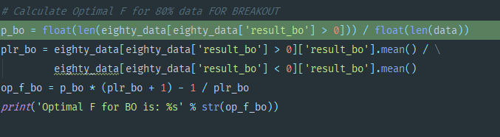



1. Find KPIs for 20% data

