1. Fetches data from Yahoo Finance, by using fix_yahoo_finance for the ticker supplied. Note that this only fetches data upto **3 years and not 25 years, and for only a couple of tickers** to save memory space and I/O timings

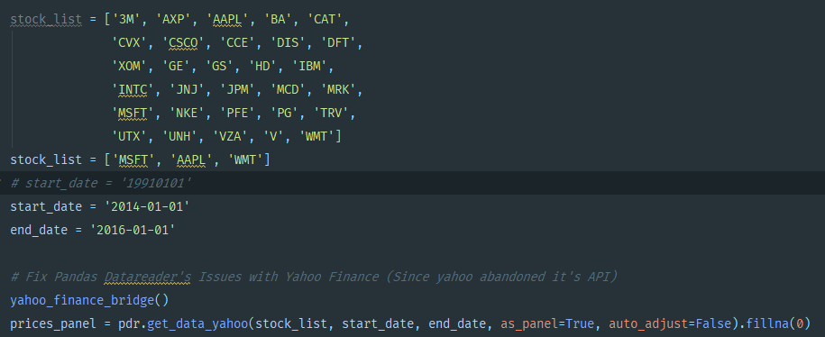

1. 21 EMA and 45 EMA is calculated

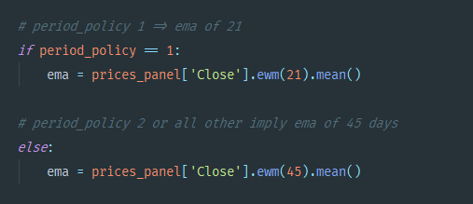

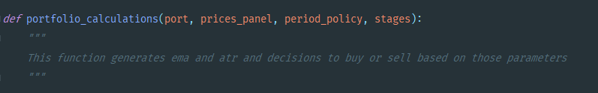

1. The position sizing models are calculated with the help of the following function

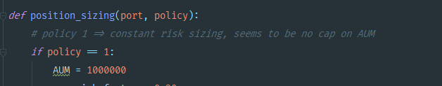

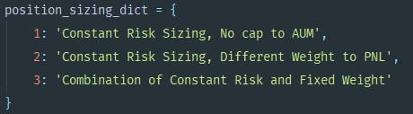

1. The pyramids are calculated with the following function

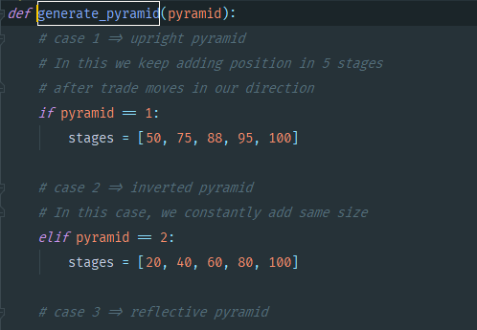

1. KPIs are determined for each portfolio with the ‘find_kpi’ method

