**Assignment 1:**

**Installation**

1. Open a command prompt in the folder, and type ‘pip install –r requirements.txt’ to make sure that all the dependencies are installed

2. To run the file, on a command prompt type ‘python a1.py’

3. Please note: This script makes use of fix_yahoo_finance, which may bug out during execution and fetch blank dataframes. Please re-run the program

**Explanation**

NOTE: I have commented out the parts that connect to yahoo finance and instead use a pickle file which I saved upon fetching the data that I get from connecting to yahoo financial. This helps save time as the process of fetching the data is long. One can always uncomment the function call to verify whether everything is working fine. I’ve kept it that way to save time

NOTE2: For Book to Market, I only took 10 stocks as it takes quite some time for generating B2M

1. **Select a universe of 100 stocks spread across different industry verticals – information technology, utilities, banking and financial services, midcaps, large caps etc**

Constituents CSV was downloaded from Morningstar. This was then filtered according to sectors, and random 100 stocks were chosen from the 11 sectors. This is depicted by the following code:

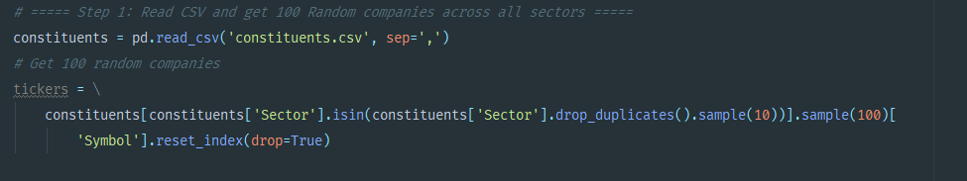

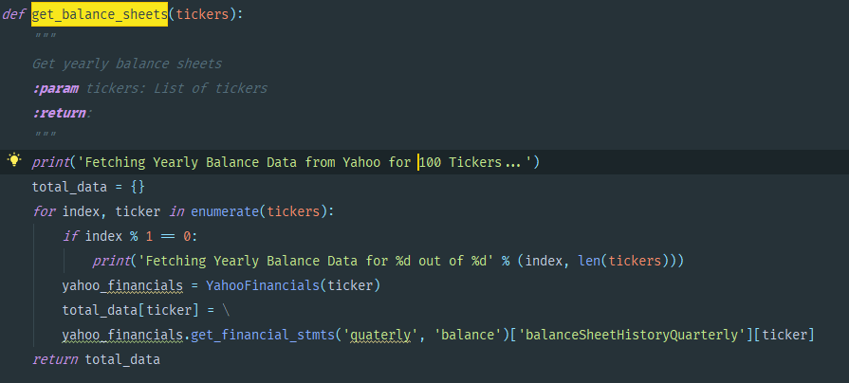

1. **Download previous year’s balance sheets for all and calculate the following metrics:**

* **Earnings Yield**
* **EBITA**
* **Free cash flow yield**
* **Return on Capital Employed**
* **Book to Market**

Earnings Yield is calculated as follows:

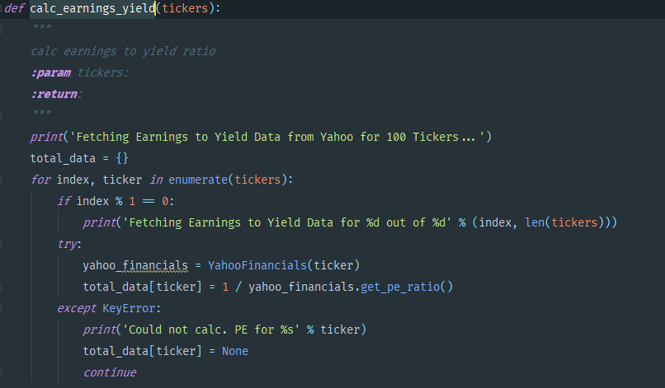

EBITA

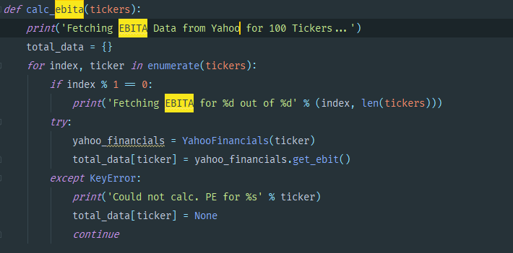

FCF ():

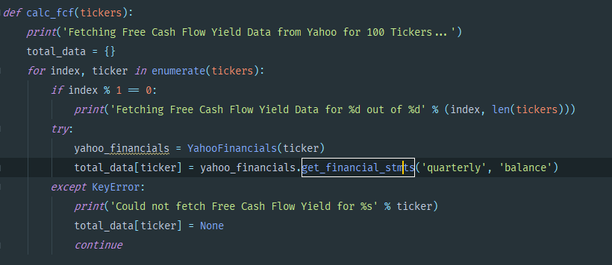

ROCE:

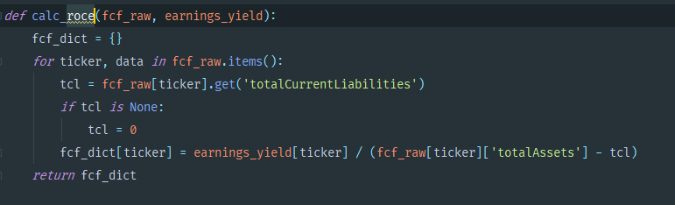

B2M:

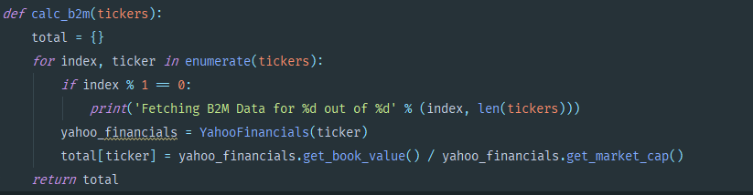

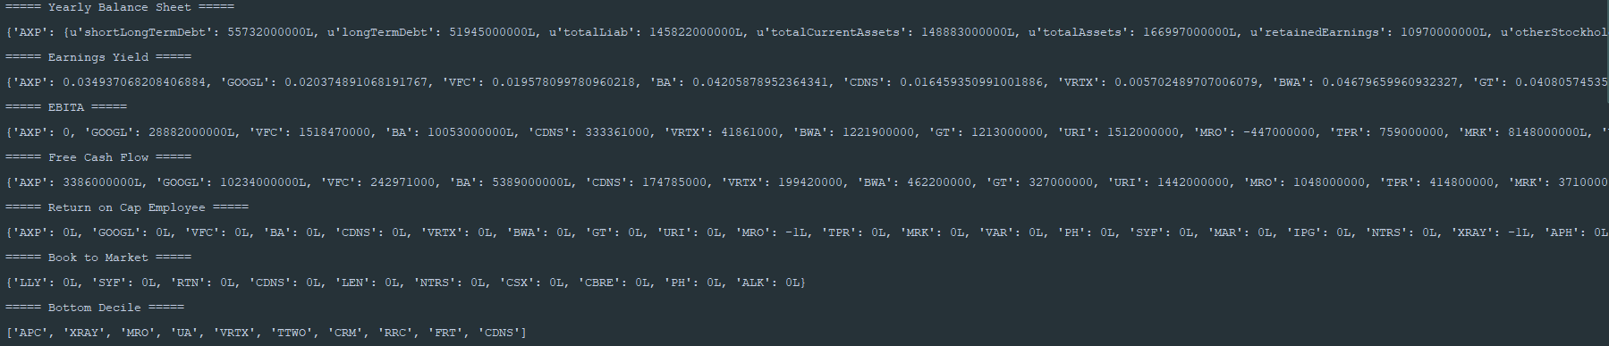

1. **Arrange stocks in deciles in according to the value of these metrics**

I took a metric (EBITA), and sorted the stocks based on it to get the top and bottom decile.

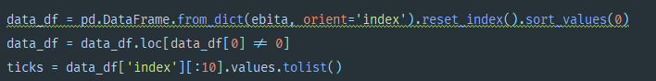

Then I took the value decile (bottom one) for further processing



1. **For the value decile stocks, calculate the following (from the time of publishing of last Annual report to date) risk  and return metrics**

I used FFN library to get the results for CAGR etc.

The results are as follows:

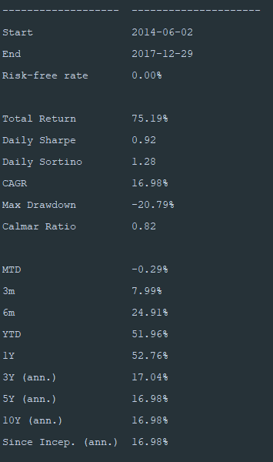

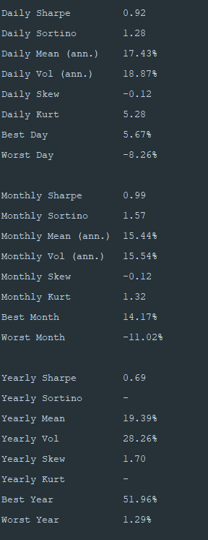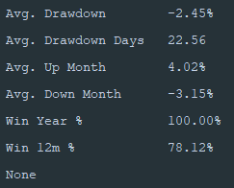

A few plots depicting drawdown are as follows:

Max Drawdown:

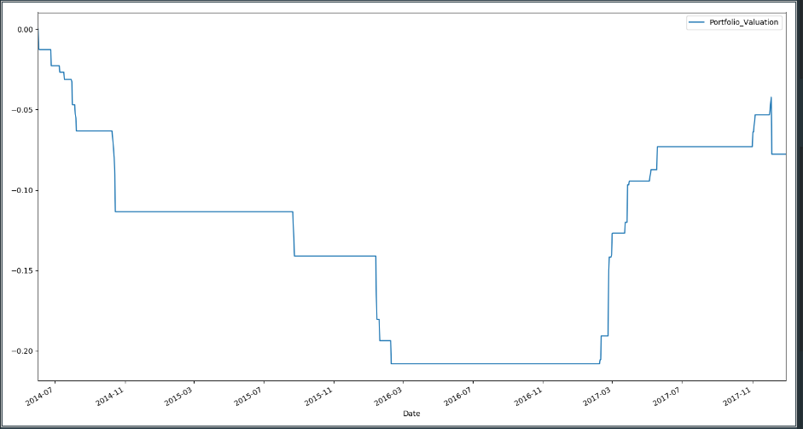

Max Daily Drawdown:

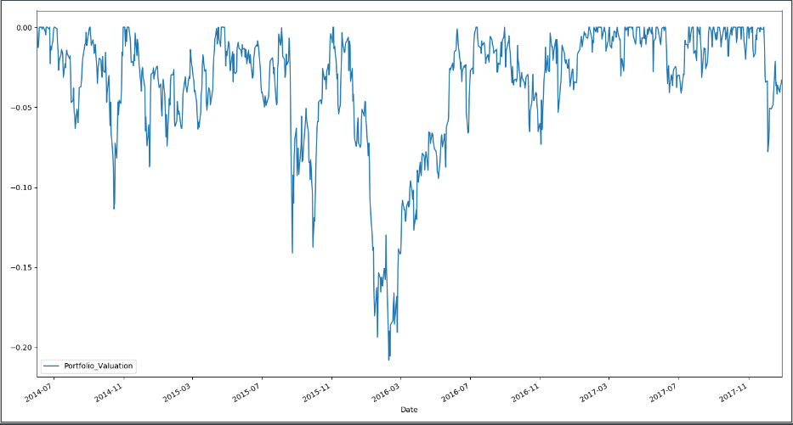

The code that finds the metrics is as follows:

