**Assignment 2:**

**Installation**

1. Open a command prompt in the folder, and type ‘pip install –r requirements.txt’ to make sure that all the dependencies are installed

2. To run the file, on a command prompt type ‘python a2.py’

3. Please note: This script makes use of fix_yahoo_finance, which may bug out during execution and fetch blank dataframes. Please re-run the program

**Explanation**

1. **Write a program that prompts the user to enter any valid stock symbol available in an appropriate financial website such as Google Finance, Yahoo Finance, Quandl, CityFALCON, or another similar source for NYSE & NASDAQ. Ensure proper error handling for wrong user inputs**

The following code downloads data from yahoo finance by prompting the user to enter a ticker to download data for, with error handling

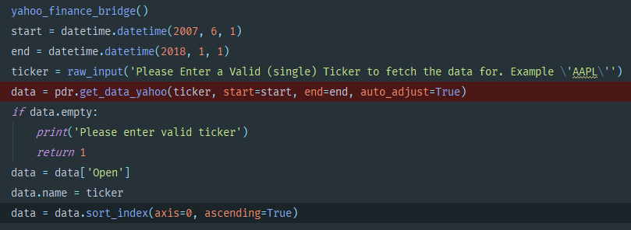

1. **Download/access End-of-day and Hourly data for last 10 years for user entered ticker from an appropriate financial website such as Google Finance, Yahoo Finance, Quandl, CityFALCON, or another similar source**

Downloads data from Yahoo Finance

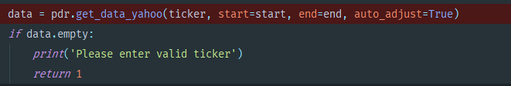

1. **Constitute a Simple Moving Average crossover system for trend trading on the daily time frame**

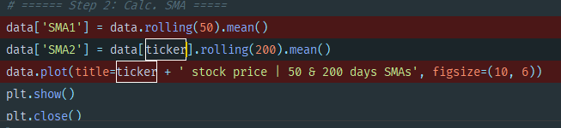

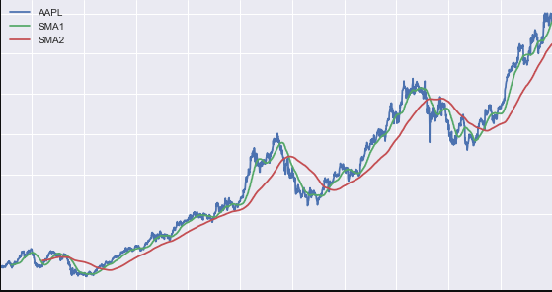

A strat is made, and a portfolio based on the strat is then constructed

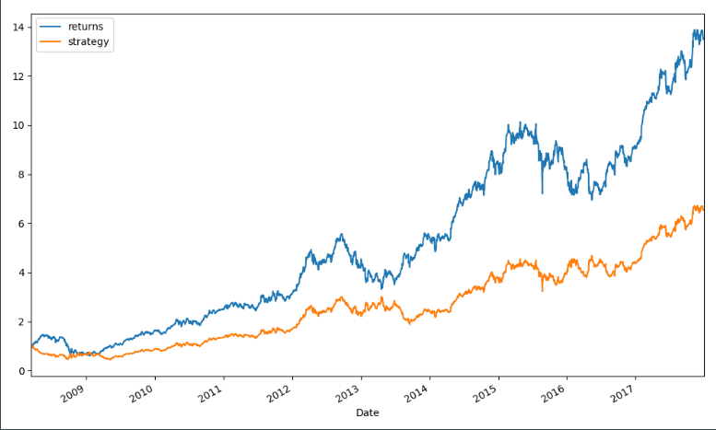

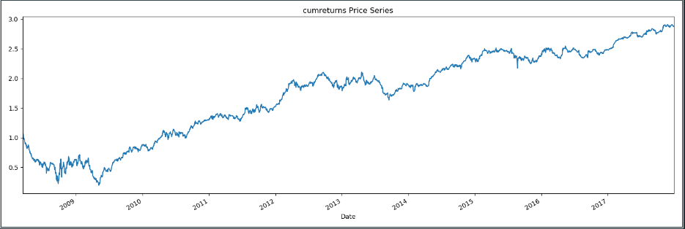

Its drawdown is as follows:

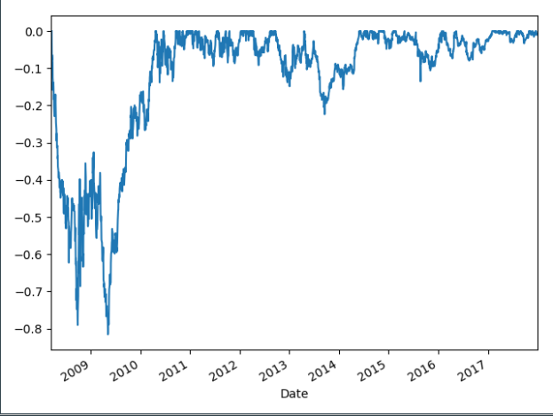

1. **Calculate 2 period RSI (Relative Strength Indicator) values for the stock in question on the hourly time frame to identify overbought and oversold conditions**

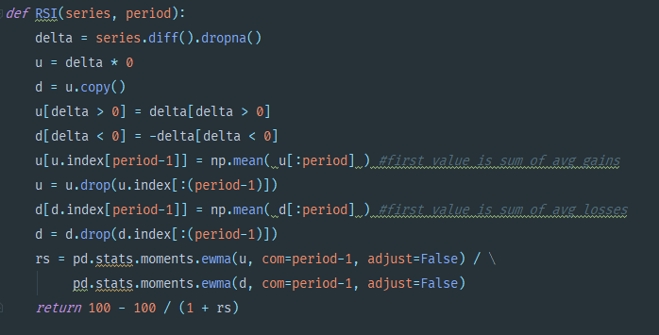

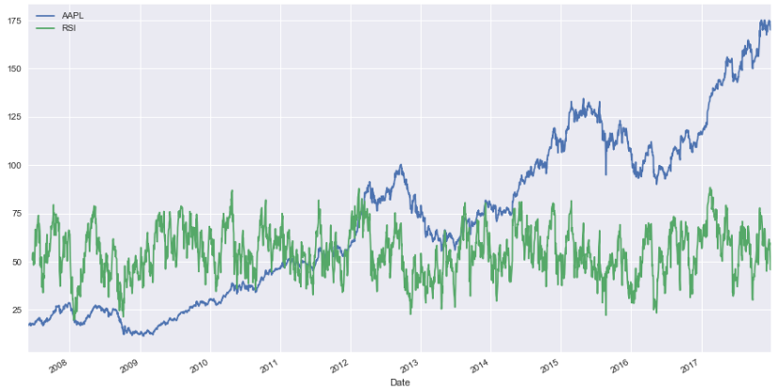

1. **Exit trade on MA Crossover in opposite direction AND favorable RSI indications on smaller time scale**

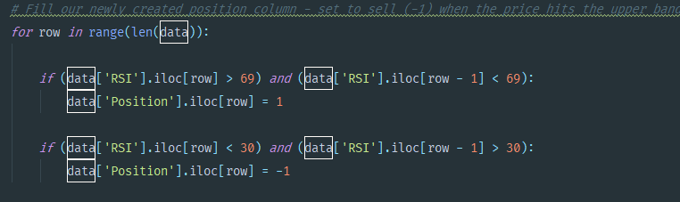

Cumulative Strat Return

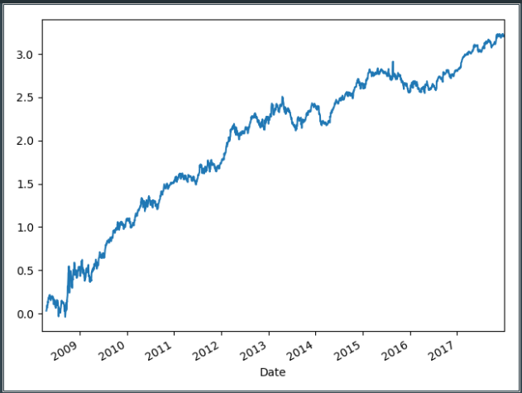

1. **Estimate and compare historic performance**

