**Assignment 2:**

**Installation**

1. To install all the relevant python packages, use the command on the command prompt as ‘pip install –r requirements.txt’ after extracting the zip folder
2. **Please Note: Python used for this assignment is python 3.6, so that we can run tensorflow**
3. To run the file, on a command prompt type ‘python a2.py’
4. NOTE: Sometimes yahoo finance bugs out and returns an empty dataframe. This is a known bug. Please rerun the program.

**Explanation**

1. The Universal set used for prediction was the SnP500 stock data. A subset that was chosen was the AAPL stock

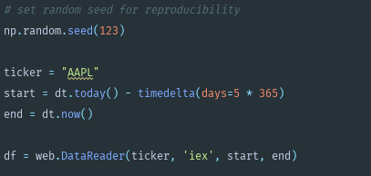

1. Reshape and scale the data for performing LSTM and visualization

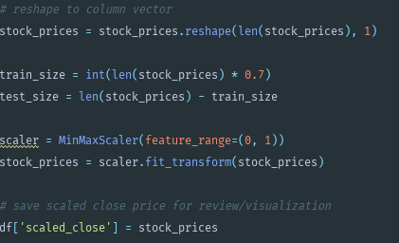

1. Split data into training and test



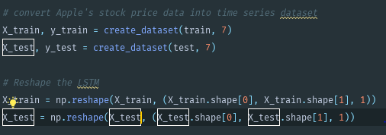

1. Create the model

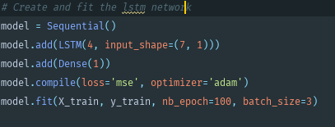

1. Use LSTM network to perform the predictions

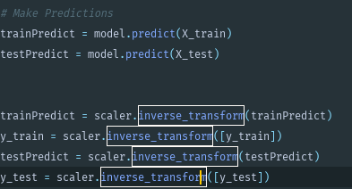

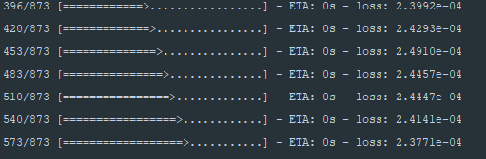

1. Calculate the Mean squared error and RSE

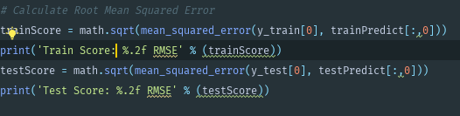



1. Plot the predicted values

